Bassett Family Newsletter, Volume XXIV, Issue 9, 20 Sep 2026

(1) Welcome
(2) Louis Bassett of Albion, New York Family Bible
(3) Nathan Bassett family Dover Township, Cuyahoga County, Ohio (b. 1785)
(4) Death of Wendell Philip Bassett of New Hamshire (2026
(5) Y-DNA result from a Basset line from France and Switzerland
(6) Trading Card for Allen Lee Bassett of Connecticut and New York
(7) Death of Robert William Bassett of Michigan (2026)
(8) New family lines combined or added since the last newsletter
(9) DNA project update

The newsletter link page is below. Once you get to this page, choose the current month to see the current newsletter.
You can either view in a PDF or in a word document format.
http://bassettbranches.org/newsletters/newsletters2014on.shtml

Section 1 - Welcome

I have been contacted by a male Bassett descendant of the #18 Daniel Bassett of Leighton Buzzard, England. He has said he will be joining the Bassett Y-DNA project soon. Also given the results shared in article #5 this month, I would like to get a few more participants from French Basset/Bassett lines. I have scholarship money to pay for these if you would like to participate.

Totals number of individuals loaded into the Bassett website: 219,891

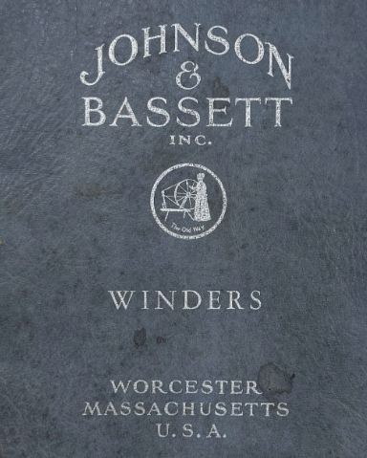

* * * * *
Section 2 - Featured Bassett: Family Bible of Louis Bassett of New York

Louis Bassett descends from #3B Thomas Bassett of Connecticut as follows:

Thomas Bassett (b. 1598) and wife Joana Beardsley
Thomas Bassett (b. 1650) and wife Sarah Baldwin
Thomas Bassett (b. 1699) and wife Sarah Pearson
Joel Bassett (b. 1734) and wife Grace Livingston
Enoch Bassett (b. 1760) and wife Esther Bristol
Louis Bassett (b. 1787) and wife Anna George

There is a possibility that I have this Louis Bassett misplaced. 1850 census shows he was born in New York, however, I have a birth record for Lewis Bassett, son of Enoch and Esther (Bristol) Bassett that does not match this date of birth in the bible.

This Bassett Family bible is currently for sale on eBay.

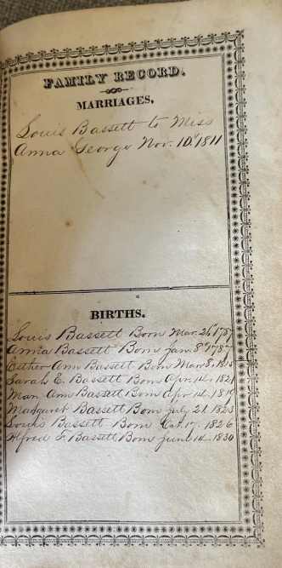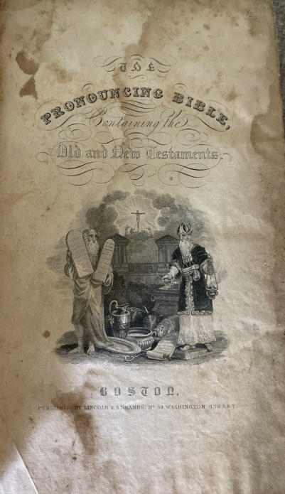
Bassett Family Bible with marriage and children’s birth dates

* * * * *

Section 3 - Featured Bassett: Nathan Bassett Family of Dover Township, Cuyahoga County, Ohio

Nathan Bassett descends from #1A William Bassett of Plymouth, Massachusetts as follows:

William Bassett and wife Elizabeth
William Bassett (b.1624) and wife Mary Raynesford
William Bassett (b. 1656) and wife Rachel Williston
Nathan Bassett (b. 1685) and wife Mary Stetson
Nathan Bassett (b. 1715) and wife Thankful Fuller
Cornelius Bassett (b. 1753) and wife Remember Nye
Nathan Bassett (b. 1785) and wife Martha Hall
Martha Bassett (b. 1818) and husband William Waterman Aldrich

My son is headed to the Cleveland, Ohio area and he told me his hotel is on Bassett Road. I couldn’t find a whole lot on this family, but did find the short article below. Bassett Road was named for Nathan Bassett.

Memorial to the Pioneer Women of the Western Reserve

In 1811 James and Barnabas Hall with their wives, also Martha Hall, wife of Nathan Bassett, came to occupy 2,100 acres of land purchased before leaving Lee, Mass. Mrs. Bassett's daughter, Vesta, was the first white baby born in Dover. Lydia, Mrs. John Porter, was born in 1814, living all her life in Dover, where her daughter, Mrs. Griffin, still resides. Mrs. Bassett's other daughters were Lucy, Harriet, Nancy, and Martha. The latter became Mrs. W.W. Aldrich, a careful, attentive mother of a large family.

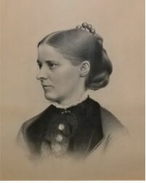
Martha (Bassett) Aldridge, wife of William Waterman Aldrich
* * * * *

* * * * *

Section 4 - Featured Bassett: Death of Wendell Philip Bassett of New Hampshire (2026)

Wendell Philip Bassett descends from #345B Samuel Bassett of New Hampshire as follows:

Samuel Bassett (d. 1872) and wife Hannah Peasley
George W. Bassett (b. 1836) and wife Sarah J. Beede
Joseph P. Bassett (b. 1867) and wife Eva Kimball
Raymond Kimball Bassett (b. 1896) and wife Priscilla Deborah Knights
Wendell Philip Bassett (b. 1931, died 2026)

Roan Family Funeral Homes & Cremation Service
Wendell Philip Bassett
Aug 4, 1931 – Aug 22, 2026
Weare, NH

WEARE – Wendell Philip Bassett, Sr., 95, of Weare, passed away peacefully at home surrounded by his loving family on Saturday, August 22, 2026.He was born on August 4, 1931, in Sandown, NH, son of the late Raymond and Priscilla (Knights) Bassett. Wendell was very active in his home church in Epsom - now Epsom Bible Church, where he served faithfully for many years, including transporting those that were unable to transport themselves. He then attended Weare Christian Church for the last 13 years. He was a great example of how to support a family by attending many sporting events for his children, grandchildren and great grandchildren, as well as visiting them in far-flung places like Illinois, Michigan, Ohio, Pennsylvania, Tennessee, California, West Virginia, Hawaii, Indonesia, China and the Philippines. Like most of the Bassetts, he had a large productive garden most years. Wendell graduated from the University of New Hampshire Thompson School of Applied Science in May 1951. He worked at Johnsons Dairy in Northwood, Cutters Farm in Epsom, Weeks Dairy in Gilford, and then Huckins Oil in Epsom for 30 years until it was sold. Wendell started out delivering oil - sometimes taking his kids to push the button to reel in the hose while he walked through the snow to connect the hose to the tank. He later became an oil burner technician for the rest of his time with Huckins. He then worked for 5 years for John Dodge Oil and in retirement did volunteer work for Christian camps, churches, civic programs and people who needed a handyman. For several years in the 1960’s, Wendell and Barbara spent many Friday and Saturday evenings square dancing. They were quite the couple! In addition to his parents, Wendell was predeceased by his beloved wife of 70 years, Barbara Katherine (Saturley) Bassett; and 12 of his 15 siblings. He is survived by his children, Philip Bassett (Susan) of Daniels, WV, Randolph (Jo-Ellen) of Laconia, NH, Jane (David) of Dallas, TX, and Rebecca (William) of Weare, NH; 19 grandchildren; 40 great-grandchildren; 3 great-great grandchildren; siblings, Donald Bassett of Epsom, NH, David Bassett of Penobscot, ME, and Caroll Bassett of Sandown, NH; and more than 60 nieces and nephews. A graveside service will be held at the New Rye Cemetery in Epsom on Saturday, September 5, 2026, at 11:00am, with ​​⁠‍a reception to follow. In lieu of flowers, donations may be made to your favorite charity in honor of Wendell’s memory. Assisting the family with arrangements is the Roan Family Funeral Home of Pembroke. To share a memory or offer a condolence, please visit www.roanfamilyfuneral.com.

* * * * *

Section 5 - Featured Bassett: Basset line of France and Switzerland

Denis Basset of Switzerland recently researched his Bassett line and has traced his line back to Louis Basset, born 1540. Louis moved from France to Switzerland. He married in France around 1565 and became a citizen of Goumoens, Switzerland.
He recently took part in the Bassett Y-DNA project and his haplogroup is R-Y265167.
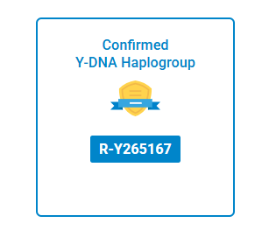

What is interesting about his result is that he matches the two Y-DNA participants from the 53B. Jean Jacques Luis Bassett family of Christchurch, Yorkshire, England. This seems to possibly confirm the family story that the family came from Switzerland via France to England then the United States.

53B. JEAN JACQUES LUIS BASSETT OF CHRISTCHURCH, YORKSHIRE, ENGLAND
Family tradition states that Basset and Lavalette went to England from Switzerland via France to run away and get married. They were only in England for two generations.

* * * * *

Section 6 - Featured Bassett: Allan Lee Bassett of Connecticut and New York

Allan Lee Bassett descends from #1B John Bassett of Connecticut as follows:

John Bassett and wife Margery
Robert Bassett and wife Mary
Robert Bassett (b. 1640) and wife Elizabeth Riggs
Captain Samuel Bassett (b. 1692) and wife Deborah Bennett
Benjamin Bassett (b. 1740) and wife Molly Hinman
John Bassett (b. 1779) and wife Nancy Atwater Lee
Allan Lee Bassett (b. 1827)

Allen/Allan later went on to found Prudential Insurance company. I have written about him in previous newsletters.

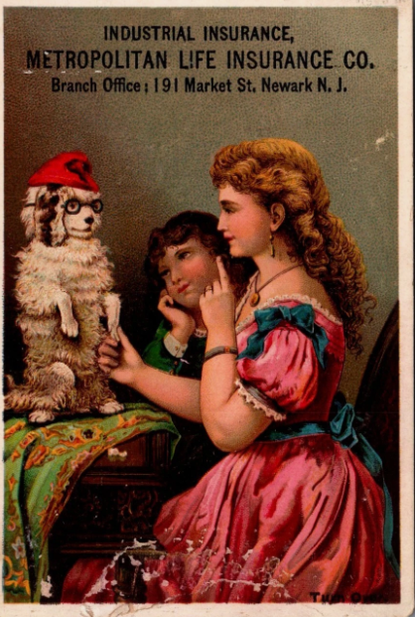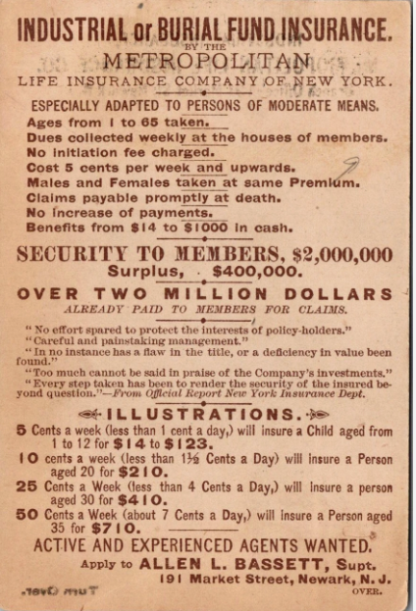

Metropolitan Life Insurance Company Trading Card recently for sale on eBay.
Allen L. Bassett, Supt.

* * * * *

Section 7 - Featured Bassett: Death of Robert William Bassett of Michigan (2026)

Robert William Bassett descends from #1 John Bassett of Connecticut as follows:

John Bassett and Margery
Robert Bassett (b. 1620) and wife Mary
Robert Bassett (b. 1640) and wife Elizabeth Riggs
Samuel Bassett (b. 1692) and wife Deborah Bennett
Ebenezer Bassett (b. 1731) and wife Hannah Smith
James Bassett (b. 1757 )and wife Betsey Canfield
Josiah Bassett (b. 1793 and wife Betsey Bassett
Elliot R. Bassett (b. 1818) and wife Julia Ann Miner
Rev. Edward Daily Bassett (b. 1855) and wife Kate Adams
Paul Adams Bassett (b. 1892) and wife Wilhelmina Schenetsky.
Robert William Bassett (b. 1929, d. 2026)

Beacon Cremation & Funeral Service
Robert William Bassett
Jan 26, 1929 – Aug 22, 2026
Traverse City

Robert William Bassett, age 97, left this earth on August 22, 2026.He was born in New Haven, Connecticut, on January 6, 1929, to Paul Adams Bassett and Wilhelmina Anna (Schenetsky) Bassett. He was predeceased in death by his two siblings, Charles and Helen. He graduated from Patchogue High School in New York in 1947. He attended the Massachusetts Institute of Technology; however, they failed to appreciate his approach to academics, and he left after three semesters. He attended Iowa State College for a brief time before obtaining an associate’s degree from Long Island Agricultural and Technical Institute .He was in training at IBM to fix computer equipment when he was drafted into the U.S. Army in 1951. True to his form, Bob negotiated to have the Army postpone his entrance into the Army until after he completed his training at IBM. He served his country at Fort Dix, New Jersey, and in Heidelberg, Germany. Bob relayed how he fell asleep during an outside lecture on the M1 Rifle and was covered in snow. His sergeant told him to go to the infirmary to make sure he did not have the flu; instead, he sneaked off to investigate how they were maintaining the computers on base. The computer specialists could not figure out how to fix a problem, and Bob volunteered to help out. They found him so useful that they had him stay with the computer maintenance team during some of his basic training while his colleagues had to sleep out in the snow. He was discharged in 1953 and resumed his employment at IBM. He attended night school and obtained a bachelor’s degree in physics from Hofstra University in 1965. He​​⁠‍ sometimes loved riding a motorcycle to work on Long Island because the gas was so expensive and it was easier to park. He met his first wife, Jean, while repairing computers. He decided to “start a conversation” with her that eventually led to their marriage on June 19, 1954. Bob and Jean Boehme Bassett had three children together: Steven (Sophia), Nancy, deceased (Jim Bair), and Carol (Jeff O’Dell). Bob continued to treat Steven’s first wife, Diane Bassett, like a close family member. Bob loved spending summer vacations with his wife and children at the cabin his father built in Connecticut. Bob talked about days filled with trap shooting, chopping wood, and playing cards. Jean died from cancer in 1979.Bob met his second wife, Carole, when his daughter Nancy was in a wedding party and Bob was also invited to the wedding. She challenged (dared) him to ask Carole out for dinner and the challenge was met. Carole was also widowed (George Shugart) and had two children, Eric (Becky) and Bob (Lena). Bob married Carole Shugart Bassett in 1981. Bob was very active with the American Legion, teaching NRA classes, winning multiple shooting competitions, and with his Church. Bob retired from IBM at age 55. He talked a local builder into hiring him at a lower wage in exchange for learning construction techniques. Bob later applied these techniques for many projects and was hauling full sheets of drywall upstairs at the lake house when he was 75 years old. Bob and Carole enjoyed many summers at Carole’s family cottage on Elk Lake in Michigan. Bob and Carole moved permanently to Elk Rapids in 1996 and enjoyed hosting children and grandchildren, sunsets, boating, and barbecues. Carole died in 1999 after battling lupus. Bob met his third wife, Janet, through their work together on Elk Rapids Chamber of Commerce and Lions’ Club projects, and they both served on the Elk Rapids Village Council. Janet had been widowed for eight years. She and Edward James (Jim) Worthington had three children together, Edward, Gregory (Desiree), and Vincent (Laura). Bob worked up the courage to ask Jan to a few concerts. They spent more and more time together and fell in love. One of Janet’s grandchildren (Brianna, age 7 at the time) asked Bob, “Why don’t you marry my grandma? I never had a grandpa; he died before I was born.” This was on the same day that they told everyone they decided to marry. Bob and Janet Worthington Bassett were married, with the blended family gathered, on a beautiful summer day in July, 2003. They remained very active in local civic organizations and loved hosting even more children, grandchildren, and eventually great and great-great-grandchildren at the house on the Lake and then in the Villages, Florida. They moved back to Michigan in 2023. Bob and Janet Worthington Bassett shared 22 ½ years before Janet died in 2025. With all of the Clan combinations, Janet and Bob have 27 grandchildren, 18 great-grandchildren, and 12 great-great-grandchildren. Bob has always been a big supporter of community service and was very active with Meals on Wheels, Lions Club, Elk Rapids Chamber of Commerce, and Elk Rapids Village Council. Bob loved playing board games, particularly Rumikub with his gang of friends. Bob said he is a big supporter of higher education, investing money, and planning for the future. He consistently advised saving and investing as much as you can and getting your money working for you. Bob has courageously pursued loving relationships despite his many losses. He said, “You know Love when you see it. Don’t hesitate!” Words of wisdom from Bob: “I have had a great life. I have had three different families, but I actually think of all of you as being one family and I am forever grateful for that. For me, it has been like magic. I have had three successful marriages. I loved each one. It was a different kind of love for each, but I am so happy that we married each other. I am the luckiest guy in the whole world. I have lived a great life. I would like the end to be with nothing but gratitude and acceptance.” His end was certainly overflowing with gratitude, acceptance, and love. Bob has decided to donate his body to Michigan State University Medical School to be used in the advancement of medical science, teaching, and study. He said he chose this path because he wanted to pay back society for the good fortune he has received. He was very pleased when his acceptance letter came and he said he was excited to be a Spartan. Bob’s family extends deep appreciation to his friends at the Village at LaFranier Woods Apartments, the loving staff of Comfort Keepers, and Heartland Hospice. All are welcome to join Bob’s family and friends for a Celebration of Life on Saturday, October 24, from 3:00 p.m. to 6:00 p.m. at the Top-of-the-Park at the Park Place Hotel (300 East State Street, Traverse City, Michigan 49684). Beacon Cremation & Funeral Service, Covell-Traverse City Chapel, is in charge of arrangements.www.beaconfh.com.

Section 8 - New family lines combined or added since the last newsletter

No new lines added and no lines combined since the last newsletter.

* * * * *

Section 9 - DNA project update.

A new result for kit a kit from the #183B line from France/Switzerland was reported above in article #5.
Donations of any amount can be made to the Bassett DNA project by clicking on the link below. Any funds donated will be used to fund select Bassett DNA tests that will further our project as a whole and benefit all Bassetts worldwide.

http://www.familytreedna.com/group-general-fund-contribution.aspx?g=Bassett
This is just a reminder that the DNA portion of the Bassett Family Association can be found at:

A current spreadsheet of results can be found at:
http://www.bassettbranches.org/dna/BassettDNA.xls
If you don't have Excel and can't open the spreadsheet above, you can now see the DNA test results at the following website.
http://www.familytreedna.com/public/Bassett/
Jeffrey Bassett
520 Salceda Drive
Mundelein, IL 60060 USA
bassettgenealogy@gmail.com

