Bassett Family Newsletter, Volume XXIV, Issue 8, 16 Aug 2026

(1) Welcome
(2) The Traveller’s Tale, by Ray Bassett
(3) More Information on William T. Bassett, Hartford Connecticut Barber
(4) 39th Annual Bassett Family Reunion Group Photo, Michigan (1947)
(5) Death of Steven Cook Bassett (2026)
(6) Will of William Bassett of Massachusetts, son of Nathaniel Bassett
(7) Marshall Bassett Family Photograph, Shelby County, Indiana
(8) New family lines combined or added since the last newsletter
(9) DNA project update

The newsletter link page is below. Once you get to this page, choose the current month to see the current newsletter.
You can either view in a PDF or in a word document format.
http://bassettbranches.org/newsletters/newsletters2014on.shtml

Section 1 - Welcome

It seems like now that I am retired, and I am busier than before and have less time for genealogy than I did while working! Hopefully I will catch up soon with getting retirement tasks settled to give me more time to devote to genealogy.

Totals number of individuals loaded into the Bassett website: 219,673

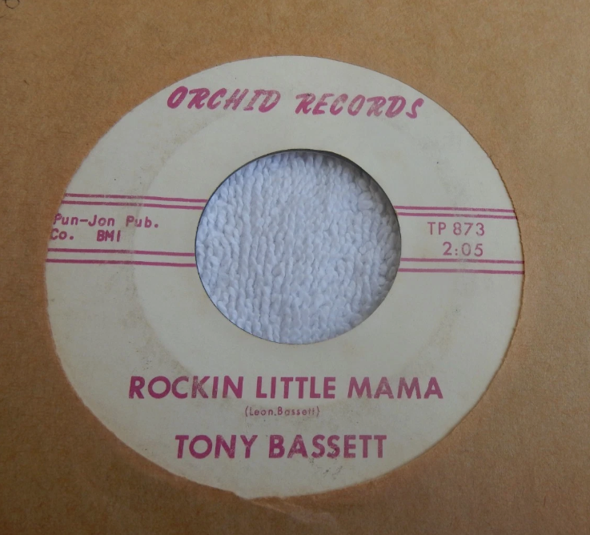

* * * * *
Section 2 - Featured Bassett: The Traveller’s Tale, book by Ray Bassett

John Raymond “Ray” Bassett descends from #368B Thomas Bassett of Ireland as follows:

Thomas Bassett of Fethard, Ireland
Alexander Bassett (b. 1845)
Thomas Bassett (b. 1879) and wife Anne Scallan
Hugh Bassett and wife Jean Conroy
John Raymond Bassett

Ray Bassett has recently published a book, The Traveller's Tale. It was launched by the former Irish Taoiseach (Prime Minister) Bertie Ahern at the National Library in Dublin.

They had the London launch at the Houses of Parliament in Westminster with North Belfast MP, John Finucane, doing the honours.

The book is about the achievement of peace in Northern Ireland through the Good Friday Agreement. Ray was one of the Irish Government negotiators at the time. .Ray provides an eye witness account of the whole process.

The book has received very good reviews and is now listed on Amazon USA, both as an ebook and also as a paperback.

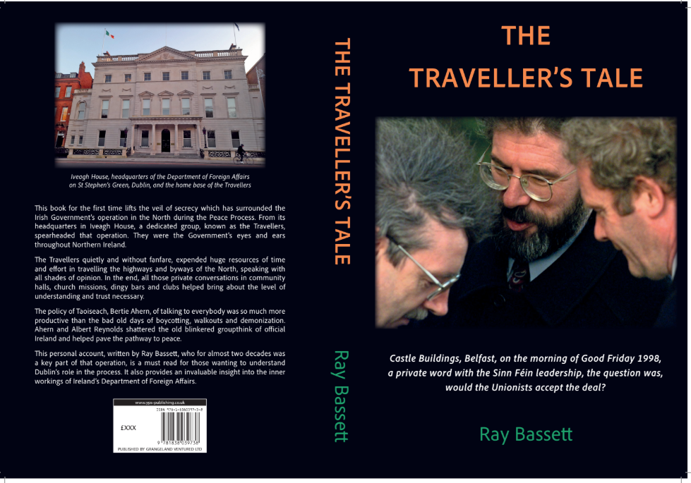

* * * * *

Section 3 - Featured Bassett: William T. Bassett, Hartford, Connecticut Barber

William T. Bassett descends from #6B William Bassett of Connecticut as follows:

William Bassett and wife Hannah (Dickerman) Ives
John Bassett (b. 1652) and wife Mercy Todd
John Bassett (b. 1691) and wife Elizabeth Thompson
Enos Bassett (b. 1724) and wife Mary Heaton
Amos Bassett (b. 1757) and wife Hannah Goodyear
Jesse Bassett (b. 1789) and wife Amelia Tuttle
William T. Bassett (b. 1825)

As a follow up to last month’s newsletter, it has been found that William T. Bassett was the personal
hairdresser/barber for Author Mark Twain.

From Twain’s Geography, we have the following:



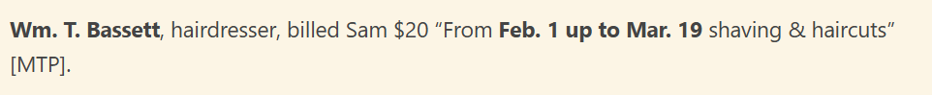

* * * * *

Section 4 - Featured Bassett: 39th Annual Bassett family reunion Group Photo (1947)

Wilbert Lee Raab is related to #25B George W. Bassett of Indiana as follows:

George W. Bassett (b. 1805) and wife Samantha Fairchild
Electa Loretta Bassett (b. 1827) and husband Samuel Marks
James Orlando Marks (b. 1855) and wife Susannah Nogel
Lula May Marks (b. 1887) and husband Wilbert Lee Raab.

You can see on the mailing tube below that the Bassett reunion photo was sent to Wilbert Raab in Tustin, Michigan.

If you can identify anyone in this Bassett family reunion photograph, please let me know.

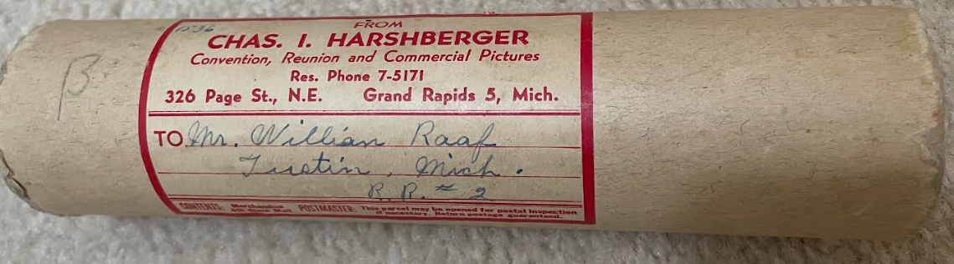

The following reunion picture was taken in 1947 at a Bassett reunion held near Grand Rapids, Michigan.

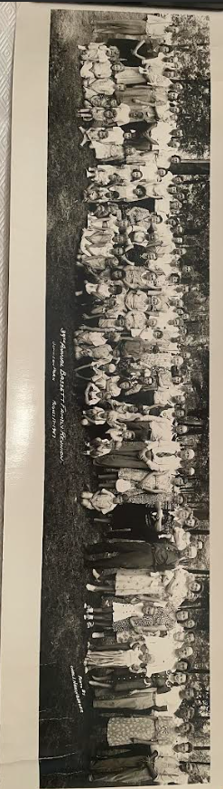
39th Annual Bassett Family Reunion Picture provided by Chris Bishop

* * * * *

Section 5 - Featured Bassett: Death of Steven Cook Bassett (2026)

Steven Cook Bassett descends from #8B John Bassett of New Jersey as follows:

John Bassett and wife Mary
Amos Bassett (b. 1760) and wife Susan Stout
William Bassett (b. 1803) and wife Lucinda Forman Hardshell
James Amos Bassett and wife Mary N. Jones
James Edward Bassett (b. 1863) and wife Elizabeth Carter
Hayes E. Bassett (b. 1889) and wife Dulcie Othelia Tucker
James Albert Bassett (b. 1914) and wife Elizabeth Cook
Steven Cook Bassett

Neptune Society
Steven Cook Bassett
January 7, 1943 – July 26, 2026

Steven C. Bassett passed away on Sunday, July 26, 2026, after a courageous battle with dementia and prostate cancer. He is survived by his loving daughter, Erin Bassett Minton, and son-in-law, Shane Minton; his brother, David Bassett, and family; along with many cherished cousins and dear friends.
Steve was born on January 7, 1943, in Fort Bragg, North Carolina, to James Albert Bassett and Elizabeth Cook Bassett Cason. After the loss of his father when Steve was just 11 years old, the family moved to Bradenton, Florida, where he grew up and graduated from Manatee High School in 1961. As a young man, he loved football, restoring cars, and figuring out how things worked—a curiosity that would shape the rest of his life..
Steve attended the United States Military Academy for two years before realizing his true calling was engineering. After moving to Atlanta, Georgia, he joined a church youth group where, during a co-ed mixer, he met the love of his life, Sherry O'Neill. He graduated from the Georgia Institute of Technology in 1965 with a Bachelor of Mechanical Engineering degree.
Steve and Sherry were married on July 23, 1966, in Aiken, South Carolina, beginning a marriage that would span 57 wonderful years. Together they built a life filled with love, adventure, and laughter. Their journey took them from Georgia, where Steve worked as an engineer—including five years with Delta Air Lines—to Dubuque, Iowa, where he earned his private pilot's license by attending flight lessons at night. Eventually they settled in South Florida, where they made their home and raised their family.
For more than three decades, Steve built an outstanding career as a professional mechanical engineer specializing in building systems, indoor environmental quality, and forensic engineering. His expertise improved the health and safety of countless homes, schools, offices, and commercial buildings throughout South Florida. He was deeply respected within the engineering profession and remained passionate about mentoring others and advancing the industry throughout his career.
Steve's professional service was extensive. He was a Life Member of both ASHRAE and the National Society of Professional Engineers (NSPE), served as National Director of NSPE from 2012 to 2018, represented the Florida Engineering Society in the NSPE House of Delegates, and was appointed by two Florida governors to serve on the Florida Building Commission for five years—an honor of which he was especially proud. Throughout his career he received numerous recognitions, including multiple Engineer of the Year awards (1990, 2002, 2013), Outstanding Service to the Engineering Profession honors (1999, 2002, 2015), the NSPE Distinguished Service Award (2016), and Rotary International's Paul Harris Fellow recognition (2019).
Beyond engineering, Steve believed in serving others. Through Rotary, he and Sherry welcomed international exchange students into their home, later traveling to visit many of them in their own countries. He also enjoyed playing Santa Claus for children in local hospitals, bringing smiles to families during the holidays.
Steve's greatest joy, however, was his family. He loved traveling with Sherry and Erin, boating, scuba diving, golf, artistic welding, tackling inventive home projects, rescuing dogs, and, much to everyone's amusement, reading romance novels. In retirement, Steve devoted himself to caring for Sherry as she battled Alzheimer's disease, serving as her steadfast caregiver with remarkable love, patience, and devotion.
Those who knew Steve will remember his unmistakable sense of humor. He rarely passed up an opportunity to wear a funny meme shirt or an outrageous hat just to make people smile. He was often described as "socially awkward and awkwardly social"—a description he likely would have laughed at himself. Beneath that quirky, quiet exterior was a man who was brilliant, kind, generous, fiercely protective of the people he loved, and always willing to lend a helping hand. Even as life became more difficult, he never lost that desire to bring joy to others.
Steve leaves behind a legacy of innovation, service, unwavering love for his family, and countless memories filled with laughter. He taught those around him that intelligence and kindness go hand in hand, that serving others is a life well lived, and that sometimes the best way to brighten someone's day is with a ridiculous shirt and an even more ridiculous hat. His is a legacy measured not only by the buildings he helped improve or the honors he received, but by the people he loved, the lives he touched, and the laughter he inspired.
A Funny Shirt & Crazy Hat Celebration of Life will be held on October 17th at the home Steve shared with his beloved wife and, in his later years, with his loving daughter and son-in-law. In honor of Steve, guests are encouraged to wear their funniest shirt, craziest hat, or both. Rather than a day of sadness, the family hopes you'll join them in sharing stories, laughter, and memories while celebrating the extraordinary life of a man who made the world brighter simply by being himself.

* * * * *

Section 6 - Featured Bassett: Will of William Bassett of Massachusetts, son of Nathaniel Bassett

William Bassett descends from William Bassett of Plymouth, Massachusetts as follows:

William Bassett and wife Elizabeth
Nathaniel Bassett
William Bassett

In the Name of God Amen ~
The Twentyeth day of Nov.r Anno, Domi Seventeen hundred &
Forty Nine, I William Bassett of Rochester in the County of
Plimoth Yeoman. Being [of sound] helth and of perfect mind and memory
thanks be Given to God therefor. Calling to mind the mortality
of my Body, an Knowing it is Appointed for all men once
to dye, do make and Ordain this my Last Will and Testament
that is to say Principally and first of all I give & commen[d]
my Soul into the hands of God that Gave it, and my Body
I Recommend to the Earth to be Buried in a Decent Christian
Buriel at the Discretion of my Execrs, nothing Doubting
but at the Generall Resurrection I shall Receive the same again
by the mighty power of God, and as Touching Such Worldly
Estate wherewith it has pleased God to Bless me in this life
I Give Demise and Dispose of the same in the Following
Manner and Form ~

Imp.s My Will is that all my Just Debts and Funerall Charges
shall be first paid ou of personal Estate by my Execr. Here
after named ~
Item I Give to my Eldest son Isaac Bassett Twenty shillings
Old Tenor, Being in full of his proportion with what he
hath allready Received ~
Item, I Give to my second Son Moses Bassett twenty shillings, Old Tenor
being in full of his Portion with what he hath already Received
Item I Give to my third son William Bassett Twenty shillings, Old Tenor
Being in full of his portion with what he hath already Received
Item I Give to my Eldest Daughter Fear Rogers Seven pounds
Old Tenor. Being in full for her Portion, with what she
hath already Received
Item I Give to my second Daughter Experience Bassett the
one half of her mother’s cloaths which she Left as she
and her Sister Mary Bassett hath already Divided
them Together with the Bed and Bedding and one half
the Pewter brought by her said Mother, and also one
of her Mother’s chests, the Bed Standing in the Bedroom
at the East End of the Lean to with which the Legacy of
Eight pounds Given her by her Grandfather Jenkins
which she hath allready Received is in full her Portion.
Item I Give to my third Daughter Mary Basset the one half
of her Mother’s Cloathes which she Left, as she and her
Sister Experience Bassett hath Divided them together
with the One half of the Pewter Brought by her said Mother
and One of her Chests, with ten pounds Old Tenor, and
a Legacy of Eight pounds Old Tenor Given her by her
Grandfather Jenkins, which sums of ten pounds Old Tenor
And Eight pounds Old Tenor is to be paid her by Execr
One year after my decease, with Lawfull Interest for
The Said Eight pounds from the First Day of May next
Till paid ~
Item, I Give and Bequeath to my Youngest Son Nathaniel
Bassett, and to his heirs and Assigns, all my Estate both
Real and Personall no before Disposed of, he paying
the Severall Legacies Herein Give to my Other Children
And Performing what I shall Hereafter Order & Direct
to & for my Loving Wife Susanna Bassett in this my
Last Will and Testament; and my Will is that my
Two Sons Samuel Bassett and Nathll Bassett shall
be Joynt Execrs of this my Last Will and Testament
untill said Nathaniel comes of Lawfull age and then
the sd. Nathl Bassett to be Sole Execr by himself and
in case the sd. Nathl shall Dye without Issue my Will
that what I have Given shall Decend, or be & belong
in Equal Partnership to my Son Saml Bassett
Experience Bassett and Mary Bassett my two youngest
Daughters ~

Furthermore my Will is that if my present &
Liveing Wife Susanna Bassett is Willing to Discharge
her Right of Dower and power of third in my Estate,
That then my said Execr shall pay her Thirty pounds
Old Tenor at my Decease, and that she be allow’d to
Carry away or Dispose of all she Brought to me at
our Intermarriage Seeing I have never either Recd or
Improved her Right of Dower or power of thirds in her
first Husbands Estate. Otherwise I am Sensable it is not
in my power to Deprive her hereby of her Right in Law

I do Hereby Disallow, Revoke & Disanull all &
every former Testament Will Lega[c]ies and Bequests
and Execrs by me in any way before named Willed &
Bequeathed Ratifying and Confirming this & no other to be
My Last Will and Testament. In witness whereof I have
hereunto sett my hand and seal the Day and Year above
written~
Signed Sealed Published William (x mark) Bassett
Pronounced & Declared by the
sd. William Bassett as his last
Will and Testament. In the
Presence of us Subscribers
Saml Sprague
Ruben Dexter
Noah Sprague

Plimoth April 7th 1755
This Will being Exhibited for
Probate the sd. Noah Sprague
made Oath that he saw the
Testator Sign, Seal & Deliver &
heard him Declare this Instrument
to be his Last Will and Testament
and That he Together with the said
Samuel Sprague and Ruben Dexter in the Testator’s presence
Subscribed as Witnesses & that according to the Best of his Judgement
he was then of Sound Mind

Before me John Cushing Judge of probt

Province of the Massachusets Bay Plimouth []

By the Honble John Cushing Esqr Judge
Of the probate of Will and for Granting
Letters of Admn on the Estates of persons dec’d
Having Goods Chattles Rights or Credits in the
County of Plim’th in the province aforesd.
To all unto whom these presents shall come Greeting
Know ye that upon the Day of ye date hereof Before me
at Plimouth in the County aforesd. the Will of William Bassett
Late of Rochester in the sd. County of Plimouth Yeoman decd. having
while he Lived and at the Time of his death Goods Chattles Rights
or Credits in the County aforesd. and the probate of the sd. Will
& power of committing admn of all and Singular the Goods, Chattles
Rights and Credits of the sd decd by Virtue thereof Appertaining
unto me the Admn. Of all and Singular the Goods Chattles Rights
& Credis of the sd decd and his Will any manner coming is
Hereby committed unto the sd Decd two sons Samuel Bassett
and William Bassett Joynt Execrs in the same will named well
and faithfully to Execute the sd Will and to Admr the Estate
of the sd Decd According thereunto, and to make a true and
Perfect Inventory of all and Singular the Goods Chattles
Rights and Credits of the sd decd and to Exhibit the same into
the Registry of the Court of probate for the County aforesd at or
Before the Seventh Day of July next ensuing; and also a plain
& True Accompt of their sd Admin upon Oath within twelve
Months next coming. In Testimony whereof I have hereunto
Sett my hand and the seal of the sd Court of probate. Dated
at Plimouth the Seventh day of April Anno Domi 1755.

John Cushing

* * * * *

Section 7 - Featured Bassett: Marshall Bassett family Photograph, Shelby County, Indiana

Marshall Bassett descends from William Bassett of Plymouth, Massachusetts as follows:

William Bassett and wife Elizabeth
William Bassett (b. 1624) and wife Mary Raynesford
William Bassett (b. 1656) and wife Rachel Willison
William Bassett (b. 1680) and wife Abigail Bourne
William Bassett (b. 1711) and wife Lydia Smith
Rufus Bassett (b. 1757) and wife Jedidah Handy
Nymphas Bassett (b. 1785) and Thankful Ann Bruce
Oliver Clemens Bassett (b. 1842) and wife Elizabeth Monroney
Marshall Bassett (b. 1858) and wife Senorah J. Israel

Marshall Bassett is in the back in the dark suit. Senorah is to his left sitting down.
I believe Ernest Bassett is the one in the front second from left holding his hat.

If you can identify any of the others, please let me know.

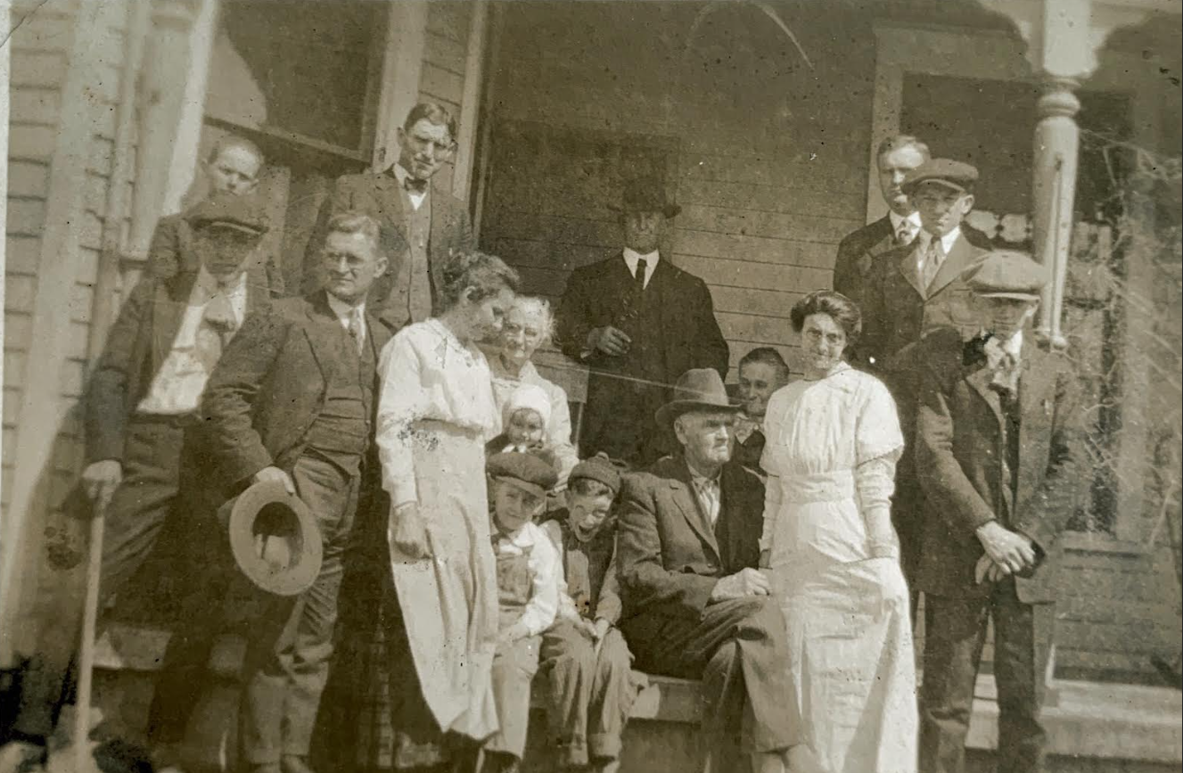
Picture provided by Jody Bomely

* * * * *

Section 8 - New family lines combined or added since the last newsletter

No new lines added and no lines combined since the last newsletter.

* * * * *

Section 9 - DNA project update.

No new results to report on the Bassett DNA project.
Donations of any amount can be made to the Bassett DNA project by clicking on the link below. Any funds donated will be used to fund select Bassett DNA tests that will further our project as a whole and benefit all Bassetts worldwide.

http://www.familytreedna.com/group-general-fund-contribution.aspx?g=Bassett
This is just a reminder that the DNA portion of the Bassett Family Association can be found at:

A current spreadsheet of results can be found at:
http://www.bassettbranches.org/dna/BassettDNA.xls
If you don't have Excel and can't open the spreadsheet above, you can now see the DNA test results at the following website.
http://www.familytreedna.com/public/Bassett/
Jeffrey Bassett
520 Salceda Drive
Mundelein, IL 60060 USA
bassettgenealogy@gmail.com

