Bassett Family Newsletter, Volume XXIV, Issue 7, 19 Jul 2026

(1) Welcome
(2) Photograph of young William, Harold and Helen Bassett of Shelby County, Indiana
(3) Bassett Strategic Communication and Marketing of Detroit, Michigan
(4) Edward Lees Bassett and his clock company of Connecticut
(5) Edward Hicks Bassett of Woodstown, New Jersey Bankruptcy Notice
(6) Death of Clyde Harold Bassett of Oklahoma and Connecticut (d. 2026)
(7) William T. Bassett, Hartford, Connecticut, Barber
(8) New family lines combined or added since the last newsletter
(9) DNA project update

The newsletter link page is below. Once you get to this page, choose the current month to see the current newsletter.
You can either view in a PDF or in a word document format.
http://bassettbranches.org/newsletters/newsletters2014on.shtml

Section 1 - Welcome

I am anxiously awaiting the Big-Y 700 results from our test taker from Switzerland. Their family line goes back more than 400 years before going to Switzerland from France.

Also, Happy Birthday to my father Roger Bassett who turns 89 today!

Totals number of individuals loaded into the Bassett website: 219,311

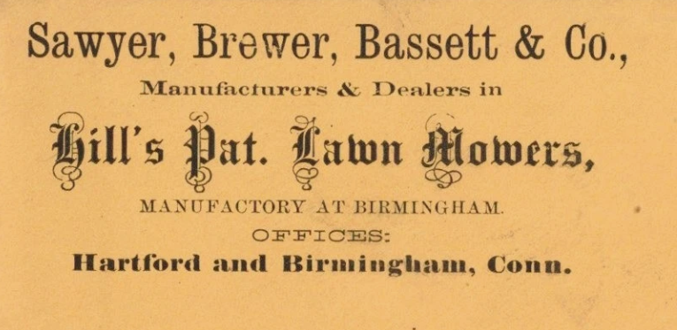

* * * * *

Section 2 - Featured Bassett: William, Harold and Helen Bassett photograph of Shelby County, Indiana

William, Harold and Helen Bassett descend from William Bassett of Plymouth, Massachusetts as follows:

William Bassett and wife Elizabeth
William Bassett (b. 1624) and wife Mary Raynesford
William Bassett (b. 1656) and wife Rachel Willison
William Bassett (b. 1680) and wife Abigail Bourne
William Bassett (b. 1711) and wife Lydia Smith
Rufus Bassett (b. 1757) and wife Jedidah Handy
Nymphas Bassett (b. 1785) and Thankful Ann Bruce
Oliver Clemens Bassett (b. 1842) and wife Elizabeth Monroney
Marshall Bassett (b. 1858) and wife Senorah J. Israel
Ernest Bassett (b. 1883) and wife Grace Lee Bass
William, Harold and Helen Bassett of Shelby County, Indiana

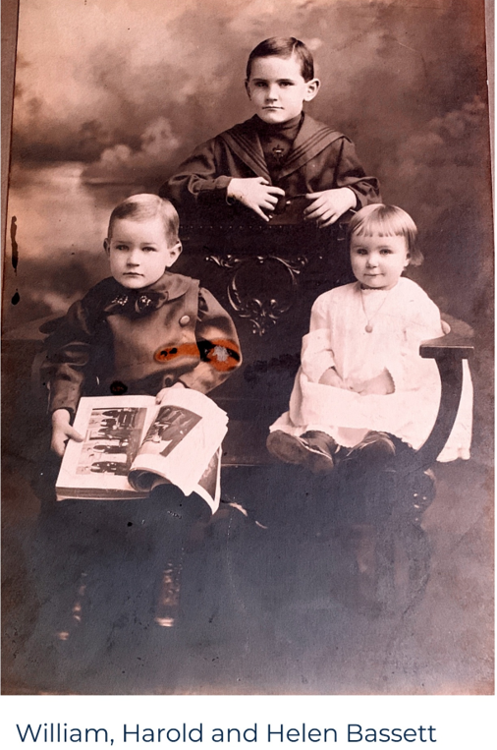
* * * * *

Section 3 - Featured Bassett: Bassett Strategic Communication and Marketing

Leland Kinsey Bassett descends from #6B William Bassett of Connecticut as follows:

William Bassett of Connecticut and wife Hannah Dickerman
Samuel Bassett (b. 1652) and wife Mary Dickerman
Samuel Bassett (b. 1686) and wife Elizabeth Humiston
Samuel Bassett (b. 1728) and wife Abigail Bradley
Samuel Bassett (b. 1752) and wife Katherine Tuttle
Lyman Bassett (b. 1787) and wife Sally Boyse
Benajah Bassett (b. 1821) and wife Catherine Bird Stanford
Edgar Stanford (b. 1852) and wife Joanna Josephine Carroll
Edgar Franklin Bassett (b. 1874) and wife Maggie
Wilfred George Bassett married Vera Agnes Scheffel
Leland Kinsey Bassett and wife Tina

* * * * *

Detroit Crains Business, Michigan
By Kirk Pinho
May 22, 2026 10:37 AM EDT
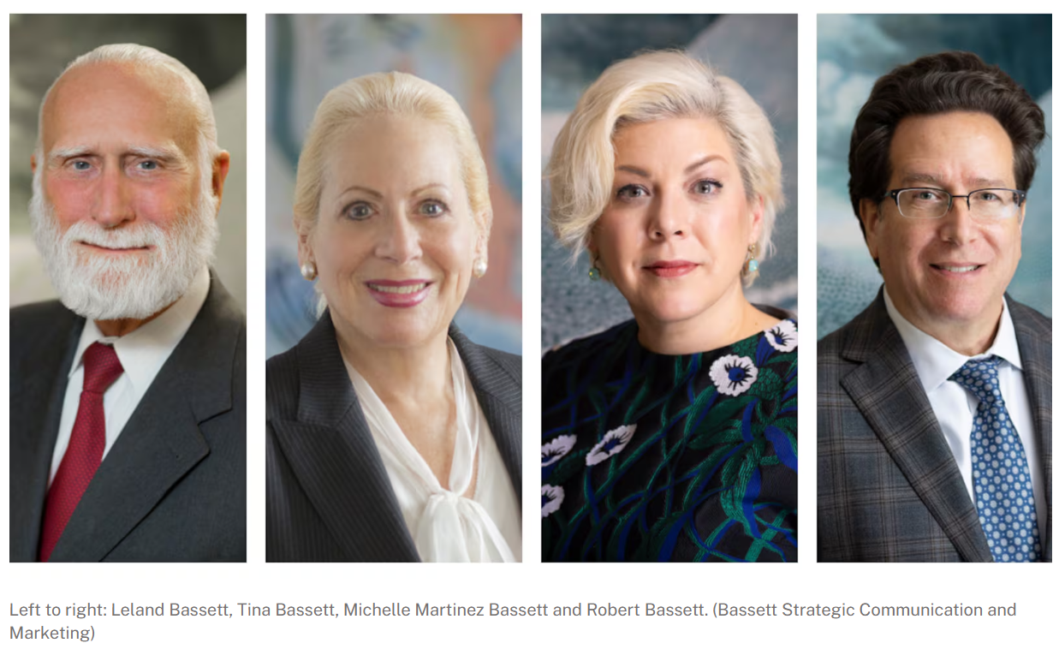

A prominent communications firm is rebranding and has named a new generation of leadership.

Detroit-based Bassett & Bassett Communication Managers and Counselors has rebranded as Bassett Strategic Communication and Marketing as its founding principals, Leland Bassett and Tina Bassett, become senior counsel to Michelle Martinez Bassett and Robert Bassett. The latter two become chairperson and CEO, and president and COO, respectively.

The husband and wife team of Leland and Tina Bassett started the firm in 1986.

Robert Bassett is Leland and Tina’s son. Michelle Martinez Bassett is married to Robert’s twin brother, Joshua Bassett, who is not involved in the business.

“This rebrand is the next chapter of something Leland and Tina built with incredible care and integrity,” Martinez Bassett said in a release. “We have changed the name of our firm, but our commitment and world-class service we provide to our clients will never change. What does change is the scale of what we can do — we now bring a fully integrated architecture of strategy, communication systems architecture, and top-level execution that corporate clients increasingly need to realize the full value of their communication and marketing programs.”

The company, which has its office in the Dan Gilbert-owned First National Building in downtown Detroit, primarily works with corporate and B2B clients.

To read more about this company, you can use the link below.

https://bassettstrategies.com/about-us/

* * * * *

Section 4 - Featured Bassett: Edward Lees Bassett and his clock company of Connecticut

Edward Lees Bassett descends from #1B John Bassett of Connecticut as follows:

John Bassett and wife Margery
Robert Bassett and wife Mary
Robert Bassett (b. 1640) and wife Elizabeth Riggs
Samuel Bassett (b. 1692) and wife Deborah Bennett
Abraham Bassett (b. 1725) and wife Phebe Miles
Samuel Bassett (b. 1759) and wife Mary McNeil
Samuel McNeil Bassett (b. 1796) and wife Hannah Lees
Edward Lees Bassett (b. 1841)

I can no longer find the dates and newspaper names for the following two articles, but both appeared in early Connecticut newspapers.
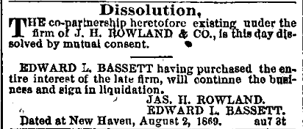

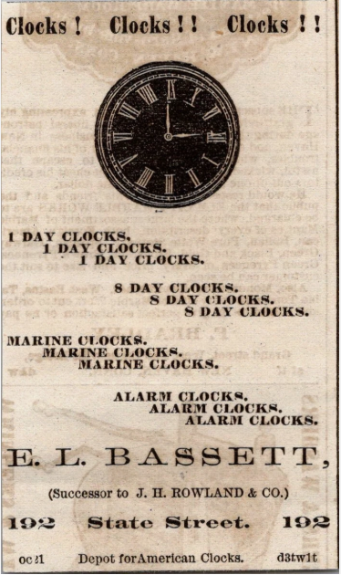

* * * * *
Section 5 - Featured Bassett: Edward Hicks Bassett of Woodstown, New Jersey

Edward Hicks Bassett descends from #4B William Bassett of Massachusetts as follows:

Roger Bassett and wife Ann Holland
William Bassett (b. 1621) and wife Sarah Burt
Elisha Bassett (b. 1649) and wife Elizabeth Collins
Elisha Bassett (b. 1692) and wife Abigail Davis
Elisha Bassett (b. 1722) and wife Mary Woodnutt
Joseph Bassett (b. 1765) and wife Mary Allen
Elisha Bassett (b. 1788) and wife Mary Nicholson
David Bassett (b. 1814) and wife Mary Smith
Howard Bassett (b. 1840) and wife Clemence A. Hinchman
Edward Hicks Bassett (b. 1869) and wife Sarah French

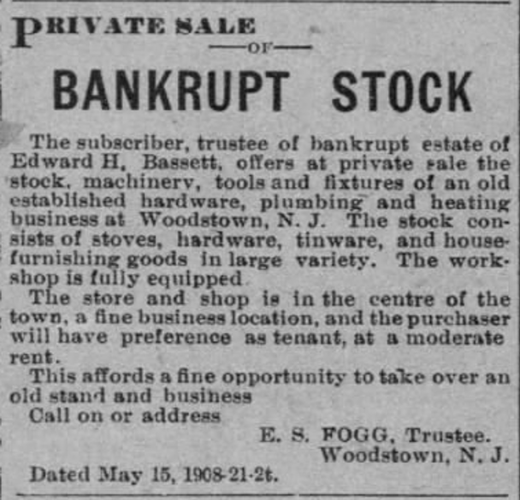Edward Hicks Bassett of Woodstown

* * * * *

Section 6 - Featured Bassett: Death of Clyde Harold Bassett of Oklahoma and Connecticut

Clyde Harold Bassett descends from #2B Thomas Bassett of Virginia as follows:

Thomas Bassett (b. 1617) and wife Mary
William Bassett (b. 1643)
Thomas Bassett (b. 1696) and wife Lydia Howle
Nathaniel Bassett (b. 1721) and wife Mary
Abner Bassett (b. 1765) and wife Susannah Harbard
William Bassett (b. 1800) and wife Patsy Galloway
John Thomas Bassett (b. 1828) and wife Cassandra Garrison
Hubert Bassett (b. 1850) and wife Gillian Ann Rourk
William A. Bassett (b. 1868) and wife Elizabeth Rebecca Redding
William Hubert Bassett (b. 1901) and wife Mary Whitson
Clyde Harold Bassett

Connecticut Funeral Home Notice and Obituaries, Wednesday, 15 July 2026
Clyde Harold Bassett

Born in Purcell, Oklahoma, he was 95 years young. His parents were Mary and William H Bassett.
Clyde passed away on July 12, with family by his bedside.
His Hospice family were also a great support.
He was a very accomplished gentleman and lived a fulfilling life. From attending a one-room schoolhouse in Oklahoma to his college days his education continued. He attended several colleges: the University of Oklahoma (BA), NYU(MA); UCLA and finally earning his Doctorate from the University of Wisconsin.
Next came the military in Korea. He was a 1st lieutenant in the Army Artillery and served honorably. Some of his stories as a forward observer on the front were frightening!
His career was quite extended. He taught theatre in several colleges-Lesley College, SUNY at Brockport, NY, Loughborough University in England and by far his favorite-Central Connecticut State University for many years. His future led him from theatre productions to teaching excited students with dreams of Broadway. He himself acted in many plays, local and in Regional Theatre. He loved doing Shakespeare plays! Theatre was his passion along with constantly reading new literature-5 books per week.
His activities were many. The Big one was the First Company Governor’s Horse Guards in Avon, CT.
He was active for 30 years as an active member and as a retired one. He made close, forever friends there. ​​⁠‍Lots of parading and military events-plus plenty of riding time. Also, he was in the Granby Horse Council for many years, the president for 2 years. Trail riding was one of his favorite things to do, even in winter. Lots of time there with his equestrian friends.
Family just made him glow with love and pride. He has left quite a legacy behind him. His wife, Joyce: best friend, lover, travel companion, problem solver and best buddy. Many happy days were shared. He was predeceased by his first wife, Millicent Bassett, who he loved along with their children. She was also in his thoughts throughout his life. Now more family: William Bassett, son. The only boy, and William was so loved by his dad unconditionally. He could make his dad laugh.
Carolyn, daughter, always someone he loved to talk with on the phone, and her husband Mark Brownawell and their son Max Brownawell (our artist) and his partner Matt.
Christine Bassett-Jellema, daughter, and her wife Alice(deceased): they both brought so much love and laughter to Clyde’s life, especially Alice’s bear hugs! Christine and her former husband John brought 3 children into this world. John Moore, son, and his sweet and kind wife Kristen, then Jordan Moore, son, and his wife Leah (both talented musicians) and their 2 beautiful girls, Lyla and Lucy and then daughter Jasmine and her husband David Peters (great hands on parents full of love). Faye, Violet and Everett are just beautiful children. Joyce’s family also were Clyde’s family too. Daughter Kristen and her husband Luke Alibozek (Dad of the year) and their 2 children Teddy and Ella (never ending fun and love), son Bryan Bakevich and his dear wife Jennifer (lovers of nature and music) and son John and his wife Caitlin(a total love) and 5 year old Julian(a smile to melt your heart)
With such a blended family, in-laws, out-laws and everyone in between, Clyde will be remembered with laughter and a warm fondness in our hearts.
Break a leg Clyde❤️
Clyde’s family will receive friends on Saturday August 1, 2026 from 4-5PM at the Hayes-Huling & Carmon Funeral Home, 364 Salmon Brook Street, Granby, CT 06035. A Celebration of Clyde’s Life will follow at Carmon’s beginning at 5PM. Burial will be private and at the convenience of the family.

* * * * *

Section 7 - Featured Bassett: William T. Bassett, Hartford, Connecticut Barber

William T. Bassett descends from #6B William Bassett of Connecticut as follows:

William Bassett and wife Hannah (Dickerman) Ives
John Bassett (b. 1652) and wife Mercy Todd
John Bassett (b. 1691) and wife Elizabeth Thompson
Enos Bassett (b. 1724) and wife Mary Heaton
Amos Bassett (b. 1757) and wife Hannah Goodyear
Jesse Bassett (b. 1789) and wife Amelia Tuttle
William T. Bassett (b. 1825)

Hartford Daily Courant, Connecticut, Saturday, 7 December 1872
New Hair Dressing Rooms – Turkish Baths

The Courant has already noticed the fact that Mr. Wm. T. Bassett, for thirty years a successful barber and hair dresser in this city, has purchased the fine hair dressing and Turkish batch establishment, No. 16 Pratt street (next door west of The Courant building) and it is his purpose to keep the entire establishment in fist-class condition. Mr. Bassett’s card in to-day’s paper will give the reader some idea of what he purposes to do. He has opened a fashionable ladies’ hair store, under the immediate charge of Mrs. Childs, a lady of experience, who will attend to the calls of the ladies of hair work; and adjoining, - a separate entrance is provided – will be found a first-class barber shop, complete in all its appointments, and attended by a corps of experienced tonsorial artists. The Turkish and common baths are given in the same building, a large sum of money having been expended in fitting up the establishment. These batch have been of the greatest benefit to many persons who were in ill-health, and they are of value in keeping the system in vigorous health. Some of our citizens have tried the Turkish baths with the most satisfactory results. Mr. Bassett will give special attention to this department, and will have in his employe none but thoroughly competent attendants. Our citizens, ladies and gentleman, will no doubt second Mr. Bassett in his efforts to sustain a first-class establishment so complete as this one is in all its different departments.

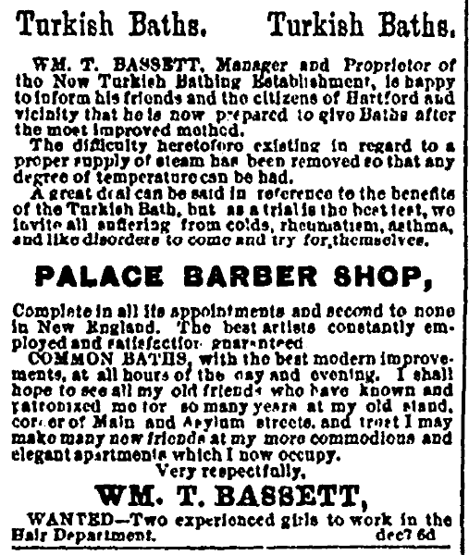
Hartford Daily Courant, Connecticut, Monday, 9 December 1872

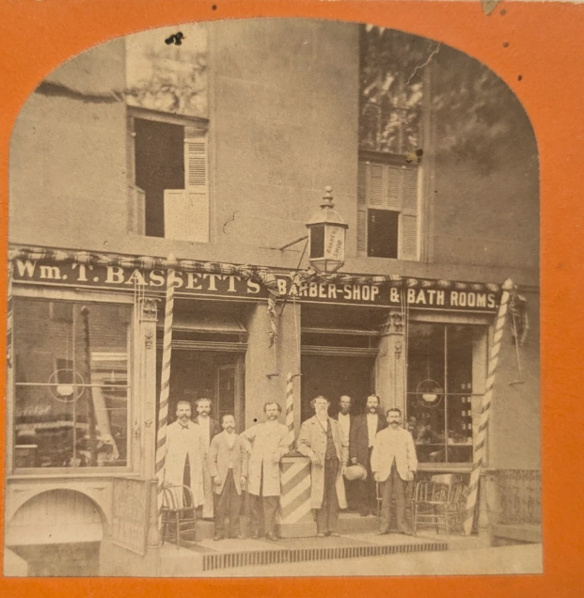

William T. Bassett’s Barber Shop located in the Allyn House, Hartford, Connecticut

Hartford Courant, Connecticut, Monday, 3 February 1896
Death of William T. Bassett

William T. Bassett, for many years a well-known barber in this city, died suddenly yesterday at his home, No. 123 Clark street. He was 70 years old. For many years Mr. Bassett kept a barber shop in the basement of what is now Mayer, Grace & Mayer’s jewelry store at the corner of Main and Asylum streets. Later he ran the Allyn House barber shop, succeeding the late William Hills. He has been out of business for several years. He was born at Great Barrington, Mass. His wife and two children survive him. His children are Mrs. Maria Clark, wife of Herman Clark of this city, and Waldo W. Bassett, who lives at Salisbury, Mass.
Mr. Bassett was always fond of outdoor life, and was known as an enthusiastic hunter and fisher. He arrangements for the funeral have not yet been made.

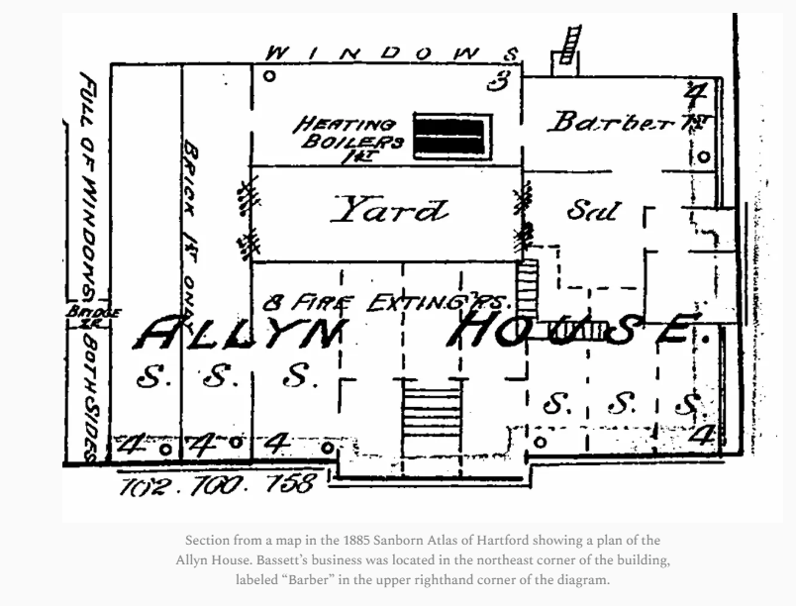

Section 8 - New family lines combined or added since the last newsletter

No new lines added and no lines combined since the last newsletter.

* * * * *

Section 9 - DNA project update.

No new results to report on the Bassett DNA project.
Donations of any amount can be made to the Bassett DNA project by clicking on the link below. Any funds donated will be used to fund select Bassett DNA tests that will further our project as a whole and benefit all Bassetts worldwide.

http://www.familytreedna.com/group-general-fund-contribution.aspx?g=Bassett
This is just a reminder that the DNA portion of the Bassett Family Association can be found at:

A current spreadsheet of results can be found at:
http://www.bassettbranches.org/dna/BassettDNA.xls
If you don't have Excel and can't open the spreadsheet above, you can now see the DNA test results at the following website.
http://www.familytreedna.com/public/Bassett/
Jeffrey Bassett
520 Salceda Drive
Mundelein, IL 60060 USA
bassettgenealogy@gmail.com

