Bassett Family Newsletter, Volume XXIV, Issue 6, 21 Jun 2026

(1) Welcome
(2) Retirement of Jeffrey Bassett (newsletter author)
(3) Pfc. Thomas Anthony Bassett of Rye, New York
(4) Ezra and Keziah (Witt) Bassett Photograph and Article, Ohio
(5) Death of William Edward Bassett (2026)
(6) Home and Cabin of Delos Bassett of Michigan
(7)
(8) New family lines combined or added since the last newsletter
(9) DNA project update

The newsletter link page is below. Once you get to this page, choose the current month to see the current newsletter.
You can either view in a PDF or in a word document format.
http://bassettbranches.org/newsletters/newsletters2014on.shtml

Section 1 - Welcome

I finally have some time to go through a box of material send to me on the Ezra Bassett family and descendants. I will feature pictures and articles about this material over the next few month. This is also a reminder that I have retired from PCA and my old packagingcorp.com email is no longer valid.

Totals number of individuals loaded into the Bassett website: 219,204

* * * * *

Section 2 - Featured Bassett: Retirement of Jeffrey Neil Bassett

Jeffrey Neil Bassett descends from William Bassett of Plymouth, Massachusetts as follows:

William Bassett and wife Elizabeth
William Bassett (b. 1624) and wife Mary Raynesford
William Bassett (b. 1656) and wife Rachel Williston
William Bassett (b. 1680) and wife Abigail Bourne
William Bassett (b. 1711) and wife Lydia Smith
Rufus Bassett (b. 1757) and wife Jedidah Handy
Oliver Clemens Bassett (b. 1842) and wife Elizabeth Monroney
Marshall Bassett (b. 1858) and wife Senorah J. Israel
Ernest Bassett (b. 1883) and wife Grace Lee Bass
Ralph J. Bassett (b.1912) and wife Elizabeth Almeda Brickley
Roger Wayne Bassett
Jeffrey Neil Bassett
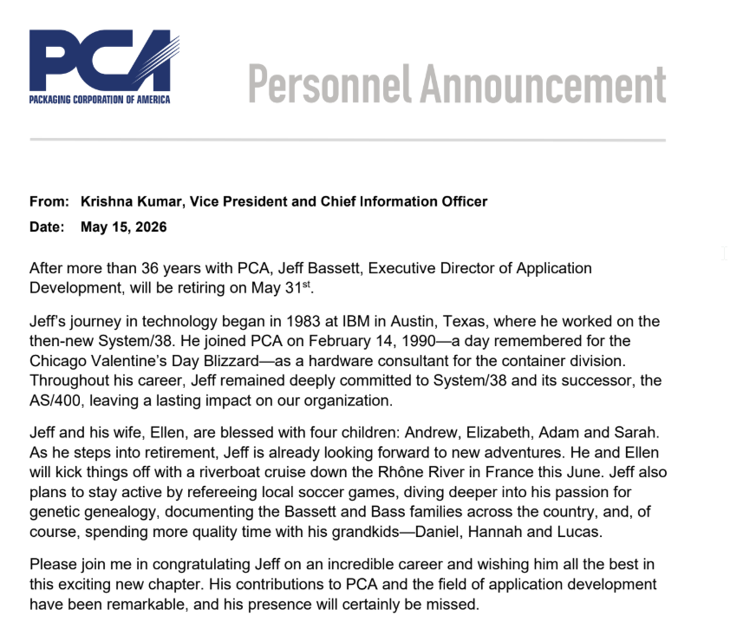

* * * * *

Section 3 - Featured Bassett: Pfc. Thomas Anthony Bassett of Rye, New York

Thomas Anthony Bassett descends from William Bassett of Plymouth, Massachusetts as follows:

William Bassett and wife Elizabeth
William Bassett (b. 1624) and wife Mary Raynesford
William Bassett (b. 1656) and wife Rachel Williston
William Bassett (b. 1680) and wife Abigail Bourne
John Bassett (b. 1716) and wife Mercy Newcomb
Thomas Bassett (b. 1759) and wife Lydia Mendall
Newcomb Bassett (b. 1781) and wife Esther Smith
Samuel Bassett (b. 1809) and wife Mary Andrew
Samuel Andrew Bassett (b. 1833) and wife Hattie F. Knevals
Thomas Andrew Bassett (b. 1869) and wife Natalie Wilson
John Humphrey Phillips Bassett (b. 1890) and wife Lucille R. Schulte
Thomas Anthony Bassett (b. 1922)

The Rye Chronicle, New York, Friday, June 1, 1945
Pfc. Thomas A. Bassett Member Twice Cited Bombing Squadron

15TH AAF In Italy – Pfc. Thomas A. Bassett, 23, son of Mr. and Mrs. J.H.P. Bassett, Rye, N.Y., clerk in a B-24 Liberator squadron, has been authorized to wear an Oak Leaf Cluster to the Distinguished Unit Badge as a member of heavy bombardment group, which has been twice cited by the War Department for “outstanding performance of duty against the enemy.”
Pfc. Bassett also wears the African-European-Middle East Theatre ribbon with five stars. He is a graduate of Watertown High School, Watertown, Conn., where he was active in track, tennis and golf.
Before entering service, Pfc. Bassett was a student at Roosevelt Aviation School, Mineola, Long Island, N.Y. Prior to his arrival overseas in April of last years, he was stationed at Harvard Army Air Base, Harvard, Neb.

* * * * *

Section 4 - Featured Bassett: Ezra and Keziah (Witt) Bassett Photograph and Article, Ohio

Ezra Bassett descends from #6B William Bassett of Connecticut as follows:

William Bassett and wife Hannah Dickerman Ives
John Bassett (b. 1652) and wife Mercy Todd
Joseph Bassett (b. 1697) and wife Miriam Bradley
Abel Bassett (b. 1728) and wife Miriam
Lemuel Bassett and wife Patience Walter
Ezra Bassett (b. 1774) and wife Sarah Blodgett
Ezra Bassett (b. 1799) and wife Keziah Witt

Bassett Family by Elizabeth Bassett McAlister

Ezra Bassett, an early settler in this part of Ohio, came from Florida Massachusetts in the year 1829.
He brought with him his family consisting of wife, Kesiah DeWitt Bassett, and five children, Homer, Henry, Marilla, Charles and Dwight. Three other children were born in Ohio, Elizabeth, John and William.
In coming to Ohio, they travelled by wagon from Florida, Massachusetts to Albany, New York. From Albany to Buffalo via the Erie canal and from Buffalo to Cleveland by steam boat.
They settled on a farm of fifty-seven acres on the corner of Puritas Springs Boulevard and Grayton Road. Houses that they lived in are still standing. They bought land on both sides of Rocky River Drive, a fifty acre parcel on the West Side and Barber property of about one hundred acres.
When Ezra Bassett died they were living in a pretty home in Brooklyn Village, now a part of Cleveland.
The children were brought up in a Christian home. Each day was reverently begun by the reading of the Scriptures and followed by all kneeling in prayer.
Several of the children attended Oberlin College.
They attended a Baptist church which stood on the corner of Riverside Drive and Lorain Road and later they attended the church now known as the West Park Congregational Church. Ezra Bassett was a deacon in the church and held civic offices.
Homer Bassett went back to New England and was city librarian in Waterbury, Connecticut for many years. He was also an author.
Henry joined the "forty niners" to California in search of gold. He made his home in California.
Marilla married Lorin Nichols and stayed in Rockport as did her sister Elizabeth who married Charles Jordan.
Charles and Dwight lived on the farms in Rocky River Drive.
John enlisted in the Civil War, was taken ill and died and his body was sent home for burial. A group of his comrades paid the expenses but Grandfather showed his appreciation by sending back to them one hundred dollars.
William, the youngest, also settled in Rockport.
Above the fireplace in the old house, and on either side were cupboards where grandmother kept good things to eat. Before we could talk, we used to point up to where the raisin cake was kept, and such cake and such bread I have never tasted anything so good since.

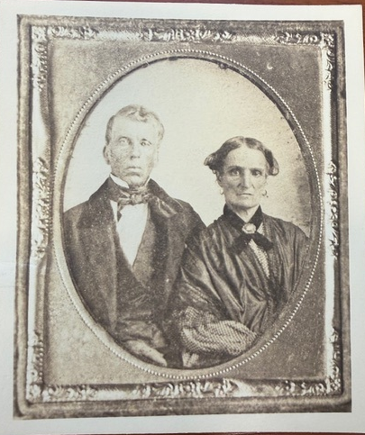
Ezra and Keziah (Witt) Bassett
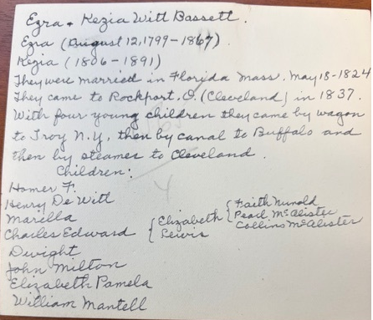
Notes on Back of Ezra & Kezith (Witt) Bassett Photograph

* * * * *

Section 5 - Featured Bassett: Death of William Edward Bassett (2026)

William Edward Bassett descends from #66B Lewis Bassett of Lavernock, Wales as follows:

Lewis Bassett (b. 1683) and wife Franes
John Bassett (b. 1767) and wife Mary William
Richard Bassett (b. 1742) and wife Mary John
Richard Bassett (b. 1778) and wife Mary Millward
Thomas Bassett (b. 1827) and wife Margaret Edwards
William Edward Bassett (b. 1851) and wife Sarah Ann Williams
Royal Clarence Bassett (b. 1878) and wife Jennie Belle Wayman
Royal Clarence Bassett Jr. (b. 1909) and wife Afton Luella Peterson
William Edward Bassett (b. 1937)

The Herald Journal, Logan, Utah, Thursday, 4 June 2026
William Edward Bassett

William Edward Bassett, 88, passed away on June 1, 2026.
Bill was raised at the family home in Wellsville, UT and attended local schools in Cache County. He was active in all things involving the outdoors including hunting, fishing and anything to do with motorcycles.
Bill had many jobs over the years. He joined the Navy at the young age of seventeen and retired after 20 years as a Chief Warrant Officer 3. While in the service he traveled the Pacific and Atlantic oceans on many ships and submarines. He was stationed in Washington, Virginia, Georgia, and several places in California, including a stint in the middle of the Mojave Desert. After his service he was a roofer, owned a firewood business in Cache Valley for many years, served as a watchman over mines in the desert, and was the water master in his hometown of Wellsville.
Motorcycles were a lifelong passion for Bill. He loved to motocross, participate in hare and hounds, and compete in enduros. He competed several times in the Barstow to Vegas motorcycle race and the Baja 500 competition in Mexico. His ability to work on motorcycles was legendary. He could break down and put back together any motorcycle made.
Bill married Karren Saunders in the same time frame as he entered the Navy. They had 5 children in quick succession. They later divorced. In his later years he met Gloria Buckingham and they spent many happy years in their dream spot on the Malad Summit near Malad, ID.
Bill was preceded in death by his father Royal C. Bassett Jr, mother Afton Peterson Bassett, prior wife Karren (Saunders) Wilson, his long-time companion Gloria Buckingham, daughter Susan (Richard) Chugg, sisters Joyce (Robert) Strebel and Sharon Bassett, and brothers Jarvis Bassett and Warren Bassett. Bill is survived by his sons Mike (Lisa) Bassett and Matt Bassett, daughters Bonnie (John) Hall and Peggy (Joe) Dortsch, and sister Shonie (Robert) Harris and brother Jimmy Bassett.
The family wishes to give a special thanks to the staff at Williamsburg.
Graveside services will be held at the Wellsville Cemetery for family and friends on Saturday, June 6, 2026 at 11:00 AM.
Arrangements entrusted to Allen-Hall Mortuary in Logan. Condolences are encouraged at www.allenmortuaries.com.

* * * * *

Section 6 - Featured Bassett: Home and Cabin of Delos Bassett of Michigan

Delos Daniel Bassett descends from William Bassett of Plymouth, Massachusetts as follows:

William Bassett and wife Elizabeth
Nathaniel Bassett (b. 1628) and wife Dorcas Joyce
Samuel Bassett (b. 1670) and wife Elizabeth Jones
Samuel Bassett (b. 1700) and wife Alice Weaver
Samuel Bassett (b. 1736) and wife Tabitha Waite
William Bassett (b. 1765)
Daniel Bassett (b. 1787) and wife Abigail Livingston
Austin Daniel Bassett (b. 1817) and wife Mariah S. Barton
Delos Daniel Bassett (b. 1843) and wife Lenora Elizabeth Lane

I was sent a link to the following pictures, but in my retirement, I have misplaced who sent them to me.

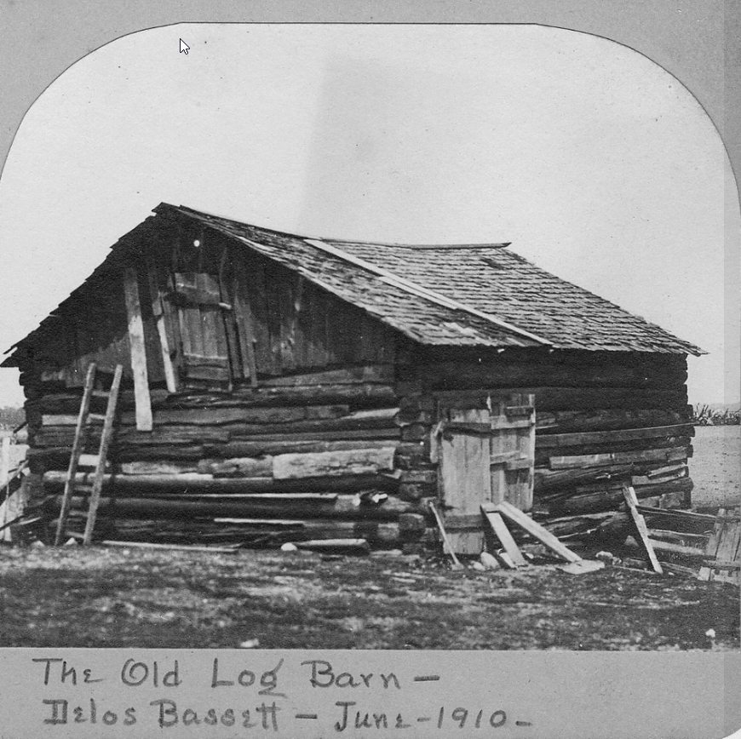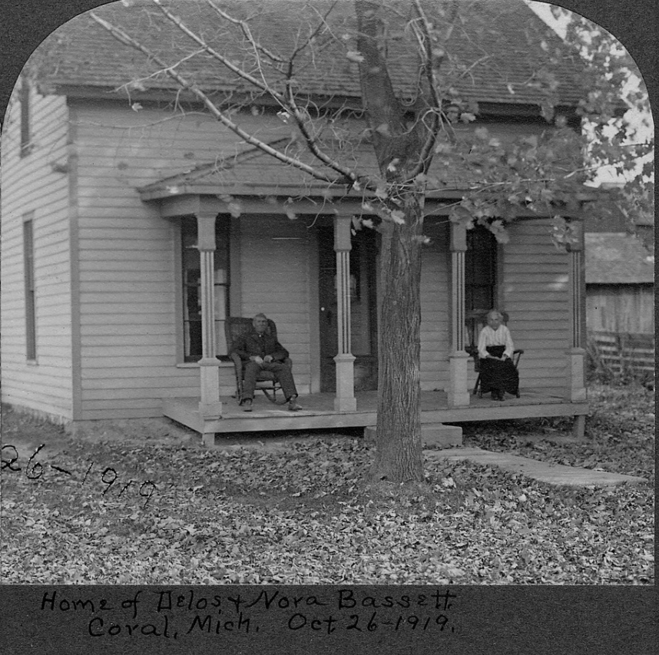
Home of Delos & Nora Bassett, Coral, Mich. Oct. 26, 1919

* * * * *

Section 7 - Featured Bassett: Parents of Oliver C. Basset of West Boylston, MA identified

Oliver C. Bassett descends from William Bassett of Plymouth, Massachusetts as follows:

William Bassett and wife Elizabeth
Joseph Bassett (b. 1635) and wife Mary Lapham
William Bassett (b. 1667) and wife Sarah Sweetland
Nathan Bassett (b. 1702) and wife Hannah Washburn
John Bassett (b. 1734) and wife Sarah Cushman
Oliver C. Bassett and wife Chrissey

For thirty years I have had Oliver C. Bassett as a son of Joel and Susannah (Snow) Bassett. New research has uncovered his death record in Massachusetts on 19 May 1891 showing his parents as Oliver Bassett and Chrissey.

Massachusetts Death Records, 1841 - 1915

Worcester Telegram, Massachusetts, Saturday, 12 July 1902
Mrs. Bassett Buried
West Boylston’s Oldest Daughter Rests in Mt. Vernon Cemetery
Special to The Telegram

WEST BOYLSTON, July 11.-The funeral of Mrs. Louisa Holt Bassett was this afternoon form the chapel at Mount Vernon cemetery. Rev. George E. Dodge, pastor of the West Boylston Congregational church, of which Mrs. Bassett was a member for the last 50 years, officiated at the service. Members of the choir sang several of the deceased’s favorite hymns. The bearers were four of Mrs. Bassett’s nephews, Frederick Harbinson, M.S. Cooley of Worcester, Frank and Winthrop Holt of Holden. Interment was in Mount Vernon cemetery.
Mrs. Bassett was the oldest native-born resident, having been born on what was known as the Jonas Holt place o Pierce street, Jan. 1, 1811. Her girlhood days were passed in West Boylston. Later she worked in the Beaman mill. On May 1, 1837, she was married to Oliver C. Bassett of Brooklyn, Ct. After marriage Mr. Bassett and wife made their home in Woonsocket, R.I., where Mr. Bassett was superintendent of a mill. In 1839 they came to West Boylston, where they have since resided.
Mrs. Bassett traced her lineage to Lord John Holt, chief justice of England, early in the 18th century. One child was born to them, George Oliver Bassett, who has been a devoted son to his aged and invalid mother.

* * * * *

Section 8 - New family lines combined or added since the last newsletter

No new lines added and no lines combined since the last newsletter.

* * * * *

Section 9 - DNA project update.

No new results to report on the Bassett DNA project. We do have one new Big Y-700 test kit that was sent out to a Basset from Switzerland that traces his Basset line back in France in the late 1500’s.
Donations of any amount can be made to the Bassett DNA project by clicking on the link below. Any funds donated will be used to fund select Bassett DNA tests that will further our project as a whole and benefit all Bassetts worldwide.

http://www.familytreedna.com/group-general-fund-contribution.aspx?g=Bassett
This is just a reminder that the DNA portion of the Bassett Family Association can be found at:
A current spreadsheet of results can be found at:
http://www.bassettbranches.org/dna/BassettDNA.xls
If you don't have Excel and can't open the spreadsheet above, you can now see the DNA test results at the following website.
http://www.familytreedna.com/public/Bassett/
Jeffrey Bassett
520 Salceda Drive
Mundelein, IL 60060 USA
bassettgenealogy@gmail.com

