Bassett Family Newsletter, Volume XXIV, Issue 5, 17 May 2026

(1) Welcome
(2) Samuel Bassett of Iron Mountain, Michigan (1941)
(3) Christopher Evans Bassett Family Bible, South Africa
(4) Death of William Mark Bassett of the LDS Church (2026)
(5) Augusta Caroline (Bassett) Sharp, Photographs and Grave
(6) Harrison & Bassett reunion held at Berkeley Plantation, Virginia
(7) Death of Loran Dee Bassett of Idaho (2026)
(8) New family lines combined or added since the last newsletter
(9) DNA project update

The newsletter link page is below. Once you get to this page, choose the current month to see the current newsletter.
You can either view in a PDF or in a word document format.
http://bassettbranches.org/newsletters/newsletters2014on.shtml

Section 1 - Welcome

If you belong to one of the many Bassett lines out of Wales, please contact me if you are interested in upgrading your kit to the BIG Y-700 test.

Totals number of individuals loaded into the Bassett website: 218,871

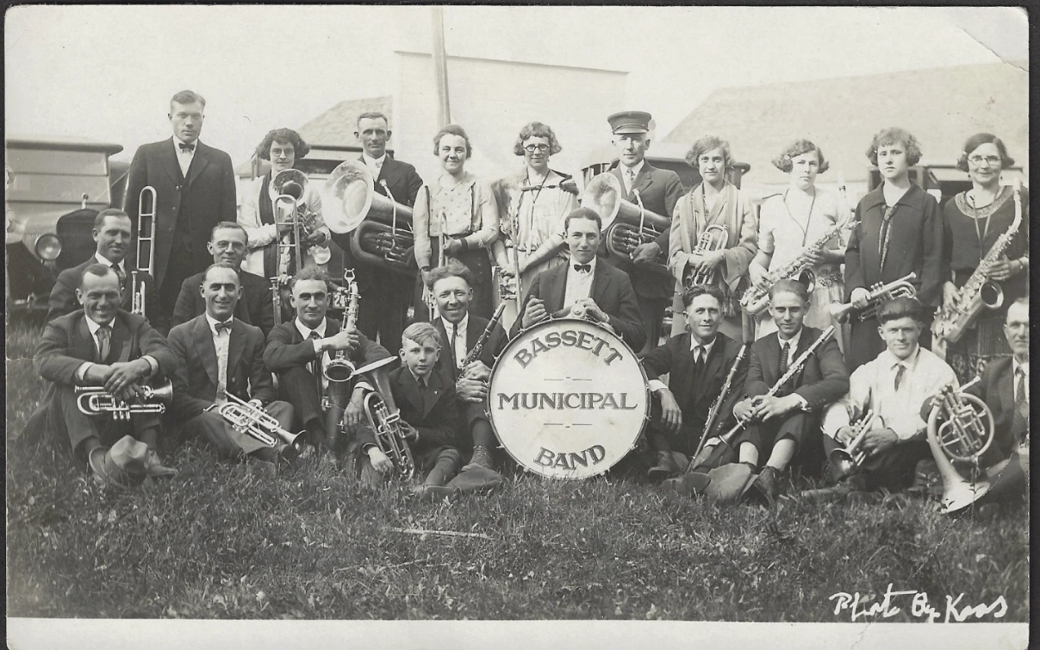

* * * * *
Section 2 - Featured Bassett: Samuel Bassett of Iron Mountain, Michigan

Samuel Bassett descends from William Bassett of Plymouth as follows:

William Bassett and wife Elizabeth
Nathaniel Bassett (b. 1628) and wife Dorcas Joyce
Joseph Bassett (d. 1749) and wife Susannah Howes
Joseph Bassett (b. 1709) and wife Mary Whelden
Samuel Bassett (b. 1748) and wife Lucretia Crowell
Jabez Bassett and wife Livonia Nichols
Samuel Bassett (b. 1842) and wife Catherine Agnes Powers

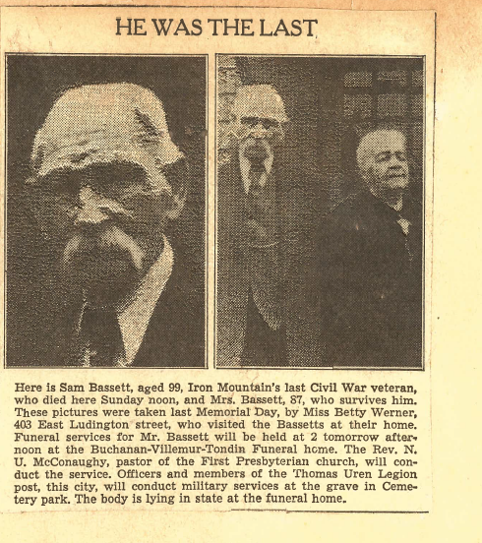

Newspaper Article provided by Jayna Huotari of Iron Mountain, Michigan

Michigan Newspaper, Monday, 30 June 1941
Sam Bassett, City’s Last Civil War Veteran, Died Yesterday

Just a few days ago Sam Bassett, aged 99, Iron Mountain’s only surviving Civil war veteran, said: “life has been more than good to me, but I want just one thing more from it. I want to live to be 100.”
But Sam didn’t quite make it. He died at 12 noon yesterday at the home of Mr. and Mrs. Stanley Miller, 304 East A street, with whom he and Mrs. Bassett had resided since last October. Death came within about two months of his 100th birthday. He was 99 last Sept. 10.
For 41 years prior to last October, Mr. and Mrs. Bassett had lived in their own home at 629 East A street. On June 13, last they observed their 66th wedding anniversary and many friends gathered at the home.
Death came peacefully to the aged veteran – as peacefully as he had lived out the last years of his life. Although ailing for the past few years, he was alert and happy. Always popular, with young and old, Mr. and Mrs. Bassett had a wide circle of friends who kept constantly in touch with them.
Mr. Bassett was born Sept. 10, 1842, in Bangor, Maine. When he was about 10 years old he moved with his family to Boston, Mass. His father was one of the many shipbuilders whose shops dotted the eastern seaboard, and Sam worked at the trade until he was 18 years of age, when he enlisted in the Civil war. He was assigned as a private, Company E, First Regiment, Massachusetts Infantry, Third Army Corps, Army of the Potomac.
Heaviest Toll
It was the Army of the Potomac, history relates, which suffered the greatest toll in men killed, wounded, captured and missing of any war in history, in proportion to the number of men engaged. From May 5, 1964, to November 31, 1864, there were 10,572 killed, 53,957 wounded, and 23,858 captured or missing – an aggregate casualty of 88,387.
Of the many engagements credited to the Army of the Potomac the principal battles were: Peninsula of Virginia, killed, 1,734; wounded 8,062; captured or missing, 6,053; aggregate casualty, 15,849. Maryland campaign – Killed 2,673; wounded, 11,756; captured or missing, 13,511; aggregate, 27,940. Chancellorsville – Killed, 1,606; wounded, 9,762; captured or missing, 5,949; aggregate, 17,287. Gettysburg – Killed, 3,155; wounded, 14,529, captured or missing, 5,365; aggregate, 23,049. Battle of the Wilderness – Killed, 2,246; wounded, 12,037, captured or missing 3,387; aggregate, 17.666. Spotsylvania – Killed 2,725; wounded 13,146; captured or missing 2,258; aggregate, 18,399. Cold Harbor and Bethesda church – Killed 1,845; wounded, 9,077; captured or missing, 1816; aggregate 12,738. Pittsburg, Va – Killed 1,672; wounded, 8,055; captured or missing, 3,930; aggregate, 13,657. Appomattox – Killed, 1,316; wounded 7,750; captured or missing, 1,714; aggregate, 10.780.
Enlisting on May 25, 1861, Mr. Bassett served with the Army of the Potomac throughout, and participated in 11 major engagements. He fought at Fair Oaks, Fredericksburg, Chancellorsville, Gettysburg, Mine Run, Battle of the Wilderness, First Bull Run, Yorktown, Williamsburg, Hanover Court and Spotsylvania.
Singularly, Mr. Bassett received his honorable discharge exactly three years from the date of enlistment, May 25, 1864.
He Met Lincoln
Sam had many exciting stories to tell, and he told them well. But his favorite was about that day in the spring of 1861, shortly after he enlisted, when – but here is how he told it:
“We had orders to go up to the front and I can recall that Mr. Lincoln, with his son, Robert, both mounted on sturdy army horses, rode into camp for inspection.
“There wasn’t much said that day, however. Everything was sort of quiet as the President rode up and down the line of troops.
“When he had finished his inspection a few of the boys mustered up the courage to walk over to where he stood at the left of the division, talking with our officers. He opened a way for them and I joined the group. We walked up to his horse and held up our hands. Lincoln reached over, smiling, and shook hands with each of us. It was no weak hand-shake, either. I can remember than plainly.”
A few days later Mr. Bassett left with his company for the front. En route he was stricken with typhoid fever and was taken to the hospital at Turner Lake, Pa. Two months later he joined his regiment at Alexandria, Va., and there began for him three years of active service.
Returned to Boston
After the war Mr. Bassett returned to Boston, and there, on June 13, 1875, he was married to Miss Catherine Powers. Mrs. Bassett, now 87, was born Dec. 16, 1854, in Cambridge, Mass., a daughter of Mr. and Mrs. John Powers.
In 1881 Mr. and Mrs. Bassett discussed with relatives the prospects of journeying west, to new territories that were then being opened up. Although several agreed to make the trip, Mr. and Mrs. Bassett were, finally, the only ones who set out for the new land.
They reached Marinette, Wis., and remained there about a year, when Mr. Bassett learned that A.F. Wright, general merchandise dealer of Quinnesec, was looking for man to work in the store – clerking, delivering groceries etc. Mr. Bassett made the trip to Quinnesec and got the job.
Mrs. Bassett yesterday related a story about that chapter in their lives. “I remember, one day, Sam was to deliver an order of groceries to Woods’ lumber camp back of Lake Antoine. He asked me to go, and I agreed. He hitched up the team, loaded the groceries in the wagon and we started out. It was then 9 a.m.
“Sam walked ahead of the team, over the rough trail, and I sat in the seat – holding on for dear life. Some of it was corduroy road, and I had to hang on tight.
“Mile after mile I bounced over that road. As the sun rose higher, it began to get hot. He had brought no water with us, and I was getting thirsty. Meanwhile, I noticed a small cask in the wagon, marked ‘pickles’. I thought a pickle might help my thirst, and when I felt I couldn’t stand it any longer I said to Sam: “Break open that tub and give me a pickle. I’m thirsty.”
“But Sam wouldn’t do it. “no, he said, “those pickles belong to somebody else. You’ll have to wait.” Finally we came to the camp, and I had all the water I wanted, and good food, too. We stayed there a short time and then started home. We reached Qinnesec at 9 p.m. I was completely tired out. I never went again – until we moved to Iron Mountain to live.”
Worked At Hospital
Mr. and Mrs. Bassett came to Iron Mountain shortly after the old Chapin hospital was opened, They were employed as steward and stewardess there, remaining eight or nine years. The old hospital building later slumped into the cavein which is now known as the Chapin pit.
Leaving the hospital, Mr. and Mrs. Bassett returned to Boston, but came back again to Iron Mountain when Mr. Bassett was offered a job as custodian of the new Carnegie library. He arrived there as the new structure was being completed. In fact, he helped sweep out the debris left by the builders.
Mr. Bassett remained at the library until 1916, when he retired from active work.
The aged veteran took his first airplane ride about 10 years ago, at the Dickinson county airport. He liked it then and had been enthusiastic about it ever since. Three years ago he flew again, in a huge, tri-motored ship which visited the airport. After the flight he said: “It was fine – but the didn’t go high enough or far enough. I’d like to take a trip to Boston in that plane.”
Enjoyed life
In the later years of his life, Mr. Bassett’s home and garden were his hobbies. Devoted to each other, Mr. and Mrs. Bassett spent their days sitting on the porch of their home, greeting visitors and enjoying life to the fullest. Their birthdays and anniversaries were always the occasion for happy gatherings.
They left their home only when their health failed to the point where they could no longer go on alone.
Nearest surviving relatives are two nieces and a nephew – Edith Graham, of Chancey, Mass.; Ella Thomas, Bangor, Maine, and Harold Grile, of Melrose, Mass.
Mr. Bassett was a member of the G.A.R., and the Thomas Uren post of the American Legion.
Funeral services will be held at 2 p.m., Wednesday at the Buchanan-Villemur-Tondin Funeral home. The Rev. N.U. McConaughy, pastor of the First Presbyterian church, will conduct the service. Officers and members of the Thomas Uren Legion post, this city, will conduct military services at the grave in Cemetery park.

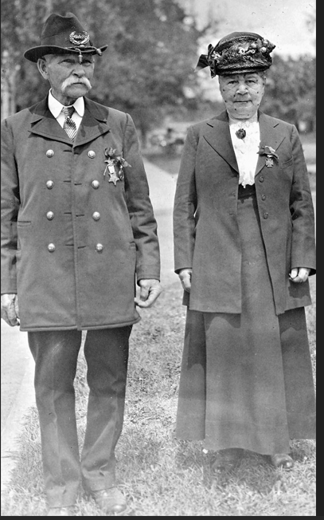

* * * * *

Section 3 - Featured Bassett: Christopher Evans Bassett Bible – South Africa

Christopher Evans Bassett descends from #196B Richard Bassett of Countesthorpe, England as follows:

Richard Bassett and wife Mary Humprhey (m. 1786)
Christopher Bassett (b. 1796) and wife Mary Main
John Charles Bassett (b. 1835) and wife Hannah Evans
Christopher Evans Bassett (b. 1865) and wife Ellen Gask

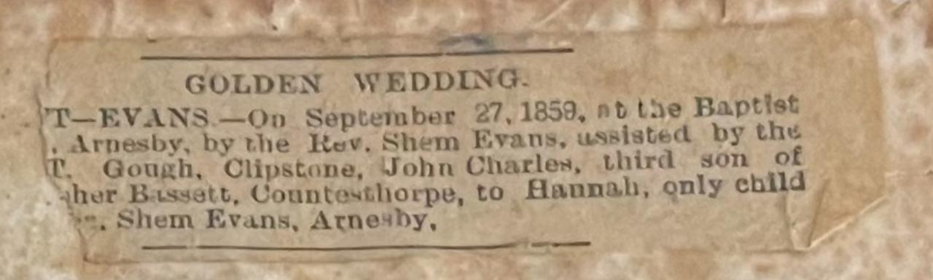
A clipping inside the Bassett family bible

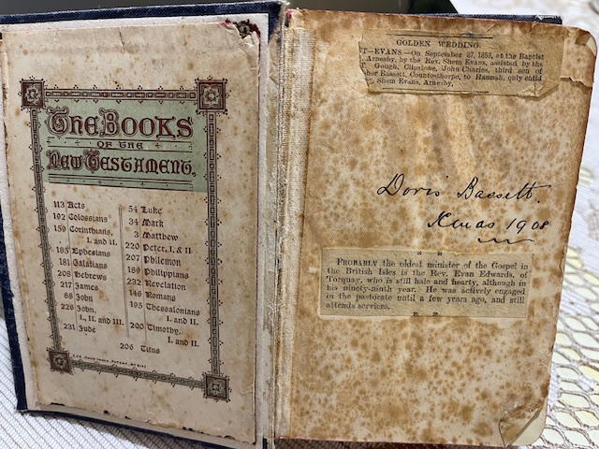

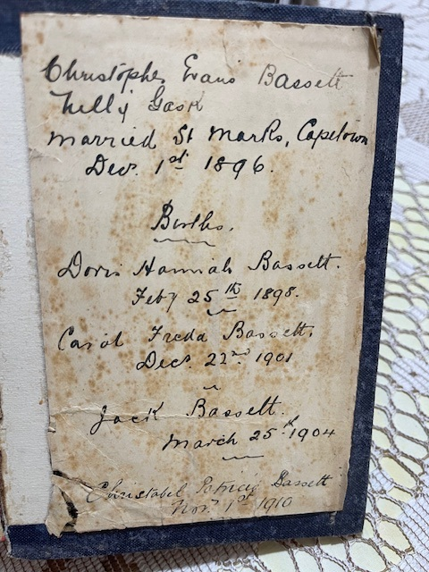

Bible Images provided by Malcolm Parker of South Africa

* * * * *

Section 4 - Featured Bassett: Death of William Mark Bassett of the LDS Church (2026)

William Mark Bassett descends from William Bassett of Plymouth as follows:

William Bassett and wife Elizabeth
William Bassett (b 1624) and wife Mary Rainsford
William Bassett (b. 1656) and wife Rachel Willison
William Bassett (b. 1681) and wife Abigail Bourne
William Bassett (b. 1711) and wife Lydia Smith
Rufus Bassett (b. 1757) and wife Jedidah Handy
Samuel Chipman Bassett (b. 1779) and wife Temperance Loveland
Heman A. Bassett (b. 1809) and wife Mary Chambers
Ralph Lowe Bassett (b. 1852) and wife Leah Rose Henroid
William Henry Bassett (b. 1880) and wife Eldula Bishop
William Smith Bassett (b. 1903) and wife Mary Bishop McMurdie
William Lynn Bassett (b. 1933) and wife Edwina Acker
William Mark Bassett (b. 1966)

Utah Funeral Home Notices and Obituaries, Wednesday, 13 May 2026
William Mark Bassett

William Mark Bassett, a devoted husband and father and a beloved leader in The Church of Jesus Christ of Latter-day Saints, passed away peacefully on May 11, 2026, at the age of 59. Known for his unwavering faith, compassionate leadership, and deep love for his family, he dedicated his life to lifting others and strengthening the Church throughout the world.
He is survived by his wife, Angela; his children, Jessica Bowden (Tyson), Taylor (Whitney), Amanda Herzog (Luke), Brandon (Bethany), and Jeffrey (Bella); and 15 grandchildren. He is now reunited with his beloved Mother, Edwina Acker Bassett, who preceded him in death earlier this year.
Mark was born on August 14, 1966, in Carmichael, California, to William Lynn and Edwina Bassett. His parents nurtured in him a deep love for the gospel and a strong sense of responsibility toward others. Growing up in a close-knit family, he developed the habits of hard work, humility, and quiet discipleship that would shape his life and ministry.
Following his graduation from Brigham Young University in 1991, where he earned a degree in accounting, Mark built a career as controller at Brasher’s Sacramento Auto Auction. He later became the CFO and co-owner of West Coast Auto Auctions, Inc., where he operated wholesale auto auctions throughout the western United States.
As a young man, Mark faithfully served a full-time mission in the Guatemala, Guatemala City Mission. He also served as ward Young Men President, Bishop, High Councilor, Stake President and Area Seventy. He and Angie served as mission leaders of the Arizona Mesa Mission from 2007 to 2010.
In April 2016, he was sustained as a General Authority Seventy, a calling he fulfilled with unwavering dedication. His assignments took him across the world, including service in the Brazil, United States Southeast, and United States Northeast Area Presidencies. He also served in the Missionary Department beginning in 2019 and spent the last three years as the Executive Director. He found great joy in being with missionaries throughout the world. His ministry was defined by his gentle manner, clear faith, and sincere desire to help others come unto the Savior.
Mark’s greatest joy was found in his family. He and Angie built a home centered on faith, love, and fun. They enjoyed family time and family vacations filled with laughter, joy, and great food. He was a devoted father to their five children, whom he loved with tenderness, humor, and unwavering support. He also treasured his role as a grandfather, delighting in the simple, joyful moments spent with his grandchildren.
To his family, he was a steady, gentle presence—patient, thoughtful, and endlessly loving.
Mark leaves behind a legacy defined by faith, humility, and a love of the Savior. His life was a testament to quiet discipleship—he taught not only through sermons and leadership, but through the way he listened, encouraged, and lifted those around him.
A public viewing will take place on Tuesday, May 19, 2026, from 9:30 to 11:30 a.m. at the North Salt Lake Utah Stake Center of The Church of Jesus Christ of Latter-day Saints located at 900 Eaglepointe Drive in Nor​​⁠‍th Salt Lake, Utah.
Funeral services will be held on Tuesday, May 19, 2026, at 12 noon at the same location, 900 Eaglepointe Drive in North Salt Lake, Utah.
Interment will follow at Larkin Sunset Gardens, Sandy, Utah.
The family would like to express their deepest gratitude to the physicians and medical teams at Intermountain St. George Regional Hospital and LDS Hospital for their dedicated and gentle care. They truly went above and beyond and treated Mark with dignity and compassion. They would also like to thank Mark’s brethren in the Quorums of the Seventy, the Quorum of the Twelve, and the First Presidency for their tender watch care during this time. Finally, the family would like to express thanks for all the fasting and prayers from friends around the world, and for the many kindnesses expressed over the past week.
Larkin Mortuary260 E South Temple Salt Lake City, UT 84111(801)-363-5781
Larkin Sunset Gardens1950 E Dimple Dell Rd Sandy, UT 84092(801) 571-2771.

* * * * *

Section 5 - Featured Bassett: Augusta Caroline (Bassett) Sharp, Photographs and Grave

Augusta Carolina Bassett descends from William Bassett of Plymouth as follows:

William Bassett and wife Elizabeth
William Bassett (b 1624) and wife Mary Rainsford
William Bassett (b. 1656) and wife Rachel Willison
Nathan Bassett (b. 1685) and wife Mary Stetson
Joshua Bassett (b. 1723) and Martha McCarroll
Isaac Bassett (b. 1760) and wife Abigail
Theodorus Bassett (b. 1781) and wife Chloe Bassett
Augusta Carolina Bassett (b. 1826/7) and husband William Henry Sharp

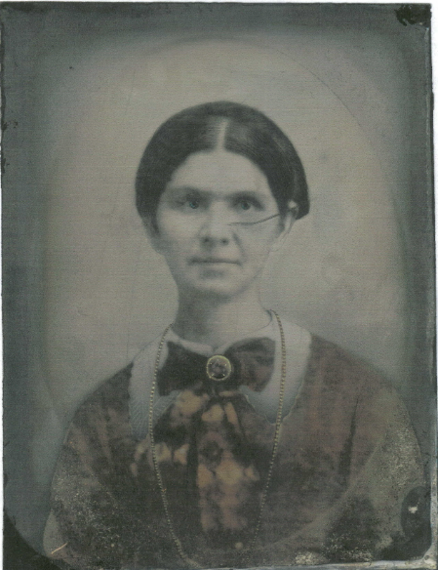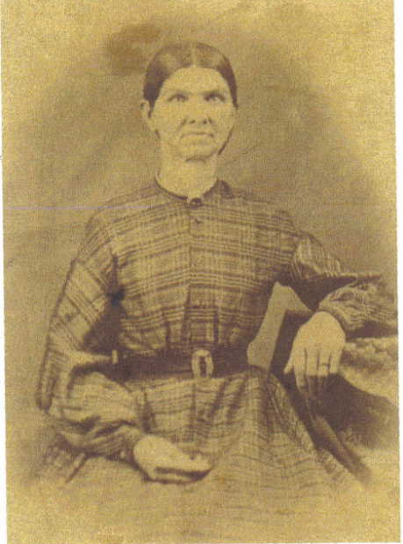

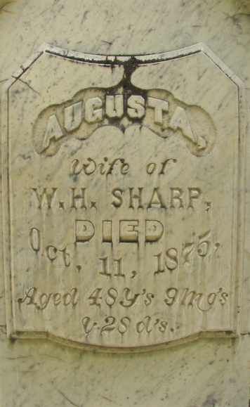
Augusta Caroline (Bassett) Sharp, Fort Jones Cemetery
Fort Jones, Siskiyou County, California

* * * * *

Section 6 - Featured Bassett: Harrison & Bassett Reunion held at Berkeley Plantation, Virginia

Elizabeth (Bassett) Harrison descends from #5B William Bassett of Virginia as follows:

William Bassett (d. 1646) and wife Anne
William Bassett (d. 1671) and wife Bridget Cary
William Bassett (b. 1671) and wife Joanna Burwell
Col. William Bassett (b. 1709) and wife Elizabeth Churchill
Elizabeth Bassett (b. 1730) and husband Benjaman Harrison V.

This family is commonly referred to as the Bassetts of Eltham, Virginia, the seat of their family for nearly 200 years.
The Bassett descendants are descended through Carter Bassett, a nephew of Benjamin and Elizabeth (Bassett) Harrison, however Y-DNA for Carter Bassett descendants matches the descendants of Benjamin Harrison. It is thought Carter Bassett is a son of Benjamin Harrison’s brother.

A DESCENDANTS DINNER AT BERKELEY PLANTATION, CHARLES CITY COUNTY, VIRGINIA
Information and picture provided be descendant Bill Orr.
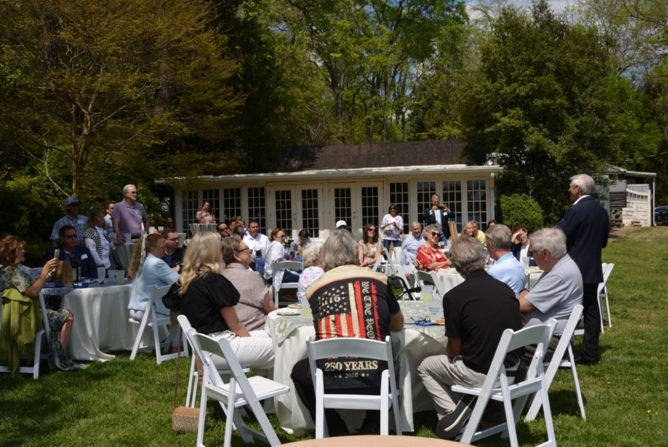Standing at right, double presidential descendant John Scott Harrison of Key West, Florida, and Sheridan, Wyoming, gives the opening address at a celebration commemorating the 300th birthday of Elizabeth Bassett’s husband, the signer Benjamin Harrison V, and the 300th anniversary of their historic home at Berkeley Plantation, Charles City County, Virginia, on April 11, 2026. The celebration drew more than 60 of the signer’s descendants from as far away as Seattle.

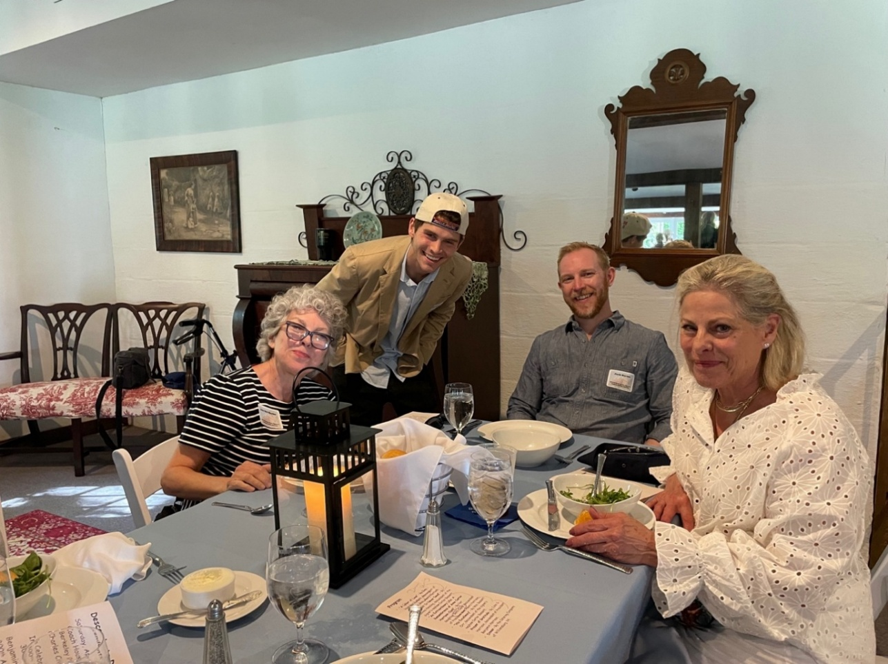
From left, Harrison- and Bassett-family descendants Jan Orr-Harter of Aledo, Texas, Henry Orr of Norman, Oklahoma, Jack Harter of Austin, Texas, and Elizabeth Gandy of Fort Worth, Texas, during the first course of a catered meal in Berkeley Plantation’s Coach House Tavern on April 11, 2026.

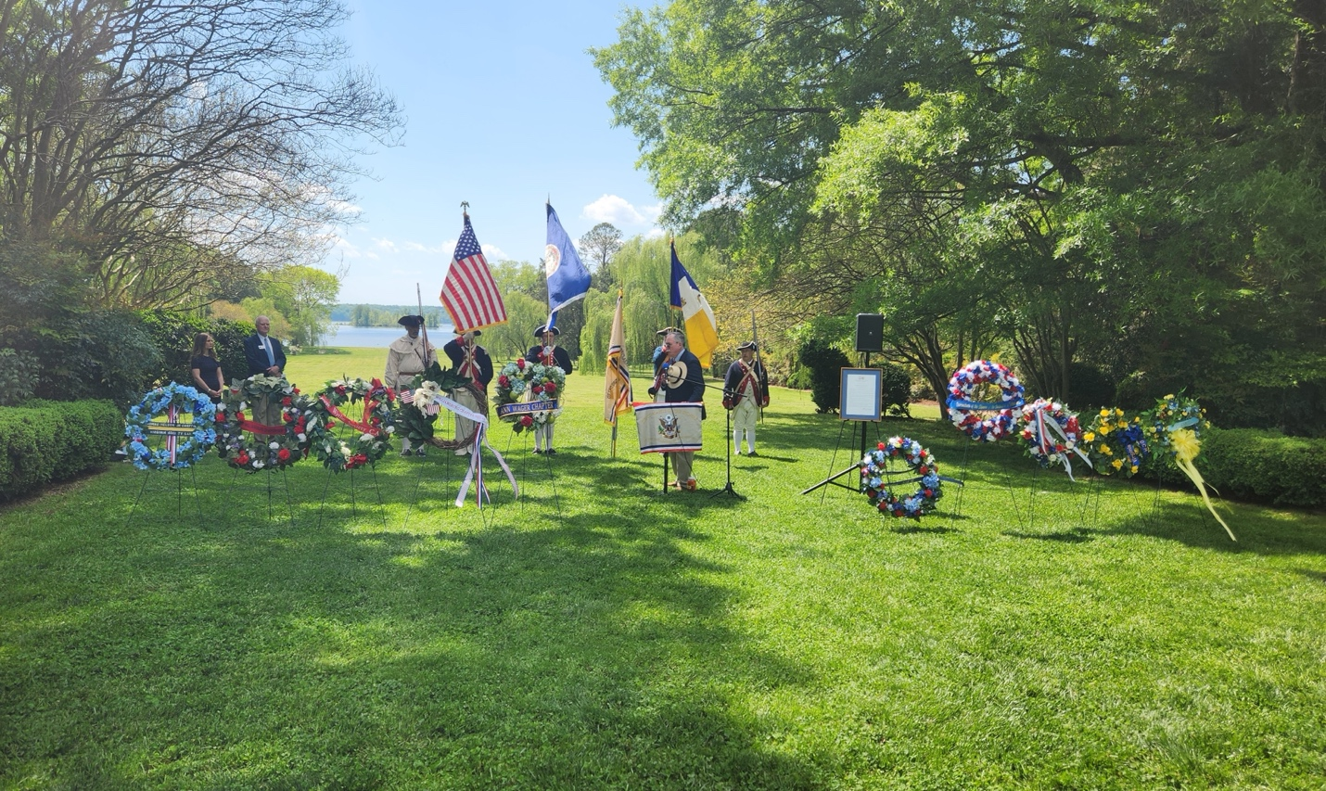
Crystal Phillips, at left, of Berkeley Plantation, and members of the Society of the Descendants of the Signers of the Declaration of Independence lead a formal commemoration of the signer Benjamin Harrison V on April 11, 2026, at his home on the banks of the James River in honor of his 300th birthday. To the right of the speaker is a framed copy of a resolution adopted by the General Assembly of the Commonwealth of Virginia also commemorating “the life and legacy of Benjamin Harrison V on the occasion of the 300th anniversary of his birth.”
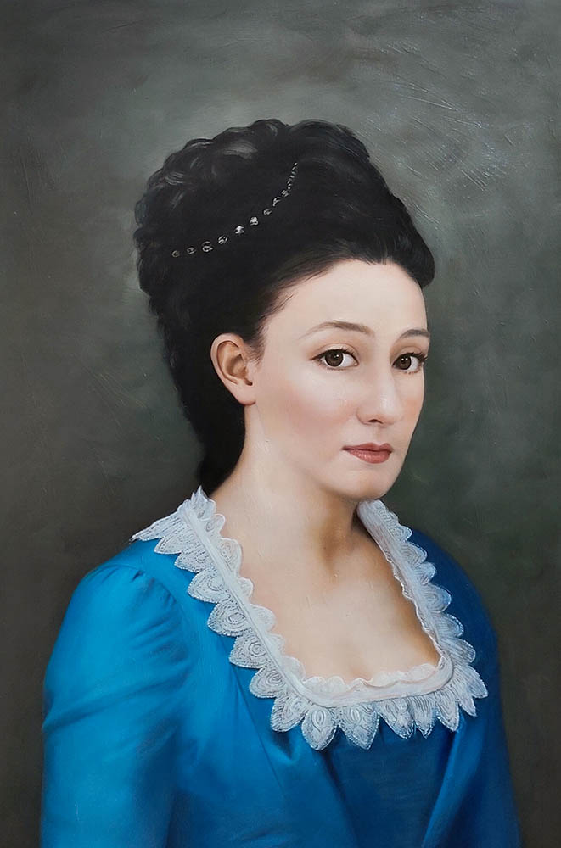
A replacement portrait of Benjamin Harrison V’s wife, Elizabeth Bassett, commissioned by their descendants as a gift to Berkeley Plantation in April 2026. The original was destroyed by Benedict Arnold when he laid waste to their home in January 1781 as punishment for their role in the American Revolution.
* * * * *

Section 7 - Featured Bassett: Death of Bradley Dee Bassett of Idaho (d. 2026)

Bradley Dee Bassett descends from #3B Thomas Bassett of Connecticut as follows:

Thomas Bassett (b. 1598) and wife Joanna Beardsley
Thomas Bassett (b. 1640) and wife Sarah Baldwin
Josiah Bassett (b. 1690) and wife Alice Canfield
Edward Bassett (b. 1727) and wife Sarah Sanford
Elias Bassett (b. 1780) and wife Lucy Gillette
Loren Elias Bassett (b. 1809) and wife Huldah Dimrus Vaughn
Loren Elias Bassett (b. 1844) and wife Emma Durfey
Alma Bassett (b. 1876) and wife Sarah Jane Harman
Loran Henry Bassett (b. 1907) and wife Helen Maryette Hansen
Loran Dee Bassett (b. 1936)
Bradley Dee Bassett (b. 1974)

Wilks Funeral Home
Bradley Dee Bassett
October 5, 1974 – January 13, 2026
Pocatello

In every room, there’s that one charismatic presence who seems larger than life — the person who fills the space with an infectious smile and a booming laugh. That was Brad Bassett. He loved deeply, laughed often, and had a way of making everyone around him feel seen and welcome.
With heavy and broken hearts, we announce that Bradley Dee Bassett passed away in the early morning hours of January 13, 2026, as the result of a tragic traffic accident while on his way to work. Brad was preceded in death by his Father Dee, Mother Pat and sisters Angela and Teresa. Brad is survived by his wife Tamra Ann, children, Cassidy Marie, Abigail Anne, Logan Bradley (Jaide Makelle Porter), brothers Wayne Bredehoft (Tina), Tom Bassett (Kelly) and sisters Rhonda Cole and Leslie Bassett.
Born in Montpelier, Idaho, to Patricia Marie Patterson Bassett and Loran Dee Bassett, Brad was the youngest of seven children. A preemie at birth, he was so tiny that his father lovingly joked he looked like “mud on a stick,” small enough to fit in the palm of Dee’s hand. In a twist that would become part of his story, that tiny baby grew into a giant of a man.
Brad cherished his childhood in Grace, Idaho, where days were spent riding bikes along quiet country roads and playing among the old cars his mechanic father kept around the family shop — memories that helped shape the man he would become.
Brad attended both elementary school and high school in Grace, Idaho, where he formed friendships that would shape his life. Many of his closest bonds began in his earliest school years and grew stronger with time. His friendship with Jacob Gepford and John Hegstrom endured through every season of life, remaining as close and meaningful as brotherhood to this day.
During his high school years, Brad was involved in just about everything. He wrestled, played football and basketball, and played the saxophone in the marching band — embracing each activity with the same energy and enthusiasm he brought to all parts of his life.
In his junior year, Brad decided to try out for the school musical. To everyone’s amazement, he revealed an angelic bass singing voice he had kept hidden until then, even from his parents. He was cast in the leading male role, and that moment opened the door to a deep love of music and performance.
While still in high school, Brad went on to sing and dance at the Pink Garter Theatre in Jackson Hole, Wyoming — an experience he cherished dearly. His parents were immensely proud of his musical talent and encouraged him to nurture it. Brad was often invited to sing at various events and would later become part of several choirs in church and at Idaho State University.
At the age of eighteen, with the loving guidance of dear friends, Brad was introduced to The Church of Jesus Christ of Latter-day Saints. He was soon baptized into the faith, and in 1994 he was called to serve a mission in Concepción, Chile. It was there that he met his wife, Tamra Ann Kesner Bassett, who was also serving in the same mission.
Brad dearly loved the people of Chile and treasured his time serving among them. He often shared funny and heartwarming stories from those years, memories filled with joy, growth, and connection. His natural charisma shone brightly, and the people were drawn to his warm smile, genuine kindness, and sincere friendship — qualities that defined Brad throughout his life.
After returning home in 1996, Brad and Tamra — his wife of nearly thirty years — were sealed in the Portland, Oregon Temple on November 29, 1996. Brad was a devoted, kind, and loving husband who cherished his family and showed his love for them consistently throughout his life.
In May 1998, Brad and Tamra welcomed their first daughter, Cassidy. Abigail followed in April 2000, and finally, Logan was born in February 2002. It was as if Brad was born to be a father. The light and joy in his eyes at the birth of each child were unmatched. When Jaide Makelle Porter married Logan, in 2023, and joined our family he couldn’t have been more thrilled.
Being there for his family was always a priority for Brad. He rarely missed a basketball game, track meet, softball game, swim meet, or lacrosse match, cheering them on with pride at every opportunity. Brad delighted in laughing with his kids, playing games, and taking them to the movies. He teased them endlessly and kept the family smiling with a constant stream of humorous memes in the family group chat. He also loved singing Karaoke with his family and would often get the whole family singing his favorite songs. His playful spirit and limitless love made every moment with him truly unforgettable.
Brad treasured every moment with his family, and family vacations held a special place in his heart. He was already planning next summer’s trip, excited to share it with the newest light of his life—his angelic granddaughter, Oakley Dean Bassett, born just a month ago. More than anything, Brad wanted Oakley to call him “Big Papa.” He even had a hat with a leather patch that joyfully labeled him as “Papa.” That wasn’t quite right so, with a Sharpie, he wrote in bold letters “BIG” above papa and proudly wore it everywhere.
The bond between Brad and Oakley was truly extraordinary, a connection that will endure even beyond his passing. The first time he laid eyes on her, tears welled up, and his heart brimmed with love—it was a moment of pure, unforgettable beauty.
Brad’s life was a testament to love, laughter, and unwavering devotion to family and friends. From his early days in Grace, Idaho, to his adventures in Chile, from the music that filled his soul to the countless memories he created with those he cherished, Brad lived fully and wholeheartedly. He was a devoted husband, a proud and playful father, a doting Big Papa, and a friend whose kindness, humor, and charisma left an indelible mark on everyone he met. Though his passing leaves a void that cannot be filled, the joy, warmth, and love he shared will live on in the hearts of all who knew him—reminding us that a life lived with generosity of spirit and depth of heart leaves a legacy that lasts eternally.
Viewings for Brad will be held on Friday, January 23rd, from 6:00 to 8:00 p.m., and again on Saturday, January 24th, from 9:30 to 11:00 a.m. at the Chapel Rd. LDS Church, 300 Chapel Rd., Pocatello, Idaho 83201.
After the viewing, Brad’s Celebration of Life will begin at 11:00 a.m.in the Chapel Rd. LDS Church on Saturday, followed immediately by his burial in Central Cemetery, near Grace, Idaho at 920 ID-34, Grace, ID 83241.
Memories and condolences may be shared by visiting the Guestbook below.

Section 8 - New family lines combined or added since the last newsletter

New Family #183B, Louis Basset of Switzerland has been added. This line begins with Louis Basset, born 1540 in France who moved to Switzerland, then continues through 11 generations of the family up through Denis Basset of Switzerland. Denis will be taking a BIG Y-700 test in the next few months.

No new lines added and no lines combined since the last newsletter.

* * * * *

Section 9 - DNA project update.

No new results to report on the Bassett DNA project.
Donations of any amount can be made to the Bassett DNA project by clicking on the link below. Any funds donated will be used to fund select Bassett DNA tests that will further our project as a whole and benefit all Bassetts worldwide.

http://www.familytreedna.com/group-general-fund-contribution.aspx?g=Bassett
This is just a reminder that the DNA portion of the Bassett Family Association can be found at:

A current spreadsheet of results can be found at:
http://www.bassettbranches.org/dna/BassettDNA.xls
If you don't have Excel and can't open the spreadsheet above, you can now see the DNA test results at the following website.
http://www.familytreedna.com/public/Bassett/
Jeffrey Bassett
520 Salceda Drive
Mundelein, IL 60060 USA
bassettgenealogy@gmail.com

