Bassett Family Newsletter, Volume XXIV, Issue 4, 19 Apr 2026

(1) Welcome
(2) Death of sisters Virginia Dare and Mary Frances Bassett of Indiana (1930)
(3) Charles Oliver Bassett Business Card, Chicago, Illinois
(4) Death of William Bassett of Countesthorpe, Leicestershire, England (1860)
(5) Last Will and Testament of Bernard Handy Bassett of Lassen County, California
(6) Death of Charles Philip Bassett of Wales and Canada (d. 2026)
(7) Big Y-700 DNA test from Family Tree DNA
(8) New family lines combined or added since the last newsletter
(9) DNA project update

The newsletter link page is below. Once you get to this page, choose the current month to see the current newsletter.
You can either view in a PDF or in a word document format.
http://bassettbranches.org/newsletters/newsletters2014on.shtml

Section 1 - Welcome

Interest has picked up on researching the #196B Richard Bassett of Countesthorpe, Leicestershire, England family. I note in a 2008 newsletter that I helped return a family photo album from this Bassett line to its family but didn’t note who ended up with the Album. If you have this album, can you contact me? We have a new line in South Africa that would like to see if their ancestors are in the album.

Totals number of individuals loaded into the Bassett website: 218,636

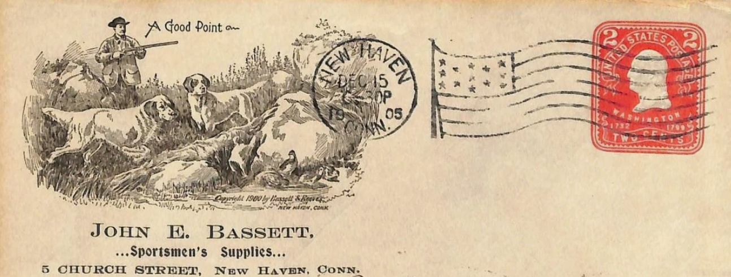

* * * * *

Section 2 - Featured Bassett: Death of sisters Virginia Dare and Mary Frances Bassett of Indiana (1930)

Virginia and Mary Bassett descend from William Bassett of Plymouth, Massachusetts as follows:

William Bassett and wife Elizabeth
William Bassett (b. 1624) and wife Mary Raynesford
William Bassett (b. 1656) and wife Rachel Willison
William Bassett (b. 1680) and wife Abigail Bourne
William Bassett (b. 1711) and wife Lydia Smith
Rufus Bassett (b. 1757) and wife Jedidah Handy
Nymphas Bassett (b. 1785) and wife Thankful Bruce
Oliver Clemens Bassett (b.1824) and wife Elizabeth Monroney
John R. Bassett (b. 1853) and wife Elizabeth E. Thompson
Charles BBassett (b. 1881) and wife Bessie Blanche Fortner
Virginia Dare Bassett and Mary Frances Bassett

I was recently in the cemetery in Indiana where these two Bassett sisters were buried and noticed the death year as being the same. I decided to find out their tragic story.

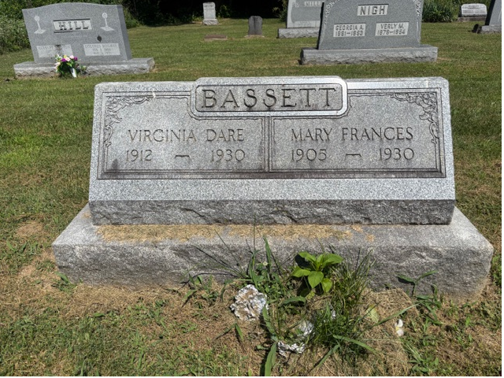

Shelbyville Republican, Indiana, Monday, 17 February 1930
Bassett

Funeral services for the Misses Mary Frances and Virginia Dare Bassett of Van Buren township, victims in one of the most terrible of railroad crossing accidents, will be held at 10 o’clock tomorrow morning in the Liberty church in Marion township, Rev. Fred Dennis of Dayton, O., officiating. The bodies of the two girls were badly mangled and their automobile, of Oakland manufacture, was converted into a tangle of metal scraps when the machine was struck by an eastbound Big Four passenger train due here at 3:35 o’clock Saturday afternoon, as the care was driven directly in the pat of the train at the Marion road crossing just north of the city. The train could not come to a stop until it reached the Walker street intersection, and the wreckage with the body of the younger girl was carried by the locomotive across the Blue river bridge. The body of the older sister was found a short distance from the scene of the crash near the west end of the bridge. Her body was more badly mutilated than that of the younger sister. Tragedy stalked into the Bassett home just as all the members of the family were happy in making preparations for the marriage of Miss Mary Frances Bassett, a school teacher in the Hendricks township schools, to Clyde McNamara, of Van Buren township. He had built and furnished a new farm house which he and his bride-elect were to make their home after the wedding ceremony. The older of the two girls, was born in Marion township April 9, 1905, attending Indiana University and Central Normal college at Danville, and was a graduate of the New Palestine high school, and the younger, born July 17, 1912, was a senior in Moral high school. Both were members of the Liberty church of Marion township, and were well liked by all who knew them. Besides the parents, two brothers, Raymond and Maurice, and Lee Fortner, their grandfather, survived. They are also survived by several aunts and uncles. Mrs. Sally Fortner Hinds formerly of this city, is one of the aunts of the victims in the tragedy. The coroner’s inquest will be held at 10:30 o’clock Wednesday morning in the community room of the city hall here. Mike Dugan was the engineer of the train, Train No. 16, and W.J. Scanlon was the conductor. Thomas Tadlock, custodian of the Marion township school, and Gerdes Sconce, of this city, were eye witnesses to the accident. Harry Walker of Morristown was driving toward the crossing a short distance ahead of the two girls. He stopped at the crossing, but seeing that he would have time to cross proceeded. The girls followed him and their machine was struck squarely in the center by the fast train. Identification of the girls was made possible soon after the accident by cards in the pocketbooks taken from the wreckage. A number of article bought by the older sister for the wedding were found scattered along the railroad right-of-way. Ralph J. Edwards is the funeral directory in charge. The body of the younger girl was taken to the Fix and Son mortuary immediately after the crash, and her sister’s body was taken to the Charles M. Ewing funeral establishment.

Shelbyville Republican, Indiana, Tuesday, 18 February 1930

According to information received this afternoon from relatives of the Misses Virginia and Mary Frances Bassett, victims in the railroad accident here last Saturday afternoon, nearly 2,000 people passed the caskets of the two girls, funeral services for whom were held at the Liberty church in Marion township this morning. Among those attending the services were teachers and pupils of the Moral high school, members of the Liberty church, Shelby county teachers, and numerous friends and relatives from all parts of the county.

* * * * *

Section 3 - Featured Bassett: Charles Oliver Bassett Business Card, Chicago, Illinois

Charles Oliver Bassett descends from #6B William Bassett of Connecticut as follows:

William Bassett and wife Hannah Dickerman
John Bassett (b. 1652) and wife Mercy Todd
John Bassett (b. 1691) and wife Elizabeth Thompson
William Bassett (b. 1718) and wife Mabel Goodyear
Hezekiah Bassett (b. 1745) and wife Sarah Ives
Eldad Bassett (b. 1784) and wife Harriet Stacey
Charles Bassett (b. 1825) and wife Sarah Dennis
Charles Oliver Bassett (b. 1866) and wife May E. Dennis

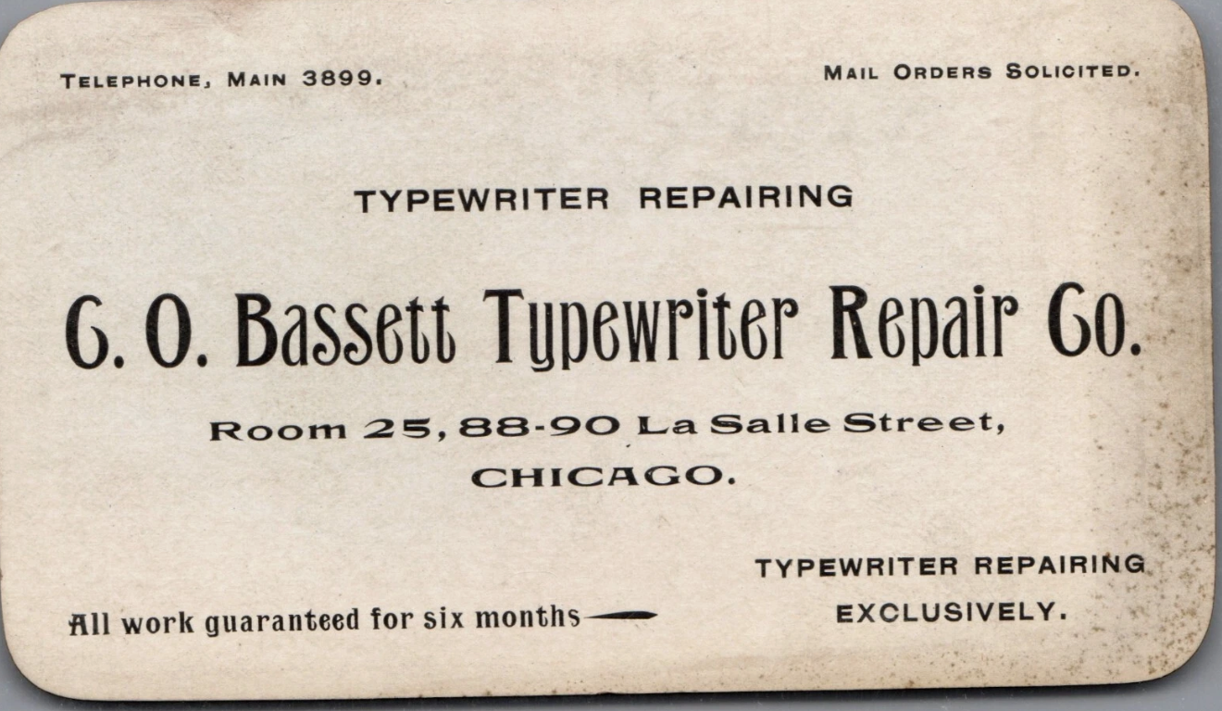

I recently found this business card for C.O. Bassett Typewriter Repair Co. of Chicago. I did identify his line, however, other than finding him in the census listed as “Typewriter Repair”, I could find nothing further. He is buried in Forest Home Cemetery, Forest Park, Cook County, Illinois. He and his wife May E. Dennis had one daughter Janet G. Bassett who married Karl Willis Waters.

* * * * *

Section 4 - Featured Bassett: Death of William Bassett of Countesthorpe, Leicestershire, England (1860)

William Bassett descends from #196B Richard Bassett of Countesthorpe, England as follows:

Richard Bassett and wife Mary Humprhey (m 1786)
William Bassett (b. 1788) and wife Elizabeth Flude

The Baptist Magazine for 1861, Volume LIII
Recent Deaths
Mr. W. Bassett

Mr. William Bassett, of Countesthorpe, Leicestershire, died, Oct. 4th, 1860, aged seventy-two0, after a short severe illness. At the early age of eighteen he had, through Divine grace, begun to develop the Christian life; and in April, 1811, he was baptized and received as a member of the church at Arnsby, there miles from his residence, by the Rev. W. Cuttris, then pastor, the second after the Rev. R. Hall, sen.
Mr. Bassett soon began to exercise his apt and appropriate gifts as a preacher in the villages around. This he continued to do, with pleasure to himself and useful acceptance to others, to the last.
In the year 1820 he was chosen deacon of the church, where he always worshipped except when called to supply neighbouring pulpits, which he often did in former years. He was truly earnest in his endeavors to discharge the duties of his office; not only in serving tables, but in maintaining the truth, securing order in worship, and discipline in the fellowship of the church.
In his latter years, after retiring from the business of farmer and grazier, he wrote and published a concise and interesting history of the church at Arnsby, copies of which he was happy to lodge in most of our denominational institutions, as well as to distribute among friends. Deeply conscious of his infirmities and unworthiness in God’s sight, he would speak and write of himself; but always with firm confidence in the glorious Gospel, and steadfast faith in Christ his Saviour. His end was peace, declaring that he “rested alone on the finished work of Jesus.” “Precious in the sight of the Lord is the death of his saints.”
Our friend and father lived only on Sabbath after that on which he preached his last sermon. It was in his native “home” village, with more than his wonted earnestness and feeling, with an eye, doubtless, to his own children, and to the young before him, from Prov. xxiii. 15, “My son, if thine heart be wise, my heart shall rejoice, even mine.”
On the Lord’s day following his funeral the event was improved by the pastor at Arnsby, from Rev. iii. 12, “Him that over-cometh will I make a pillar in the temple of my God, and he shalt no more go out;” and at Countesthorpe by Mr. Joseph H. Bassett (nephew of the deceased) from Mat. xxiv. 44, “Therefore, be ye also ready, for in such an hour as ye think not the Son of man cometh.” S.E.

* * * * *

Section 5 - Featured Bassett: Last Will and Testament of Bernard Handy Bassett of Lassen County, CA

Bernard Handy Bassett descends from William Bassett of Plymouth as follows:

William Bassett and wife Elizabeth
William Bassett (b. 1624) and wife Mary Rainsford
William Bassett (b. 1656) and wife Rachel Willison
William Bassett (b. 1681) and wife Abigail Bourne
William Bassett (b. 1711) and wife Lydia Smith
Rufus Bassett (b. 1757) and wife Jedidah Handy
Nymphas Bassett (b. 1785 and wife Thankful Ann Bruce
Bernard Handy Bassett (b. 1808) and wife Hannah Elizabeth Wilson
Isaac Wilson Bassett (b. 1835) and wife Saran Vernon Ormsby
Bernard Handy Bassett (b. 1867) and wife Grace Eleanor Wilsey

Bernard Handy Bassett Jr. last Will and Testament

In the Name of God, Amen. I, Bernard Handy Bassett , of the County of Lassen,State of California of the age of fourty - four years , and being of sound and disposing mind and memory , and not acting under duress, menace, fraud, or under the influence of any person whatever, do make, publish and declare this my last Will and Testament in the manner following, that is to say:

First: I hereby provide that all just debts be paid.

Secondly: I give, devise and bequeath all my property, both personal and real, also all credits of any nature, of which I am now in possession or may be at the time of my death to my lawful wife, Grace Eleanor Bassett, who is my sole heir.

Third: I further provide that in the event of any one claiming to be my heir claiming any interest in my estate as such, and trying to contest this my last will and testament, that such party so claiming shall received the sum of One Dollar.

Fourth: I hereby appoint my wife, Grace Eleanor Bassett, Executrix of my estate and provide that she shall act as such without bond.

Thirdly: I hereby nominate and appoint Grace Eleanor Bassett, the executrix of this, my last will and Testament, and hereby revoke al former wills by me made. In Witness Whereof, I have hereunto set my hand this thirteenth day of August one thousand nine hundred and twelve.
Bernard Handy Bassett

The foregoing instrument consisting of one page and one blank page besides this, was at the hereof, 8 by the said Bernard henry Bassett.

Signed and Published as, and declared to be his last Will and Testament, in presence of us who at his request, and in his presence, and in the presence of each other, have subscribed our names as witnesses thereto.

Errol M. Auble Residing at Adin Wade Co. Cal.
W.A. Wilson Residing at Adin, Modoc Co. Cal.

Recorded at the Request of W.A. Wilson, Aug. 19th 1902 at 10 min past 9 o’clock. AM.G. B Bailey, Recorder.
* * * * *

Section 6 - Featured Bassett: Death of Charles Phiilip Bassett of Wales and Canada

Charles Philip Bassett descends from #202 Anthony Bassett of Carmarthenshire, Wales as follows:

Anthony Bassett (b. 1720) and wife Margaret Griffith
Anthony Bassett (b. 1746) and wife Catherine John
John Bassett (b. 1783) and wife Jane Samuel
Daniel Bassett (b 1830) and wife Mary Morgans
John Bassett (b. 1849) and wife Elizabeth
William John Bassett (b. 1884) and wife Mary Anne Evans
Vincent Bassett (b. 1911) and wife Hilda Jones
Charles Philip Bassett (b. 1937)

Tubman Funeral Homes
Charles Philip Bassett
January 8, 1937 – February 22, 2026

Charles died suddenly, following a brief illness, on February 22. He was 89. He was born and raised in a small village in Wales. Along with the love of his life for 70 years, Sandra, he graduated from Cardiff University. They were married in 1961, living near Manchester, England.
In 1968, Charles moved their young family to Ottawa, accepting a job with the Public Service Commission. He went on to work at the Post Office and Privy Council Office before finding his true passion and extended family at the Canadian International Development Agency. At CIDA he held various positions, including Vice-President of the Africa, Corporate Affairs, and Central and Eastern Europe branches, ultimately becoming Senior Vice-President. From 1989 to 1993 he was Canadian Ambassador to Angola and Mozambique and High Commissioner to Botswana and Zimbabwe, living in Harare. Upon leaving the public service he was appointed Canadian Executive Director to the Inter-American Development Bank in Washington, D.C., where he lived until retiring back to Ottawa.
Charles had boundless energy and was always on the go and doing things. He loved travel, classical music, telling overly elaborate jokes and stories, gardening, wine tasting and life. He was a passionate and talented home cook and made countless excellent meals over the years for his family and many friends.
He leaves behind his three children, Caroline, Christopher and Matthew, and eight grandchildren, Alexa, Jason, Justine, Joshua, Adam, Liam, Rhys and Miles.
Many thanks to his wonderful neighbors and friends who supported Charles, particularly in the last few years. There will be a private family service; a celebration of his wonderful life will follow later.

* * * * *

Section 7 - Featured Bassett: Big Y-700 DNA test from Family Tree DNA

I attended the Roots Tech conference in Salt Lake City last month and learned some new information about Y-DNA tests. In the past we would primarily group male Bassetts together based on their STR markers. However new technology has proven that STR markers have a tendency to mutate back and forth. Family Tree DNA now has what is called the Big Y-700 test. A dozen or more in the project have already upgraded to this new test. The result of the test gives you your terminal SNP. Below is the AI overview of a terminal SNP.

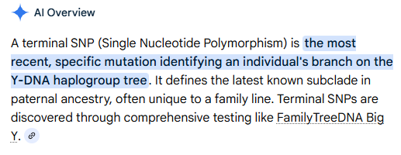

What that then allows us to do is compare each of the testers that have taken the Big Y-700 test to show exactly how they are related. The more people that take the test, the better the tree is.

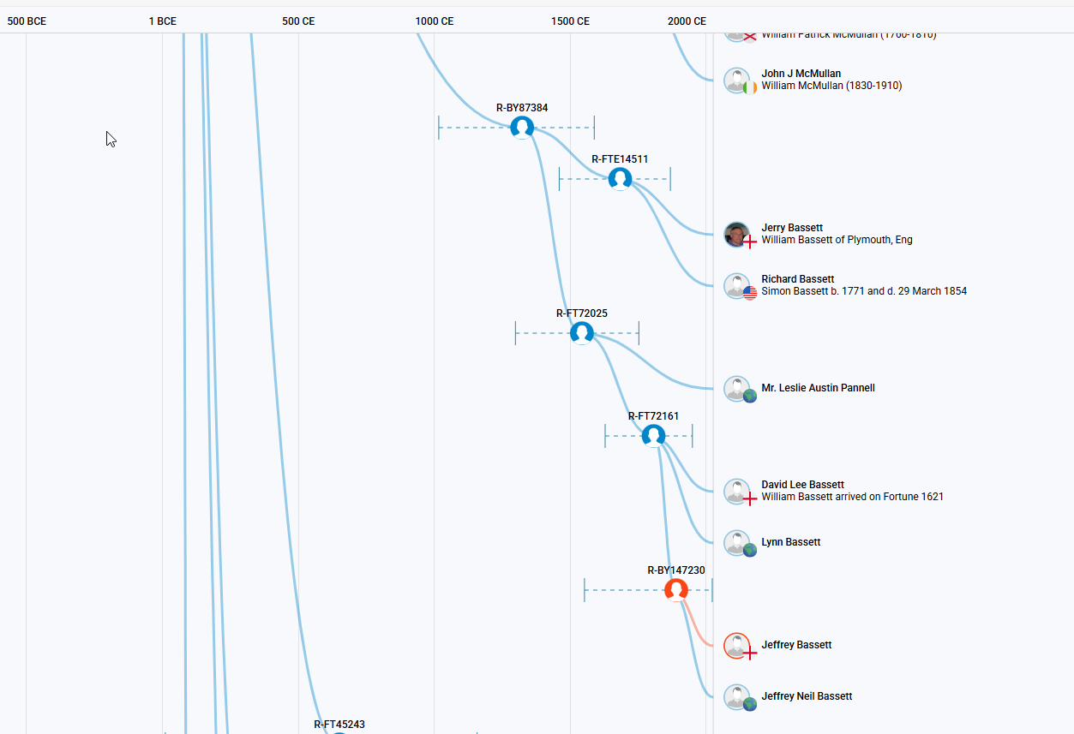
The chart above shows the new tree for those descendants of William Bassett of Plymouth. If you are a descendant of William Bassett based on your original DNA test, but still don’t know how you connect to the William of Plymouth tree, consider ordering an upgrade to your existing test. The more people that upgrade, the more helpful the test results are to everyone.

For example, for Bassetts with roots in Wales, we have more than a dozen different Bassett lines not yet linked. We know from the 37 markers tests they are related and share a common ancestor, but don’t yet know how. If we were to get one Bassett from each of these trees to upgrade to the Big Y-700 test, we could put a chart together that would show how each of the branches are related to each other.

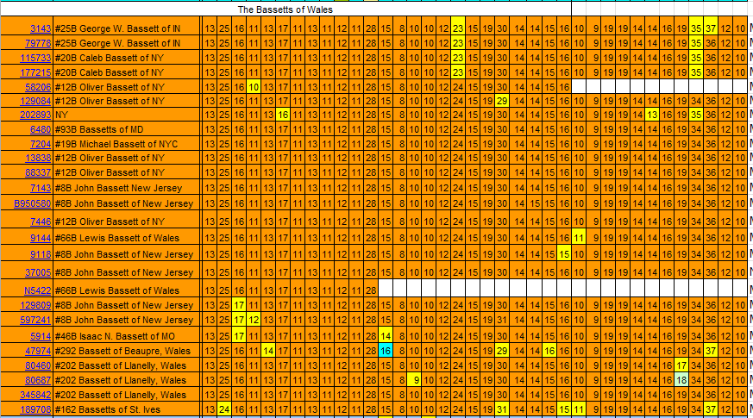

In addition to haplogroup tree above, we also now get a migration map of where the family migrated over the past centuries. The chart below is for William Bassett of Plymouth, Massachusetts.

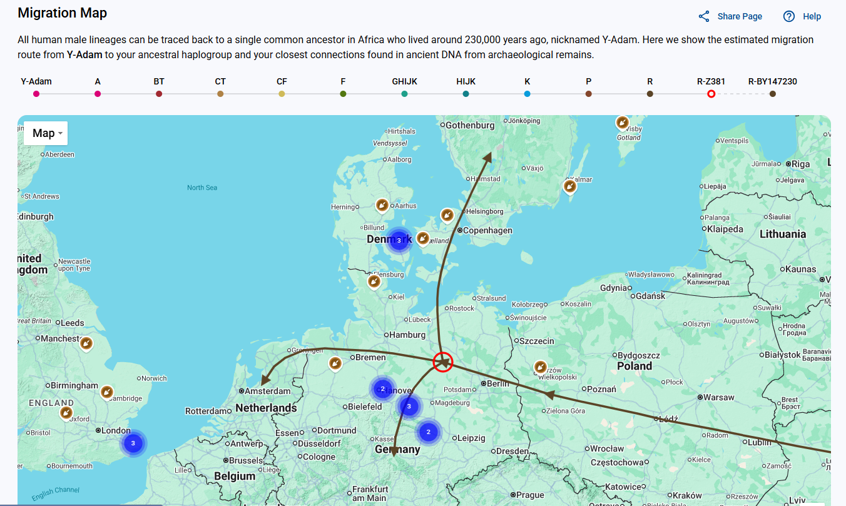

Section 8 - New family lines combined or added since the last newsletter

No new lines added and no lines combined since the last newsletter.

* * * * *

Section 9 - DNA project update.

I have been contacted by a Basset from Switzerland whose family moved from France to Switzerland back in the 1500’s. They plan on taking the Big Y-700 test once they have saved enough money for the test. I will report on the results in several months once the results are back.
Donations of any amount can be made to the Bassett DNA project by clicking on the link below. Any funds donated will be used to fund select Bassett DNA tests that will further our project as a whole and benefit all Bassetts worldwide.

http://www.familytreedna.com/group-general-fund-contribution.aspx?g=Bassett
This is just a reminder that the DNA portion of the Bassett Family Association can be found at:

A current spreadsheet of results can be found at:
http://www.bassettbranches.org/dna/BassettDNA.xls
If you don't have Excel and can't open the spreadsheet above, you can now see the DNA test results at the following website.
http://www.familytreedna.com/public/Bassett/
Jeffrey Bassett
520 Salceda Drive
Mundelein, IL 60060 USA
bassettgenealogy@gmail.com

