Bassett Family Newsletter, Volume XX, Issue 12, 18 Dec 2022

(1) Welcome

(2) Death of Martin Marshall Bassett Jr. of Indiana

(3) Portrait of Elizabeth Golden Bassett, wife of Moses Park Bassett

(4) Bassett family pictures from the Bassett-Rust Photo Album

(5) Grave of Clarissa R. (Bassett) Kenyon

(6) Allen Mordorf Bassett, Gemologist

(7) Sharon Bassett & Norway Iron Bolt Works Letterhead (1860)

(8) New family lines combined or added since the last newsletter

(9) DNA project update

The newsletter link page is below. Once you get to this page, choose the current month to see the current newsletter.   
You can either view in a PDF or in a word document format.

[http://bassettbranches.org/newsletters/newsletters2014on.shtml](https://urldefense.proofpoint.com/v2/url?u=http-3A__bassettbranches.org_newsletters_newsletters2014on.shtml&d=CwMFAg&c=S6jE3hMA0s16gx2_CUBBn4vjc1odLunI6MSvd_AfdV8&r=ADbYgOapkXRpzHmfUAhxbzP0otyJJPOFv2Ppp_j_StQ&m=E4bwtBvPwffnJ-zHKAyFoYZentSBz8mzTMl1D0zbtg4&s=q9GysExyxT--pgs3SG5MQx4qRfPXEdgrggHGRsv5wmo&e=)

Section 1 - Welcome

Merry Christmas and Happy Holidays!

Totals number of individuals loaded into the Bassett website: 202,644

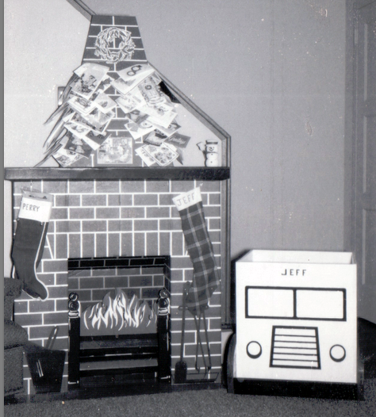

My Christmas “Fireplace” and new home-made toy chest circa 1960

* * * * *

Section 2 - Featured Bassett: Death of Martin Marshall Bassett Jr. of Indiana

Martin Marshall Bassett Jr. descends from William Bassett of Plymouth, Massachusetts as follows

William Bassett and wife Elizabeth

William Bassett (b. 1624) and wife Mary Rainsford

William Bassett (b. 1656) and wife Rachel Willison

William Bassett (b. 1681) and wife Abigail Bourne

William Bassett (b. 1711) and wife Lydia Smith

Rufus Bassett (b. 1757) and wife Jedidah Handy

Nymphas Bassett (b. 1785 and wife Thankful Ann Bruce

Oliver C. Bassett (b. 1824) and wife Elizabeth Monroney

Marshall Bassett (b. 1858) and wife Sonorah J. Israel

Herbert Dale Bassett (b. 1880) and wife Audra M. Jones

Martin Marshall Bassett (b. 1904) and wife Catherine Watson

Martin Marshall Bassett Jr. (b. 1936)

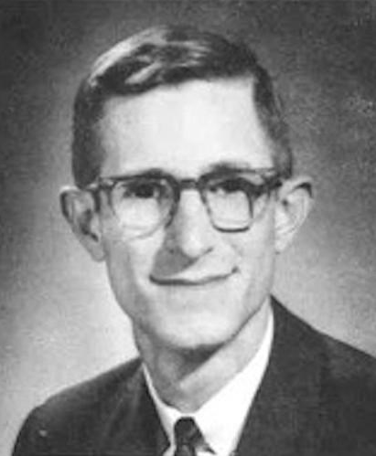

Legacy Remembers, 29 November 2022

Martin Marshall Bassett Jr.

Martin Marshall Bassett, Jr., age 86, of Bloomington, passed away on Friday, November 25, 2022. He was born in Goshen, Indiana on April 3, 1936, the son of the late Martin and Catherine (Watson) Bassett. Marty was predeceased by his dear sister Barbara (Robert Phillips).  
  
Marty was a descendent of many generations of Indiana farmers who farmed in Shelby County. He spent his childhood on the family farms in Goshen. His life-long passion for John Deere tractors started on the farm. In high school Marty played guard on his varsity basketball team and ran cross country.  
  
Marty graduated from the Indiana University School of Business in 1958. He was a member of the Sigma Alpha Epsilon fraternity.  
  
Marty married Deanna Janovic in 1958. She was an Indiana University Chi Omega. What a wonderful journey they had! After serving in the U.S. Army Reserve at Fort Lee, Virginia as a second lieutenant, Marty and Deanna returned to Bloomington and raised four children Christine Ann (Christopher Hollon), M. Scott (Diane McCormick), Martin M. III (Natalie Hay), Stephanie Ann (Greg Orman).  
  
In Bloomington, Marty began his life-long career as an insurance agent. He purchased the abc Insurance Agency and then in 1987 founded the First Insurance Group with Frank Eberle and the late Bill Meyer. He was a tireless problem-solver, but especially enjoyed working with others to grow and develop their potential.  
  
This life story also includes countless memories with family and friends at his cottage at Sweetwater lake in Brown county. He especially enjoyed time at the lake surrounded by his grandchildren: Lesley Hollon, Ali Hollon, Elizabeth Hollon (John Hails), Catherine Hollon, Katherine Bassett (Michael Epstein), Kelly Bassett, Michael Bassett, Grant Bassett, Patrick Bassett, Andrew Orman (Molly Pilgrim), Kaitlyn (Patrick Cashman), Lexi Orman and Caroline Orman.  
  
Marty is survived by his children, grandchildren, and great daughter Lindy Ann Hails.  
  
Marty was an ardent Hoosier fan and long-time member of the Varsity Club and a proud supporter of IU Athletics. He and Deanna were patrons of the Musical Arts Center and IU Auditorium.  
  
A Mass of Christian Burial will be held at 12:00 p.m. on Tuesday, December 6, 2022 at St. Charles Catholic Church, 2222 East 3rd Street. Burial will follow at Valhalla Memory Gardens. Family will receive friends from 10:00 a.m. until the time of Mass. In lieu of flowers, donations can be made to the Monroe County History Center (monroehistory.org).  
  
Allen Funeral Home and Crematory, 4155 South Old State Road 37, Bloomington, have been entrusted with arrangements. Online condolences, photos and memories may be shared with family and friends at www.allencares.com.

* * * * *

Section 3 - Featured Bassett: Portrait of Elizabeth Golden Bassett

Moses Park Bassett descends from William Bassett of Plymouth, Massachusetts as follows

William Bassett and wife Elizabeth

Joseph Bassett (b. 1635) and wife Mary Lapham

William Bassett (b. 1667) and wife Mary Bumpus

Benjamin Bassett (b. 1712) and wife Hannah Macomber

Benjamin Bassett (b. 1742) and wife Mercy Crossman

Simeon Bassett (b. 1770) and wife Abigail Huse

Moses Park Bassett (b. 1809) and wife Elizabeth Golden (b. 1827, died 1907)

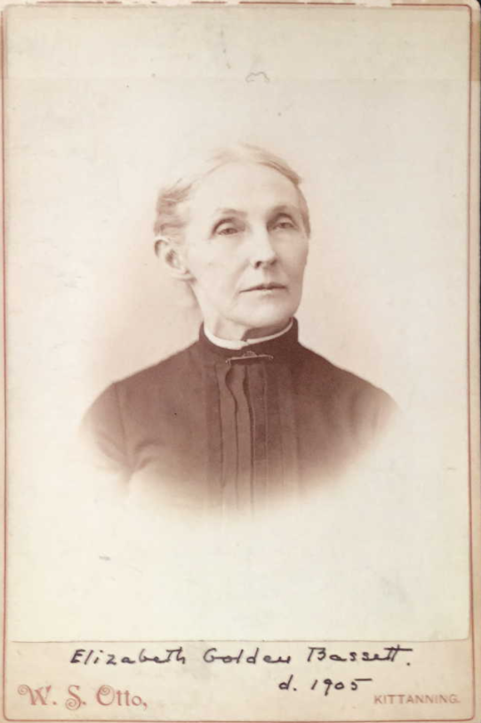

Elizabeth Golden Bassett, wife of Moses Park Bassett

* * * * *

Section 4 - Featured Bassett: Pictures from the Bassett-Rust Family Album

Nymphas B Bassett descends from William Bassett of Plymouth, Massachusetts as follows

William Bassett and wife Elizabeth

William Bassett (b. 1624) and wife Mary Rainsford

William Bassett (b. 1656) and wife Rachel Willison

William Bassett (b. 1681) and wife Abigail Bourne

William Bassett (b. 1711) and wife Lydia Smith

Rufus Bassett (b. 1757) and wife Jedidah Handy

Nymphas Bassett (b. 1785 and wife Thankful Ann Bruce

Bernard Handy Bassett (b. 1808) and wife Hannah Wilson

Nymphas B. Bassett (b. 1833) and wife Amanda Harris

We saw last month a few unidentified photos from this Bassett-Rust Family Album. This month we feature two that have been identified.

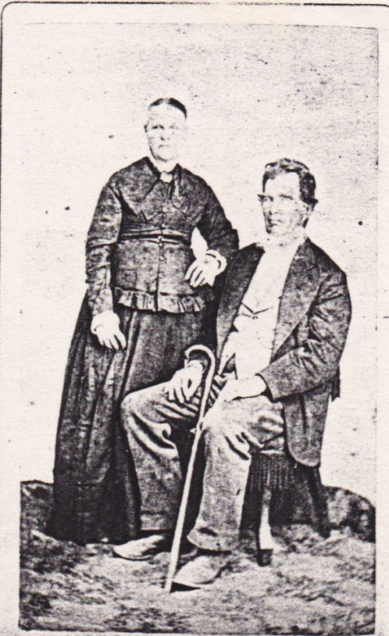

This is most likely a picture of Bernard Handy Bassett and wife Hannah Wilson.

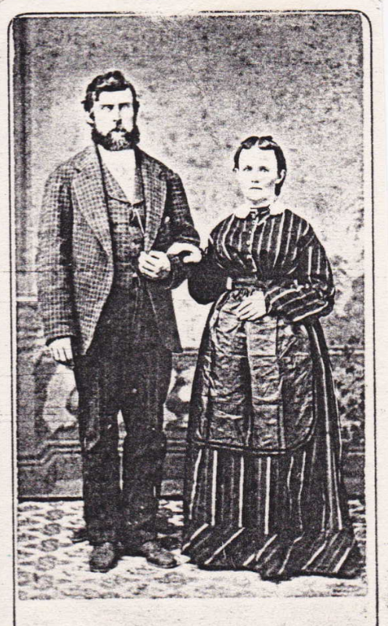

This is most likely a picture of Nymphas B. Bassett and wife Amanda Harris

* * * * *

Section 5 - Featured Bassett: Updated Find-a-Grave page for Clarissa R. Bassett

Clarissa R. Bassett descends from William Bassett of Plymouth as follows:

William Bassett and wife Elizabeth

Joseph Bassett (b. 1635 and wife Mary Lapham

William Bassett (b. 1667) and wife Mary Bumpus

Seth Bassett (b. 1715) and wife Mary Hayward

Seth Bassett (b. 1739) and wife Lydia

Seth Bassett (b. 1785) and wife Mary Toby

Clarissa R. Bassett (b. 1812). She married several times.

In doing some research for a neighbor of mine who is descended from Clarissa R. Bassett, we found several errors in Clarissa’s Find-a-Grave page including her birth year, death date, maiden name and place of burial. They have now been updated.

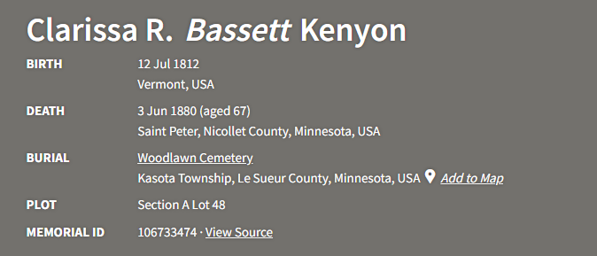

Birth date comes from the Seth Bassett family bible. Death dates comes from the letter below.

Envelope: addressed to Mrs. Phila Ann Bailey, Mannsville, Jefferson Co., New York

Postmark: Saint Peter, Minn. Jun 9

Enclosure:

A list of addresses for Tomlinsons, Mortindale, Benedict, and Cosner.

Notes: Mary is Phila Ann’s sister. Grandma was most likely their sister, Clarissa (Bassett) Tomlinson. Aunt “Adaline” = Bassett’s sister & Phila Ann’s daughter.

Clarissa’s daughter, Mary Ann (Tomlinson) Cosner, was Phila Ann’s niece. I have a letter to Phila Ann from Mary Ann.

Minerva Cosner is Mary Ann’s daughter.

Saint Peter

June 8th 80

Dear Great Auntie,

Have just written to Great Aunt Mary and now I must pen to you the same sad news. Grandma is dead. Died last Thursday June the 3rd at 4 o’clock in the afternoon. Was buried the next day at 8 (?) p.m. None of the boys were there but both Aunt Adaline and Aunt Maria (?). Aunt Adaline come eight weeks ago Thursday. She has been very sick since she come with Eyrsiplus (?). In bed about two weeks. Aunt Marie would come and stay two weeks then go home and stay two weeks. She only lives 45 miles from there. The last time she came was in the morning and Grandma died in the afternoon. She did suffer terrible for the last three months. Mother hardly left the room. For ten weeks we had one or two watching all the time. We dare not leave for a minute. But alas we watch by her bedside no more. She was so happy. She said the Lord was King. And she had a strong arm to lean upon. And she was ready and willing to go when the time came. Some times she would be suffering so terrible hard she would say (O dear. How much longer.) Then she would stop a minute and say (It must be all right or it wouldn’t be so.) If you could only of seen her. She was so happy. Mother is about wore out. She is so tired. She has no ambition to do anything. Her and Aunt Adaline and Father are going over to the graveyard. I am left alone with the hired (?) girl. The minute they go away I want to go to sleep for I get so lonesome. I expect you are wondering who I am. Your great niece Minerva daughter of your niece Mary Ann. Will close for this time hoping to hear soon. I remain your great niece Minerva Cosner. St. Peter

PS will send you a lock of Grandma’s hair and a piece of her shroud.

Have written this for Mother for she said she could not set [sic] down to write. She was so tired.

* * * * *

Section 6 - Featured Bassett: Allen Mordorf Bassett. Gemologist

Allen Mordorf Bassett descends from William Bassett of Plymouth, Massachusetts as follows:

William Bassett and wife Elizabeth

William Bassett (b. 1624) and wife Mary Raynesford

William Bassett (b. 1656) and wife Rachel Williston

William Bassett (b. 1680) and wife Abigail Bourne

Elisha Bassett (b. 1714) and wife Ruhamah Jennings

Lot Bassett (b. 1755 and wife Deborah Howes

Francis Edward Bassett (b. 1796) and wife Mehitable Ford

Charles Ralph Bassett (b. 1836) and wife Elvira Rogers

Edward Murray Bassett (b. 1863) and wife Annie Rebecca Preston

Preston Rogers Bassett (b. 1892) and wife Jeanne Reed Mordorf

Allen Mordorf Bassett (b. 1925)

Rocks & Minerals, Volume 89, 2014 – Issue 5

Allen Mordorf Bassett

Adventure and Gems were the twin passions of geologist and gemologist Allen M. Bassett. From a very young age these forces propelled him through a lifetime of scientific inquiry, exploration, and thrilling exploits in exotic locations around the world. The spark was ignited when as a young boy he spotted gemmy quartz crystals known as Herkimer “diamonds” in the window of a locksmith's store in Rockville Centre, New York, the town where Allen grew up alongside his sister and two brothers. As an avid collector of mineral specimens, the locksmith found a kindred spirit in this young boy who returned again and again to purchase crystals with his weekly allowance—the start of a collection that would grow for the rest of Allen's life. His interest in these crystals soon morphed into serious gem and mineral collecting, always with a geologist's eye for pairing cut gems with representative crystals of minerals from which they had been fashioned.

This early interest in collecting comes as no surprise considering that Allen was born, on 2 February 1925, to parents who were collectors: a father who collected antique blown glass and a mother who collected fancy handheld fans. Needless to say, Allen's interests received much encouragement and guidance at every turn. His father, a physicist and aeronautical engineer, led him to delve into the fascinating science of geology, mineralogy, and crystallography. Even Allen's grandparents had a curio cabinet filled with items that they had collected from all over the world; it was a huge magnet for Allen and his siblings and cousins when they visited.

As a student at Amherst College, surrounded by the extraordinary collections in the vast old gymnasium-turned-museum, Allen quickly determined that he would major in geology. He then went on to graduate work at Columbia University where he conducted a PhD research project at the Naica mine in Mexico. Although studying the sulfide mineralization, he was fascinated by the huge crystals of gypsum in the caves that the mine had encountered. One day while working there he heard that management had decided that pumping water out of the lowest levels was too expensive and they planned to let the caves flood. He immediately went to his friend, the lift operator, and talked him into taking him down one last time before the caves were lost forever. Upon arriving in the depths, Allen found that the water was already rapidly rising around his legs, and he rushed about saving armloads of gypsum crystals before they were submerged forever. He raced back to the lift, half-swimming and half-running with his crystals, rang the bell for the lift operator, and was brought back to the surface as the water continued to rise. He gave those crystals to Amherst College and museums elsewhere. (It was many years later that even more amazing caves were found at Naica, caves in which the gypsum crystals are tens of feet long instead of just a few feet.)

Allen's infectious enthusiasm for geology helped inspire the same in his younger brother, William, who at age fifteen accompanied him on a geological tour of the West, including many operating mines. This memorable trip influenced his brother's own lifelong path in the geological sciences.

After graduation, Allen took a position with the U.S. Geological Survey (USGS) in Claremont, California, where he mapped the mineral deposits of the Mojave Desert. When the government became concerned that the borate deposits of the Mojave might be too limited a supply for potential rocket fuel under consideration at that time, Allen and some of his colleagues were sent to the Altiplano of South America to map the extensive borate deposits there.

After leaving the USGS, Allen took a teaching position in the geology department of San Diego State College, now San Diego State University. His desire to explore exotic places and not only study their geology but also to search for rare minerals and gems led to a life-changing trip to Nepal as part of the San Diego Himalayan Expedition. The objective of this 1970 scientific mission was to investigate the recently proposed “Plate Tectonics Hypothesis,” a theory now taught as fact in today's geology classrooms and which contributed to Allen's future success in predicting the location of Nepal's ruby deposits. He later became the first Western-trained scientist to trek to these high-altitude localities in the Ganesh Himal (Dhading District), and he was the first scientist to describe in detail the incredibly tight and repetitious folding of the region. During the next two decades, he returned year after year to hike, explore, and, ultimately, live in this country of stunning beauty and harsh contrasts. In his quest to establish a fully integrated gem industry in Nepal, he brought in the first faceting machines, initially starting this endeavor with the unique tourmalines of the Hyakule mine. He later helped found the Kathmandu-based company “Himalayan Gems, Nepal” and was instrumental in developing the mines of Chumar and Ruyil, which produced some of the loveliest ruby cabinet-sized specimens and gems ever to come out of that country (Skalwold 2014).

Allen met his first wife, Ann Bradley, the daughter of a geologist, while still a student. They have three children, Elizabeth, Bradley, and Shepard. His second marriage was to Frederique Geoffroy, who he met on one of his far-flung trips; they have a son, Geoffroy. When not exploring, Allen lived with Frederique in Paris until his death on 1 May 2014. Allen leaves behind many friends around the world, as well as an extended family circle, including his siblings. His geological and gemological legacy endures in his many publications (see Bassett 1979; Skalwold 2014) and as the Allen and William Bassett Gem Collection that resides in the Timothy N. Heasley Mineralogy Museum of Cornell University in Ithaca, New York.

* * * * *

Section 7 - Featured Bassett: Sharon Bassett and Norway Iron Bolt Works of Connecticut

Sharon Bassett descends from #6B William Bassett of Connecticut as follows:

William Bassett and wife Hannah (Dickerman) Ives

John Bassett (b. 1652) and wife Mercy Todd

Joseph Bassett (b. 1697) and wife Miriam Bradley

Joel Bassett (b. 1733) and wife Mary

David Bassett (b. 1778) and wife Hannah Tuttle

Sharon Bassett (b. 1808) and wife Amelia Munson

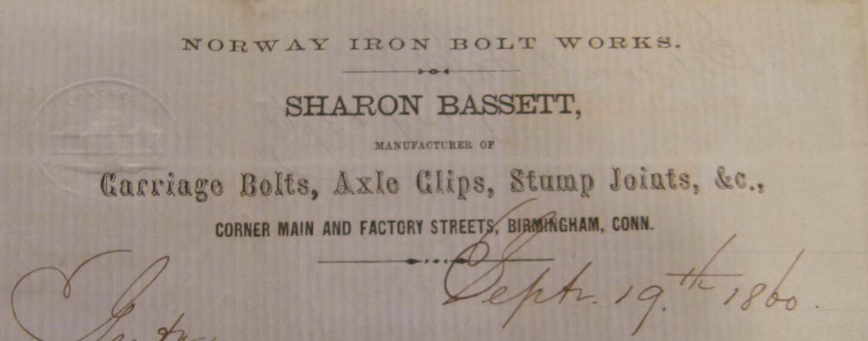

Norway Iron Bolt Works Company letterhead from 1860

New York Herald-Tribune, December 21, 1880

Sharon Bassett

WATERBURY, Conn., Dec. 20 – Sharon Bassett, one of the pioneers in the manufacture of bolts, and well known throughout New England, died of heart disease, at Birmingham, Conn., this afternoon, where he has lived for thirty years. He was seventy-three years old.

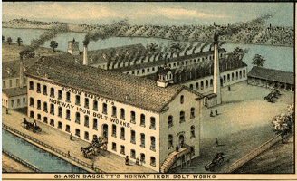

* * * * *

Section 8 - New family lines combined or added since the last newsletter

No lines have been combined/eliminated since the last newsletter.

The following family lines have been added since the last newsletter.

561B. Dominico Basset of Italy and New York (11/23/22)

* * * * *

Section 9 - DNA project update.

One new Bassett Y-DNA kit was sent out this month.

No new results to report on the Bassett Y-DNA project.

|  |
| --- |
| Donations of any amount can be made to the Bassett DNA project by clicking on the link below. Any funds donated will be used to fund select Bassett DNA tests that will further our project as a whole and benefit all Bassetts worldwide.  http://www.familytreedna.com/group-general-fund-contribution.aspx?g=Bassett  This is just a reminder that the DNA portion of the Bassett Family Association can be found at:  A current spreadsheet of results can be found at:  <http://www.bassettbranches.org/dna/BassettDNA.xls>  If you don't have Excel and can't open the spreadsheet above, you can now see the DNA test results at the following website.  <http://www.familytreedna.com/public/Bassett/>  Jeffrey Bassett 520 Salceda Drive Mundelein, IL 60060 USA bassettgenealogy@gmail.com |