Bassett Family Newsletter, Volume XX, Issue 9, 18 Sep 2022

(1) Welcome

(2) Arthur Judson Bassett and the Grand Crossing Tack Company of Chicago

(3) Francis Bassett historic pewter teapot

(4) Will and Obituary for Francis Bassett J.P., M.P. Leighton Buzzard, England

(5) Death of Ramon Bassett of St. George, Utah

(6) Letterhead of Daniel Bassett, Coal and Wood Dealer of Hingham, Massachusetts

(7) Cool Apple Orchard of Lima, Ohio

(8) New family lines combined or added since the last newsletter

(9) DNA project update

The newsletter link page is below. Once you get to this page, choose the current month to see the current newsletter.   
You can either view in a PDF or in a word document format.

[http://bassettbranches.org/newsletters/newsletters2014on.shtml](https://urldefense.proofpoint.com/v2/url?u=http-3A__bassettbranches.org_newsletters_newsletters2014on.shtml&d=CwMFAg&c=S6jE3hMA0s16gx2_CUBBn4vjc1odLunI6MSvd_AfdV8&r=ADbYgOapkXRpzHmfUAhxbzP0otyJJPOFv2Ppp_j_StQ&m=E4bwtBvPwffnJ-zHKAyFoYZentSBz8mzTMl1D0zbtg4&s=q9GysExyxT--pgs3SG5MQx4qRfPXEdgrggHGRsv5wmo&e=)

Section 1 - Welcome

The following trees were added to the Bassett website database since the last newsletter:

557B. Matthew Walker Bassett of Paris, Missouri (25 individuals)

Total number of individuals loaded into the Bassett website: 197,976

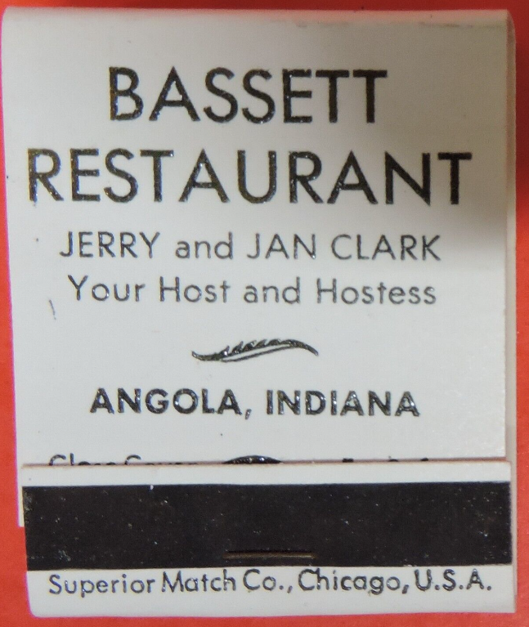

* * * * *

Section 2 - Featured Bassett: Arthur Judson Bassett and the Grand Crossing Tack Company

Arthur Judson Bassett descends from William Bassett of Plymouth as follows:

William Bassett and wife Elizabeth

Joseph Bassett (b. 1635) and wife Martha Hobart

Jeremiah Bassett (b. 1678) and wife Mary Felch

Jeremiah Bassett (b. 1722) and wife Sarah Alger

Jeremiah Bassett (b. 1751) and wife Hannah Woodward

Jeremiah Bassett (b. 1787) and wife Lydia Stone

Lerned Orin Bassett (b. 1874) and wife Sarah J. King

Arthur Judson Bassett (b. 1852)

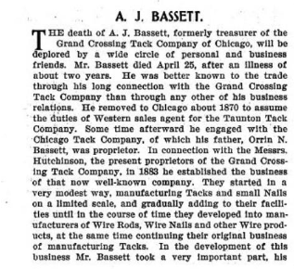

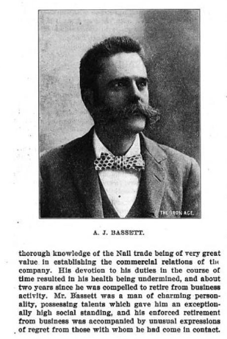

History of Cook County, Illinois

* * * * *

Section 3 - Featured Bassett: Antique Pewter Teapot made by Francis Bassett

Francis Bassett of New York descends from #19B Michael Bassett of New York as follows:

Michael Bassett and wife Helena Van Alst

John Bassett (b. 1696) and wife Altje Vischer

Francis Bassett and wife Elizabeth Mary

The will of Francis Bassett

N.Y. Historical Collection, Abstracts of Wills, Vol. 5, p.242; N.Y. Surrogate, Liber 21, p.37:

I, Francis Bassett, of New York, pewterer, this 16th of December 1749, I leave to my wife, Elizabeth Mary Bassett, all my real and personal estate, to her and her heirs and assigns for ever, and I make her sole executor.

Witnesses: Christopher Roberts, Francis Foy, Simon Johnson.

Proved Jun 14, 1758.

Note: The residence of Francis Bassett, who was a well-known citizen of his time, was on the south side of Pearl Street, a little east of Maiden Lane.

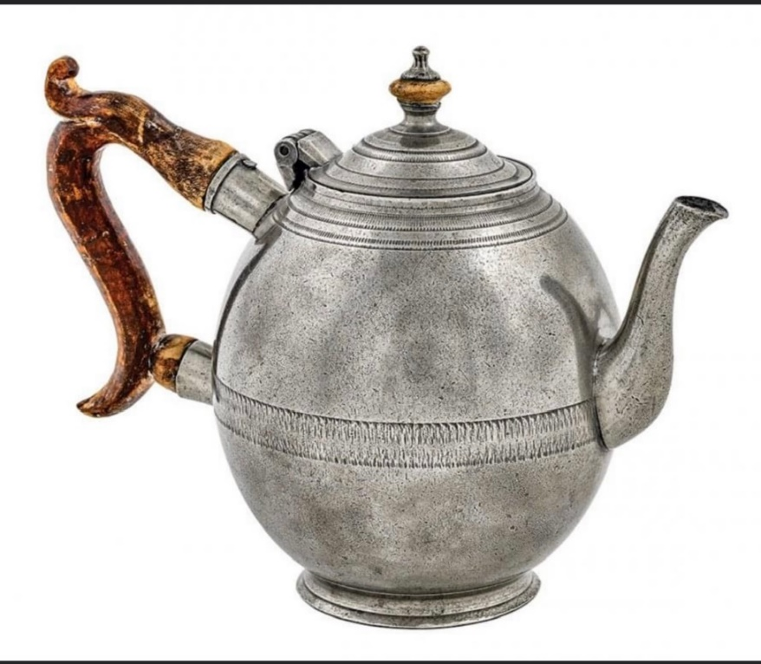



This was sent to me by Ron Reed who comes from a different Bassett line.

* * * * *

Section 4 - Featured Bassett: Will and Obituary for Francis Bassett of Leighton Buzzard

Francis Bassett descends from #18B Daniel Bassett of Leighton Buzzard, England as follows:

Daniel Bassett

Peter Bassett (b. 1745) and wife Ann Dollin

John Dollin Bassett (b. 1786) and wife Mary Theobold

Francis Bassett (b. 1820 d. 1899)



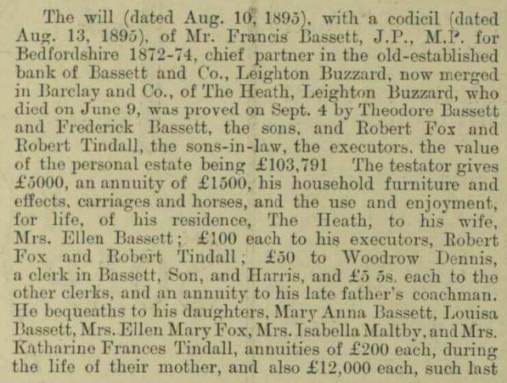 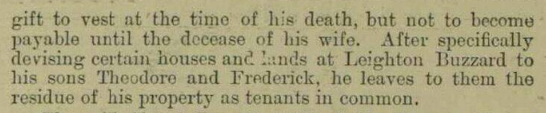

The Aberdeen Weekly Journal, Wednesday, June 14, 1899

Death of Mr. Bassett, Banker

The death took place on Friday night at Leighton Buzzard, at the age of eighty-years, of Mr. Francis Bassett, chief partner in the old established bank of Bassett and Co., Leighton Buzzard and elsewhere, now merged in Barclay and Co. Mr. Bassett, from 1872 to 1875, represented Bedfordshire in Parliament in the Liberal interest. Deceased had been in failing health for a year, and four months ago was seized with paralysis. He was a member of the Society of Friends.

* * * * *

Section 5 - Featured Bassett: Death of Ramon Bassett of St. George, Utah

Ramon Eugene Bassett descends from #179B Cesare Bassettii as follows:

Cesare Bassetti and wife Carolina Adelaide Binda

Andre Bassett (b. 1899) and wife Laura Irene Lewis

Ramon Eugene Bassett (b. 1931 d. 2022)

Metcalf Mortuary – St. George, August 23, 2022

Ramon Bassett

St. George, Utah - Ramon Eugene Bassett Ray was born on August 24, 1931, in Palo Alto, California. He was the second child of Andre and Irene Bassett. As a young boy, he loved to build models and was very proud of the replica baseball stadium he built. Growing up, he was very close to his older brother, Richard, and younger sister, Kathy. They loved spending time together. Ray attended school (K-12) in California, Missouri, and Arizona.  
Ray found great joy serving in The Church of Jesus Christ of Latter-day Saints. He served a mission in the Eastern States Mission, primarily preaching the gospel in Pennsylvania. He touched many lives as bishop of the Cleveland East Ward and as a High Priest Group Leader in multiple wards. Ray served on the high council, was a ward clerk (his favorite calling), and recently taught Gospel Doctrine and Family Home Evening classes at the Meadows at Escalante. He also had the opportunity to serve as the chair of the Bountiful City Handcart Days.  
While attending the University of Utah 3rd Ward, Ray met Peggy Hansen at a genealogy class he was teaching. They began dating and were married July 20, 1959, in the Logan, Utah Temple. Together, they raised five children: Teresa, Gregory, Bryan, Rochelle and Richard. The family built many treasured memories taking vacations together and visiting Ray s parents in St. Helena, California, and Peggy s parents in American Fork, Utah.  
Ray received a bachelor s degree in Civil Engineering from Brigham Young University. He also did post-graduate work at the University of Utah. He worked his way through college as a fireman on a steam engine locomotive with the Southern Pacific Railroad. Firemen on the railroad were responsible to keep the boiler fire going in order to create steam power for their train.  
After college, Ray began his career as a Civil Engineer at Sperry Utah Company. Throughout his career, he also worked in Texas, Missouri, and Ohio. He retired from Hill Field Air Force Base in Utah as an Aerospace Engineer after 38 years of service. Following his retirement, Ray and Peggy served a family history mission. They also enjoyed going on cruises together.  
One of Ray s life-long passions was family history work. He dedicated many hours and years to work on family group sheets, clear names for the temple, and teach others how to find their ancestors. Ray also enjoyed watching many different BYU sports teams and was an avid BYU fan. He loved to play chess and won trophies and medals in several tournaments including a gold medal at the Huntsman Senior Games.  
Ray was a loving husband, father, grandfather, great-grandfather and brother. He is survived by his sister, Kathy (Brett) Paulsen; his children: Teresa (Brad) Byington, Gregory (Joni) Bassett, Bryan (Julie) Bassett, Rochelle (Grant) Blatter, and Richard (Tiffany) Bassett; 21 grandchildren; and 20 great-grandchildren. He was preceded in death by his wife, Peggy, and brother, Richard Bassett. Ray passed away on August 20, 2022, four days before his 91st birthday. He received the best birthday present this year: being reunited with his wife, Peggy.  
Funeral services will be held Saturday, August 27, 2022, at 1:00 p.m. in the Metcalf Mortuary Chapel, 288 West St. George Blvd., St. George, Utah. A visitation will be held Saturday, prior to the service, from 11:30 a.m. to 12:30 p.m. at the mortuary. Interment will be in Tonaquint Cemetery, 1777 South Dixie Drive, St. George, Utah.  
Live streaming webcast is available by clicking on the broadcast at the bottom. Webcast will remain on-line for 90 days.

* * * * *

Section 6 - Featured Bassett: Letterhead for Daniel Bassett, Dealer in Coal and Wood

Daniel Bassett descends from William Bassett of Plymouth as follows:

William Bassett and wife Elizabeth

Nathaniel Bassett (b. 1628) and wife Dorcas Joyce

Joseph Bassett (b. 1669) and wife Susannah Howes

Daniel Bassett (b. 1710) and wife Elizabeth Howell

Joseph Bassett (b. 1747) and wife Mary Pette

Daniel Bassett (b. 1787) and wife Mary Gray

Daniel Bassett (b. 1820) and wife Lydia Thaxter Gill

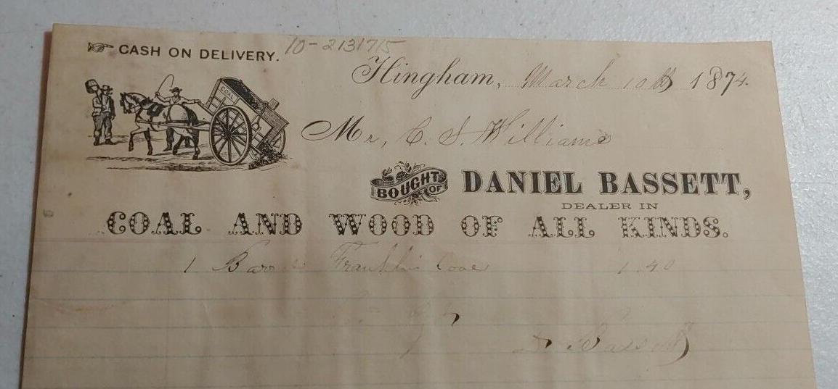

Letterhead for Daniel Bassett, Dealer of Coal and Wood, Hingham, Massachusetts

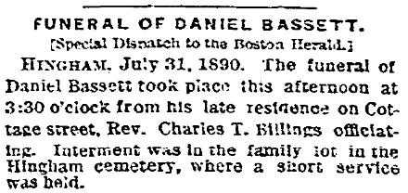

The Boston Herald, Boston, Massachusetts, Friday, August 1, 1890

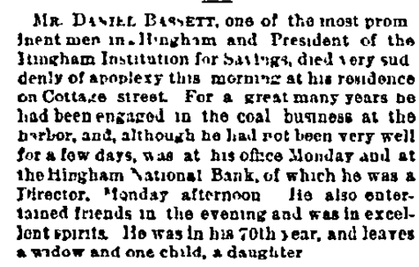

* * * * *

Section 7 - Featured Bassett: Cool Apple Orchard of Lima, Ohio

Jenni (Bassett) Moore descends from William Bassett of Plymouth as follows:

William Bassett and wife Elizabeth

Nathaniel Bassett (b. 1628) and wife Dorcas Joyce

Samuel Bassett (b. 1670) and wife Elizabeth Jones

Samuel Bassett (b. 1700) and wife Alice Weaver

Samuel Bassett (b. 1736) and wife Tabitha Waite

William Bassett (b. 1765)

Samuel Bassett (b. 1795) and wife Elsie Lewis

Lewis Bassett (b. 1825) and wife Sarah Edgecomb

Philo Horace Bassett (b. 1852) and wife Alice Everett

Howard Everett Bassett (b. 1893) and wife Doris Delphin Giffin

William Howard Bassett

Jenni (Bassett) Moore

While on a drive through Ohio this summer, my wife and stopped by to find the Sugar Creek Orchard in Beaverdam, Ohio only to find that the orchard had been sold. However, the new homeowner referred us to another orchard just down the street. It is owned by John and Jenni (Bassett) Moore. Jenni is a sister to Gary Bassett who owned Sugar Creek Orchard. It is now apple picking season so if you are in the area of Lima, Ohio, stop by the Cool Apple Orchard to pick up some apples.

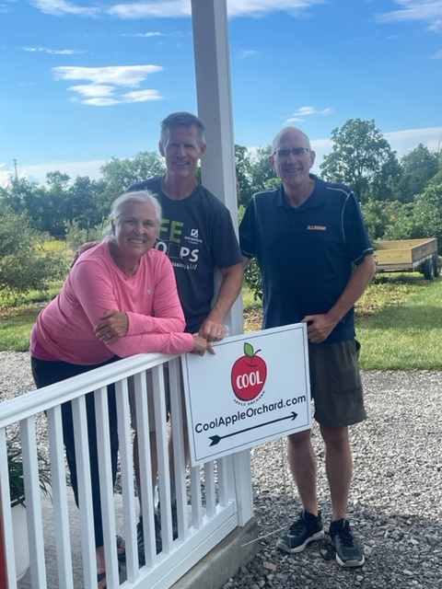 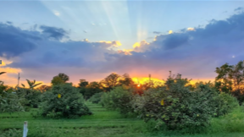

John & Jenni (Bassett) Moore Cool Apple Orchard at sunset

with newsletter author Jeff Bassett

Here is a link to their web page.

[www.CoolAppleOrchard.com](http://www.CoolAppleOrchard.com)

* * * * *

Section 8 - New family lines combined or added since the last newsletter

The following family lines have been added since the last newsletter.

557B. Matthew Walker Bassett of Paris, Missouri. (b. 1918)

* * * * *

Section 9 - DNA project update.

No new results to report on the Bassett DNA project.

I have funds available for anyone from a Bassett line that has not yet taken part in the Y-DNA project and can fund your 37 marker test if you are interested but cannot afford to pay for your own test.

|  |
| --- |
| Donations of any amount can be made to the Bassett DNA project by clicking on the link below. Any funds donated will be used to fund select Bassett DNA tests that will further our project as a whole and benefit all Bassetts worldwide.  http://www.familytreedna.com/group-general-fund-contribution.aspx?g=Bassett  This is just a reminder that the DNA portion of the Bassett Family Association can be found at:  A current spreadsheet of results can be found at:  <http://www.bassettbranches.org/dna/BassettDNA.xls>  If you don't have Excel and can't open the spreadsheet above, you can now see the DNA test results at the following website.  <http://www.familytreedna.com/public/Bassett/>  Jeffrey Bassett 520 Salceda Drive Mundelein, IL 60060 USA bassettgenealogy@gmail.com |