Bassett Family Newsletter, Volume XX, Issue 6, 19 Jun 2022

(1) Welcome
(2) Dr. Lorraine Rahija Rebecca Bassett Scott of West Virginia
(3) William Bassett Will of Massachusetts
(4) A.L. Bassett Insurance Trading Card
(5) Death of Paul Merritt Bassett of Kansas
(6) Francis Peterson Bassett, Aviator
(7) Leland K. Bassett Receives Jackson College Service Award
(8) New family lines combined or added since the last newsletter
(9) DNA project update

The newsletter link page is below. Once you get to this page, choose the current month to see the current newsletter.
You can either view in a PDF or in a word document format.
http://bassettbranches.org/newsletters/newsletters2014on.shtml

Section 1 - Welcome

No new trees were added this month.

We tried to record my Bassett DNA presentation last week to put online, but ran into techinical difficulties. One of my four children attended the presentation, the first child to attend any genealogy presentation I have ever made.

Happy Fathers Day!

Totals number of individuals loaded into the Bassett website: 195,404

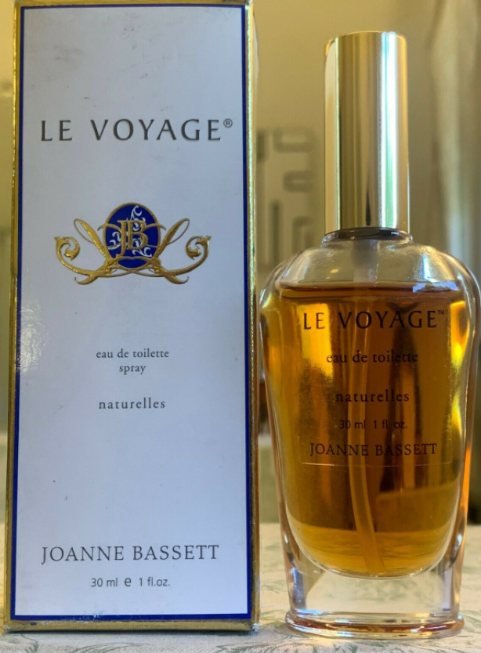

* * * * *

Section 2 – Featured Bassett: Dr. Lorraine Rahija Rebecca Bassett Scott

Lorraine Rahija Bassett descends from #107B. Abrahim Bassett of Kfeir, Lebanon as follows:

Ibrahim Bassett and wife Jamra
Ferris Bassett (b. 1810) and wife Regina Tweel
Joseph Bassett (b. 1840) and wife Adlah Jamra
Abraham Joseph Bassett (b. 1885) and wife Rahija Saad
Lorraine Rahija Bassett Scott (b. 1929)

Legacy Remember, 25 May 2022
Dr. Lorraine Rahija Rebecca Bassett Scott

Dr. Lorraine Rahija Rebecca Bassett Scott, 93, born 1 January 1929 in Williamson, West Virginia, the fifth daughter of Abraham Joseph Bassett and Rahija Abou Jamra Saad, natives of El-Kfeir, Hasbaiya, Lebanon, passed away 4 January 2022 in Helena, Montana of natural causes.
Lorraine was preceded in death by her husband William Allen Scott, both parents, and four sisters-Gladys Shumla (Richard Parlette), Selma Mae (James Edinger), Wadad Ethyl (James Bofysil), and Alice Tamam (John Rutherdale). She is survived by her brother Abe J. Bassett (Sharon Kinnaird), two sons, (Paul [Valerie Soe] and Clay Scott) and two grand-daughters, Rose and Ivy Scott, and numerous nieces and nephews and grand-nieces and grand-nephews.
A 1946 graduate of Williamson High School, she entered Berea College in September of that year, and married William Allen Scott of Hardy, Kentucky on 8 June 1947. She entered the University of Kentucky in September, 1947, completing two years of study before her father asked the couple to come to Columbus, Ohio, to help him operate his tavern. Following her father's death in March 1949, Lorraine and Bill moved to California.
While working full time, she resumed her studies at San Jose State University earning a Bachelor's degree in Art and Art History in 1968, a Master's degree in 1976. She pursued a Doctor of Education degree at the University of the Pacific, completing it in 1986, and becoming a high school principal.
Lorraine was an adventurous and curious soul. She was a world traveler whose travels took her to Lebanon and Palestine among other places. She loved her Lebanese heritage and was an excellent cook of Arabic food. It was with great pleasure when she could attend the annual Kfeirian Reunion and the services of the Eastern Orthodox Church.
She is missed.

* * * * *

Section 3 - Featured Bassett: William Bassett Will of Massachusetts

William Bassett descends from William Bassett of Plymouth, Massachusetts as follows:

William Bassett and wife Elizabeth
Nathaniel Bassett (b 1628) and wife Dorcas Joyce
William Bassett (b. 1686)

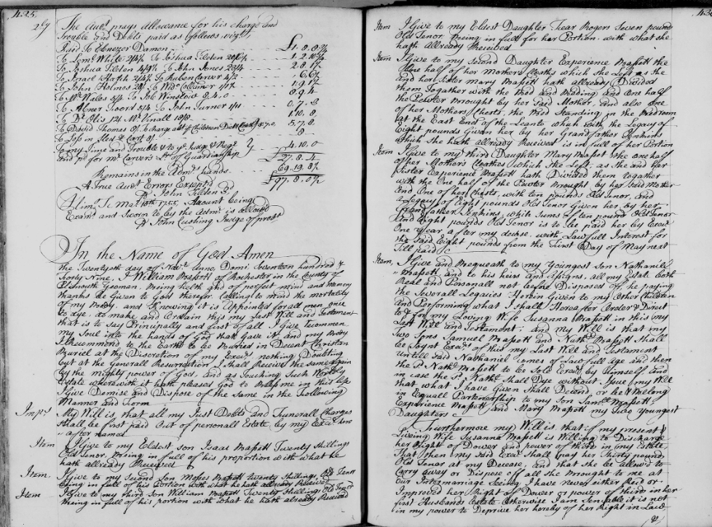
Will of William Bassett of Massachusetts, son of Nathaniel Bassett, grandson of William of Plymouth

* * * * *

Section 4 - Featured Bassett: A.L. Bassett Insurance Trading Card

Allan Lee Bassett descends from #1B John Bassett of Connecticut as follows:

John Bassett and wife Margery
Robert Bassett and wife Mary
Robert Bassett (b. 1640) and wife Elizabeth Riggs
Captain Samuel Bassett (b. 1692) and wife Deborah Bennett
Benjamin Bassett (b. 1740) and wife Molly Hinman
John Bassett (b. 1779) and wife Nancy Atwater Lee
Allan Lee Bassett (b. 1827)

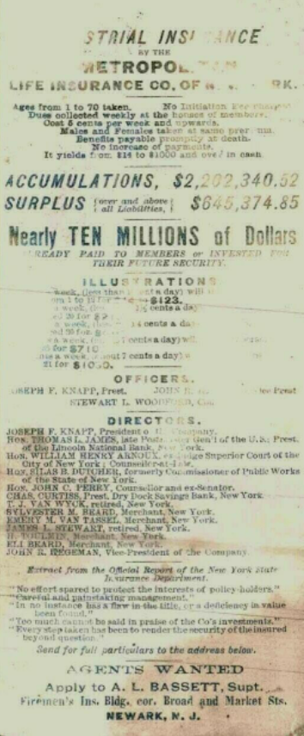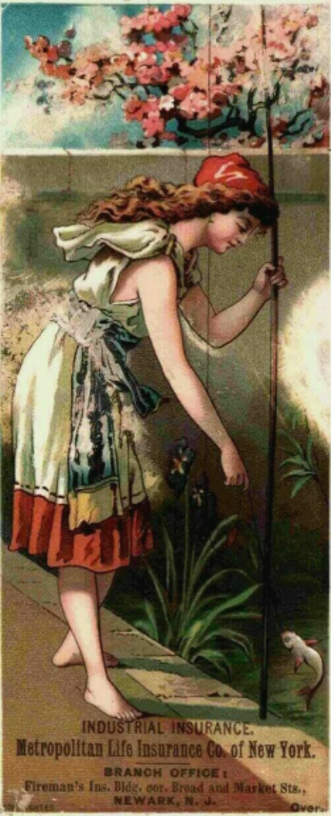
Old Trading Card for Allan Lee Bassett of Newark, New Jersey for sale on ebay

Click on the link below to read a previous newsletter about Allan Bassett.

Allan Lee Bassett, First President of Prudential Insurance | Bassett Family Association (bassettbranches.org)

* * * * *

Section 5 - Featured Bassett: Death of Paul Merritt Bassett

Paul Merritt Bassett descends from William Bassett of Plymouth, Massachusetts as follows:

William Bassett and wife Elizabeth
Joseph Bassett (b. 1635) and wife Mary Lapham
William Bassett (b. 1667) and wife Sarah Sweetland
William Bassett (b. 1694) and wife Mary Crossman
William Bassett (b. 1726) and wife Lydia Fisher
Nathan Bassett (b. 1769) and wife Mehitable Buell
Ira Bassett (b. 1799) and wife Narcena Hunt
Sereno Buell Bassett (b. 1833) and wife Lucy Fish
Merritt Grant Bassett (b. 1861) and wife Nancy May Rice
Paul Gardner Basstt (b. 1910) and wife Ruth Abbott Weiss
Paul Merritt Bassett

Kansas City Star, Missouri, 5 June 2022
Paul Merritt Bassett
May 28, 1935 – May 7, 2022

Overland Park, Kansas - Paul Merritt Bassett, 86, of Overland Park, Kansas, passed away on Saturday, May 7, 2022, at Kansas City Hospice, in Kansas City, Missouri.
Paul was born on May 28, 1935, in Lima, Ohio, to Paul and Ruth (Weiss) Bassett. He had a brother and two sisters: David Bassett (Joan), Nancy Krumrie (Lyle), and Karen Bassett. All but Nancy preceded him in death.
Paul married Pearl Householter, in Eureka, Illinois, August 8, 1958. Paul and Pearl have three children: Emilie Taggart (David), Paul Stephan Bassett (Michelle), and Anita Zakarian. He is survived by six grandchildren: Jori Avery, Corbin Taggart, Johnathan Reinhart, Jacob Reinhart, Jesse Parsons, and Chloe Bassett, and by one great grandchild, Rowan Avery.
In 1957, Paul graduated from Olivet Nazarene College, (now University), in Illinois, with a degree in psychology. He attended Duke University and earned a B.D. in 1960, and a Ph.D. in the History of Christianity in 1967.
Paul served as Professor of the History of Christianity at Nazarene Theological Seminary from 1969 to 2014. Other teaching assignments took him to England, Mexico, Costa Rica, Australia, The Philippines, and Ecuador. He was a member of numerous professional societies and commissions, and a prolific writer. He taught an Adult Sunday School class and was Church Organist at Overland Park Church of the Nazarene for more than 40 years. His work was a response to Christ's love for us.
A memorial service will be held at Overland Park Church of the Nazarene, 9030 Lamar, Overland Park, Kansas, on June 11, 2022, at 10:00 a.m.
In lieu of flowers, memorials can be sent to Ukraine Crisis Response, Nazarene Compassionate Ministries, 17001 Star Parkway, Lenexa, KS, 66220.

* * * * *

Section 6 – Featured Bassett: Francis Peterson Bassett, Aviator

Francis Peterson Bassett descends from #1B John Bassett of Connecticut as follows:

John Bassett and wife Margery
Robert Bassett and wife Mary
Robert Bassett (b. 1640) and wife Elizabeth Riggs
Robert Bassett (b. 1699) and wife Eunice Clark
Daniel Bassett (b. 1743) and wife Elizabeth Bassett
Lemuel Bassett (b. 1788) and wife Julia Benet
Jared Beardsley Bassett (b. 1824) and wife Mary Wheeler
Dewitt Clinton Bassett (b. 18590 and wife Mary Peterson
Francis Peterson Bassett (b. 1908, d. 1992)

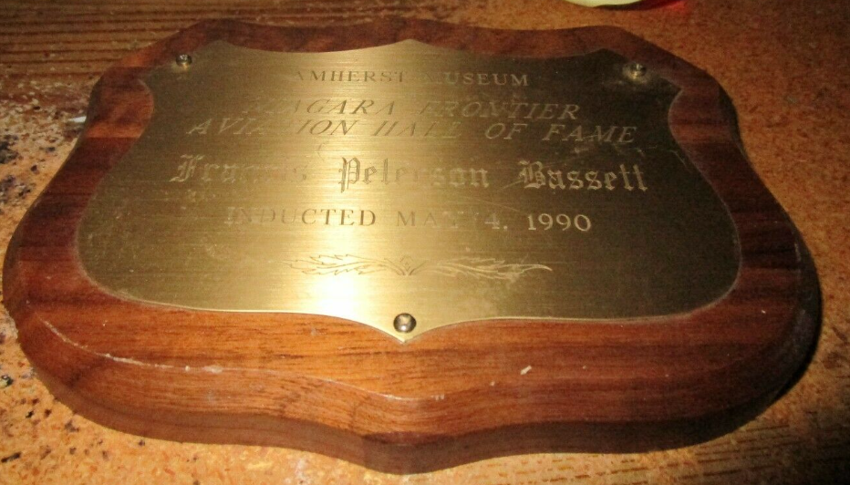
Bassett Plaque currently for sale on ebay.

The Buffalo News, New York, 30 Oct 1992
F. Peter Bassett, Aviation Pioneer, Inventor

F. Peter Bassett, 85, an aviation pioneer, died Wednesday (Oct. 28, 1992) in the Harris Hill Nursing Home, Clarence, after a short illness. He was born in Covert and lived in Lockport for more than 30 years. He attended the University of Michigan's School of Engineering. Bassett worked at Bell Aircraft as an aeronautical designer and project engineer for more than 40 years, retiring in 1970. He had several aircraft inventions and was issued patents that applied to airplanes and helicopters. He was an avid pilot of light aircraft. He was a member of the Aero Club of Buffalo, the Airplane Owners and Pilot Association and the OX5 Aviation Pioneers. He also was a member of Dutch Reform Church of Interlaken. Survivors include his wife, the former Elsie M. Schaefer of Williamsville; a daughter, Jane E. Wright of Maryland, and two grandsons. A private memorial service will be held at a later date.

* * * * *

Section 7 – Featured Bassett: Leland K. Bassett, Jackson College Service Award

Leland K. Bassett descends from #6B William Bassett of CT as follows:
William Bassett of Connecticut and wife Hannah Dickerman
Samuel Bassett (b. 1652) and wife Mary Dickerman
Samuel Bassett (b. 1686) and wife Elizabeth Humiston
Samuel Bassett (b. 1728) and wife Abigail Bradley
Samuel Bassett (b. 1752) and wife Katherine Tuttle
Lyman Bassett (b. 1787) and wife Sally Boyse
Benajah Bassett (b. 1821) and wife Catherine Bird Stanford
Edgar Stanford (b. 1852) and wife Joanna Josephine Carroll
Edgar Franklin Bassett (b. 1874) and wife Maggie
Wilfred George Bassett married Vera Agnes Scheffel
Leland K. Bassett

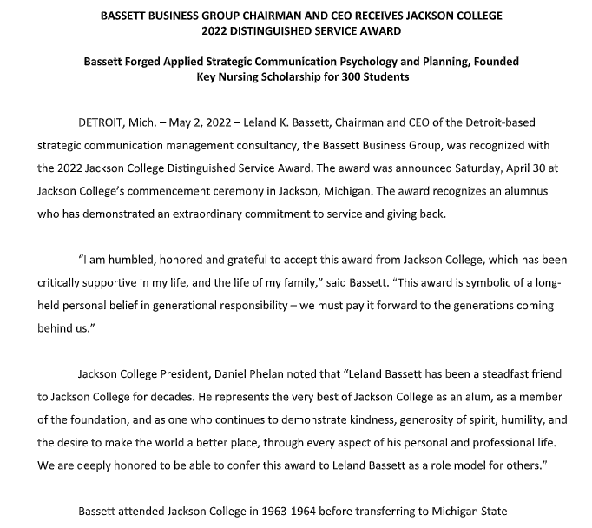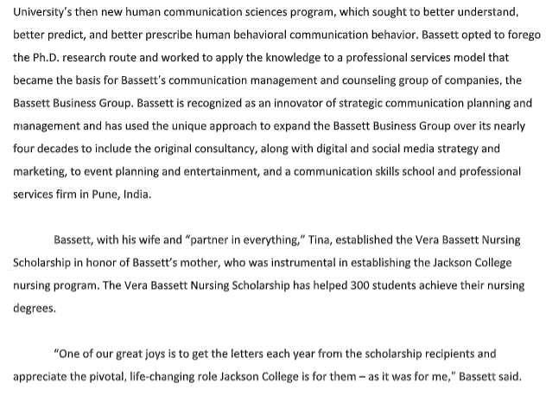

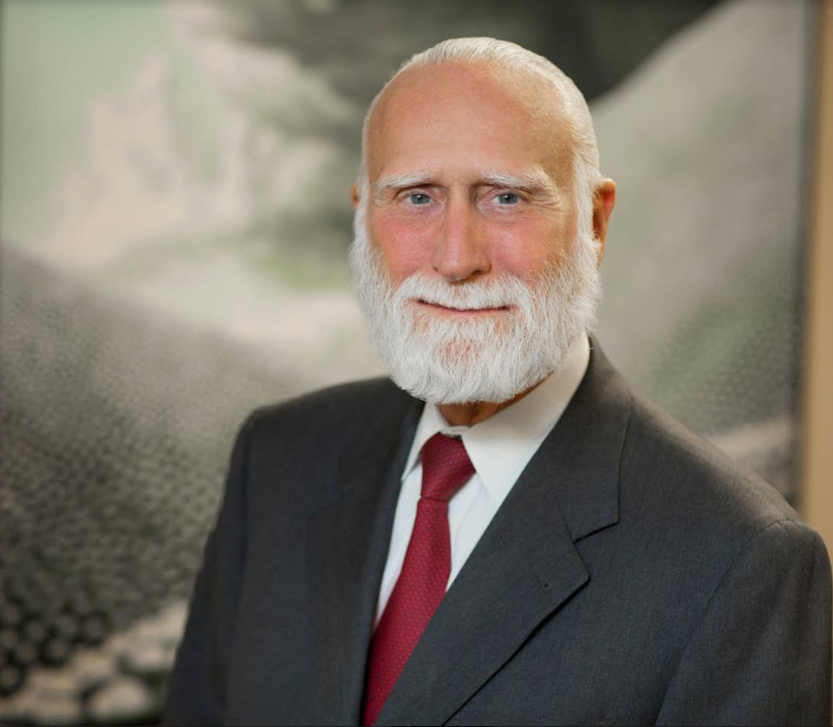

* * * * *

Section 8 - New family lines combined or added since the last newsletter

No new families added or combined since the last newsletter.

* * * * *

Section 9 - DNA project update.

In some old histories, the Bazett family below is identified as being related to the Bassett family. I found a male Bazett descended from this family to participate in my Bassett Y-DNA project. Results are back. Not only did this Bazett not match any other with the Bassett surname, his Y-DNA matched no other males at all!

FIRST GENERATION

547B. Matthew Bassett/Matthew Bazett

Mattieu Basset/Matthew Bazett, was born about 1668 in France. A Hugenot, he arrived in St Helena as an East India Company soldier. He died after 3 Apr 1719. He married Bridget Coales on 15 Dec 1691 in St Helena.

Donations of any amount can be made to the Bassett DNA project by clicking on the link below. Any funds donated will be used to fund select Bassett DNA tests that will further our project as a whole and benefit all Bassetts worldwide.

http://www.familytreedna.com/group-general-fund-contribution.aspx?g=Bassett
This is just a reminder that the DNA portion of the Bassett Family Association can be found at:

A current spreadsheet of results can be found at:
http://www.bassettbranches.org/dna/BassettDNA.xls
If you don't have Excel and can't open the spreadsheet above, you can now see the DNA test results at the following website.
http://www.familytreedna.com/public/Bassett/
Jeffrey Bassett
520 Salceda Drive
Mundelein, IL 60060 USA
bassettgenealogy@gmail.com

