Bassett Family Newsletter, Volume XIX, Issue 9, 26 Sep 2021

(1) Welcome
(2) Update on Bassett Reunion in Massachusetts
(3) Gary Bassett & Sugar Creek Orchard of Allen County, Ohio
(4) Death of William F. Bassett of Bonita Springs, Florida
(5) Bassett Center of El Paso, Texas
(6) Bassett Owned Gould Hill Farm & Orchard, New Hampshire
(7) Death of Larel Lee Bassett of Idaho
(8) New family lines combined or added since the last newsletter
(9) DNA project update
The newsletter link page is below. Once you get to this page, choose the current month to see the current newsletter.
You can either view in a PDF or in a word document format.
http://bassettbranches.org/newsletters/newsletters2014on.shtml

Section 1 - Welcome

Thank you to Karen Bassett Hendren who made a generous donation towards the Bassett DNA project.

September is apple season in the United States and I have featured two Bassett owned orchards this month where you can go and pick your own apples, one located in Allen County, Ohio, the other located in Contoocook, New Hampshire.

Totals number of individuals loaded into the Bassett website: 183,515

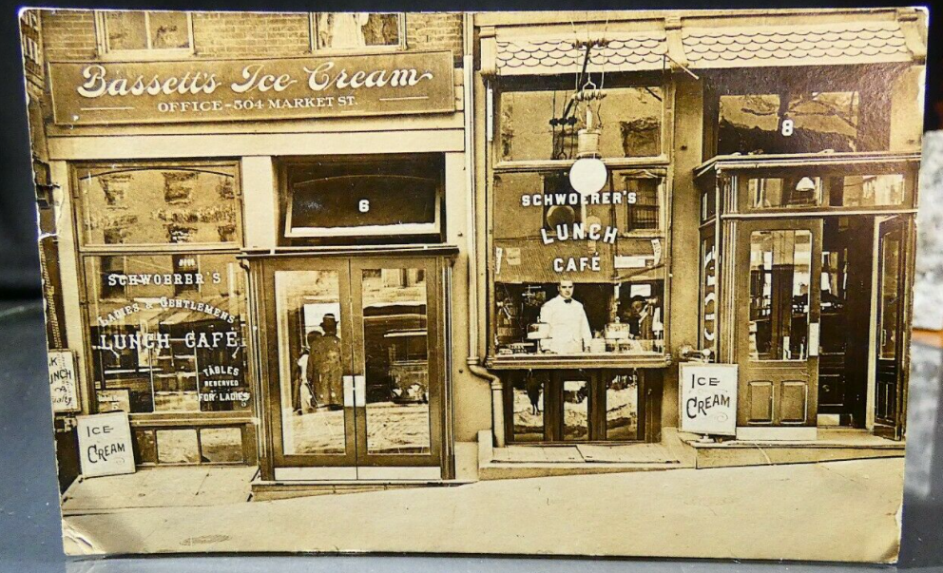

* * * * *

Section 2 - Featured Bassett: Update on the Bassett Family Reunion in Massachusetts, Nov 2019

Bassett400 Celebration & Reunion
With our Bassett400 Registration deadline this week,
We have received several questions regarding COVID concerns.

We will still take registrations from those who postponed registration due to COVID uncertainty!

The good news is, Massachusetts is very near their lowest numbers, and we will follow all their recommendations for safety. By November, we expect very little issue with COVID.

The “official” word from the State of Massachusetts is:

Mask Guidance
Effective May 29, 2021
All industries will be permitted to open. With the exception of remaining face-covering requirements for public and private transportation systems and facilities housing vulnerable populations, all industry restrictions will be lifted, and capacity will increase to 100% for all industries. The gathering limit will be rescinded.
All industries will be encouraged to follow CDC guidance for cleaning and hygiene protocols.

Face Covering Guidance
In line with updated CDC face covering guidance, the Administration will rescind the current face covering order and issue a new face covering advisory effective May 29.
Non-vaccinated individuals are advised to continue wearing face masks and to continue distancing in most settings. The advisory will also recommend fully vaccinated individuals no longer need to wear a face covering or social distance indoors or outdoors except for in certain situations.

Face coverings will still be required for all individuals on public and private transportation (including rideshares, livery, taxi, ferries, MBTA, Commuter Rail and transportation stations), healthcare facilities and providers, congregate care settings and health and rehabilitative day services.
Face coverings will also remain required indoors for staff and students of K-12 schools and early education providers.

The state is not taking a position that COVID vaccines will be required and nor are they planning a state-issued vaccine ‘passport’. That said, businesses can and should speak to their own legal counsel about any wishes to implement their own requirements.

HOTEL1620 Policy is:
Hotel 1620 – COVID Response Banquets and Events
- Sanitation stations in all meeting rooms
- Masks available for attendees
- Meeting rooms sprayed with sanitizer each evening after sessions
- AV Equipment sprayed after each use
- All banquet employees in masks and gloves
- Rooms will be spaced out as much as possible
- Hand sanitizer dispensers located throughout public spaces
Let me know if you have any questions
And let us know if you are planning to register depending on the COVID conditions.

Regards, Walt Bassett
bassett1621@gmail.com

* * * * *

Section 3 - Featured Bassett: Gary Bassett and Sugar Creek Orchard of Allen County, Ohio

Gary Bassett descends from William Bassett of Plymouth as follows:

William Bassett and wife Elizabeth
Nathaniel Bassett (b. 1628) and wife Dorcas Joyce
Samuel Bassett (b. 1670) and wife Elizabeth Jones
Samuel Bassett (b. 1700) and wife Alice Weaver
Samuel Bassett (b. 1736) and wife Tabitha Waite
William Bassett (b. 1765)
Samuel Bassett (b. 1795) and wife Elsie Lewis
Lewis Bassett (b. 1825) and wife Sarah Edgecomb
Philo Horace Bassett (b. 1852) and wife Alice Everett
Howard Everett Bassett (b. 1893) and wife Doris Delphin Giffin
William Howard Bassett
Gary Bassett
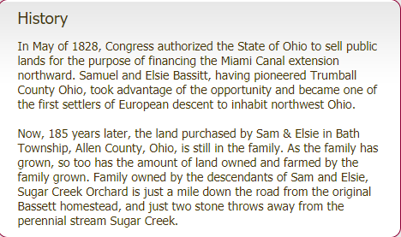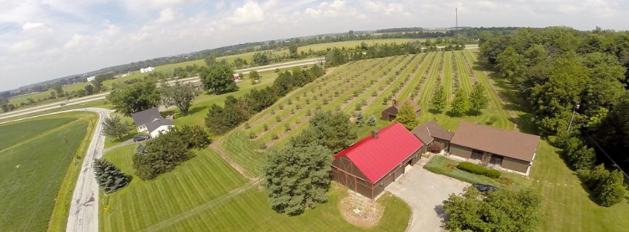

POSTED ON SEPTEMBER 2, 2016

Local man chooses apple orchard over corporate career
BUSINESS, NEWS

Small Business Saturday: Sugar Creek Orchard
By John Bush - jbush@civitasmedia.com

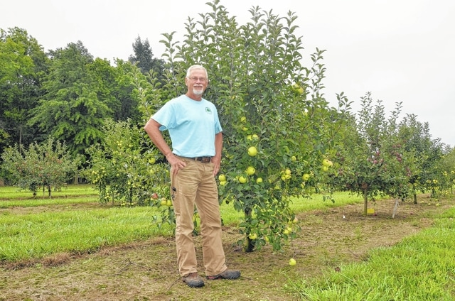
Gary Bassett, owner of Sugar Creek Orchard in Beaverdam, stands near a row of apple trees he planted with his wife. Bassett said they’ve planted nearly 1,000 apple trees in the last five years, and they are now selling them to the public.
BEAVERDAM — An inherent desire to be his own boss and return to the field of agriculture led Gary Bassett to leave the corporate world to develop his own apple orchard.
Sugar Creek Orchard, located at 5395 Sugar Creek Road in Beaverdam, is the result of five years of planning, planting and harvesting, as well as a leap up faith for the former business intelligence software developer.
“I found that I really don’t fit well in the corporate world where I’m not in charge,” said Bassett, owner of Sugar Creek Orchard. “Now that I’m out of the corporate world, I’m all in on this.”
The road to the apple orchard wasn’t easy, however. Up until the fall, Bassett maintained his position as a business intelligence software developer as he was trying to get his business off the ground. He didn’t even start harvesting apples until last year when the trees began to bear fruit.
Even then, Bassett didn’t sell a single apple. Instead, he gave away thousands of pounds of apples to family, friends and members of the community who heard about his endeavor through word of mouth.
“Last year I just wasn’t ready to sell anything,” he said. “I didn’t have business insurance, or a lot of other things you have to have to face the public. I just ended up giving everything away.”
Now, Bassett’s company is fully certified as an LLC, and he has begun selling the apples he’s spent half a decade cultivating. He said he and his wife have planted close to 1,000 apple trees on 10 acres of land.
Bassett, who has a degree in agronomy from The Ohio State University, sells more than 30 varieties of apples, including gala, fuji, honeycrisp, braester and more. He grows the apples in two separate fields on his father’s property in Beaverdam, where he also sells them.
In addition to apples, Bassett sells candles — mostly apple-scented — and plans to start producing apple jam, cider and sauce. Before he ventures out, Bassett wants to establish a strorefront on the property. Currently, he sells his products out of a fruit stand.
In the future, Bassett’s ultimate goal is to develop a “full orchard experience.”
“I’d like to have a place where families can come out and not just buy apples, but also enjoy hayrides through the field, a corn maze and that sort of thing,” he said. “I’d love to have a shop with every conceivable type of apple product.
“I envision a joyful place to visit in the fall that is welcoming and accepting.”
When asked why people should buy his apples instead of from a grocery store, Bassett noted that his products are fresher and are locally grown.
“They’re going to be fresher than any apple you can buy anywhere because our time to market is shorter than anywhere,” he said. “They’re absolutely fresh, and you can definitely tell the difference.”
Reach John Bush at 567-242-0456 or on Twitter @bush_lima

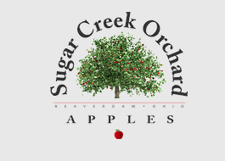
Click on the link below to visit the home page for Sugar Creek Orchard
Apples | OH | Sugar Creek Orchard

* * * * *

Section 4 - Featured Bassett: Death of William F. Bassett of Bonita Springs, Florida

William Francis Bassett descends #14 Jean Besset as follows:

Jean Besset (b. 1642) and wife Anne Seigneur
Francois Besset (b. 1685) and wife Marie Claude Dubois
Francois Bessette (b. 1724) and wife Genevieve Marguerite Gaboriau
Francois Bessette and wife Louise Racine
Jean Baptiste Bessette and wife Emilie Boucher
Joseph Bessett and wife Zoe Benoit
Justilien Bessette (b. 1868) and wife Agnes LcClair
William Moise Bassett (b. 1896) and wife Agnes Winfred Reardon
William Francis Bassett (b. 1916) and wife Brenda Pauline Sullivan
William Francis Bassett, born 1943, died 2021

Russell & Pica Funeral Home
William F. Bassett
January 7, 1943 – August 7, 2021

William F. Bassett of Bonita Springs, Florida, formerly of Brockton, Massachusetts, died on August 7, 2021 at the age of 78 in Naples, Florida after a brief illness.
He was the beloved husband of the late Elizabeth “Betty” (DiNunno) Bassett for 44 years.
Born January 7, 1943 in Brockton, Massachusetts, he was the son of the late W. Francis Bassett and Brenda (Sullivan) Bassett.
Bill was a resident of Bonita Springs, Florida for the past 17 years. He was raised in Brockton and graduated from Brockton High School in 1961. After high school, he enlisted and proudly served his country in the United States Army, where he was stationed at Fort Hood, Texas.
Together with his wife Betty, they proudly owned and operated Leonard’s Restaurant in Brockton for nearly 20 years. During this time, they raised eight children. For many years, Bill was a member of Thorny Lea Golf Club and The Club National. He was also an appointed member of the Massachusetts State Boxing Commission.
While living in Bonita Springs, he was a communicant of St. Leo the Great Catholic Church and while living in Brockton he was a communicant of Our Lady of Lourdes Church.
He was an avid Boston sports fan with a special affinity for the Boston Red Sox. During his time in Florida, he enjoyed cooking, golfing, bocce, fishing and playing cards with his friends. He looked forward to visits from his children and grandchildren where many memories were made. The highlight of his week was spending Friday nights at Steamers Restaurant with his close friends from Florida and Brockton.
He is survived by his children, Brenda Bassett, Jeanne and her husband John Balutis, Carrie and her husband Scott Balutis, William Bassett Jr., Daniel and his wife Janelle Bassett, Lori Bassett, Brian and his wife Tanya Bassett, and Elizabeth Bassett and her fiancé Jeffrey Cronin. He is also survived by his 17 loving grandchildren, Katherine, Christopher, Michael and Kevin Morganti, Abigail, Lily and Ellie Balutis, Chase and Jack Balutis, William and Alyssa Bassett, Tyler and Ashlyn Bassett, Aiden Bassett, Avery and Georgia Bassett, and Kailen Cronin. In addition to his family, he leaves behind many friends and Sally Dmytryck, his loving companion.
Following Cremation, A funeral mass will be celebrated for the repose of his soul in Our Lady of Lourdes Church, 439 West St., Brockton on Monday, August 23rd at 10:00AM. Interment will follow in the Massachusetts National Cemetery, Bourne at 12:30PM. A memorial gathering will be held in the Russell & Pica Funeral Home, 165 Belmont St., Brockton on Sunday, August 22nd from 2:00PM-6:00PM.

* * * * *

Section 5 - Featured Bassett: Bassett Center of El Paso, Texas

Charles Nebeker Bassett descends from William Bassett of Plymouth as follows:

William Bassett and wife Elizabeth
William Bassett (b. 1624) and wife Mary Rainsford
William Bassett (b. 1656) and wife Rachel Williston
William Bassett (b. 1684) and wife Abigail Bourne
William Bassett (b. 1711) and wife Lydia Smith
Stephen Bassett (b. 1743) and wife Thankful Handy
Perez Bassett (b. 1774) and wife Lydia Snow
Abner S. Bassett (b. 1810 and wife Betsey
Oscar Thomas Bassett (b. 1847) and wife Myrtle Alma Nebeker
Charles Nebeker Bassett
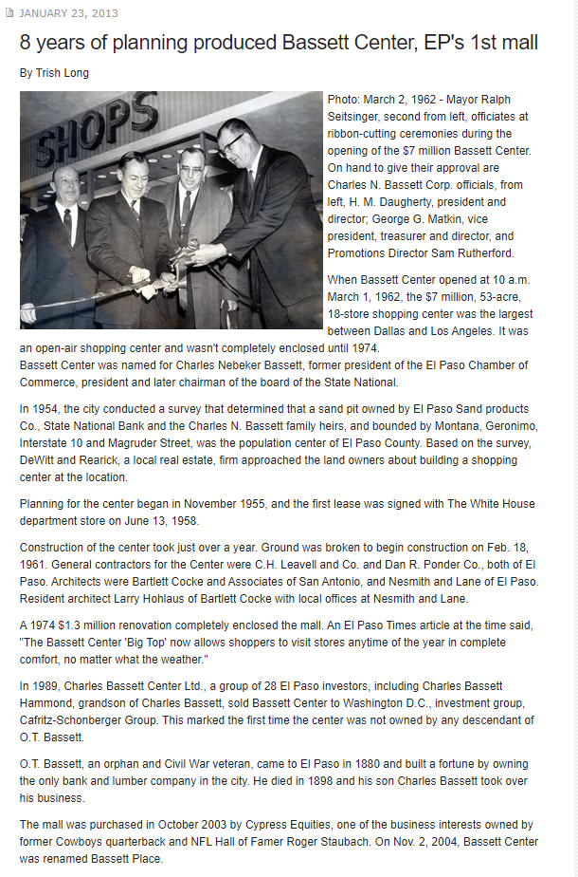

* * * * *

Section 6 - Featured Bassett: Bassett owned Gould Hill Farm & Orchard in New Hampshire

Timothy Albert Bassett descends from William Bassett of Plymouth as follows:

William Bassett and wife Elizabeth
Joseph Bassett (b. 1635) and wife Mary Lapham
William Bassett (b. 1667) and wife Mary Bumpus
Seth Bassett (b. 1705) and wife Mary Hayward
Hayward Bassett (b. 1740) and wife Lois Damon
Seth Bassett (b. 1787) and wife Elizabeth Meacham
John Sutherland Bassett (b. 1817) and wife Rachel Elvira White
Seth Hayward Bassett (b. 1845) and wife Orenda B. Wyman
Talmadge Wyman Bassett (b. 1872) and wife Allura Carrie Bennett
Milton Albert Bassett (b. 1905)
Albert Milton Bassett (b. 1936)
Timothy Albert Bassett

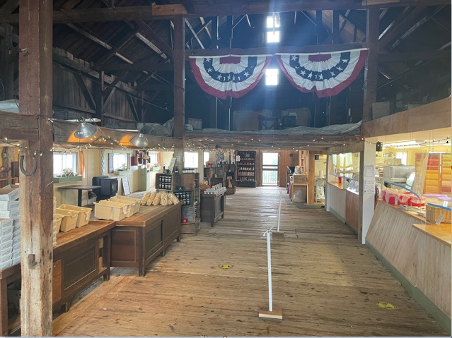
Picture inside the farm store. I visited Gould Hill Farm while on vacation in August.

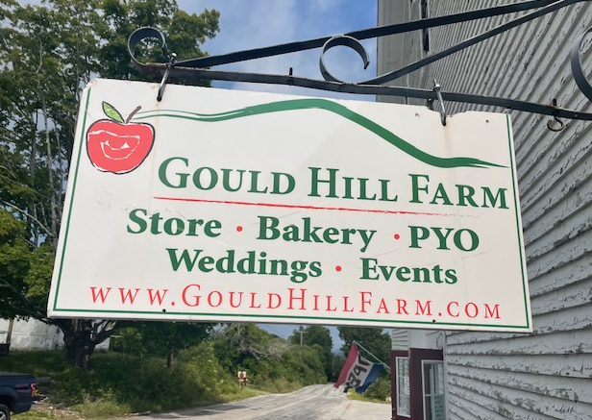
Gould Hill Farm Store & Orchard, Contoocook, New Hampshire, August 2021

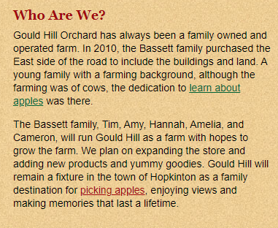

Here is a link to their website.

Welcome to Gould Hill Farm - Apples, donuts, pick-you-own, New Hampshire

* * * * *

Section 7 - Featured Bassett: Death of Larel Lee Bassett of Idaho

Larel Lee Bassett descends from #4B William Bassett of Lynn as follows:

Roger Bassett and wife Ann Holland
William Bassett (b. 1623) and wife Sarah Burt
William Bassett (b. 1647) and wife Sarah Hood
John Bassett (b. 1682) and wife Abigail Berry
Daniel Bassett and wife Lydia Hood
John Bassett (b. 1739) and wife Ruth Newhall
Daniel Bassett (b. 1773) and wife Abigail Bean
Philip C. Bassett (b. 1821) and wife Mary Berry
William D. Bassett (b. 1851) and wife Elizabeth A. Mulherin
Lester Metalis Bassett (b. 1882) and wife Emma Cecelice Hagaman
Elard Raymond Bassett (b. 1911) and wife Mildred Irene Reese
Larel Lee Bassett 1938-2021

Bowman Funeral Directors
Larel Lee Bassett
July 13, 1938 – September 7, 2021

Larel Lee Bassett passed away on September 7, 2021 at the age of 83. Larel was born on July 13, 1938 in Livingston, Montana to Elard and Mildred Bassett. He graduated from Gallatin County High School in Bozeman, Montana and immediately joined the United States Navy in 1956. Larel was very proud of his naval service where he served on the USS Sperry, and learned the refrigeration and HVAC mechanic’s trade that would make him successful the rest of his working life.
Larel married Ruth Van Aalsburg in December of 1960 in Bellflower, California. Larel and Ruth had two sons (Jeff in 1961 and Randy in 1962). They moved from California to Boise in 1970.
Larel finished his career as an HVAC Mechanic with Boise State University. He made many friends while working at the University, and was proud to be part of the Bronco family. Prior to that, he spent many years with the Idaho Plumbers and Pipefitters Union, and worked on many large construction projects including the Brownlee and Cascade Dams, and the Alaska Pipeline. Larel was a good neighbor and friend, and was happy to use his skills to help those he cared about when they needed him.
Larel loved Idaho, and enjoyed spending time in the mountains and hills, exploring and pursuing his hobby and passion of prospecting for gems and precious metals. Larel was well known in the Idaho prospecting community, and developed lifelong friends who loved Idaho as much as he did.
Larel was a devoted husband to Ruth, a proud father to Jeff and Randy, a very proud grandfather to Caroline (Randy), Amanda (Jeff), and Kristine (Jeff), and finally, a very, very proud great-grandfather to Ruby Warren (Caroline). Larel was preceded in death by his parents (1991 and 1992) and his two brothers, Ronnie (1961) and Reese (2016).

* * * * *

Section 8 - New family lines combined or added since the last newsletter

No lines added or combined since the last newsletter.

* * * * *

Section 9 - DNA project update.

No new results to report on the Bassett DNA project.
Donations of any amount can be made to the Bassett DNA project by clicking on the link below. Any funds donated will be used to fund select Bassett DNA tests that will further our project as a whole and benefit all Bassetts worldwide.

http://www.familytreedna.com/group-general-fund-contribution.aspx?g=Bassett
This is just a reminder that the DNA portion of the Bassett Family Association can be found at:

A current spreadsheet of results can be found at:
http://www.bassettbranches.org/dna/BassettDNA.xls
If you don't have Excel and can't open the spreadsheet above, you can now see the DNA test results at the following website.
http://www.familytreedna.com/public/Bassett/
Jeffrey Bassett
520 Salceda Drive
Mundelein, IL 60060 USA
bassettgenealogy@gmail.com

