Bassett Family Newsletter, Volume XVII, Issue 11, 17 Nov 2019

(1) Welcome
(2) 1627 Map of Duxbury, Massachusetts, home of William Bassett of Plymouth
(3) Gravestone for Vernon Arthur Julius Bassett of South Africa
(4) Death of Roosevelt Bassett, Philadelphia Artist
(5) Sale ads for Bassett Jewelry of Wahpeton, North Dakota
(6) J. B. Bassett Tugboat of Minnesota
(7) Death of Kimbrough Stone Bassett
(8) New family lines combined or added since the last newsletter
(9) DNA project update

Section 1 - Welcome

For anyone that has been thinking about taking the Y-37 DNA test, now is a good time to sign up. Family Tree DNA is offering the test through Thanksgiving weekend for just $99. I even have scholarship money for two tests if you are a male Bassett from a line that has not yet tested and can’t afford to take the test on your own.

Totals number of individuals loaded into the Bassett website: 168,114

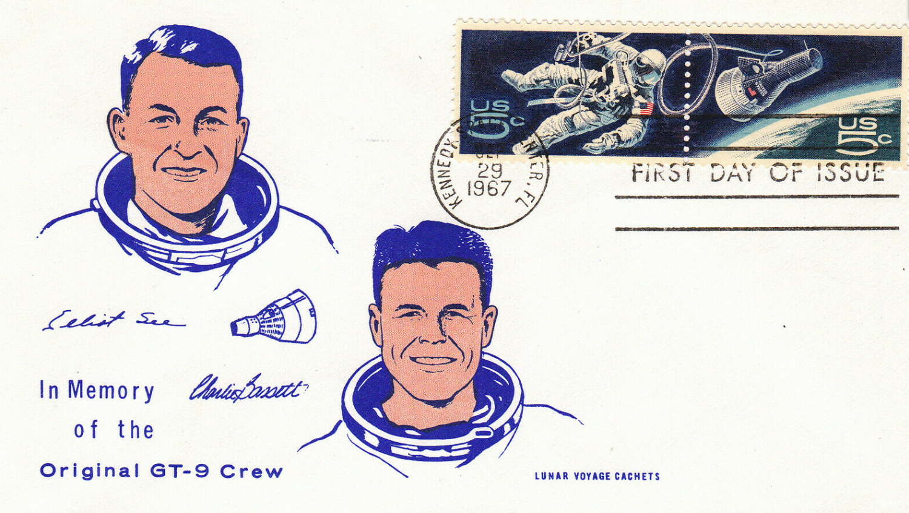

* * * * *

Section 2 – Featured Bassett: Land Owned by Immigrant William Bassett in 1627

For those who are descended from William Bassett of Plymouth, Massachusetts, you may find the following map interesting. On the left is a map showing land owned in 1627 in Duxbury, Massachusetts. On the right you can see the same area from Google Maps today.

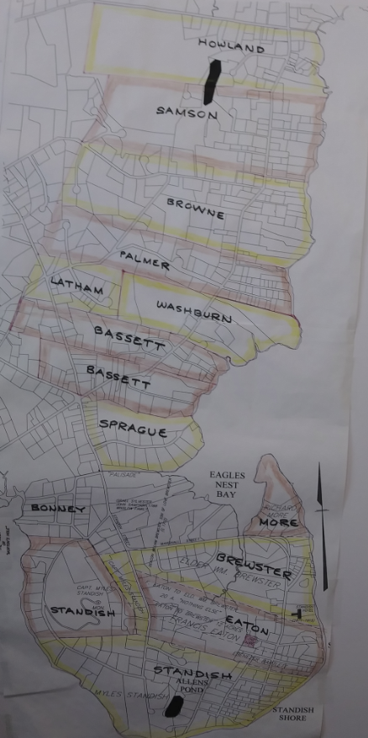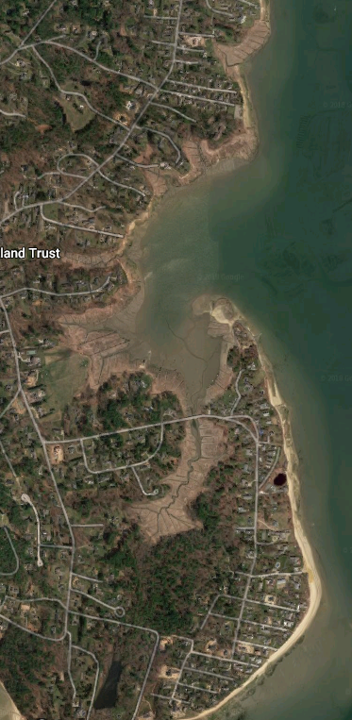

1627 Map of Duxbury, Massachusetts Google Maps view of the same area today.

* * * * *

Section 3 – Featured Bassett: Gravestone of Vernon Arthur Julius Bassett of South Africa

Vernon Arthur Julius Bassett descends from #486B Henry Bassett of South Africa as follows:

Henry Bassett (b. 1830) and wife Mary Ann Nash
Alfred William Bassett (b. 1868) and wife Christina Maria Dorothea Meyers
Alfred Raleigh Bassett (b. 1893) and wife Alice Maud Mudge
Vernon Arthur Julius Bassett and wife Beatrice Hendrina Basson

Note the use of the Afrikaans language on the tombstone. As far as we know, this is a line of Bassetts from England.

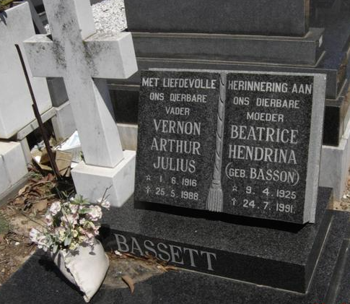
Durbanville Main Cemetery, Western Cape, South Africa

* * * * *

Section 4 – Featured Bassett: Death of Roosevelt Bassett, artist

Other than the names of his parents, no other information is known yet about Roosevelt and his line.

Allendale Community Funeral Home
Roosevelt Bassett (Picture included)
Passed October 12, 2019

Funeral services for Mr. Roosevelt Bassett, 79, of 149 Texas Street Allendale, SC will be held 11:00 am Friday, October 18, 2019 at Doe Pond Missionary Baptist Church in Martin, SC., with Reverend Donald Goode officiating. Burial will follow in the church cemetery.
In 1940 Franklin D. Roosevelt was president. Forty hour wages went into effect. That was good news to everyone. But the greatest news was unfolding in Martin, South Carolina, in Allendale County. Eli and Bertha Bassett became the proud parents of a baby boy; they named him Roosevelt Bassett.
Seeking God’s direction and guidance, at an early age, he joined and was baptized at the Doe Pond Missionary Baptist Church in Martin, SC where he served as an usher until he left South Carolina in 1961.
Roosevelt graduated from Allendale Training School in 1961. He knew there was a better life for him other than picking cotton, so he moved to Philadelphia, Pennsylvania. God blessed him to get a good job at Orrefors Crystal Company in Mt. Laurel, New Jersey.
Roosevelt supported his mother and two younger sisters, Josephine and Nora back home. In 1974, Roosevelt opened an antique business in Englishtown, New Jersey. He did very well in this business, which he kept, until he moved back to South Carolina in May 2019.
He liked working with his hands. Many people knew him for his artistic skills. His main artistic skill was with wood. He had the ability to make picture frames, purses, birdhouses and other items, which was on display at the Philadelphia International Airport.
He received many gifts throughout his journey in life. On Saturday, October 12, 2019 at 7:14 p.m. at Allendale County Hospital in Fairfax, SC, Roosevelt received the greatest gift of all, eternal life as promised to him by God.
His parents, four brothers and three nieces: Lawrence, Charlie, William, Alfred, Zandra Salters, Unisha Jefferson and Gloria Cohen, all preceded him in death.

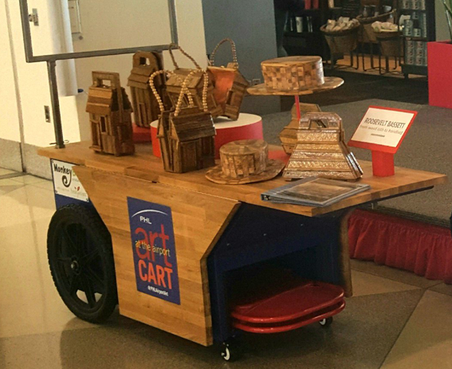
Roosevelt Bassett art on display at the Philadelphia Airport

He leaves to cherish his memories: three sisters: Lillie Mae Gill of Irmo, SC, Josephine Cohen and Nora Bassett both of Allendale, SC; nieces: two of which he helped raise: Sherri (Cryus) Jackson of Williamsport, PA and Katrina (Don) Carter of Bethesda, MD, Yvonne (Glenn) Williams, LaDon (Ernest) Rivers of Walterboro, SC and Michele (Cecil) Major of Irmo, SC; nephews: One of which he helped raise: Charlie Bassett Jr. and Shannon Mckeiver both of Philadelphia, PA, Lawrence Bassett of Walterboro, SC, Dennis (Sharon) Bassett of Spartanburg, SC, Michial Gill of Baltimore, MD and Bernard Doe of Barnwell, SC; two sisters-in-law: Evelyn Bookhart of Philadelphia, PA and Hettie Bassett of Allendale, SC; a special grandniece, Iris (Brian) Finley of Summerville, SC and grand nephew, Alton Bassett Cohen; and a host of other relatives and sympathizing friends among them all are: Rick (Eydie) Mehr, Clearance Cambell, Harold Davis, Ellen Harrison and Mae Lanier all of Philadelphia, PA, Albert Allen and Beverly Loadholt both of Allendale, SC. Visitation will be held on Thursday, October 17, 2019 from 5-7 p.m. at the funeral home.
Friends may call at the residence of his sisters, Josephine Cohen and Nora Bassett at 149 Texas Street Allendale, SC.
Online condolences may be sent to allendalecommunityfuneralhome.com.

* * * * *

Section 5 – Featured Bassett: Sale Ads for Bassett Jewelry of Wahpeton, North Dakota

Elmer Ellsworth Bassett descends from William Bassett of Plymouth as follows:

William Bassett and wife Elizabeth
William Bassett (b. 1624) and wife Mary Raynesford
Nathan Bassett (b. 1667) and wife Mary Huckens
Samuel Bassett (b. 1693) and wife Martha Pease
Cornelius Bassett (b. 1722) and wife Lydia Norton
Ebenezer Bassett (b. 1751) and wife Abigail Adams
Francis Bassett (b. 1793) and wife Mary Cushing
Stephen James Bassett (b. 1822) and wife Victoria Reed
Elmer Ellsworth Bassett (b. 1865) and wife Annie Teressa Morden
Raymond Bassett

To read a previous article on this family, click on the link below.

http://www.bassettbranches.org/newsblog/jeweler-elmer-ellsworth-bassett-and-son-raymond-bassett-of-wahpeton-nd/

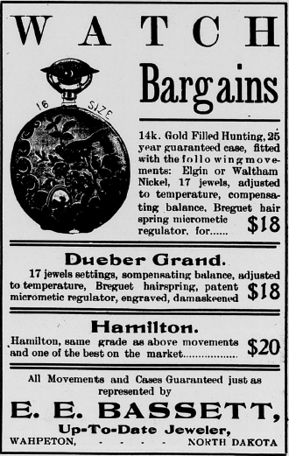
The Wahpeton Times, December 5, 1907
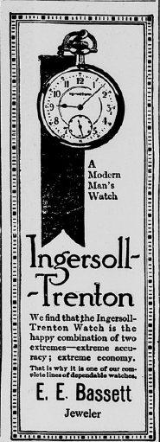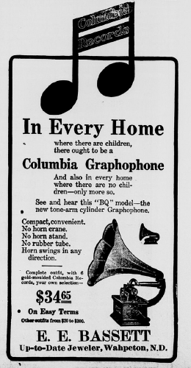
The Wahpeton Times The Wahpeton Times
December 21, 1911 January 6, 1911

* * * * *

Section 6 – Featured Bassett: J.B. Bassett Tugboat of Minnesota

Joel Bean Bassett, descends from #4B Roger Bassett as follows:

Roger Bassett and wife Ann Holland
William Bassett (b. 1624) and wife Sarah Burt
William Bassett (b. 1647) and wife Sarah Hood
John Bassett (b. 1682) and wife Abigail Berry
Daniel Bassett (b. 1716) and wife Lydia Hood
John Bassett (b. 1739) and wife Ruth Newhall
Daniel Bassett (b. 1773) and wife Abigail Bean
Joel Bean Bassett (b. 1817) and wife Aurelia Bernard Carpenter

To read an earlier article about Joel Bean Bassett, click on the link below.

http://www.bassettbranches.org/newsblog/joel-bean-bassett-lumberman-of-minnesota/

From Images of America – Around Clearwater, we have the following:

Joel Bean Bassett, who owned the J.B. Bassett Lumber Company, designed and built the J.B. Bassett in 1894. This paddle-wheeled operation followed log drives from St. Cloud to Anoka, stopping in Clearwater coming and going.
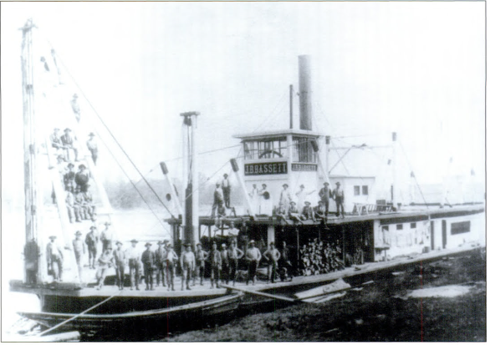
Picture courtesy of Images of America – Elk River

* * * * *

Section 7 – Featured Bassett: Death of Kimbrough Stone Bassett

Kimbrough Stone Bassett descends from William Bassett of Plymouth as follows:

William Bassett and wife Elizabeth
William Bassett (b. 1624) and wife Mary Raynesford
Nathan Bassett (b. 1667) and wife Mary Huckens
John Bassett (b. 1706) and wife Jane Mayhew
Joseph Bassett (b. 1743) and wife Mary Mayhew Tilton
William Bassett (b. 1801) and wife Martha Smith
William Jackson Bassett (b. 1834) and wife Rosa Musgrove
Albert Edward Bassett (b. 1887) and wife Elizabeth Louise Stone
Kimbrough Stone Bassett (b. 1931)

The Daily Breeze, October 19, 2012
Kimbrough Stone Bassett (Picture included)
January 19, 1931 – October 7, 2019

Kimbrough Stone Bassett of Riverside and Palos Verdes Estates, CA passed away on Monday, October 7, 2019 at the age of 88, following complications from an ischemic stroke. A private ceremony will be held by the family to honor his memory and legacy. Kimbrough Bassett was born on January 19, 1931 in Evanston, Illinois to Albert Bassett and Betty Lou Stone. He attended St. Alban's School in Washington D.C. and graduated from the U.S. Naval Academy at Annapolis MD in 1953. Although sailing would remain a lifelong passion, his ambition to be a pilot led him to join the Air Force and report to Denver, Colorado as one of the first Air Training Officers instructing cadets at the newly-formed U.S. Air Force Academy. He and his fellow ATO's were later made honorary members of the USAFA's first graduating class of 1959. While helping to launch the Air Force Academy, he fell in love with another staff member, Carole Gilchrist. They were married in Denver, Colorado on May 21, 1956, and remained so for 56 years until her passing in September 2012. After the Air Force, Mr. Bassett worked in the nascent computer industry, traveling across the country computerizing Procter & Gamble operations before settling in California with his young family. His work at the Pacific Coast Stock Exchange pioneered the first computerized reconciliations of stock trading. He later joined an investment firm in Southern California until his retirement in 2003. Throughout life, Mr. Bassett remained a loving father and devoted husband, making time for family sailing trips to Catalina Island off the Los Angeles coast, and traveling the world with his wife Carole. His love of the ocean persisted -- he took up kayaking after retirement, and contributed to The Nature Conservancy's coastal conservation efforts. He and Carole were avid tennis players, and upon her passing he supported the U.S. Air Force Academy Women's Tennis Award in her memory. He also established a memorial award for Bataan survivor Col. Jay Harrelson, whose widow Kit Harrelson remained a dear companion throughout Mr. Bassett's later life. Kimbrough Bassett is survived by his two daughters, Leslie Ann Bassett and Diane Moran Bassett; his son, Kimbrough Stone Bassett Jr., granddaughters, Nadia Jean Bassett and Miranda Stone Sterling-Bassett, and sister Susan Finnegan.

* * * * *

Section 8 - New family lines combined or added since the last newsletter

No new lines added or combined since the last newsletter.

* * * * *

Section 9 - DNA project update.

No new results to report on the Bassett DNA project.
Donations of any amount can be made to the Bassett DNA project by clicking on the link below. Any funds donated will be used to fund select Bassett DNA tests that will further our project as a whole and benefit all Bassetts worldwide.

http://www.familytreedna.com/group-general-fund-contribution.aspx?g=Bassett
This is just a reminder that the DNA portion of the Bassett Family Association can be found at:

A current spreadsheet of results can be found at:
http://www.bassettbranches.org/dna/BassettDNA.xls
If you don't have Excel and can't open the spreadsheet above, you can now see the DNA test results at the following website.
http://www.familytreedna.com/public/Bassett/
Jeffrey Bassett
520 Salceda Drive
Mundelein, IL 60060 USA
bassettgenealogy@gmail.com

