Bassett Family Newsletter, Volume XVII, Issue 3, 17 Mar 2019

(1) Welcome
(2) Annie J. Bassett Pension Relief Document
(3) Bassett’s In The American Revolution
(4) Charles Wallace Bassett of Chicago, Illinois
(5) Harry Hood Bassett, Florida Banker
(6) Florence Knoll Bassett Obituary
(7) Marjorie Bassett Postcard from Cape Cod, Massachusetts
(8) New family lines combined or added since the last newsletter
(9) DNA project update

Section 1 - Welcome

No new trees were added this month.

Totals number of individuals loaded into the Bassett website: 153,237

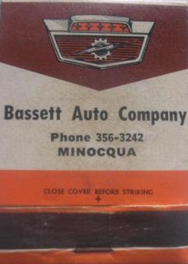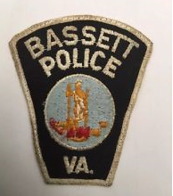

* * * * *

Section 2 – Featured Bassett: Annie J. Bassett Pension Relief

Wesley Wheeller Bassett descends from #1B John Bassett of Connecticut as follows:

John Bassett and wife Margery
Robert Bassett
Robert Bassett (b. 1640) and wife Elizabeth Riggs
Jonadab Bassett (b. 1695) and wife Mary Phippeny
Benjamin Bassett (b. 1725 ) and wife Deborah Edwards
John Bassett (b. 1755) and wife Hepsibeth Buckingham
Augur Bassett (b. 1788) and wife Olive Wheeler
Wesley Wheeler Bassett (b. 1819) and wife Annie J. Smallwood

The following item is currently for sale on ebay. It deals with payments for Annie J. Bassett, widow of Wesley W. Bassett.

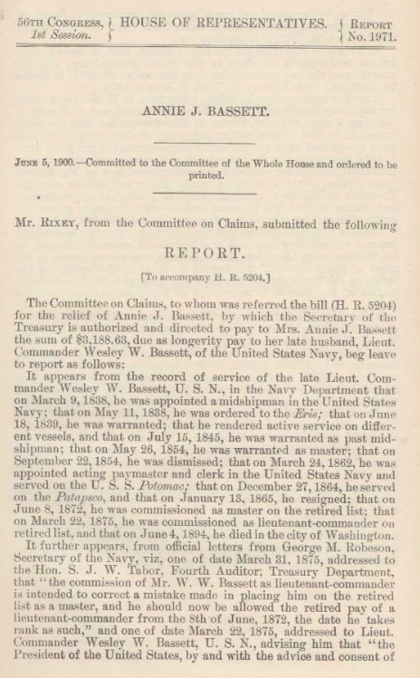

* * * * *
Section 3 – Featured Bassett: Bassett’s in the American Revolution

The following article was provided by Sandy Zodrow.

BASSETT’S IN THE AMERICAN REVOLUTION

There are many ways to approach genealogy. One lady I know keeps track of all the men and women who have served in the American military in her records. I thought it might be interesting to see which Bassett’s served in the Continental Army. I used the Daughter’s of the American Revolution website which lists male Bassett’s with “approved” service. If you can prove descent from any of these men you would be eligible to join either the DAR or the Son’s of the American Revolution. Please remember that there were also many Bassett women who married men who may have served. This is how I found my “own” three revolutionary war soldiers. https://www.dar.org/national-society/genealogy

1A William Bassett of Plymouth
Benjamin Bassett of Martha’s Vineyard, Massachusetts, born August 1, 1752
Cornelius Bassett of Chilmark, Massachusetts, born about 1722
Cornelius Bassett of Sandwich, Massachusetts, born June 24, 1754
Cornelius Bassett of East Hampton, New York, born 1754 or 1755
Daniel Bassett of Yarmouth, Massachusetts, born August 7, 1736
David Bassett of Chatham, Massachusetts, born June 10, 1749
Ebenezer Bassett of Martha’s Vineyard, Massachusetts, born about 1751 or 1752
Elisha Bassett of Massachusetts, born February 15, 1714
Elisha Bassett of Sandwich, Massachusetts, born February 11, 1760 or 1761
Isaac Bassett of Norton, Massachusetts, born December 18, 1755
Jedediah Bassett of Norton, Massachusetts, born December 28, 1751
Jeremiah Bassett of Taunton, Massachusetts, born February 9, 1750 or 1751
John Bassett of Chilmark, Massachusetts, born September 1, 1752 or 1753
John Bassett of Sandwich, Massachusetts, born April 11, 1716
Joseph Bassett of Bridgewater, Massachusetts, born February 3, 1731
Joseph Bassett of Norton, Massachusetts, born March 6, 1725 or 1726
Joseph Bassett of Bridgewater, Massachusetts, born October 26, 1747 or 1748
Joseph Bassett of Barnstable, Massachusetts, born April 21, 1763
Joseph Bassett of Hingham, Massachusetts, born October, 1747
Joseph Bassett of Chilmark, Massachusetts, born April 26, 1743
Joseph Bassett of Taunton, Massachusetts, born 1759 or 1760
Joshua Bassett of Quaker Hill, New York, born January 22, 1757 (also listed on the Valley Forge Muster Roll)
Jotham Bassett of Norton, Massachusetts, born April 29, 1738
Lot Bassett of Barnstable, Massachusetts, born January 22, 1754 or 1755
Nathan Bassett of Guildford, Connecticut, born December 11, 1751 (also listed on the Valley Forge Muster Roll)
Nathan Bassett of Bridgewater, Massachusetts, born August 12, 1763
Nathan Bassett of Barnstable, Massachusetts, born about 1713, died December 2, 1800
Nathan Bassett of Barnstable, Massachusetts, born December 30, 1750
Nathan Bassett of Barnstable, Massachusetts, about 1715, died 1791
Nathan Bassett of Chilmark, Massachusetts, born August 15, 1751
Nathaniel Bassett of Chatham, Massachusetts, born March 20, 1754 or 1755
Nathaniel Bassett of Barnstable, Massachusetts, born October 15, 1719
Nathaniel Bassett of Barnstable, Massachusetts, born December 6, 1758
Nehemiah Bassett of Barnstable, Massachusetts, born September 12, 1743
Richard Bassett of Chatham, Massachusetts, born March 25, 1747, 1748 or 1749
Rufus Bassett of Rochester, Massachusetts, born April 6, 1757
Samuel Bassett of Barnstable, Massachusetts, born March 10, 1745 or 1746
Samuel Bassett of Norton, Massachusetts, born March 1, 1753 or 1754
Samuel Bassett of Kent County, Rhode Island, born about 1740
Thomas Bassett of Rochester, Massachusetts, born June 19, 1759
William Bassett of Chilmark, Massachusetts, born December 17, 1702

Barachiah Bassett of Chilmark, Massachusetts, born about 1732 is not listed on the DAR website, but has military service in the Revolutionary War. He is listed on the Valley Forge Muster Roll with the 14th Massachusetts.

1B John Bassett of Connecticut
Abraham Bassett Sr. of Derby, Connecticut, born February 27, 1725
Abraham Bassett Jr. of Derby, Connecticut, son of Abraham Sr.
Benjamin Bassett of Derby, Connecticut, born November 20, 1740
David Bassett of Derby, Connecticut, born November 14, 1749
John Bassett of Derby, Connecticut, born February 15, 1721
John Bassett of Derby, Connecticut, born June 11, 1758
Samuel Bassett of Derby, Connecticut, born November 29, 1719

3B Thomas Bassett of Connecticut
David Bassett of New Haven, Connecticut, born about 1754
Isaac Bassett of New Haven, Connecticut, born May 16, 1760 (also listed on the Valley Forge Muster Roll)

4B William Bassett of Lynn, Massachusetts
Elisha Bassett of Salem County, New Jersey, born December 15, 1722
Lemuel Bassett of Connecticut, died 1820 in Florida, Massachusetts

5B William Bassett of Virginia
Burwell Bassett of New Kent, Virginia, born March 3, 1734

James Bassett of Virginia is not listed on the DAR website, but is listed on the Valley Forge Muster Roll with the 6th and 10th Virginia.

Nathaniel Bassett of Virginia is not listed on the DAR website, but is listed on the Valley Forge Muster Roll with the 4th Virginia.

6B William Bassett of Connecticut
Abel Bassett of New Haven, Connecticut, born February 29, 1759
Abraham Bassett of New Haven, Connecticut, born August 12, 1733
Amos Bassett of New Haven, Connecticut, born February 13, 1757
William Bassett of New Haven, Connecticut, born October 10, 1743 (also listed on the Valley Forge Muster Roll

7B William Bassett of Cross Plains, Indiana
William Bassett, born 1755 in England, enlisted in Virginia, died in 1840 in Indiana

8B John Bassett of Hunterdon County, New Jersey
Jeremiah Bassett of New Jersey, born about 1759

13B Richard William Bassett of Georgia
Richard Bassett of Georgia, died in 1840 Harris County, Georgia

19B Michael Bassett of New York
Michael Bassett of Albany, New York, born October 25, 1741

93B Bassett’s of Worcester, Maryland
John Bassett of Maryland, born about 1740, died 1789
William Bassett of Maryland, died 1832 in Worcester, Maryland

* * * * *

Section 4 – Featured Bassett: Charles Wallace Bassett of Chicago, Illinois

Charles Wallace Bassett descends from William Bassett of Plymouth as follows:

William Bassett and wife Elizabeth
William Bassett (b. 1624) and wife Mary Raynesford
Nathan Bassett (b. 1677) and wife Mary Huckens
William Bassett (b. 1702) and wife Ann Mayhew
Nathan Bassett (b. 1751) and wife Martha Bassett
Nathan Bassett (b. 1785) and wife Rhoda Merry
Isaac Chauncey Bassett (b. 1815) and wife Lucinda Boutwell
Charles Wallace Bassett (b 1844)

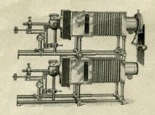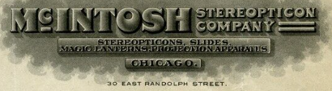

The American School Board Journal, January 1906
Leading In Its Line
The McIntosh Stereopticon Company and Its Manager

The stereopticon lantern has become an indispensable factor in the education effort of the country. Its utility is generally recognized and no first-class college or high school is without certain projective apparatus. The lecturer on popular subjects not only adds interest to his subject but enlivens it to the highest degree by the use of lanterns.
The wonderful perfection which has been attained in stereopticons or projective apparatus is due more largely to the enterprise of the manufacturer than to any improvements suggested by scientists. The possibilities were recognized by the manufacturer, and through him the knowledge of the scientist was brought into play.
There are those among the manufacturers in this line that cannot be ignored in any discussion of the subject. Notably among then, C.W. Bassett of Chicago, one of the pioneers in this industry, who must be mentioned for the part he has taken in its development.
As manager and manufacturer he has a long career of useful service behind him. The McIntosh Stereopticon Co., of which he is the directing head, and has been for many years, has seen the growth and development of an industry which furnished valuable accessories to the pursuit of educational effort. With one exception, the McIntosh Company is the oldest lantern house in the country. It furnishes stereopticons not only to the leading lecturers in this country, but abroad as well. When Dwight I. Elmendorf, the famous lecturer, was in Chicago recently, he ordered a complete lantern outfit from the McIntosh concern for his European trip. Foreign orders recently included some from India.
Mr. Bassett’s personal history has some interesting phases. At the age of seventeen he became a soldier in the war of the Rebellion on the Union side. After gallant service he entered upon a mercantile career and soon drifted into the sale and manufacture of surgical instruments. From this he became connected with the old established McIntosh Battery and Optical Company.
With this company he has pursued his labors to this date. He became the president of the company and directed its affairs until it developed into the present company, which makes an exclusive feature of stereopticons and projection apparatus.
The years of patient application and industry which he has given to the work can better be appreciated by those who know the man and his qualities of head and heart, than can be told in a brief and cursory sketch.
The writer knew Mr. Bassett when he was a sturdy, Handsome, blond-haired gentleman, with a military bearing. Today he is a stately man, whose beard is tinged with gray, and whose features have assumed a determined air, but who is withal a genial entertainer and whole-souled companion.

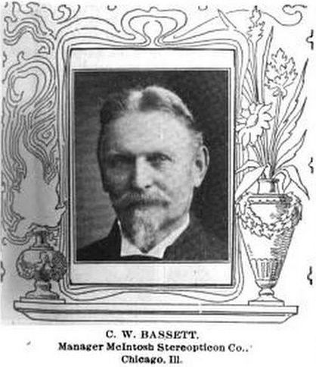

* * * * *

Section 5 – Featured Bassett: Harry Hood Bassett

Harry Hood Bassett descends from William Bassett of Plymouth as follows:

William Bassett and wife Elizabeth
Nathaniel Bassett (b. 1628) and wife Dorcas Joyce
Samuel Bassett (b. 1670) and wife Elizabeth Jones
Samuel Bassett (b. 1700) and wife Alice Weaver
William Bassett (b. 1731) and wife Mary Closson
William Bassett (b. 1753) and wife Avis Burdick
Lewis Bassett (b. 1776) and wife Dorcas Hoxie
Peleg Hoxie Bassett (b. 1800) and wife Cornelia Clarke
William Lewis Bassett (b. 1834) and wife Mary Tammeson Babcock
Harry Hoxie Bassett (b. 1875) and wife Jessie M. Hood
Harry Hood Bassett (b. 1917)

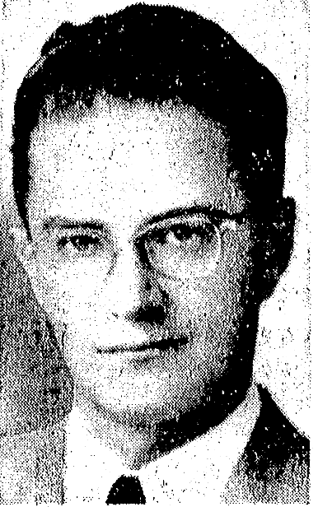

Chicago Tribune, June 28, 1946
The many who knew Harry Hood Bassett when he lived in Chicago and who are winter time neighbors in Palm Beach, Fla., of his mother, Mrs. Edward F. Swenson, will be interested to hear that he is to marry a French woman. His engagement to Marguerite Marie Petitjean was announced recently by her parents, Mr. and Mrs. Georges Alfred Petitjean of Strasburg, France. Mr. Bassett, son of the late Harry H. Bassett, is a lieutenant in the army air forces. The wedding is expected to take place immediately in Paris, where he and his bride will live until they come to the United States at the end of August. Lt. Bassett was graduated from Yale in 1940. His fiancée – who might be his bride by now, as the wedding was planned for the end of June – was active with the French resistance forces having been released last May as a captain in the paratroops.
FLORIDA Historic - Dramatic - Contemporary
Family and Personal History (Volume IV)
Lewis Historical Publishing Company, Inc.

Harry Hood Bassett - With banking on the East Coast of Florida, Harry Hood Bassett has been identified since his graduation from Yale University in 1940, with the very large exception of years out for military service of his country, and civilian aviation patrol activities. As vice president and a director of the First National Bank of Miami, and an official of other financial institutions in the area, he plays an important part in the business world of the city. Of wide personal interests he has entered many phases south Florida life and is exceptionally well known in community activities.
Harry Hood Bassett was born at Flint, Michigan, on May 6, 1917, son of Harry Hoxie and Jessie (Hood) Bassett. His father, who died on October 25, 1926, in Paris, France, was the first vice president of General Motors Company, and president of the Buick Motor Division of this vast corporation. After attending the public schools of Flint and Jackson, Michigan, and a private school in Palm Beach, Florida, the son prepared for higher education in the noted Hotchkiss School at Lakeville, Connecticut, where he was graduated in 1936. Matriculating at Yale University, New Haven, Connecticut, four years later he received his degree of Bachelor of Science in Industrial Administration from its Sheffield Scientific School.
Beginning his business career after leaving Yale, Mr. Bassett in 1940 became assistant trust officer and director of the First National Bank of Palm Beach, Florida. Becoming interested in the Civil Air Patrol of World War II, and organization that did such splendid work with inadequate equipment, he devoted his best attention to this endeavor until he entered the United States Army Air Corps. Before being separated from the Armed Forces in 1946, he had spent some fifteen months overseas in Europe, Africa and the Middle East, with the rank of first lieutenant. Earlier he had been associated with the anti-submarine patrol off the Florida Coast, for which he received the Air Medal. He had enlisted in the United States Air Corps Reserve on September 15, 1942.
Upon his return to civilian life, Mr. Bassett was for some time trust officer and a director of the First National Bank of Palm Beach. In April, 1947, he came to Miami with the First National Bank of this city, being named assistant vice president in June of that year. Since July, 1948, he has been vice president of this substantial financial institution. He likewise is vice president and a director of the Coral Gables First National Bank; remains a director of the First National Bank of Palm Beach, and serves on the boards of directors of the Little River Bank and Trust Company, and the First National Bank of Fort Lauderdale.
In civic, club and social affairs, Mr. Bassett is especially prominent. He serves on the board of trustees of the University of Miami; the board of directors of the Community Chest of Dade County, is an associate member of the Orange Bowl Committee, a member of the Inter-American Cultural and Trade Center Committee, and is a Rotarian. His clubs include the Bath Club of Miami Beach, the Indian Creek Country Club, the LaGorce Country Club, the Key Largo Anglers Club, Cat Key Club of Cat Cay, in the British West Indies, and the Yale Club and the Madison Square Garden Club of New York City. He attends All Souls Episcopal Church.
In July 1, 1946, in Paris, France, Harry Hood Bassett married Marguerite Petitjean, daughter of Georges and Marie Emily (Biersohn) Petitjean. Mr. and Mrs. Bassett are the parents of three children: 1. Harry Hood Jr., born June 27, 1948. 2. and 3. George Rodney and Patrick Glenn, twins, born June 2, 1950.
The Miami Herald, Florida, 5 Aug 1999
Marguerite Petitjean Bassett, 78

Marguerite Petitjean Bassett lived an extraordinary life - devoted mother, society hostess and the first woman to parachute into enemy territory in France during World War II. Bassett, 78, died Sunday.
"She was an extremely kind and loving woman," said her daughter-in-law, Melissa Bassett. "But at the same time, she was very stern. You really saw the soldier in her." Bassett, born in Strasbourg, France, in 1921, was trained as a nurse during her teenage years. She volunteered as a Red Cross ambulance driver in 1939. But a single act of cruelty propelled her to become a World War II soldier. Bassett witnesses a Nazi officer shoot a little girl who lived in her town. The incident inspired her to join the French Resistance.
Bassett joined the Free French Forces and went to England, where she received special training by the Royal Air Force. She learned how to parachute and perform dangerous acts of sabotage. When she returned to France, she made her first jump near Lyons and eventually completed 17 missions. Bassett's assignments supported military actions to disable enemy bridges and power stations. She suffered multiple injuries, including a fractured skull and spine, and her life was often in grave danger. During one sabotage mission, she was captured by two enemy soldiers, her family said. Bassett waited until they fell asleep and then tied them up while holding her .32-caliber gun, which she nicknamed Josephine and kept throughout her life.
Bassett's missions were so successful that the Germans placed a 10-million-franc ($500,000) price on her head. Known by the code name Binette, she attained the rank of captain and was awarded the Legion of Honor, the highest military decoration in France. She was also a five-time recipient of the Croix de Guerre, a French award for bravery.
When World War II ended in 1945, Bassett cast of her military fashions and immersed herself in the elegant fashions and milieu of high society. At the Cathedral of Notre Dame in Paris, she married American Harry Hood Bassett, whom she had met during the war. They moved to Palm Beach and then to Miami. Harry Hood Bassett became well known in South Florida banking, rising to chairman of Southeast Banking Corp.
Yellowed newspaper clippings show that Marguerite Bassett cut a striking figure in Miami during the 1950s. "Stunning was Mrs. Harry Hood Bassett, co-chairman of the grand ball, wearing a white silk brocaded sheath with a cascade ow white tulle," reported one Miami Herald column that spotlighted her social standing. "It's just incredible how she went from her life as a war hero to become part of the social world," Melissa Bassett said.
After her divorce in 1955, Marguerite Bassett focused her attention on raising three young sons - Harry Hood Jr., Patrick Glenn and George Rodney. "She was always there for the good times and bad times throughout our lives," her son George recalled. "She was always a supporter, and there was a complete sense of trust between her and the three of us." In 1959, Allen Dulles, then director of the CIA, honored her and other World War II heroes at a reception at his home.

Bassett participated in many charitable events and belonged to a variety of civic organizations. "She was also passionate about the issue of desegregation," Melissa Bassett said. "She invited black performers to her home at a time when it wasn't acceptable."
In addition to her three sons, Bassett is survived by eight grandchildren.
A Mass is scheduled for 11 a.m. today at the Church of the Epiphany, 8235 SW 57th Ave.

* * * * *

Section 6 – Featured Bassett: Florence Knoll Bassett Obituary

Florence was the 2nd wife of Harry Hood Bassett featured in the article above.

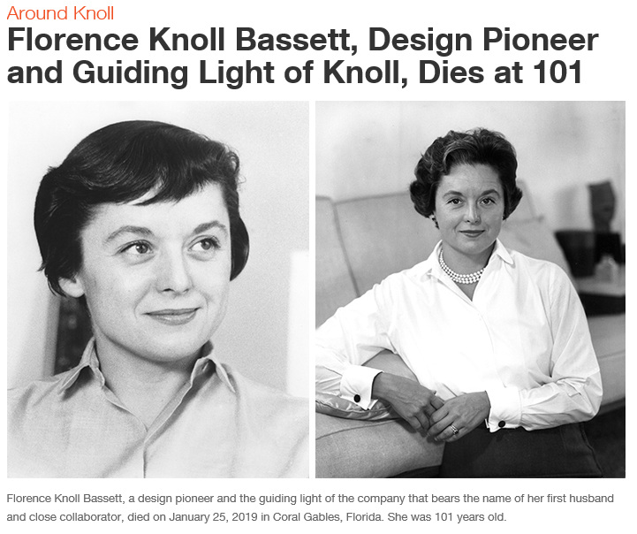
The above pictures are from the Knoll Company website.

Remembering Designer and Entrepreneur Florence Knoll Bassett
The woman who shaped the very concept of modern
American design has died at age 101
By Heather Corcoran
January 28, 2019

Pioneering architect, designer, and businesswoman Florence Knoll Bassett, who died this past Friday at age 101 in Florida, is best remembered for defining the modern office, but changing the way we work represents only a fraction of her wide-ranging contributions to design. Through her own furniture creations, including the oval-topped desk table and streamlined sofa she created for Knoll, the now-iconic work she commissioned from the likes of Marcel Breuer, Isamu Noguchi, and Harry Bertoia as partner and creative force behind Knoll Associates, and her groundbreaking approach of “total design,” Knoll Bassett basically wrote the book on interior design, as one longtime friend recalls.

Florence Knoll Bassett was never one to promote herself—I think it was her Midwestern upbringing,” says Paul Makovsky, a close friend and the editor in chief of Contract Magazine, a New York–based publication for architects and interior designers. “As a pioneer of interior and furniture design and a successful entrepreneur, she is one of the most influential architects and designers of postwar America, and her mark on Modern design transcends any one of these fields,” says Makovsky, who sparked a friendship with Knoll Bassett in 2001 after a rare interview with the designer (who had been largely absent from the public eye since her retirement in 1965), and who is now writing a biography of her life and work. “She created the modern profession of interior design in America, so much so that when Encyclopedia Britannica had an entry on Interior Decoration in the 1964 edition, Florence Knoll Bassett wrote the entry, which was essentially an essay on her design philosophy and approach.”

While Knoll Bassett’s accomplishments were recognized during her life, she also worked hard to transcend the boundaries placed upon interior design at the time, especially as a woman in the field. “I am not a decorator,” she famously told The New York Times in 1964, “the only place I decorate is my own house.” The same article, which speculated Knoll Bassett was at the time “surely the most successful woman architect anywhere,” asserted the true secret behind her success was even more innate than her impressive résumé: “her unerring taste.”

Florence Knoll Bassett was born Florence Schust (the origin of her nickname, “Shu”) in Michigan in 1917. With an early aptitude for design, she attended the Cranbrook Academy of Art, where she was mentored by early modernist Eliel Saarinen—father of Eero Saarinen, who would later create the Womb chair for Knoll under Knoll Bassett’s direction. She went on to study at Columbia University's School of Architecture in 1935 before apprenticing for Bauhaus architects Walter Gropius and Marcel Breuer and studying under Ludwig Mies van der Rohe at the Armor Institute (later the Illinois Institute of Technology) in Chicago. During World War II, she began to work for German furniture manufacturer Hans Knoll, whom she later married, embarking on a creative and business journey that would last even after his death in 1955, until her retirement in 1965.

Along the way, Knoll Bassett designed such landmark projects as the Seagram Building interiors and CBS headquarters with the Knoll Planning Unit, innovating the “paste-up” technique and utilizing her signature “total design” philosophy, an approach that considered everything from the floor plan to furniture to wall covering, fixtures, and, of course, textiles—after all, she founded KnollTextiles in 1947. Throughout her life, Knoll Bassett was honored for her contributions to architecture and design, including the 1961 AIA Gold Medal for Industrial Design, the first ever awarded to a woman, and the National Medal of the Arts in architecture in 2002. Though, perhaps, she’ll best be remembered through the lives she touched as a leader in design.

“Over the years, ‘Shu’ would call me unexpectedly and comment on our showrooms and products,” Knoll CEO Andrew Cogan recalled in an address to the company’s associates, using Knoll Bassett’s lifelong nickname. “She reminded me of the time she spent with associates on the factory floor and ideas they had about ways to do things better. She humored me with advice on building our brand and creating new products. Florence Knoll’s commitment to design and communication with clients, teaching them along the way, inspires us today.”

For many, Knoll Bassett’s legacy remains felt in the open offices and sleek furniture that her work inspired. Above all, she’ll be best remembered through the Knoll mission, to be modern, always.

* * * * *

Section 7 – Featured Bassett: Marjorie Bassett Post Card, Cape Cod Massachusetts

Can anyone identify this Marjorie Bassett? She is possibly the Marjorie, daughter of Charles Rodney Bassett, born about 1905.

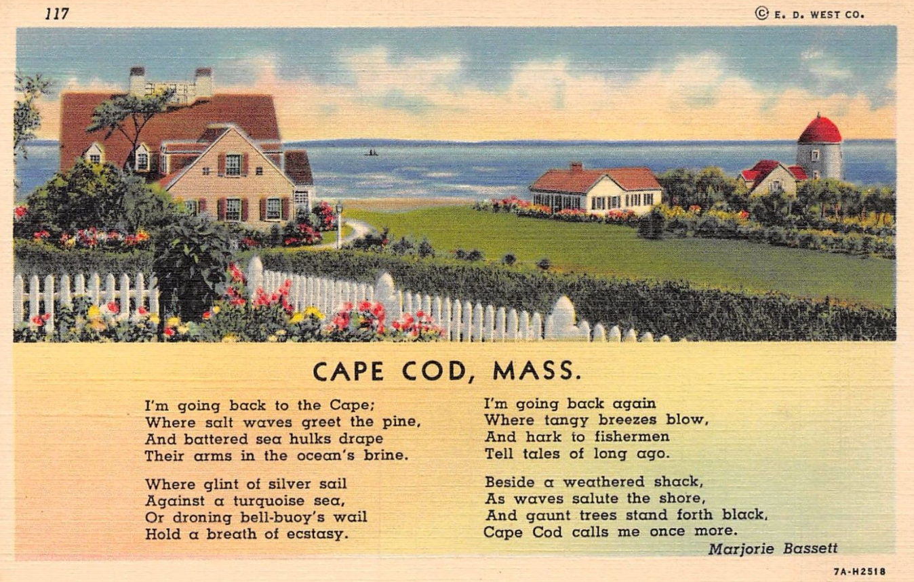

* * * * *

Section 8 - New family lines combined or added since the last newsletter

No new family lines have been added or combined since last month.

* * * * *

Section 9 - DNA project update.

No new results to report on the Bassett DNA project.
Donations of any amount can be made to the Bassett DNA project by clicking on the link below. Any funds donated will be used to fund select Bassett DNA tests that will further our project as a whole and benefit all Bassetts worldwide.

http://www.familytreedna.com/group-general-fund-contribution.aspx?g=Bassett
This is just a reminder that the DNA portion of the Bassett Family Association can be found at:

A current spreadsheet of results can be found at:
http://www.bassettbranches.org/dna/BassettDNA.xls
If you don't have Excel and can't open the spreadsheet above, you can now see the DNA test results at the following website.
http://www.familytreedna.com/public/Bassett/
Jeffrey Bassett
520 Salceda Drive
Mundelein, IL 60060 USA
bassettgenealogy@gmail.com

