Bassett Family Newsletter, Volume XVII, Issue 1, 20 Jan 2019

(1) Welcome
(2) William Bassett family Bible of Cross Plains, Indiana
(3) Death of Eugene Timothy Bassett, Basketball Player
(4) Autobiography of Rollin Bassett of Massachusetts
(5) Picture of Beaupre Castle in Wales
(6) Mary Ann Virginia McPherson Family Photograph
(7) Death of Lieutenant Geoffrey Edward Bassett of England, 1918
(8) New family lines combined or added since the last newsletter
(9) DNA project update

Section 1 - Welcome

My wife and I are once again hosting a high school student through AFS Intercultural Programs beginning in August of 2019. We are hosting a young lady from Switzerland for the school year. If you are interested in hosting a high school student or know of a family that might be interested you can send me a message and I can help get you touch with the proper local staff to help you out.

The following trees were added to the Bassett website database since the last newsletter:

258B. Charles Bassett of Gloucestershire, England (29 individuals added)
550B. William Bassett of Bristol, England (28 individuals added)
551B. Alanson D. Bassett of New York (43 individuals added)
552B. Augustus Bassett of Massachusetts (22 individuals added)

Totals number of individuals loaded into the Bassett website: 151,035

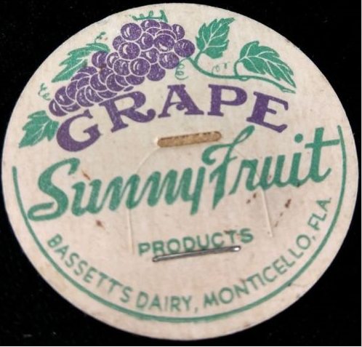

* * * * *

Section 2 – Featured Bassett: William Bassett Family Bible

Pictures of the family bible of William Bassett of Cross Plains, Indiana were shared by descendant Ronald “Smokey” Bassett.

7B. William Bassett, son of Michel Bassett

William Bassett, son of Michel Bassett, was born 18 Apr 1755 in Limpsfield, Surrey County, England. He died 6 Feb 1840 in Cross Plains, Ripley County, Indiana. He married Margaret "Peggy" McQuiddy, daughter of David and Mary (Todd) McQuiddy, on 27 Nov 1786 in Mercer County, Kentucky. She was born in 1768 in Spotsylvania, Virginia. She died 26 Sep 1844 in Cross Plains, Ripley County, Indiana.
William was a Revolutionary War Soldier, serving from 1776 to 1779 and was wounded in 1778 at "Baylor's Massacre" in Old Tappan, New Jersey. He enlisted in the month of August 1776 under Gen. Pulaski, Col. George Bailor, Maj. Clough, and Lieut. Custis. He left the service in the month of May 1779, after serving faithfully for two years and nine months for which service he got a pension. At the time he entered the service he resided in Bottetourt County, Virginia and continued to reside there until his services were rendered. He was in the Battle of Monmouth Courthouse and also in the Massacres at Tanporo. He was captured at Tanporo, but made his escape after being bayonetted in the back.

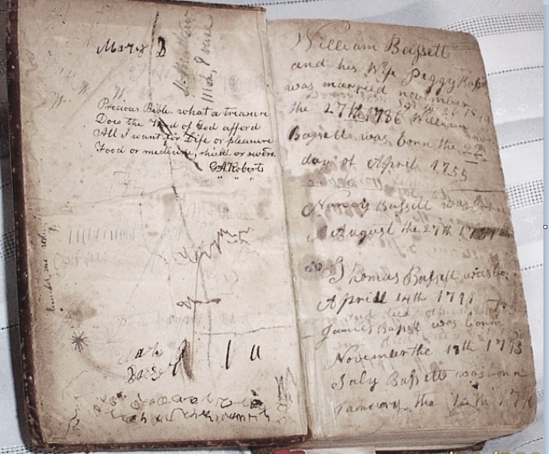
William Bassett Family Bible

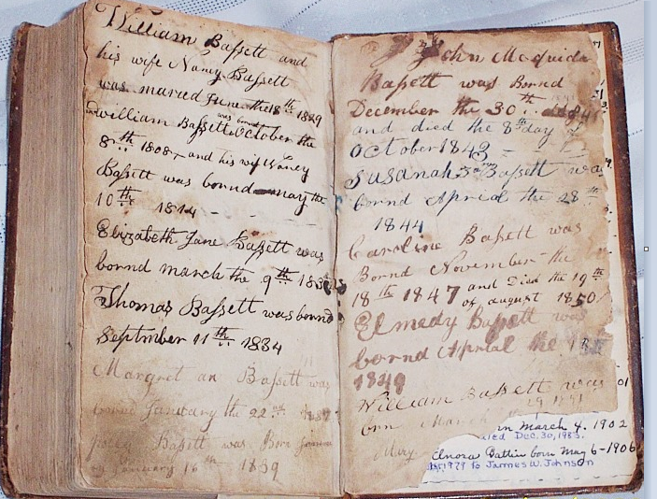
William Bassett Family Bible

* * * * *

Section 3 – Featured Bassett: Death of Eugene Timothy Bassett, Former Basketball Player

Tim Bassett descends from #178B. James Theodore Bassett of Virginia as follows

James Theodore Bassett (b. 1909) and wife Emma Jane
Sylvia A. Bassett (b. 1935)
Eugene Timothy Bassett (b. 1951):

Brooklyn Nets: Former Net Tim Bassett passes at 67
by Phil Watson Follow @PhilWatsonFS

Tim Bassett, a role playing power forward who spent parts of five seasons with the Brooklyn Nets organization in the 1970s, has died at the age of 67.
Tim Bassett, a power forward for the New York Nets and New Jersey Nets — forerunners to the present-day Brooklyn Nets that bridged the franchise’s ABA and NBA years — has passed away at the age of 67.

Bassett played for the New York Nets in their final ABA season, 1975-76, and for three full seasons and part of another with the Nets on both Long Island and in New Jersey from 1976-79.

He was a physical role player and a presence on the inside at 6-foot-8 and 225 pounds — bulky for that era — and played three seasons in the ABA and four in the NBA before spending his final two professional seasons in Italy.
Bassett’s family confirmed his death on Bassett’s Facebook page.

Bassett was a key reserve for the Nets’ 1976 ABA title team and averaged 5.8 points and 5.7 rebounds in 25 minutes per game in the 1976 ABA Finals victory over the favored Denver Nuggets, including going for 12 boards in 23 minutes in a key Game 3 victory at Nassau Coliseum.

Bassett came to the Nets in September 1975 as part of a restructuring by the Nets, who had won a franchise-record 58 games in 1974-75 before being stunned in the first round of the playoffs by the youthful Spirits of St. Louis in five games.

The team traded center Billy Paultz and All-Star power forward Larry Kenon to the San Antonio Spurs and flipped one of the players acquired in those deals, guard Bob Warren, to the San Diego Sails to get Bassett, who played his first two ABA seasons with San Diego.

After averaging 4.8 points and 6.3 rebounds in 21.3 minutes per game during the regular season for New York, Bassett played a bigger role in the playoffs, averaging 24.0 minutes with 6.3 points and 7.2 rebounds a night.

He had his best statistical season in the Nets’ first NBA campaign in 1976-77, moving into a starting role and averaging 9.0 points, 8.4 rebounds and 1.3 steals in 32.1 minutes per game.

Never a great shooter, Bassett shot 39.9 percent overall and 59.3 percent from the foul line during his five seasons with the Nets, who released him in December 1979.

He caught up briefly with the Spurs in march 1980 and came off the bench for them in five late-season games and three playoff games before heading to Varese in the Italian LBA for two seasons.

Bassett was a native of Washington, born in the District of Columbia on April 1, 1951, and graduated from McKinley High School in D.C. before playing two seasons at the College of Southern Idaho – a junior college – before transferring to the University of Georgia.

At Georgia from 1971-73, he was one of the first blacks to play in the Southeastern Conference.

He was selected by the Buffalo Braves in the seventh round of th3e 1973 NBA Draft, but opted to sign with the San Diego Conquistadors in the ABA, who had tabbed him in the second round of the league’s supplemental draft.

As a rookie, he played under coach Wilt Chamberlain in San Diego – a one-year experiment that resulted in assistant coach Stan Albeck doing the bulk of the coaching – and played two years with the Conquistadors, who were renamed the Sails before the 1975-76 season and folded after just 11 games.

Bassett later ran The Back Room in Manhattan and was profiled in a 2009 New York Times piece about his career and post-basketball life, which included volunteering with a project called Heroes & Cool Kids that partners with schools in the New Jersey-New York metro area.

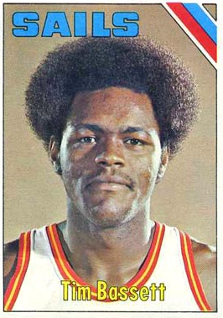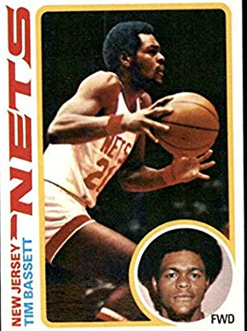

* * * * *

Section 4 – Featured Bassett: Autobiography of Rollin Bassett of Massachusetts

Rollin Bassett descends from William Bassett of Plymouth as follows:

William Bassett and wife Elizabeth
William Bassett (b. 1624) and wife Mary Ryanesford
William Bassett (b. 1656) and wife Rachel Willison
William Bassett (b. 1680) and wife Abigail Bourne
Elisha Bassett (b. 1714) and wife Ruhamma Jennings
Lot Bassett (b. 1755) and wife Deborah Howes
Thomas Bassett (b. 178) and wife Fanny Sears
William Bassett (b. 1822) and wife Antonette A. Joy
Rollin Bassett (b. 1855)

Extracted from:
“The Story of My Life: or Forty Busy Years”
By Ithiel T. Johnson, Evangelist
Published by Free Press Printing Company
Burlington, VT 1912
Prepared by Sandra Murphy Conley, Rollin’s great-granddaughter through Samuel Dwight and Marjorie Louise.

Rollin Bassett
1855-1921
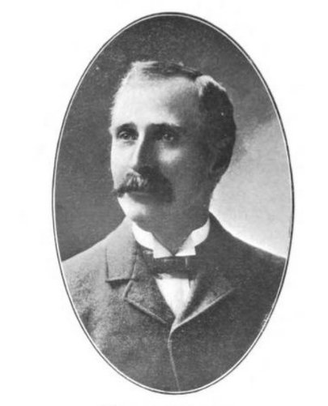
Autobiographical Sketch
I was born in the little hill town of Heath, western part of Franklin County, Mass., son of William and Antoinette Joy Bassett. I was one of six children, two brothers having died, just a week apart, of diphtheria in 1862. My mother was from early life a thoroughly Christian woman, and my father, though not a professing Christian, was quite regular in attendance at church, so that my home influences were for good, and early in life I learned to attend church, and was also fond of the Sunday School. Later having developed something of a talent for music I began singing tenor in the choir or at times played the church organ, which position I held for some four years. But for all this and notwithstanding I was considered a fairly average moral young man, there was constantly a feeling that I was not yet right in the sight of God.
Late in November, 1874, Rev. W.E. Dwight, pastor of our M.E. church, engaged the services of Bro. I.T. Johnson, and he appeared, as I remember, the first time, in our church Sunday morning, Nov. 15th, preaching from the text found in John II, 28: “The Master is come and is calling for thee.” This was when I was past nineteen years old. It was a powerful sermon, and somehow it seemed as though every word of it was fired at me, but still I yielded not to the Master’s call, but had become interested and during the week attended some of the evening services, conviction getting a deeper hold all the while. The following Sunday found me in my accustomed place with the choir. Bro. Johnson took for his text the last clause of Mark II: 22: “Have faith in God.” This was the accepted time with me. I yielded to the Spirit’s call and with many others, went forward for prayers, found the blessed Savoir ready to receive me, and how He filled my heart and soul with joy and happiness. I wanted to go right out and bring in others. Not many days after my father and many others, very dear to me, were numbered with those who had sought and found the Savior. I think there were over thirty converted during the two weeks or so that Bro. Johnson was with us; and as far as I am able to know, I believe the most of them have become active in Christian work.
My mother died in 1896, my father in 1901, both happy in the Christian faith.
In 1879 I was married in East Charlemont to Miss Emma L. Howard, by her pastor, the late Rev. C.L. Guild. My wife was a devoted Christian girl and a member of the Congregationalist Church, of that place.
I had taken possession of the “Old Homestead” the previous April, my parents having moved to the centre of the town, and after our marriage we immediately took up the work that they had laid down and for nearly nineteen years we worked together cleaning up the debt on our farm, and making improvements which we might enjoy in later life. My wife took her letter from her home church to our M.E. church, which I had joined some five years earlier. Together we erected our family altar, reading God’s Holy Word, and together offering our prayer to Him, who had so greatly blessed our lives. Seven dear children were born to us here in the old home.
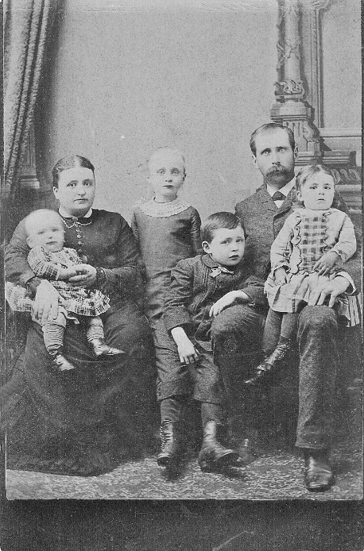
Emma, Maude, Rollin,
William Ralph, Bertha

In 1898 we moved away from the old home to a new house in Greenfield Meadows, where two more children came to bless our happy home.
Sorrows come sooner or later to all, and in December 1901, our baby, of only two months, a bright little girl, whom we had learned to love, was taken from us to the home above. In July, 1908, our eldest son, a fine, manly fellow of twenty-seven years, who had been for five years a postal clerk in Springfield postoffice, was accidentally drowned in the Agawam River, near that city. The telegram came like a bolt out of a clear sky to his parents and the whole family.
In April, 1909, the farm was left in charge of the oldest son then living, who had been married the previous December, and we moved into town, where we hoped to take life a little easier, my wife and I having worked hard for thirty years, and perhaps the sorrows of recent years telling on our lives.
On Oct. 6 the same year, only six months after our occupying our new home, came the heaviest blow, and the deepest sorrow of all, for the dear wife and mother was suddenly taken, after only one hour of suffering and sickness, to her Heavenly home and I was left so lonely, and not alone, for God was with me, and the seven dear children to comfort and help me bear this, the greatest sorrow of my life. I am glad also to say that my children are all members of our church, and I trust are trying to live the blessed life which their dear mother and myself have tried to present before them. Some blessed day I expect to meet all these dear ones and an innumerable company, including our dear Bro. Johnson, who has been so faithful and instrumental in bringing so many into the fold.
May God’s richest blessing rest upon all who may read this and may we all meet in His Kingdom.
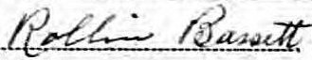
* * * * *

Section 5 – Featured Bassett: Pictures of Beaupre Castle in Wales

Most of the Bassetts of Wales can trace their ancestry back to the Bassett family of Beaupre Castle either via a paper trail or via DNA testing.
I have featured Beaupre several times in the past, but wanted to share a few picture from my recent to trip to Wales. If you belong to this line of Bassetts, I would suggest making this trip to see this wonderful ruins sometime during your lifetime.

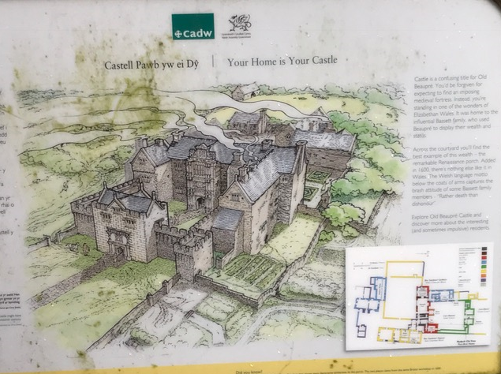
Drawing showing what Beaupre looked like back in its heyday.

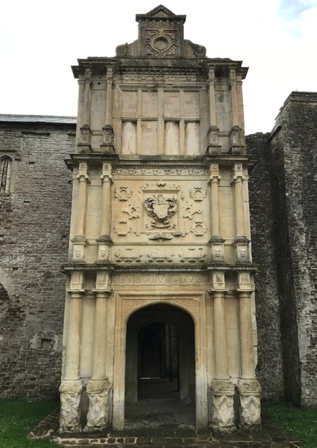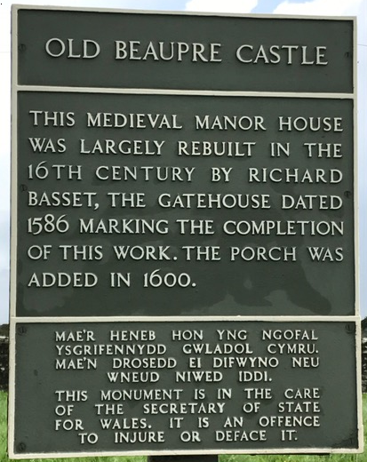
The Basset “Porch” with Basset Family Crest

* * * * *

Section 6 – Featured Bassett: Family Picture of Mary Virginia (Bassett) MacPherson

Mary Virginia (Bassett) MacPherson descends from #59B Benjamin Carter Bassett as follows:

Benjamin Carter Bassett and wife Martha Davis
William Bassett (b. 1796) and wife Eleanor O’Neill
Mary Virginia Bassett (b. 1825) and husband Samuel Chapman MacPherson

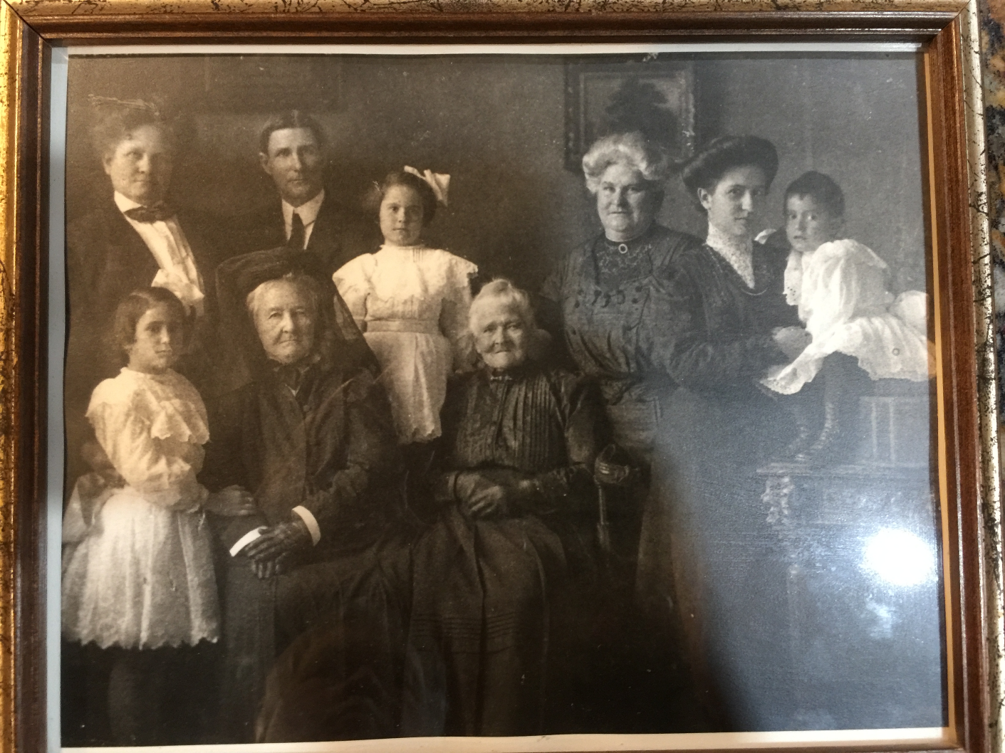
Picture courtesy of Bill Orr
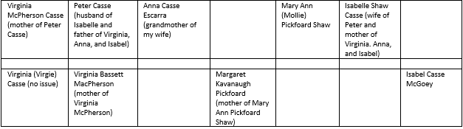
* * * * *

Section 7 – Featured Bassett: Death of Geoffrey Edward Bassett, 1918

Geoffrey Edward Bassett descends from #18B Daniel Bassett as follows:

Daniel Bassett and wife Mary
Peter Bassett (b. 1745) and wife Ann Dollin
John Dollin Bassett (b. 1786) and wife Mary Theobold
Alfred Bassett (b. 1819) and wife Louise Hanmer
John Dollin Bassett (b. 1864) and wife Victoria Edith Rowland
Geoffrey Edward Bassett (b. 1894, died 1918)

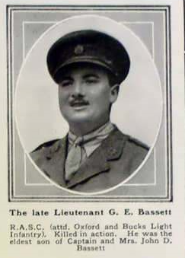

* * * * *

* * * * *

Section 8 - New family lines combined or added since the last newsletter

The following family lines have been added since the last newsletter.

551B. Alanson Delos Bassett of Chenango County, New York
552B. Augustus Bassett of Boston, Massachusetts

* * * * *

Section 9 - DNA project update.

No new results to report on the Bassett DNA project.
Donations of any amount can be made to the Bassett DNA project by clicking on the link below. Any funds donated will be used to fund select Bassett DNA tests that will further our project as a whole and benefit all Bassetts worldwide.

http://www.familytreedna.com/group-general-fund-contribution.aspx?g=Bassett
This is just a reminder that the DNA portion of the Bassett Family Association can be found at:

A current spreadsheet of results can be found at:
http://www.bassettbranches.org/dna/BassettDNA.xls
If you don't have Excel and can't open the spreadsheet above, you can now see the DNA test results at the following website.
http://www.familytreedna.com/public/Bassett/
Jeffrey Bassett
520 Salceda Drive
Mundelein, IL 60060 USA
bassettgenealogy@gmail.com

