Bassett Family Newsletter, Volume XVI, Issue 10, 21 Oct 2018

(1) Welcome

(2) Governor Richard Bassett of Delaware Check from 1802

(3) Seth Bassett Ink Well from 1758

(4) Cyrus William Bassett Obituary

(5) Photograph of G.W. Bassett of Clover Lea, Virginia

(6) Artist Vera Bassett of Wales

(7) William Bassett of Blore

(8) New family lines combined or added since the last newsletter

(9) DNA project update

Section 1 - Welcome

No new trees were added.

I had a great time in England and Wales. I will be sharing some stories and pictures of my trip over the next several newsletters.

Totals number of individuals loaded into the Bassett website: 150,566



* * * * *

Section 2 – Featured Bassett: Governor Richard Bassett of Delaware Check

Richard descends from 32B Arnold Bassett as follows:

Arnold Bassett and wife Judith Thompson

Richard Bassett (b. 1745)

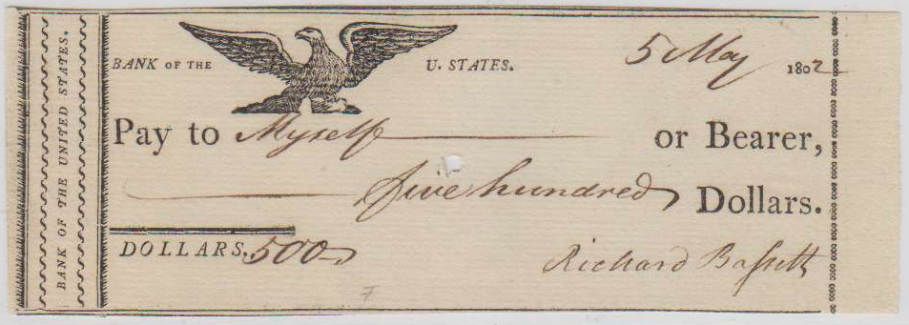

This is currently for sale on e-bay.

* * * * *

Section 3 – Featured Bassett: Seth Bassett Ink Well from 1758

Seth Bassett descends from William Bassett of Plymouth as follows:

William Bassett and wife Elizabeth

Joseph Bassett (b. 1635 and wife Mary Lapham

William Bassett (b. 1667) and wife Mary Bumpus

Seth Bassett (b. 1715) and wife Mary Hayward

Seth Bassett (b. 1739)

You may remember earlier in the year when I shared a photograph of a Revolutionary War powderhorn that belonged to Seth Bass.

<http://www.bassettbranches.org/newsblog/seth-bassett-revolutionary-war-powder-horn/>

The family has now shared pictures of the Seth Bassett Ink Well dated 1758.

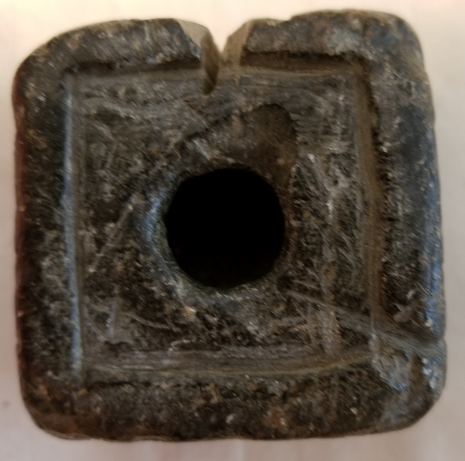

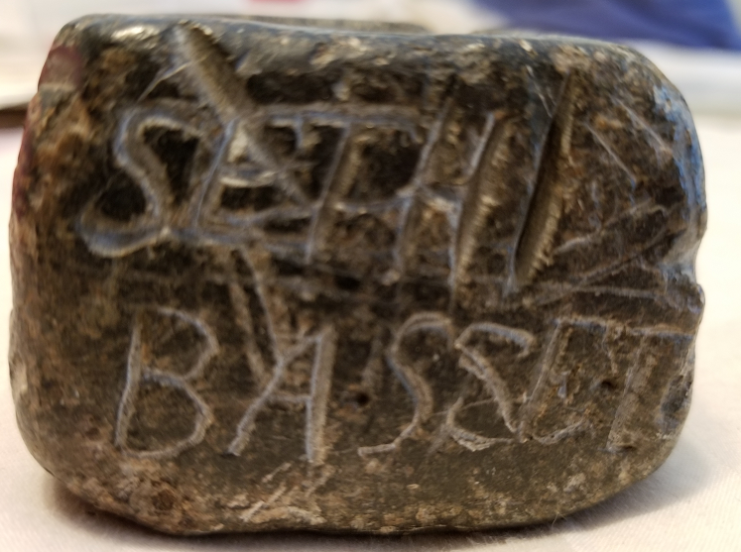 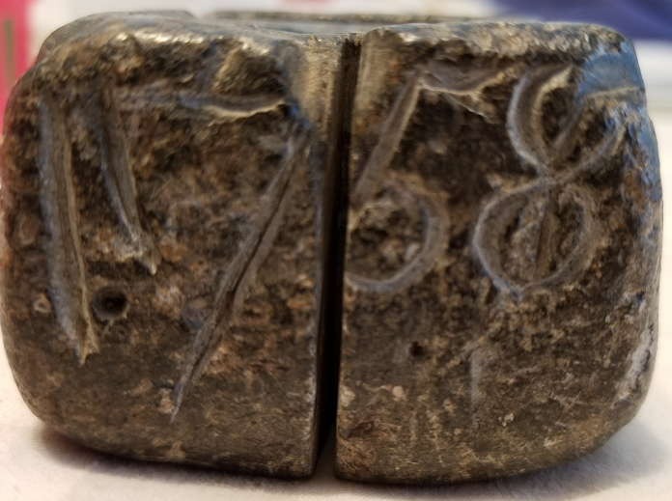

* * * * *

Section 4 – Featured Bassett: Cyrus William Bassett Obituary

Cyrus William Bassett descends from William Bassett of Plymouth as follows:

William Bassett and wife Elizabeth

Joseph Bassett (b. 1635 and wife Mary Lapham

William Bassett (b. 1667) and wife Sarah Sweetland

Joseph Bassett (b. 1696) and wife Elizabeth Ames

Joseph Bassett (b. 1731) and wife Phebe Cushman

Caleb Bassett (b. 1757) and wife Bethia Keith

Cyrus Bassett (b. 1785) and wife Cynthia Randall

Cyrus Bassett (b. 1811) and wife Elizabeth Riley

Cyrus Robert Bassett (b. 1867) and wife Ellen Curry

Cyrus Joseph Bassett and wife Mabel Anabel Inglis

Cyrus William Bassett (b. 1924)

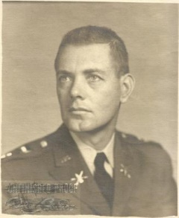

Cyrus William Bassett

The Burlington Free Press, September 10, 2018

Cyrus William Bassett (1924 – 2018)

South Burlington – Lt. Colonel Cyrus William Bassett, retired U.S. [Army](http://www.legacy.com/memorial-sites/army/?personid=190175692&affiliateID=2506), age 94, went to be with his God on Sept. 7, 2018. He leaves a life marked by integrity, thoughtfulness, service to others, love of family and of country. He was a true gentleman and treated all with dignity and respect.  
  
Bill was born in Lowell, Mass. on March 6, l924 to Cyrus Joseph Bassett and Mabel Ingles Bassett. He was a graduate of Sacred Heart School, Keith Academy and Boston College, class of 1950. He enlisted in the U.S Coast Guard in 1942 serving on anti-submarine patrol and signal duty in the Statue of Liberty. He was accepted into the Naval Air Corps and trained at Monmouth College, IL, University of Georgia, and was in pre-flight training at University of Oklahoma when World War II ended. He was accepted at Boston College and entered into the ROTC program where he was named a Distinguished Military Graduate and commissioned a Second Lieutenant in the US Army Field Artillery, upon graduating in 1950.   
  
He served in the Korean War 1950-1952 and in the Vietnam War 1965-1966. He retired in 1977 as a Lt. Colonel at Ft. Monmouth NJ where he was Deputy Post Commander. He was awarded two Bronze Star medals and the Legion of Merit during his military career. Bill was married in July 1950 to the former Mary Corby also of Lowell; they shared 68 years of marriage. He was a devoted husband, father and grandfather and often said his family was his greatest achievement.

Upon retirement, Bill was involved in many areas of public service. He lectured and provided program's promoting nuclear disarmament via Beyond War. He was a member of St. Thomas Church Parish Council. For many years, he served as a Eucharistic Minister and chaired committees and was also an Officer in the Knights of Columbus.   
  
He is survived by his wife and four children, David and wife Lynda of Norwood, MA. Kathleen Bassett Cramer of Jericho, Vt. Douglas and wife Stephanie of Chicago, IL. and Michael Bassett of Colchester, VT. His three Grandsons; William Cramer of Montclair VA, Colin Cramer of New York City NY, & Joshua Jasso of San Antonio TX. Nieces & Nephews; Martha & Thomas Dufresne, Mary E. Bassett and Art Giacomarra Ann & Richard Bienvenue, Drs. Robert & Marilyn Ray-Bassett, Thomas and Carol Spindell-Bassett, Violet Bassett-Mathy and Jay Mathy, Richard Bassett & Michael Bassett. Bill was predeceased by his parents, Brother Robert, & Sister-in-law Margaret (Scanlon) Bassett & Brother Joseph Bassett.   
  
Calling hours will be Sunday September 16, 2018 from 3:00 until 5:00 PM at the Ready Funeral Home Mountain View Chapel 68 Pinecrest Drive, Essex Jct. A Mass of Christian Burial will be said on Monday September 17, 2018 at 11:00 AM at St. Thomas Catholic Church in Underhill. Burial will take place on Tuesday September 18, 2018 at 1:00 PM at the Vermont Veterans Cemetery in Randolph, VT. To place on-line condolences please visit www.readyfuneral.com.

In lieu of flowers please consider giving to St. Thomas Parish 6 Green St. Underhill Center, VT 05490.

* * * * *

Section 5 – Featured Bassett: Photographs of G.W. Bassett of Clover Lea, Virginia

George Washington Bassett descends from #5B William Bassett of Virginia as follows:

William Bassett (d. 1646) and wife Anne

William Bassett (b. 1604) and wife Bridget Cary

William Bassett (b. 1671) and wife Joanna Burwell

William Bassett (b. 1709) and wife Elizabeth Churchill

Burwell Bassett (b. 1734) and wife Anna Maria Dandridge

John Bassett (b. 1765) and wife Betty Carter Browne

George Washington Bassett (b. 1800) and wife Betty Burnett Lewis

Here are photographs of George Washington Bassett (1800-1878) and his wife, Betty Burnet Lewis (1808-1886), of Clover Lea Plantation, Hanover County, Virginia.

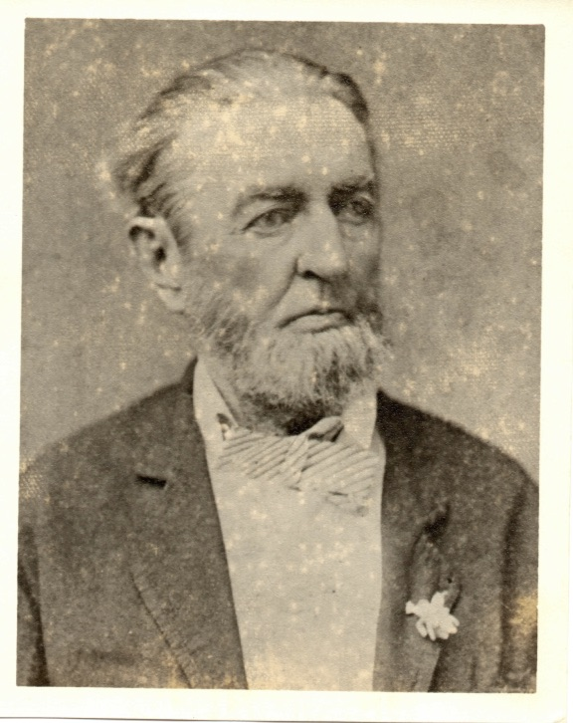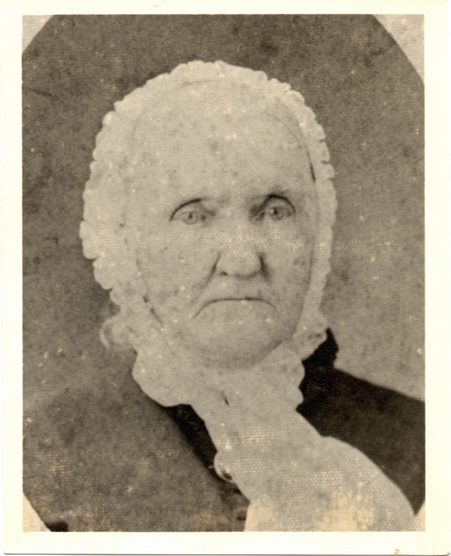

Picture from Bill Orr Courtesy of Carol Williams

* * * * *

Section 6 – Featured Bassett: Artist Vera Bassett of Wales

Vera Bassett descends from #202B Anthony Bassett of Wales as follows:

Anthony Bassett (b. 1720) and wife Margaret Griffith

Anthony Bassett (b. 1746) and wife Catherine John

John Bassett (b. 1783) and wife Jane Samuel

Daniel Bassett (b. 1830 and wife Mary Morgans

John Bassett (b. 1849) and wife Elizabeth

William John Bassett (b. 1884) and wife Mary Sarah Lloyd

Vera Bassett (b. 1912)

Pontardualais Town Council

Vera Bassett held her first one-woman exhibition in the Hendy Urdd Centre in 1943, followed by others at the Mechanics Institute in the Bont in 1948 and the Glynn Vivian Art Gallery, Swansea, in 1949. She was born on the Fforest, Pontardulais, in 1912, and lived in Glenview and, after 1946, at 7, Fforest Road. Her parents were William John Bassett, a furniture salesman, and Mary Sarah Lloyd – they married in 1907. They had six children, of whom Vera was the youngest. She married William Owen Reynolds in 1956 and they moved to Bury Port in 1969. Vera died in 1997. In 1938 her sister, Edna, married Gethin Morgan, who later ran the Spot newsagent’s shop on St. Teilo Street. His father, J. Rhys Morgan, had established the Spot newspaper about 1920. It ran to 1938.

While on my recent trip to England and Wales, I visited the National Museum of Wales in Cardiff. I ran across the following painting.

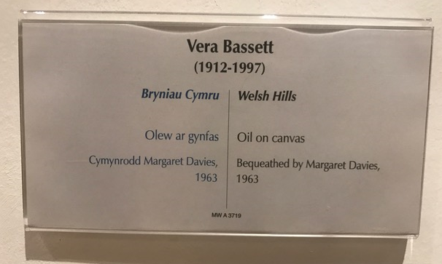

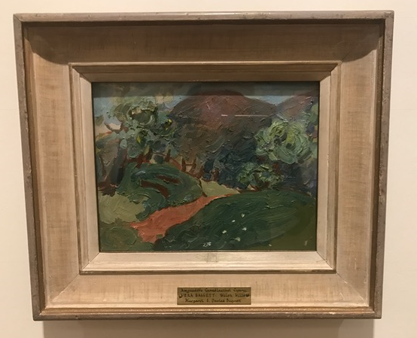

* * * * *

Section 7 – Featured Bassett: William Bassett of Blore

While in England, I had the opportunity to visit St. Bartholomews Church in Blore.

It is a very old church (over 900 years) with historic Bassett significance. Anyone from the #33B Bassett line from Staffordshire, most of whom descend from Thomas Bassett of Hints, should make time to visit.

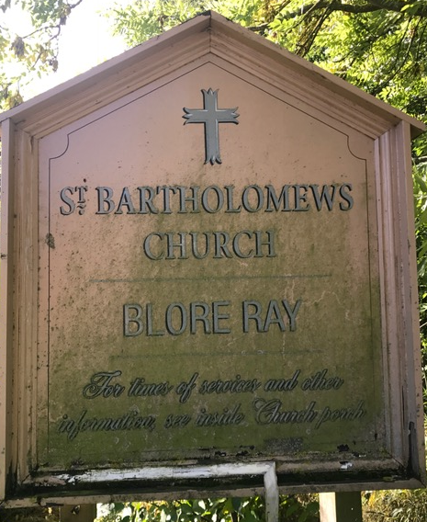 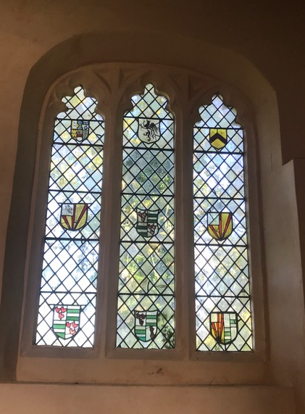

Church sign Stained glass with several Bassett coats of arms

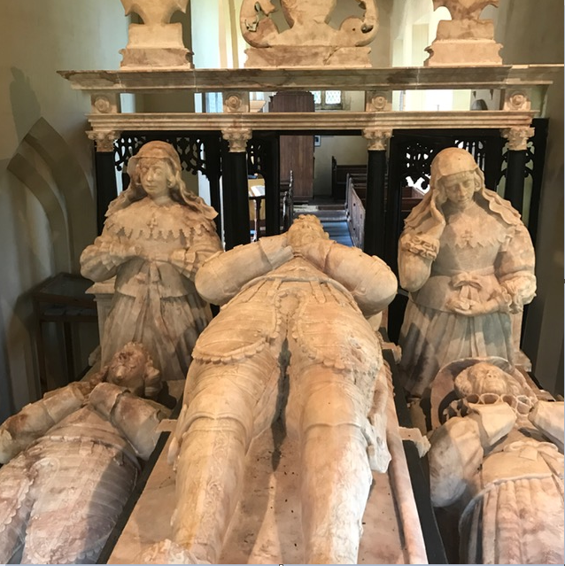

Bassett Tomb which includes William Bassett of Blore

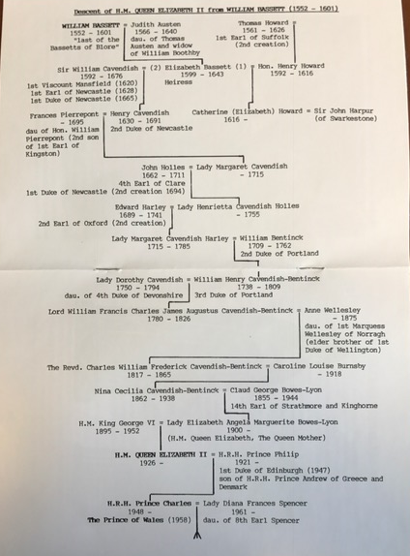

Genealogy chart showing the descent of Her Majesty Queen Elizabeth II, an eleventh generation direct descendant of William Bassett of Blore.

* * * * *

Section 8 - New family lines combined or added since the last newsletter

No trees added or combined since the last newsletter.

* * * * *

Section 9 - DNA project update.

No new results to report on the Bassett DNA project.

|  |
| --- |
| Donations of any amount can be made to the Bassett DNA project by clicking on the link below. Any funds donated will be used to fund select Bassett DNA tests that will further our project as a whole and benefit all Bassetts worldwide.  http://www.familytreedna.com/group-general-fund-contribution.aspx?g=Bassett  This is just a reminder that the DNA portion of the Bassett Family Association can be found at:  A current spreadsheet of results can be found at:  <http://www.bassettbranches.org/dna/BassettDNA.xls>  If you don't have Excel and can't open the spreadsheet above, you can now see the DNA test results at the following website.  <http://www.familytreedna.com/public/Bassett/>  Jeffrey Bassett 520 Salceda Drive Mundelein, IL 60060 USA bassettgenealogy@gmail.com |