Bassett Family Newsletter, Volume XVI, Issue 6, 17 Jun 2018

(1) Welcome
(2) Henry & William Basset of Margate, Kent, England
(3) Parents of #65B George Bassett of Pennsylvania identified with help from DNA
(4) William Silas Bassett and wife photograph
(5) Will of Ebenezer Bassett of New York State
(6) Walter Bassett of Australia, Poultry Raiser
(7) Glenn Willard Bassett, “Voice of a Rare Quality”
(8) New family lines combined or added since the last newsletter
(9) DNA project update

Section 1 - Welcome

I will be traveling to England on Monday, 17 Sep 2018, for a genealogy trip. I have not yet made plans other than my flight arrangements, but I plan on going to Cornwall and Glamorgan, Wales, among other sites. I fly home on Monday, 24 Sep 2018. Is anyone interested in holding a small Bassett reunion on Saturday, 22 September 2018, possibly in Cornwall?

The following trees were added to the Bassett website database since the last newsletter:

543B. John Bassett of Ontario, Canada (16 individuals)
544B. Richard Bassett of Winchester, England (33 individuals)
545B. Terrance Bassett of Bermuda (46 individuals)

Totals number of individuals loaded into the Bassett website: 149,110

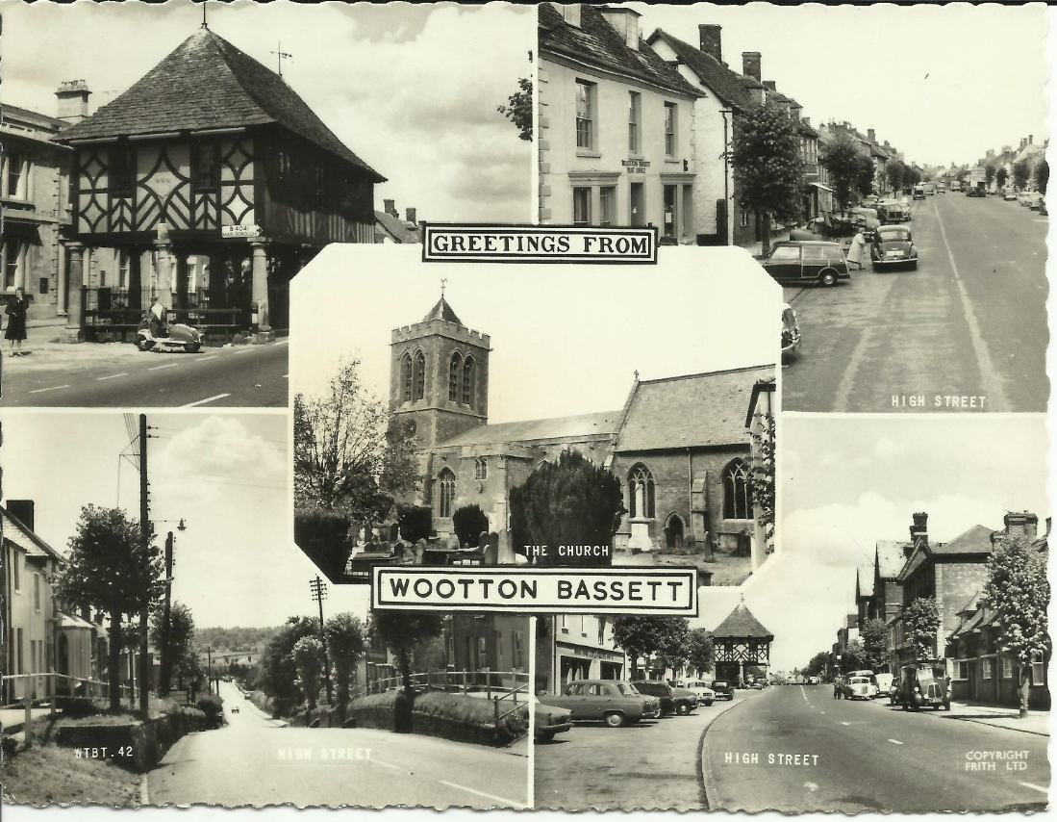
* * * * *

Section 2 – Featured Bassett: Henry Basset of Margate. Kent, England

Henry Bassett descends from #185B Henry Bassett of Margate, Kent, as follows:

Henry Bassett (m. 1720) and wife Frances Paradice
Henry Bassett (b. 1725) and wife Mary Newby
William Bassett (b. 1761)

Kentish Gazette, Tuesday, 22 January 1788
At Margate
Partnership Dissolved

Notice is hereby Given, That the Partnership between Henry Basset and William Basset, Upholders, Ironmongers and Brokers, at Margate, Kent, was dissolved by mutual Consent, on the 30th Day of November last past; all Persons therefore who are any Ways indebted to the late Partnership, are desired to pay their respective Debts to Mr. William Basset, on or before the First Day of February next, who is appointed to receive the same. And all Persons having any Demands on the late Partnership, are desired to send or bring their respective Accounts to Mr. William Basset, that they may be paid.

Henry Basset
William Basset

The Business is now carried on in all its various Branches, in the usual Manner, by William Basset, the Continuance of the Favours of whose Friends and the Public in general will ever be thankfully acknowledged.

* * * * *

Section 3 – Featured Bassett: DNA results from a Bassett from Bristol, England

DNA results are back from a descendant of John Bassett through his son James Bassett. It was an exact 25/25 match for a descendant of George Bassett of Pennsylvania. Given this information, we have now proven that George is the oldest son of John and Jane (Bailey) Bassett of Bristol, England. I have now combined the two families into the #65B John Bassett line.

Also interesting to note is that there is a close match between these two and descendants of the #3B Thomas Bassett of Connecticut family. Does this mean that Thomas Bassett is from the Bristol area as well?

65B. The Family of John Bassett

John Bassett was born about 1770. He married Jane Bailey/Bayley on 7 Jan 1804 in Bristol, Gloucester, England. John died Jun Qtr 1843 in Clifton, Gloucestershire, England. Jane died Mar Qtr 1850 in Clifton, Gloucestershire, England. She was buried 9 Jan 1850 at Clifton, St. Andrew, Gloucestershire, England, aged 69 years.

+ 65B1. George Bassett – born 8 Oct 1805 in Bristol, England. He was
christened 28 Jun 1807 in Christ Church, Bristol,
Gloucestershire, England. He married Elizabeth Butler, daughter
of Edward and Jane Butler.

65B2. Joshua Bassett – christened 28 Jun 1807 in Christ Church,
Bristol, Gloucestershire, England. He was buried 19 Apr 1829
in Bristol, Gloucester, England.

65B3. Mary Bassett – christened 7 Jan 1810 in Clifton, Gloucester,
England.

65B4. Ann Bassett – christened 11 Aug 1816 in Saint Andrews, Clifton,
Gloucester, England.

65B5. Thomas Bassett – christened 11 Aug 1816 in Saint Andrews,
Clifton, Gloucester, England.

65B6. Emma Bassett – christened 26 Sep 1819 in Saint Andrews, Clifton,
Gloucester, England.

+ 65B7. James Bassett – christened 25 Jan 1826 in Saint Andrews, Clifton,
Gloucester, England. He married (1) Lydia Mead. He married (2)
Catherine Elizabeth Burrow.

* * * * *

Section 4 – Featured Bassett: William Silas Bassett photograph

William Silas Bassett descends from William Bassett of Plymouth as follows:

William Bassett and wife Elizabeth
Joseph Bassett (b. 1635) and wife Mary Lapham
William Bassett (b. 1667) and wife Sarah Sweetland
Nathan Bassett (b. 1702) and wife Hannah Washburn
Joseph Bassett (b. 1747) and wife Hannah Lathrop
William Bassett (b. 1777) and wife Abiah Williams
William Church Bassett (b. 1803) and wife Martha Pickens
William Silas Bassett (b. 1828) and wife Clara Louis Ketcham
Ida May Bassett

Listed on the back of the photo
William Silas Bassett Father of Ida May
Clara Louise (Ketchum) Bassett Mother of Ida May

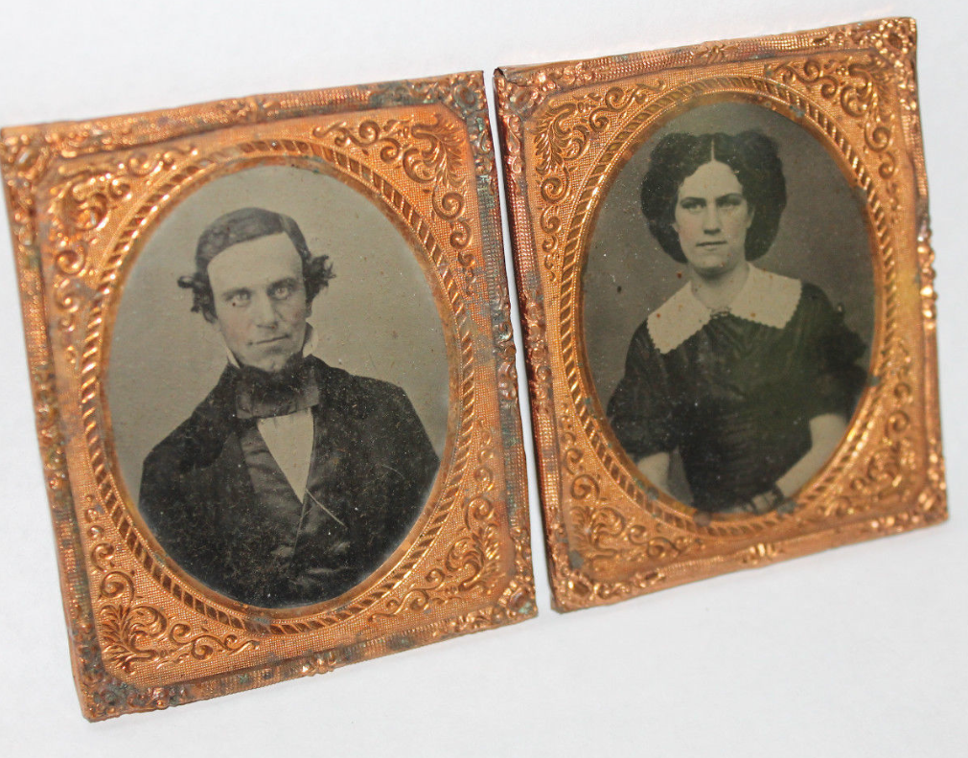
William Silas Bassett and wife Clara Louise (Ketchum) Bassett for sale on ebay

* * * * *

Section 5 – Featured Bassett: Will of Ebenezer Bassett of New York State

Ebenezer Bassett descends from William Bassett of Plymouth as follows:

William Bassett and wife Elizabeth
Nathaniel Bassett (b. 1628) and wife Dorcas Joyce
Nathan Bassett (b. 1677) and Mary Crowell
Samuel Bassett (b. 1714) and wife Susannah Lombard
Nehemiah Bassett (b. 1743) and wife Dorcas Cole
Ebenezer Bassett (b. 1781)

New York Wills and Probate Records
Ebenezer Bassett (25 Sep 1815)

In the name of God Amen, I Ebenezer Bassett of the City and State of New York blacksmith, being weak in body but of sound mind and memory (blessed be God therefor) do make and publish this my last will and Testament in manner and form following viz First, I order all my Estate real and personal to be sold to the best advantage and all my just and honest debts paid and the remaining balance to be put out at Lawful interest for the support and Education of my five children and when the elder James Bassett Jr. shall arrive at the age of twenty one years, I order five hundred dollars to be paid him out of his proportion of inheritance to his own use, and the remainder to remain at interest until my youngest living child becomes to the age of twenty one years and then to be equally divided between James Bassett Jr. (after deducting the aforesaid Five hundred dollars) Nancy (or Ann) Newkirk Bassett Catharine Bassett, Rebecca Bassett and Ebenezer Bassett Jr. or their heirs lawfully begotten I order my Executors to place my children (above named) to board as they may think most prudent and advantageous I bequeath the sum of fifty dollars to be first paid out of my effects to Elizabeth Everson for her care and attention to me in my illness and I further bequeath to Barnet Baldwin my step son twelve months after me decease one hundred dollars and I expect my Executor will see both these bequests faithfully fulfilled I do also request my brother Nehemiah Bassett to have the offer of my Tools and Stock in trade of my Shop with the establishment at a fair valuation and my Executors are authorized to take his notes for the amount at six and twelve months credit and for the better fulfillment of this my last will and Testament, I do hereby appoint my trusty friends John A. King and David Harriott my Sole Executors hereby revoking all former wills by me made (over) Signed Sealed published and declared by the aforesaid Ebenezer Bassett to be his last will and Testament in the presence of us who have hereunto subscribed our names as witnesses in the presence of the Testator “my Executors” first interlined. Ebenezer Bassett

* * * * *

Section 6 – Featured Bassett: Walter Bassett of Australia, Poultry Raiser

Walter Bassett descends from #149B William Bassett as follows:

William Bassett (b. 1680) and wife Ann Ripper
William Bassett (b. 1711) and wife Margery Greenfield
William Bassett (b. 1736) and wife Eleanor Sampson
William Bassett (b. 1762) and wife Jane Mathews
John Bassett (b. 1790) and wife Martha Carbis
John Bassett (b. 1820) and wife Catherine Davey
Francis Davey Bassett (b. 1843) and wife Elizabeth Ann Scott
Walter Bassett (b. 1885)

The Bendigo Independent, Victoria, Australia, Saturday, 24 May 1913
With Poultry Fanciers

Mr. W. Bassett, miner, of Hill street, is one of the most enthusiastic members of the Bendigo Poultry Society. When one sees his yard he cannot wonder that he is but energetic in anything that he is associated with. Some three years ago he was induced into the poultry fancing hobby. He decided on the prize birds in in preference to the layers. He started with an Ellis black orpington cockerel and hen. The cock is now a fine good typed bird. He has been awarded several prizes, including a gold medal. The medal was won at Kilmore. Three judges had ten birds in the section to examine. When they were near the end they overhauled the first three birds and gave the prize to Mr. Bassett. The hen is not too large, but has a fine head, splendid body, and perfect feet and legs, and it is no wonder that at the three shows at which she was shown that she gained three first prizes.
Mr. Bassett has bred from the Ellis pair, and this year he has several excellent chickens with which he should gain many prizes. One pullet in particular gives much promise. She is a clear typed bird. This season’s stock has a little of the Mitchell strain mixed, and layers will be bred during the coming hatch for next year’s pens at Kangaroo Flat will be equal to Burnley.
The main house is 10ft x 10ft neatly constructed of cheap wood amongst rose bushes and other garden greenery. This has a two fold effect. One of making the place look smart, while the second is of providing shelter during the hot days for the birds. Besides the big shed there are smaller ones. One like a small cage with wooden bars is raised 3 ft and into this any sickly bird is placed. She is isolated, and Mr. Bassett is able to give her much attention. With this he has frequently found that a disease is kept from the rest of the stock. Probably it was on account of this great precaution that Mr. Bassett was free from the chicken pox this year. Round the runs, which are in front of each pen, green feed is grown, and when required is chopped into fine pieces. The fowls are healthy.
In addition to the orpingtons, Mr. Basset has four American rock hens, and two cockerels. These birds, which will very shortly be laying, look like six overgrown and moulting chickens, but as they are reputed egg producers, Mr. Bassett intends studying them. His yard is complete with two old English game bantams. He has two of the midget ornamental fowls, which were presented to one of the children some time ago.
Mr. Bassett is deserving of great praise for the splendid example he is showing other poultry men. It behoves many more miners to share his enjoyment after a shift below. He says he cannot understand why he did not take a fancy to poultry years ago. He finds it a splendid pastime and is very optimistic and hopes to see his name on more first prize tickets.

* * * * *

Section 7 – Featured Bassett: Glenn Arthur Bassett, “A Voice of Rare Quality”

Glenn Willard Bassett descends from William Bassett of Plymouth as follows:

William Bassett and wife Elizabeth
William Bassett (b. 1624) and wife Mary Rainsford
William Bassett (b. 1656) and wife Rachel Willison
William Bassett (b. 1681) and wife Abigail Bourne
William Bassett (b. 1711) and wife Lydia Smith.
Rufus Bassett (b. 1757) and wife Jedidah Handy
Nymphas Bassett (b. 1785) and wife Thankful Ann Bruce
Bernard Handy Bassett (b. 1808) and wife Hannah Elizabeth Wilson
Nymphas B. Bassett (b. 1833) and wife Amanda E. Harris
Glenn Otis Bassett (b. 1873) and wife Lizzie Olive Davis
Glenn Willard Bassett (b. 1909)

Oregon Journal, Wednesday, August 30, 1922
Newberg Youth Has A Voice Of Rare Quality

Discovery of a Newberg, OR., boy with a voice of wider range than any other voice in the world, with the single exception of “Bobbie” Murray, the Tacoma phenomenon, was announced today by Dr. H.E.K. Whitney, director of the Whitney Boy chorus.
Glenn Willard Bassett, 13 years old, son of Mrs. Olive D. Bassett of Newberg, is the professor’s “find”. He is able to reach D and even B flat above high C. “Bobbie” Murray, when discovered by the music scouts, was able to reach E above high C, so there is practically no difference between the two.
Willard, who goes generally by the name of Billy, was practically without training until nine months ago, when he joined the Whitney Boy chorus in Newberg. Even then he was just “one of the boys.”

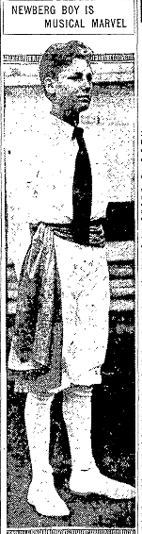

NOTE FINE QUALITY

Professor Whitney did not hear him in solo work until a few weeks ago. Then one night three Newberg boys sang, each a verse of a song, with the entire chorus joining at the end. The perfect quality of Willard’s voice was noticed at this time.
And one day Billy said to the professor: “Why, I can sing as high as ‘Bobbie’ Murray.”
Last Saturday at Newburg he was given a trial. His voice rose to unbelievable heights. Professor Whitney, astonished, brought Willard to Portland with him and gave him a hearing at Ellers Music house, Sunday. It was then he attained the E flat above high C.
Now the problem is to give Billy the proper training, and Professor Whitney is seeking a godfather or godmother for him. Enough time has been wasted, he pointed out today, and it will soon be time for the boy’s voice to begin to change. Billy is quite excited at learning of his own possibilities.

HE IS AMBITIOUS

“You bet I want to work,” he said.
He is the seventh in a family of nine children, seven girls and two boys. His father, who was an Oregon lumberman, is dead. He will be in the eighth grade in school this fall.
“our mother has taken some training at Eugene and Corvallis, and is quite an accomplished vocalist,” said Miss Florence Bassett, Willard’s sister, of Portland, who is chaperoning him during these exciting days. “All of us able to carry a tune, but there have been no unusual singers or musicians in the family.”

* * * * *

Section 8 - New family lines combined or added since the last newsletter

The following family lines have been combined/eliminated since the last newsletter.

404B. John Bassett of Clifton combined into the #65B George Bassett of Pennsylvania Line

The following family lines have been added since the last newsletter.

543B. John Bassett of Ontario, Canada
544B. Richard Bassett of Winchester, Hampshire, England
545B. Terrance Bassett of Bermuda

* * * * *

Section 9 - DNA project update.
No new results to report on the Bassett DNA project..Donations of any amount can be made to the Bassett DNA project by clicking on the link below. Any funds donated will be used to fund select Bassett DNA tests that will further our project as a whole and benefit all Bassetts worldwide.

http://www.familytreedna.com/group-general-fund-contribution.aspx?g=Bassett
This is just a reminder that the DNA portion of the Bassett Family Association can be found at:

A current spreadsheet of results can be found at:
http://www.bassettbranches.org/dna/BassettDNA.xls
If you don't have Excel and can't open the spreadsheet above, you can now see the DNA test results at the following website.
http://www.familytreedna.com/public/Bassett/
Jeffrey Bassett
520 Salceda Drive
Mundelein, IL 60060 USA
bassettgenealogy@gmail.com

