Bassett Family Newsletter, Volume XV, Issue 11, 23 Nov 2017

(1) Welcome
(2) Death of Dr. John Seymour Bassett of New York
(3) Fred Herbert Bassett, Inventor and Optician
(4) Bassett Brothers Mercantile College of New York
(5) Seymour Bassett and “The Floating Gin Mill”
(6) Jeremiah Johnson Bassett Photograph
(7) Obituaries for Parley Bassett and wife Asenath (Hall) Bassett
(8) New family lines combined or added since the last newsletter
(9) DNA project update

Section 1 - Welcome

No new trees were added to the Bassett website database since the last newsletter:

For those living in the United States, I hope everyone has a nice Thanksgiving Holiday.

Totals number of individuals loaded into the Bassett website: 146,308

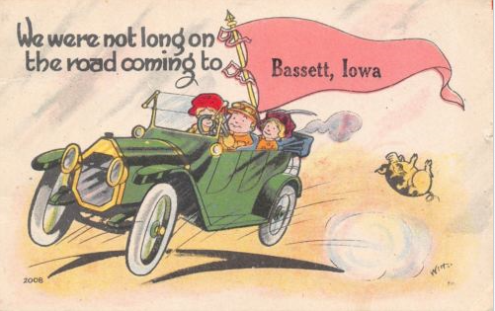

* * * * *

Section 2 - Featured Bassett: Death of Dr. John Seymour Bassett of New York

John Seymour Bassett descends from William Bassett of Plymouth as follows:

William Bassett and wife Elizabeth
William Bassett (b. 1624) and wife Mary Raynesford
William Bassett (b. 1656) and wife Rachel Williston
William Bassett (b. 1680) and wife Abigail Bourne
John Bassett (b. 1716) and wife Mercy Newcomb
Thomas Bassett (b. 1759) and wife Lydia Mendall
John Bassett (b. 1795 and wife Laura Wing
John Seymour Bassett (b. 1830)

The Evening Post, New York, Thursday, August 1, 1912
Dr. John Seymour Bassett

Dr. John Seymour Bassett, of No. 11 West Thirty-first street, died yesterday at New Milford, Conn. Dr. Bassett was born in Marion, Mass., eighty-four years ago, and was graduated from the Berkshire Medical School, now connected with Harvard University. He practiced at Paterson, N.J., until the early fifties, when he came to New York. He married Miss Hannah Valeria Cevill in New York in 1869. He is survived by her, a son, Acton Cevill Bassett of New York, and three daughters, Miss Laura C. Bassett of New York, Mrs. Philip Cook of San Antonio, and Mrs. William H. Lane of South Orange, N.J.

New York Tribune, Wednesday, August 21, 1912
Disinherits Eldest Son
Will of Dr. J. Seymour Bassett Gives All to the Widow

The will of John Seymour Bassett, for more than fifty years a practicing physician of this city, who died on July 31 at New Milford, Conn., was filed yesterday in the Surrogate’s office. Dr. Bassett cut off his eldest son with a bequest of $100, explaining “The smallness of this bequest is accounted for by the fact that my said son has not been to me a dutiful, obedient or loving child, but, on the contrary, undutiful and disobedient, causing much sorrow, pecuniary loss and sacrifice to me, and he has been already the recipient of a larger share of my estate then ever could of right belong to him.”
The rest of the estate, valued at “more than $10,000” in real estate and about $5,000 in personal property, is left to Mrs. Hannah V.C. Bassett, wife of Dr. Bassett.
Dr. Bassett had one other son and three daughters, who were not mentioned in the will but will inherit from their mother. Dr. Bassett lived at No. 11 West 31st street. His death was caused by a stroke of paralysis. He was eighty-four years old.

* * * * *

Section 3 - Featured Bassett: Fred Herbert Bassett, Inventor and Optician

Fred Herbert Bassett descends from #6B William Bassett of Connecticut as follows:

William Bassett and wife Hannah (Dickerman) Ives
Samuel Bassett (b. 1654) and wife Mary Dickerman
Abraham Bassett (b. 1692) and wife Mehitable Street
Abraham Bassett (b. 1733) and wife Lydia Smith
Charles Bassett (b. 1773) and wife Huldah Barrett
Lemuel Bassett (b. 1798) and wife Persis Gardner
Darwin Bassett (b. 1825) and wife Mary Angeline Blakesley
Fred Herbert Bassett (b. 1853)

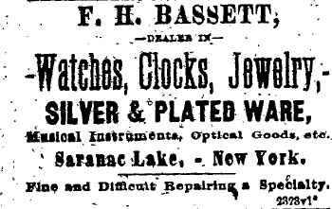
Essex County New York Republican, Thursday Evening, June 18, 1885

Notes from Mrs. H.C. Loney, 1417 South Maple, Spokane, Washington (1930's)

My father was an optician and quite an inventor, having at one time as many as 200 patents registered. Worked on invention similar to Holland tunnel machines (Discussed several times with Holland), also window shades, traps, etc. Had a complete small shop in back of his optical shop in Georgetown, D.C. for turning out models. He went to Kansas at age of six, his father ran post office and general store in Kansas (1858), built first church and first to be buried there-Hartford, Kan. He returned to Mass. shortly afterwards (due to his parents deaths), but during that time lived with Indians (after their death and while waiting for his uncle to arrive, via Prairie schooner, from St. Louis). Some years later my father guided in the mountains at Lake Placid, N.Y. later met Robert Louis Stevenson, and knew him well, thence moved to N.Y. City and worked in a shop on Madison Ave. in opticians' shop.

The Electrical World, October 5, 1895, Page 389

The Holmes & Bassett Company, Waterbury, Conn., has been formed to manufacture and deal in curtain fixtures, electrical appliances, etc. The promoters are Walter W. Holmes, Charles L. Holmes, Waterbury, Conn.; Fred H. Bassett, Saranac Lake, N.Y. Capital stock $20,000.

The Elizabethtown Post, October 24, 1889, Page 2

The Bassett Curtain Fixture Co., of Saranac Lake has been organized with F. H. Bassett, president; C.H. Kendall, secretary, and J.H. Mill, treasurer. Their capital stock is $10,000, and they will manufacture the celebrated adjustable curtain fixture invented by Mr. F.H. Bassett, at that place.

Scientific American, February 1, 1896, Page 86
The Bassett Curtain Fixture

We illustrate on this page an excellent device for an adjustable and self-locking window curtain, which has been patented by Mr. F.H. Bassett, of Saranac Lake, N.Y., and is being manufactured and sold by The Holmes & Bassett Company of Waterbury, Conn.

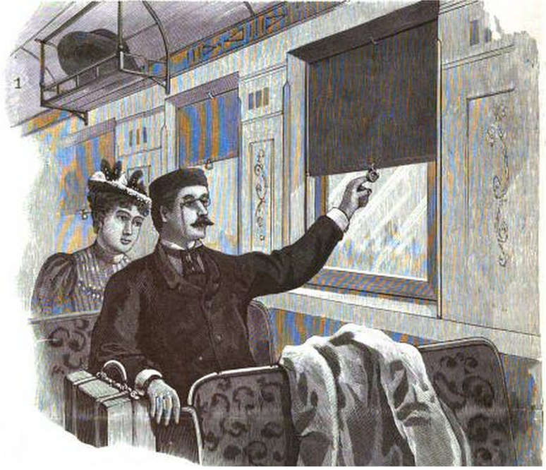

* * * * *

Section 4 - Featured Bassett: Bassett Brothers Mercantile College of New York

Seth Martin Bassett and Noble Page Bassett descend from William Bassett of Plymouth as follows:

William Bassett and wife Elizabeth
Joseph Bassett (b. 1635) and wife Mary Lapham
William Bassett (b. 1667) and wife Mary Bumpus
Seth Bassett (b. 1715) and wife Mary Hayward
Seth Bassett (b. 1739) and wife Mary
Seth Bassett (b. 1785) who married twice
Noble Page Bassett (b. 1817) and Seth Martin Bassett (b. 1822)

Syracuse Central City Courier, Monday Morning, February 20, 1860
Death of Prof. Seth M. Bassett

Seth M. Bassett, Professor of Book Keeping, Practical Accountant, &c., at the Syracuse Commercial College, expired at his rooms in the Dillaye Buildings, on Friday night last at half-past ten o’clock. Prof B. has been at the head of this Institution for five years past, and has succeeded in building it up to the rank of a first class Mercantile College. He was ambitious to render it the model and leading Institution of its kind in the State. To accomplish this end he has labored most steadily and vigorously – far too much so for his health, which has been yielding to the pressure of a too heavy and too long protracted taxation.
For a long time this community has been accustomed to see and admire those elegant and elaborate specimens of chirography which decorate the walls of the College Hall, and some of the public rooms of the city. Not only curiosity is awakened, but astonishment is aroused at the skill, elegance, and genius of his magnificent efforts. Whenever he entered upon competition he always carried the prize. And there is making for him now the prize silver medal of the Franklin Institute which he so lately won, but which he is never to behold.
Kind, courteous and winning, Prof. Bassett was one of the most successful instructors in this country. And the judgement and skill which he exhibited has impressed our citizens that he was a man of more years than twenty-seven. He was building up an institution which would have been not only creditable to himself, but the pride of our city. He improved and systematized his manner and theory of instruction, and continually advanced the profession in which his whole soul was enlisted.
The attachment of those who came under this charge and care can better be told in the expression of his scholars, in their resolutions published below, and in their following him to a distant grave, than we can tell in this brief but well deserved notice.
Whereas, Death has removed from our midst, and from the care and conduct of this Institution, our friend and teacher Seth M. Bassett; we, the students of the Syracuse Commercial College, gathered together in the hall where we have been accustomed to meet him in his daily intercourse with us as our preceptor.
Resolve, That in the death of Seth M. Bassett, we have been suddenly deprived of a competent, capable and most worthy instructor, whose teachings have been most valuable to us as well as to others who have enjoyed the advantages of the institution. That we feel this loss with peculiar force from the ever pleasant and beneficial relations which have existed between us as teacher and pupils, and from our high regard towards him as a man, a friend, and a companion.
Resolved, That we extend our sympathies to the widow and family of the deceased, and particularly to his brother and associate who has been connected with him in his intercourse with us, and that we can share their sorrow with them under this sudden and severe affliction; that we also regret that our citizens and the commercial community have been deprived of so valuable a citizen and benefactor.
Resolved, That these resolutions be published in the city papers, and a copy of them signed by us, be presented to the widow and brother of the deceased, and that we will attend his funeral services in a body.

W.R. Boldgett
W.P. Tisdell
J.W. Dunning
Thos. Molloy
W.H. Benedict
Committee

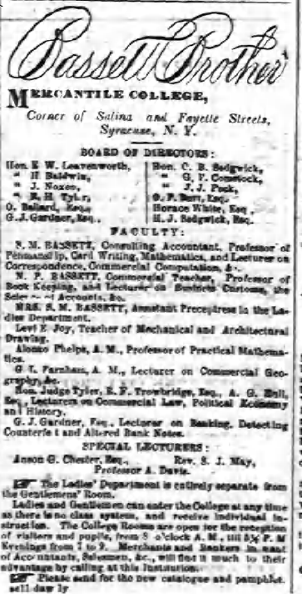

The Daily Courier, Syracuse, New York, Saturday, Sept. 18, 1858

* * * * *

Section 5 - Featured Bassett: Seymour Bassett and “The Floating Gin Mill”

I have not yet figured out which branch of the family Seymour Bassett belongs to.

Troy New York Daily Times, November 1873
Tragedy On Lake Champlain
“The Floating Gin Mill” Burned
Its Proprietor Killed – The Work of a Mob

The men employed in building the New York and Canada railroad, and which when completed will extend from Whitehall to Rouse’s Point, have been gathered from all parts of the country, and are largely addicted to the bottle. The section of country in which they are employed has long been noted for the temperance proclivities of its inhabitants. The laborers found it extremely difficult to procure liquor, and when they succeeded the cost was large. At different times within the past year various persons, incited thereto by the large profits accruing from the traffic, have opened places for the sale of alcoholic stimulants. The moral, disrepute into which they at once fell induced some to suspend business; others were forced to close their places by inability to procure licenses, or notifications that is was unsafe for them to linger in the vicinity.
In August a queer looking craft was seen near the New York shore of Lake Champlain, in close proximity to the places where the railroad laborers were at work. The craft consisted of an old raft, upon which a small house was placed. In this house always could be found a large supply of the worst liquors. The proprietor, Seymour Bassett, recognized and obeyed neither the prohibitory law of Vermont nor the license law of New York, asserting that his craft was outside of the jurisdiction of both states. The vessel soon became notorious along the lake and was dubbed, “The floating gin palace.” On every pay day the craft was secured in close proximity to the New York shore. The proprietor required no advance announcements; whenever his “floating gin palace” appeared the laborers would leave work and proceed to board the vessel in swarms, spending the hard earnings that belonged to their families for Bassett’s decoctions. On these occasions drunken broils invariably took place and sometimes they resulted fatally. As an instance, following the pay day of the 15th of September the boat was again filled with disorderly and intoxicated laborers. They had imbibed fighting rum, and as a meter of course the tangle-foot became demonstrative, resulting in a knock-down argument all ‘round. Before it was quelled, one man was knocked overboard and drowned, his companions, mad with drink, being to crazy even to attempt to rescue him.
The presence of the boat was a constant threat against the peace and safety of the foremen of the railroad work and the residents, and its partial destruction by fire week before last was hailed with joy by these classed. Bassett, it seems, was a man of a great deal of energy, and he forthwith repaired his floating groggery. On Friday last some persons at present unknown resolved to take the law into their own hands. After dark fourteen men started out in boats from the vicinity of what is known as Fifteen Lighthouse, twelve miles north of Whitehall. They reached the craft without being discovered, and blindfolded and handcuffed George Wood, the bartender. They also secured two watches, thirty gallons of liquor and a double-barreled shot gun, which was loaded. Applying a torch to the concern, they then left for shore with their prisoner and booty. The boat was soon enveloped in flames.
At this time, Bassett, the owner, was at Benson’s landing, on the Vermont side. His attention was attracted by the flames. He immediately started to row across the lake, which at this point is narrower than the Hudson river. When he came within range of the party who had applied the torch, he fired fifteen shots at them, none taking effect. In the meantime Bassett had placed himself within five rods of the party. With the gun taken from the burning vessel once of them then returned the fire, which seemed to take effect, as Bassett called out that he was wounded. The party, however, it is said fired again. After Bassett was shot he contrived to get upon a lighter, where Wood, who had been released by the self-constituted officials, found him and conveyed him to Byram’s dock in Benson, where he died Sunday morning. He was twenty-six years of age. The affair has created much excitement at Benson Landing. One result at least will be security by the affair, and that is the illicit traffic which has been carried on in the above mentioned manner, to such a fearful extent, will be summarily ended. The bartender positively affirms that he can identify three out of the fourteen men who boarded the boat. From whose particular hands Bassett received his death we are unable to state, but it may come to light at at the inquest.
It seems that Bassett’s remains were after his death removed to the New York side of the lake. Coroner Clark of Cambridge was summoned by telegraph last night, and he immediately proceeded to Whitehall. Bassett resided in the town of White Creek near Eagle Bridge. It is stated seventeen bullets were found in his body after death.

* * * * *

Section 6 - Featured Bassett: Jeremiah Johnson Bassett Photograph

Jeremiah Johnson Bassett descends from #266B John H. Bassett as follows:

John H. Bassett (b. 1805) and wife Abigail Gifford
Jeremiah Johnson Bassett (b. 1845) and wife Phoebe C. Hammond

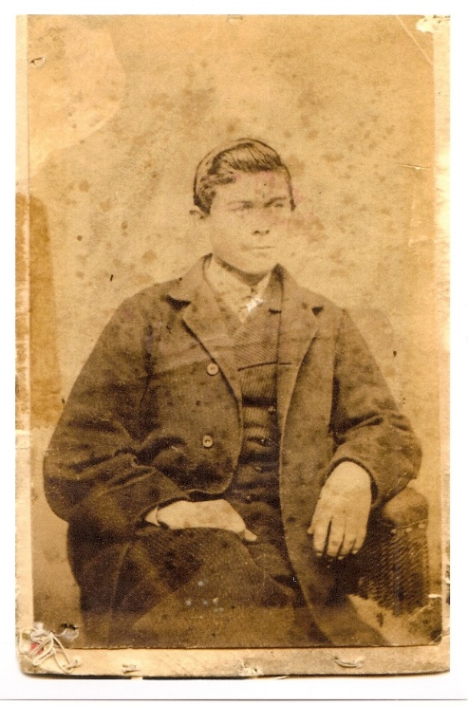
Jeremiah Johnson Bassett

Certificate of Marriage - 8 Jan 1868 Jeremiah J. Bassett & Phebe C. Hammond

This is to certify, that in accordance with the Laws of God and of the State of Illinois, Jeremiah J. Bassett of Chicago, Illinois and Phoebe C. Hammond of Chicago, Illinois were by me, a Minister of the Gospel, united in Holy Matrimony, at Chicago, in the County of Cook, and State of Illinois, on the Eighth day of January, in the Year of our Lord one thousand eight hundred and sixty eight (1868). The Marriage above was performed by virtue of a License duly issued by the Clerk of the Court of Cook county, State of Illinois. Witnesses - Clerk, Edward Cheney, Rector of Christ Church, Chicago, Ill. Witness and remarks - The Bridgegrooms Family Generally.

* * * * *

Section 7 - Featured Bassett: Obituaries for Parley and Asenath (Hall) Bassett

Parley Bassett descends from William Bassett of Plymouth as follows:

William Bassett and wife Elizabeth
William Bassett (b. 1624) and wife Mary Raynesford
William Bassett (b. 1656) and wife Rachel Williston
Nathan Bassett (b. 1685) and wife Mary Stetson
William Bassett (b. 1732) and wife Alice Cleveland
Jonathan Bassett (b. 1763) and wife Lucy Spafard
Parley Bassett (b. 1795) and wife Asenath Hall

The Syracuse Standard, Saturday, April 19, 1885
Parley Bassett
Death of an Old and Respected Resident of Syracuse

Word reached the city last night of the death of Parley Bassett, who was, at the time of his death, at the residence of Stanley Bagg, on the Alvord road, north of the city. Mr. Bassett’s death occurred at 7:30 o’clock last evening. He had been sick since Monday, suffering at first from a severe cold and being prostrated afterward by an attack of eyrsipelas. Prior to Monday of this week Mr. Bassett had been in good health and, although nearly 89 years of age, had no premonitory symptoms of the disease which suddenly ended his life.
Mr. Bassett was New Englander, his boyhood home being in Dalton, Mass., where he was born July 6, 1796. About fifty-two years ago he came to this city, where his home has since been. After the opening of the Syracuse & Oswego railroad he was employed by that company in the capacity of freight agent. For many years his home was in Fayette street, in the Seventh ward, and in 1863, when Daniel Bookstaver was mayor, he represented that ward in the Board of Alderman. he also served for a time in the office of city treasurer.
Few men had a wider acquaintance with his townsmen than did Mr. Bassett, especially during the active years of his life. He was a gentleman who made friends readily and who attached to himself all who came into business or social relations with him. All respected him and his unquestioned probity was recognized wherever he was known. In the prime of life he was a man of great energy in business affairs, and when he grew to be a hale old gentleman his neighbors regarded him with a sentiment akin to affections. During all his life Mr. Bassett was an ardent Democrat. He was a member of the Unitarian church from the time when that denomination established itself in this city.
Mr. Bassett’s venerable wife died a few months ago. His children are Mrs. Dr. Bartlett of Meridian, Mrs. Stanley Bagg and Mrs. Robert H. Davis of this city.

New Berlin, New York Gazette, Obituary, January 1885
The following we clipped from the Syracuse Courier and published by request
Asenath Hall Bassett

After an illness of eleven weeks Asenath Hall, wife of Ex-City Treasurer Parley Bassett, died yesterday morning at the residence of her daughter, Mrs. Stanley Bagg, n the eightieth year of her age. In stooping over to pick up something in her room on the 16h of October last Mrs. Bassett fell and sustained a shock to her nervous system so severe that she never rallied from it. She was a great sufferer, especially in the latter days of her illness and was conscious to the last. her three daughters, as well as her bereaved husband, were with her at her death.
Mrs. Bassett was born near Pittsfield, Otsego county, N.Y., March 26, 1805, and was therefore a few week so completing her four score years. She came of New England stocker, her father, Benjamin Hall, having emigrated from Vermont. Lyman Hall, one of the signers of the Declaration of Independence, was his uncle. As a girl she had made the acquaintance of Parley Bassett, who had come to Otsego county from Berkshire county, Mass. Mr. Bassett made his home in Syracuse, then a promising young village, in 1828. Three years later, in 1831, he went back to Otsego and made Asenath Hall his br4ide. From that day until her death Syracuse was her home. In 1881 the venerable couple celebrated their golden wedding, at their home on East Fayette street, an occasion which will long be remembered with much pleasure by the friends who gathered there to extend their congratulations and share their hospitality. About a year ago, Mr. and Mrs. Bassett gave up housekeeping and went to live with their daughter, Mrs. Stanley Bagg. The deceased leaves to mourn her loss, besides the partner of fifty-three happy years, three daughters, the wife of Dr. Bartlett, of Meridian, Cayuga county; Mrs. Stanley Bagg and Mrs. Robert H. Davis, of this city, Two children, a son and daughter, died while quite young.
Mrs. Bassett was one of the original members of the Church of the Messiah (Unitarian) of Syracuse, and was always sincerely devoted to its interests. Her loss will be deeply felt far beyond the domestic circle of which she was the centre. The funeral services will be held at the reside3nce of Stanley Bagg, Esq., in Salina, tomorrow (Sunday) afternoon at half past two o’clock, to which friends are invited.

* * * * *

Section 8 - New family lines combined or added since the last newsletter

No lines were combined/eliminated or added since the last newsletter

* * * * *

Section 9 - DNA project update.

Two new results are back. I will include the results in the December newsletter.
Donations of any amount can be made to the Bassett DNA project by clicking on the link below. Any funds donated will be used to fund select Bassett DNA tests that will further our project as a whole and benefit all Bassetts worldwide.

http://www.familytreedna.com/group-general-fund-contribution.aspx?g=Bassett
This is just a reminder that the DNA portion of the Bassett Family Association can be found at:

A current spreadsheet of results can be found at:
http://www.bassettbranches.org/dna/BassettDNA.xls
If you don't have Excel and can't open the spreadsheet above, you can now see the DNA test results at the following website.
http://www.familytreedna.com/public/Bassett/
Jeffrey Bassett
520 Salceda Drive
Mundelein, IL 60060 USA
bassettgenealogy@gmail.com

