Bassett Family Newsletter, Volume XIV, Issue 12, 18 December 2016

(1) Welcome
(2) Stephen Richard Bassett of New York, journalist, Civil War soldier (blog sent)
(3) Larry L. Bassett of Bassett Pontiac GMC (blog sent)
(4) Volney Love Bassett Family Photograph (blog sent)
(5) New Book “A Portrait of our Past” by Tony Bassett
(6) Confederate Soldier Clement Newton Bassett of Texas (blog sent)
(7) Detailed DNA testing of the Bassetts of Cornwall, England
(8) New family lines combined or added since the last newsletter
(9) DNA project update

Section 1 - Welcome

The following trees were added to the Bassett website database since the last newsletter:

279B. Cesare Bassetti of Italy/California (17 individuals added)
373B. George Bassett of Australia (32 individuals added)

Totals number of individuals loaded into the Bassett website: 142,457

For anyone in the Chicago area, I will be giving another DNA talk on Saturday, March 4th, 2017 at the Fox Lake District Library at 10 am.

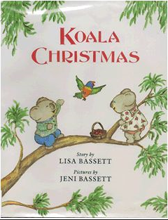

* * * * *

Section 2 - Featured Bassett: Stephen Richard Bassett, journalist and Civil War soldier

Stephen Richard Bassett descends from William Bassett of Plymouth as follows:

William Bassett and wife Elizabeth
Joseph Bassett (b. 1635) and wife Mary Lapham
William Bassett (b. 1667) and wife Sarah Sweetland
William Bassett (b. 1694) and wife Thankful Briggs
Jotham Bassett (b. 1738) and wife Neoma Newland
Joel A. Bassett (b. 1786) and wife Mary Orpha Richardson
Isaac Joseph Bassett (b. 1815) and wife Julia Ann Clauharty
Stephen Richard Bassett (b. 1847)

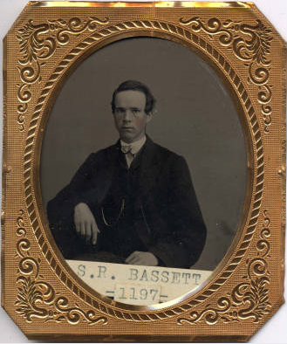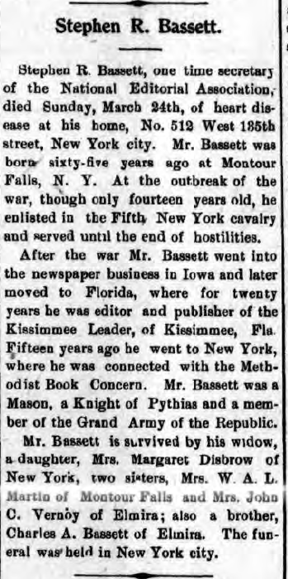

New York State Military Museum Photo Montour Falls Free Press
Wednesday, April 3, 1912

* * * * *

Section 3 - Featured Bassett: Larry L. Bassett of Bassett Pontiac GMC

Larry Lee Bassett descends from William Bassett of Plymouth as follows:

William Bassett and wife Elizabeth
William Bassett (b. 1624) and wife Mary Rainsford
William Bassett (b. 1656) and wife Rachel Willison
William Bassett (b. 1681) and wife Abigail Bourne
William Bassett (b. 1711) and wife Lydia Smith
Rufus Bassett (b. 1757) and wife Jedidah Handy
Nymphas Bassett (b. 1785) and wife Thankful Ann Bruce
Samuel Bassett (b. 1815) and wife Permelia Drake
Roscoe Owens Bassett and wife Grace Angeline Lee
Roscoe Larry Bassett
Larry Lee Bassett

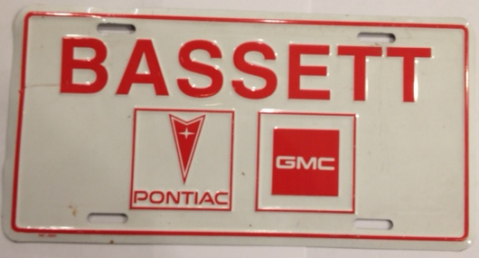
Bassett License Plate from Bassett Pontiac GMC from a visit there in the 1990’s.

The Star Press, November 27, 2016
Larry L. Bassett, 77 (1939-2016) (Picture included)

MUNCIE - Larry L. Bassett, 77, passed away Thursday, November 24, 2016.

He was born February 2, 1939 in Alexandria. He graduated from Alexandria High School in 1957 and married his middle school sweetheart Lonita (Friend) one year later.
After the sudden death of his father at a very young age, Larry was encouraged by a mentor to gain experience in accounting, finance, and sales to learn how to run a small business. These experiences led to a successful thirty-five-year career as a dealer principal of car and truck dealerships, including General GMC Truck Sales and Bassett Pontiac-GMC Truck. Throughout his career, Larry participated in The Junto Club, Ball State Business Roundtable, various car and truck industry organizations, and the GM President's Roundtable.
In addition to his wife, Lonita, Larry is survived by his son, Steve Bassett (Amy) of Muncie; his daughter, Susan Helfrich (Patrick) of Muncie; grandchildren, Rachel Danziger (Jeff) of Worthington, OH, Lindley Bassett of West Palm Beach, FL, Adam Helfrich (Jennifer) of West Lafayette and Max Helfrich of Muncie; one brother, Jerry Bassett (Georgia) of Alexandria; aunt, Mary Bassett of Alexandria; brother-in-law, Tom Friend (Pam) of Anderson; and several nieces, nephews, and cousins.
Larry was preceded in death by his parents Roscoe and Mildred (McCarty) Bassett.
Friends and family may call at The Meeks Mortuary, Mt. Pleasant Chapel, 7901 W. Isanogel Road from 4:00 p.m. until 7:00 p.m. on Monday, November 28, 2016.
In lieu of flowers, memorial contributions can be sent to The Community Foundation of Muncie and Delaware County, P.O. Box 807, Muncie, IN 47308-9901 or to the charity of the donor’s choice. .
Online condolences may be directed to the family at www.meeksmortuary.com.

* * * * *

Section 4 - Featured Bassett: Volney Love Bassett Family Photograph

Volney Love Bassett descends from William Bassett of Plymouth as follows:

William Bassett and wife Elizabeth
Joseph Bassett (b. 1635) and wife Mary Lapham
William Bassett (b. 1667) and wife Sarah Sweetland
William Bassett (b. 1694) and wife Thankful Briggs
Jotham Bassett (b. 1738) and wife Neoma Newland
John Bassett (b. 1765) and wife Eunice Smith
Jotham Bassett (b. 1801) and wife Jeanette Woodworth
Volney Love Bassett (b. 1833) and wife Adeline Foster

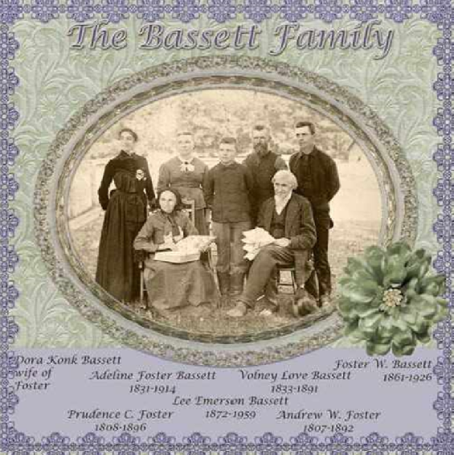
Volney Love Bassett Family Photograph from ancestry.com

* * * * *

Section 5 - Featured Bassett: “A Portrait Of Our Past” by Tony Bassett

Tony Bassett is descended from the #184B Bassetts of Chiddingstone, England as follows:

William Bassett (b. 1480)
John Bassett (b. 1509) and wife Joanne
Henry Bassett (b. 1542) and wife Joan Vane
Henry Bassett (b. 1572) and wife Joane Johnson
Henry Bassett (b. 1593) and wife Barbara Baker
William Bassett (b. 1620) and wife Mary
Edward Bassett (b. 1659) and wife Elizabeth Younge
Thomas Bassett (b. 1687) and wife Mary Ashbye
Thomas Bassett (b. 1702) and wife Elizabeth Johnson
Thomas Bassett (b. 1726) and wife Jane Snell
Henry Bassett (b. 1767) and wife Saran Peckham
Maria Bassett (b. 1821)
Edward Bassett (b. 1839) and wife Rebecca Bowler
Alfred Cuthbert Bassett (b. 1874) and wife Ethal Ada Hostler
Jack George Edward Bassett
Antony E. Bassett

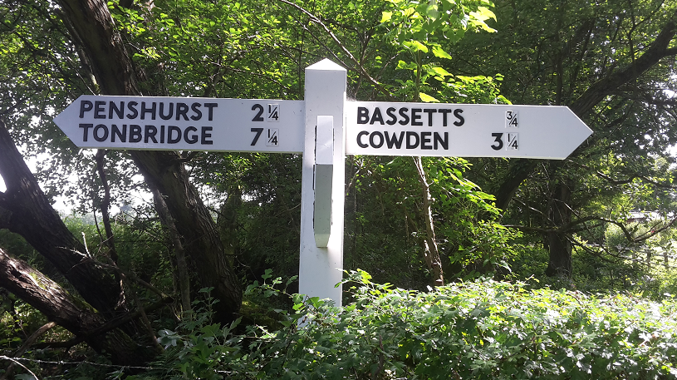
Less than a mile from Bassetts Farm House at Chiddingstone is a signpost to help visitors find the historic building. Picture provided by Tony Bassett

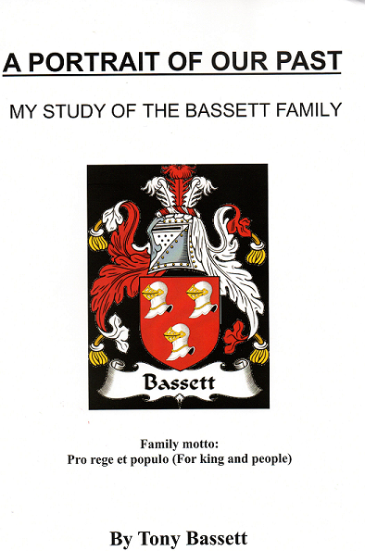
I was very delighted to receive a new book about the Bassett family in the mail this week. This book covers the ancestors of Tony Bassett of England. He has spent ten years researching his line of the family. He descends from Henry Bassett of Chailey, Sussex, England which was originally my #258 Bassett line. He has now linked his family to the #184B Bassetts of Chiddingstone.

* * * * *

Section 6 - Featured Bassett: Confederate Soldier Clement Newton Bassett of Texas

Clement Newton Bassett descends from William Bassett of Plymouth as follows:

William Bassett and wife Elizabeth
William Bassett (b. 1624) and wife Mary Raynesford
Nathan Bassett (b. 1667) and wife Mary Huckens
Fortunatus Bassett (b. 1742) and wife Mary Bassett
Fortunatus Bassett (b. 1775) and wife Sybil Bacon
Clement Newton Bassett and wife Julia Ann Beale
Clement Newton Bassett (b. 1842)
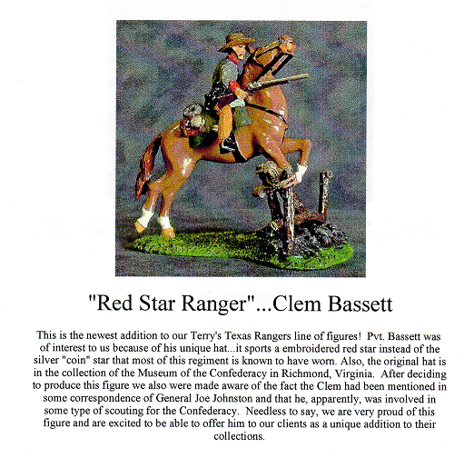
A HISTORY OF TEXAS AND TEXANS by FRANK W. JOHNSON
VOLUME III (1914)

Captain Clement Bassett. Among Texas veterans of the Confederacy there is not one whose name shows more enthusiasm and fine affection for his character than Captain Clem Bassett of Richmond. He made a splendid record during the war and in the years of quiet Citizenship which have ensued since that great struggle, his part has not been less faithful in performance and strong in achievement. There is a history of the Civil war published by the United States government, in a great many large volumes, and believed to be the largest individual work on one subject ever published. In all the thousands of pages which recount the operations of the contending army during the four years of war in the south, it is said that the name of only one private soldier is mentioned for special distinction, and that name is Clement Bassett.
Fort Bend county feels especial interest and proprietorship in Captain Bassett since he was the first white male child born in the old town of Richmond, and is now the oldest native citizen. He was born at Richmond January 7, 1842. He is the son of Clement N. and Julia (Beale) Bassett. His father and mother came from Virginia shortly after the battle of Jan Jacinto, and were married in Harris county this state. Captain Bassett's maternal grandmother was a member of the famous Lee family of Virginia, and a cousin of General Robert E. Lee. She was an F.F.V. Bob Beale, a brother of Captain Bassett's mother took part in the Mier expedition, which has a chapter to itself in every Texas history, and in the battle of Mier he was shot and left for dead in the street. But that night he started on his way home on foot, arriving barefooted and ragged.
The father of Captain Bassett was for a number of years a lawyer in Richmond, and is the sole survivor of five children. The others of the family were Winfred, wife of George Chambers; Robert Edwin, and Russell. He remained home during the period of his boyhood, and on September 7, 1861, at the age of nineteen, joined the Eighth Texas Cavalry, which was a part of Terry's Texas Rangers. The regiment first went to Kentucky, was sent to Corinth, Mississippi, took part in the battle of Shiloh, next went to Murfreesborough, and Captain Bassett was a participant in practically every battle of the western army and fought in fully a thousand skirmishes. His battle record includes the engagements at Perryville, Chattanooga, Missionary Ridge, Atlanta, Lookout Mountain, Savannah and others. His first wound came at Eagleville, Tennessee, and at Aiken, South Carolina, he was shot in the back of the head by a minie ball. He was wearing a fine broad-brimmed Spanish hat. The bullet went through a silver ornament, a thick cord and the hat and, after shattering the skull, imbedded itself in the outer covering of the brain. The bullet was removed by the field surgeon, and the captain then spent six weeks in the hospital. He continued to suffer from this wound for twenty years after it had been inflicted. The war ended while Captain Bassett was off duty as the result of this wound.
Among the old soldiers of the south, there was never one who was associated with Captain Bassett who did not give him the highest tribute as to his gallantry and courage and individual efficiency. The occasion of his being mentioned in the voluminous work pertaining to the Civil war, as related above, was the capture of a battery at Murfreesborough, an exploit in which he was chiefly responsible, and for which he was voted a medal by the Confederate Congress. Owing to the outcome of the war, this medal was never struck nor bestowed. Captain Bassett was a warm personal friend of the late Joe Wheeler, and a deep mutual admiration subsisted between the two, though differing widely in official rank. It is related that on one occasion General Wheeler openly applauded this gallant Confederate soldier. This occurred at Sandersville, Georgia, when Bassett led a brave charge against the enemy, and his dashing courage caused General Wheeler to toss his hat in the air and shout "Three cheers for Clem Bassett."
After the war, and on his return to Richmond, Captain Bassett began his career as a farmer and stock raiser, and for twenty years was in the mercantile business at the old town of Richmond. He finally retired two years ago on account of ill-health, and now enjoys a quiet prosperity and lives among his friends and associates of many years. He has been prosperous in business, has acquired considerable property, and in April, 1913, finished a very elegant and beautiful residence in Richmond.
In October, 1869, Captain Bassett married Miss Lida Moore, a sister of the present Congressman from this district in Texas, and a daughter of Dr. Matt Moore of Alabama. Mrs. Bassett died with her first child, and she and her baby were buried on her first wedding anniversary. Fifteen years later Captain Bassett married Miss Libbie Mitchell of Fort Bend county, and a daughter of Captain John C. Mitchell, who was an eminent lawyer and pioneer citizen of this part of the state. Six children were born to this marriage and four are now living. One son, Clement Bassett Jr., died on year ago at the age of twenty-one, and his death was a severe blow to his devoted father. A daughter, Winnie, died at the age of two years. The living children are: Eleanor, wife of H.L. Williams, a resident of St. Louis; Robert, who is studying law at Austin; Winston and Gerald who are in school. Mr. and Mrs. Bassett are members of the Baptist church, in which he is a deacon. He is life commander of Bassett's Camp of the United Confederate Veterans at Richmond, this camp being named for him and in itself being the finest tribute that could be paid by veterans to one of their living comrades. Captain Bassett still has as a most prized xxx the Spanish hat which is perforated by the ball which so nearly put an end to his career. Captain Bassett has had many honors offered him, some of which he xx declined and others accepted, so far as private circumstances and opportunity allowed him to serve his community. In 1890 the county placed him on the ballet for sheriff by acclamation, and he subsequently served four years as tax collector.

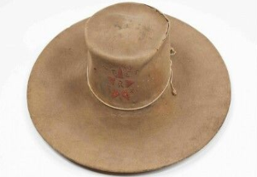
Clement Newton Bassett hat
Museum of the Confederacy, Richmond, Virginia

* * * * *

Section 7 - Featured Bassett: Detailed DNA testing of the Bassetts of Cornwall

Nevile Bassett of Australia has led work to reconstruct the Bassett family tree of Cornwall using results from our DNA testing. Using our 37-marker y-chromosome tests, some BIG-Y tests, and SNP tests on specific markers, we now have the following tree showing how the different Bassetts branches from Cornwall are related. We have now expanded the testing to include a few test kits from Devonshire as well to see if they might fit into this tree. Results will be reported once we have feedback from the testing lab.

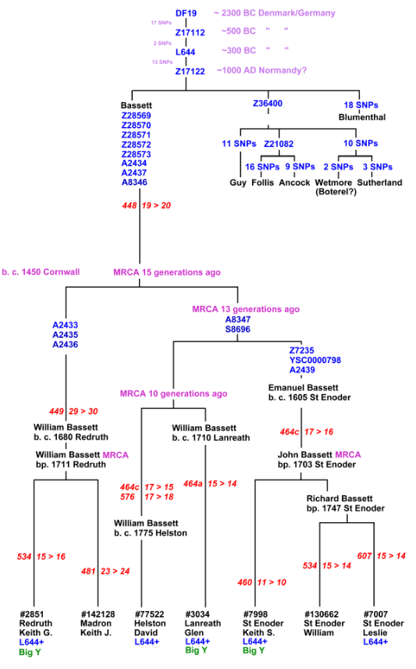
Section 8 - New family lines combined or added since the last newsletter

The following family lines have been combined/eliminated since the last newsletter.

109B. Bassetts of Wayne County, NY into the #1A William Bassett of Plymouth family line
258B. Henry Bassett of Chailey, Sussex into the #184 Bassetts of Chiddingstone, Susssex England line
373B. Richard Bassett of Holsworthy, Devon has been combined into the #285B William Bassett of Devonshire line
393B. James Bassett of Bigbury into the #316B Bassetts of Thornbury, Devonshire

The following family lines have been added since the last newsletter.

279B. Andre Bassetti/Bassett of California and Utah
507B. Samuel Bassett of Devonshire, England

* * * * *

Section 9 - DNA project update.

Two new kits were ordered this month. No new results to report.
Donations of any amount can be made to the Bassett DNA project by clicking on the link below. Any funds donated will be used to fund select Bassett DNA tests that will further our project as a whole and benefit all Bassetts worldwide.

http://www.familytreedna.com/group-general-fund-contribution.aspx?g=Bassett
This is just a reminder that the DNA portion of the Bassett Family Association can be found at:

A current spreadsheet of results can be found at:
http://www.bassettbranches.org/dna/BassettDNA.xls
If you don't have Excel and can't open the spreadsheet above, you can now see the DNA test results at the following website.
http://www.familytreedna.com/public/Bassett/
Jeffrey Bassett
520 Salceda Drive
Mundelein, IL 60060 USA
bassettgenealogy@gmail.com

