Bassett Family Newsletter, Volume XIV, Issue 6, 19 Jun 2016

(1) Welcome
(2) Abbot Bassett scrapbook pictures (2 of 3)
(3) Frederick William Bassett and his wife’s school chum
(4) Margaret (Bassett) Johnson, actress, singer and model
(5) Four generation picture of Eliza Bassett Warner and family
(6) Family photo of Albert Moses Bassett of Lawrence, Massachusetts
(7) Autobiography of Edward Murray Bassett
(8) New family lines combined or added since the last newsletter
(9) DNA project update

Section 1 - Welcome

With the beginning of warm weather, I continue to struggle getting my research done in a timely manner and getting each month’s newsletter ready for publication.

Totals number of individuals loaded into the Bassett website: 140.470

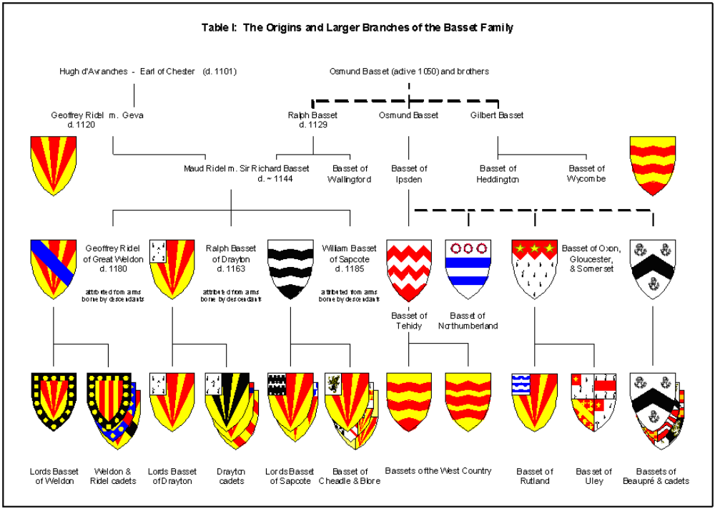

Section 2 - Featured Bassett: Abbot Bassett Family Scrapbook pictures (2 of 3)

Abbot Bassett descends from #4B William Bassett of Lynn, Massachusetts as follows:

William Bassett (b. 1624) and wife Sarah Burt
William Bassett (b. 1647) and wife Sarah Hood
John Bassett (b.1682) and wife Abigail Berry
Zephaniah Bassett and wife Mary
Edward Bassett (b. 1742) and wife Huldah Cleverly
Samuel Bassett (b. 1775) and wife Elizabeth Scott
Edward Bassett (b. 1809) and wife Clara Jane Morgan
Abbot Bassett (b. 1845 Chelsea)

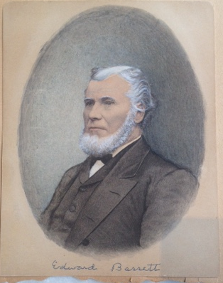
Edward Bassett, father of Abbot Bassett

Abbot was at one time the president of the Bassett Family Association (1899) and served as secretary of the League of American Wheelman.

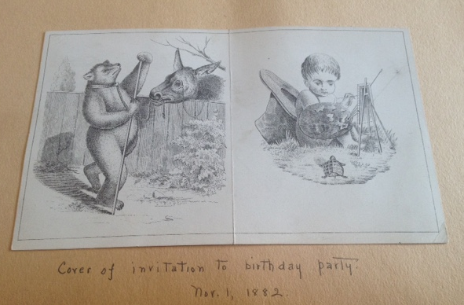
Birthday Card Invitation, November 1, 1882

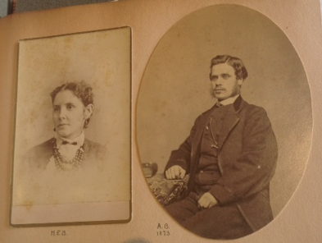
Abbot Bassett and wife Helen, 1873 (They were married in 1873)

* * * * *

Section 3 - Featured Bassett: Frederick William Bassett and his wife’s School Chum

Frederick William Bassett descends from #180 William Bassett of Hadlow, Kent as follows:

William Bassett
William Bassett (b. 1683) and wife Ester Sheath
John Bassett (b. 1711) and wife Elizabeth Philpot
John Bassett (b. 1744) and wife Elizabeth Bennet
James Bassett (b. 1770) and wife Mary Seager
George Bassett (b. 1808) and wife Sarah Knight
Charles Bassett (b. 1840) and wife Ann Parsons
William Bassett (b. 1863) and wife Helen Buchler
Frederick William Bassett (b. 1887)

It is interesting to note that in the 1930 census, Frederick can be found with new wife Cora and Louise and son Fred are living nearby. Louise is listed as a widow in the 1930 census.

Denver Rocky Mountain News, Sunday, February 1, 1920
Woman Charges Her School Chum Stole Husband
Special to the News.

NEW YORK, Jan. 31 – Mrs. Louise K. Bassett, who formerly lived at 8920 One Hundred and Seventeenth street, Richmond Hill, but whose present residence is 242 East Eighty-seventh street, Manhattan, is plaintiff in an action for divorce from her husband, Frederick William Bassett, a former well-known business man of Richmond Hill, the facts of which are being tried before a jury in Part II, of the Queens county Supreme court.
In her complaint Mrs. Bassett alleges that she was married on Feb. 15, 1900, and that she lived happily with her husband at Richmond Hill until, in August last, she invited her former school chum, Mrs. Cora Whalen, to come and visit her. Immediately upon entrance of the latter into her home, Mrs. Bassett alleges, her husband became violently in love with her and within a few days told her, Mrs. Bassett, that she could move out of the house as soon as she desired, but that Mrs. Whalen was going to remain. Mrs. Bassett alleges that after a short time she did leave and Mrs. Whalen remained.
Bassett has denied the allegations of his wife and he has also charged that his wife was friendly with Isador Wolin, a business man of 395 Broadway, Manhattan. He alleges that Mrs. Bassett and he took frequent automobile trips while they were at Bradley Beach. Wolin has denied the allegations that Bassett makes and he is represented at the trial.

* * * * *

Section 4 - Featured Bassett: Margaret (Bassett) Johnson, actress, singer and model

Margaret Bassett descends from #2B Thomas Bassett of Virginia as follows:

Thomas Bassett (b. 1617) and wife Mary
William Bassett (b. 1643) and wife
Thomas Bassett (b. 1668) and wife Elinor
Thomas Bassett (b. 1696) and wife Lydia Howle
Nathaniel Bassett (b. 1721) and wife Mary
Burwell Bassett (b. 1767) and wife Mary Hunter
George Hairston Bassett (b. 1806) and wife Columbia Renfro Staples
Alexander Martin Bassett (b. 1853) and wife Molly Settles
Rev. Wallace Bassett (b. 1884) and wife Lottie Bounds
Margaret Bassett and sister Evelyn Elaine Bassett

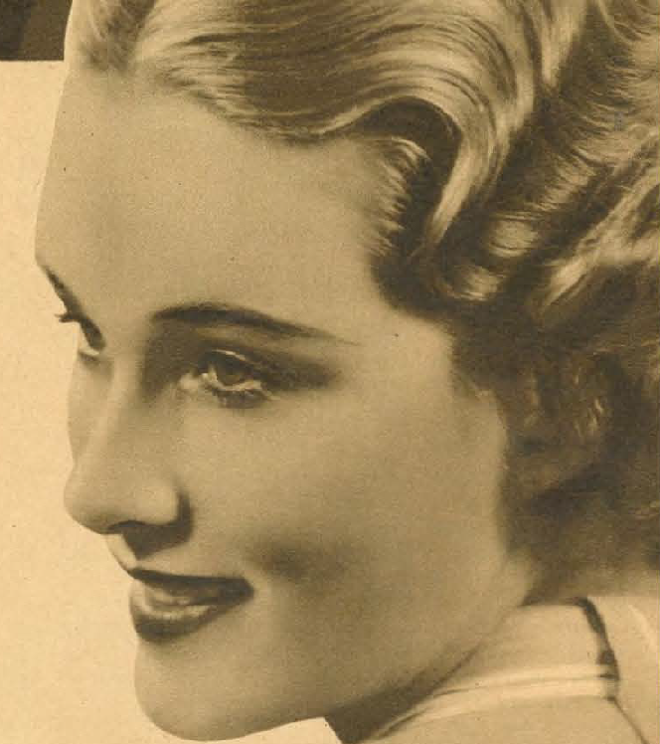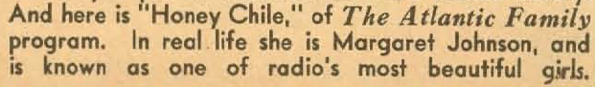

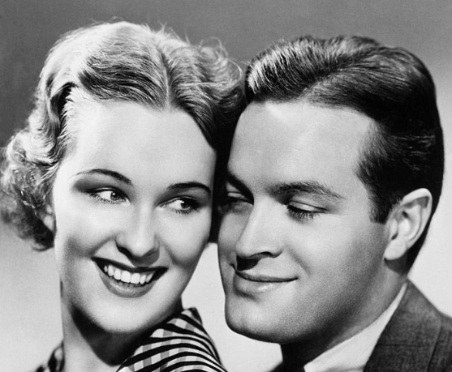

“Honey Chile” Margaret (Bassett) Johnson and Bob Hope about 1938

Dallas Morning News, Thursday, July 25, 1940
Bassett Family To Hold Reunion

A family reunion will be held this week end at the home of the Rev. Wallace Bassett, 219 Montreal, when Mr. Bassett’s four children will meet in Dallas.
Mrs. Travis Johnson, New York City, and her son, Wallace Henry Johnson, arrived Tuesday. Mr. and Mrs. John J. Selig Jr., New York City arrived by plane Wednesday and Mrs. Wesley Tomlinson, New Orleans, also arrived Wednesday. Dr. and Mrs. Wallace H. Bassett, Houston, will be in Dallas Saturday to complete the family gathering.
Mrs. Johnson, who has been a photographer’s model in New York City for several years, as has Mrs. Selig Jr., was pictured in eight color pages in the July issue of American Magazine as a typical model.

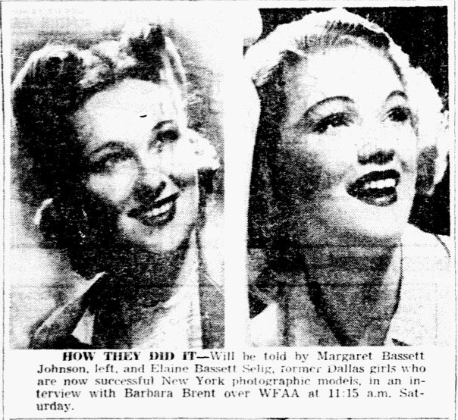
Dallas Morning News article about Margaret (Bassett) Johnson and Elaine (Bassett) Selig
Saturday, July 27, 1940

Dallas Morning News, 3 Jun 2007
Margaret Bassett Johnson (picture included)

Margaret Bassett Johnson, 99, Musician, Model, Radio & TV Personality, a resident of Walnut Place, Dallas, died peacefully on May 27, 2007. Born Marcella Margaret Bassett, October 24, 1907 in LaGrange, Missouri, she was the oldest child of Rev. Wallace Bassett and his first wife, Charlotte. A skilled pianist at an early age, Margaret attended Hannibal-LaGrange College in Missouri and Baylor University in Waco, graduating in 1928 and marrying young tenor and fellow graduate Travis Johnson of Troup, Texas. The couple moved to New York City in 1931 to pursue musical careers. In New York, tall, blond Margaret quickly found work as a model and appeared regularly in newspaper and national magazine ads. In 1936, she joined the Bob Hope radio show as "Honey Chile." She turned down a Hollywood contract to remain in New York with her husband where they organized the Song Spinners quartet, providing musical backgrounds for "The Wayside Cottage," a radio show dramatizing early American folk Ballads. Here Johnson emerged as one of New York's top vocal arrangers. In 1943 the Song Spinners had two hit records on the Decca Label, "You'll Never Know," backing up crooner Dick Haymes and their own "Comin' in on a Wing and a Prayer." Margaret and the Song Spinners did similar work with Bing Crosby and Ella Fitzgerald, and performed on numerous radio shows of the 40's and 50's, including "Melody Roundup with Roy Rogers and Andy Devine, "The Henry Aldrich Show," "The House of Mystery" and the "I'd Walk a Mile" quiz show with Bill Cullen. From 1949 to 1952 Johnson hosted her own daily television show in New York, the "Maggie Johnson, Television Shopper Show," interviewing guests and demonstrating new household products. By the mid 1950's, Johnson was a prominent composer-lyricist of jingles, creating musical identities for many products including the highly successful "Winston taste good, like a (clap clap) cigarette should." This was named one of the ten job jingles of the twentieth century by Advertising Age Magazine. Margaret retired to Dallas with her husband in 1967 and was widowed in 1970. Then she began her final career as a volunteer pianist for organizations throughout Dallas, giving hundreds of sing-along performances at numerous senior rest homes, including Walnut Place, where she became a resident in 2004. Margaret Bassett Johnson is survived by her brother, Dr. Wallace Bassett of Dallas, her three children, Wallace "Hank" Johnson of Westminster, MD, Janet Presswood of Dallas, and Claudia Orpin of Long Beach, CA, grandchildren Dan Stover, and Dr. Scott Stover and Joshua Orpin of Dallas, Dr. Amy Lungren and Jennifer Lawton of Lewisville, TX, Christine Dyer of Vina del Mar, Chile, Mark Johnson of New York, NY, Brian Johnson of Union Bridge, MD, and Maggie Orpin of Huntington Beach, CA as well as great-grandchildren Peter and Janet Lawton, Nathan, Andrew and Matthew Lungren and Kimberly Orpin. A memorial service will be held at 2 PM, June 16th at Cliff Temple Baptist Church, 125 Sunset Av. Dallas, TX 75208.

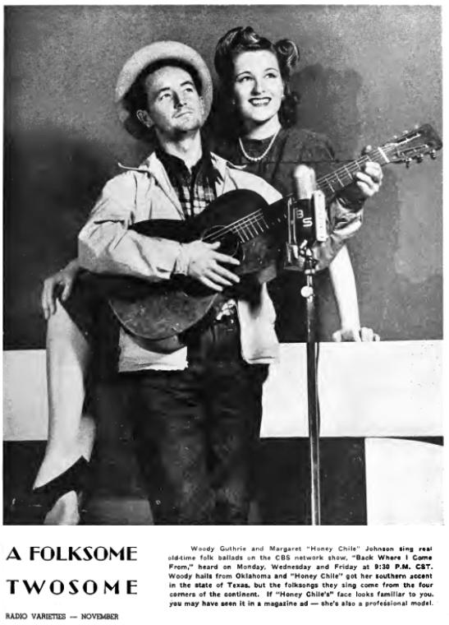
Woody Guthrie and Margaret (Bassett) Johnson

* * * * *

Section 5 - Featured Bassett: Four generation picture of Eliza (Bassett) Warner

Eliza Bassett descends from #1B John Bassett of Connecticut as follows:

John Bassett and wife Margery
Robert Bassett and wife Mary
Robert Bassett (b. 1640) and wife Elizabeth Riggs
Samuel Bassett (b. 1692) and wife Deborah Bennett
John Bassett (b. 1721) and wife Naomi Wooster
Truman Bassett (b. 1764) and wife Annie Pangbourne
George Bassett (b. 1803) and wife Sarah Russell
Eliza Bassett (b. 1830) and husband Theron Warner

Unknown Newspaper clipping, May, 1925
Mrs. Theron Warner

Mrs. Eliza Basset Warner, widow of Theron Walker, formerly of Homer, N.Y., died at the home of her daughter, Mrs. George Walker in Marathon, Tuesday, May 26th at the age of 95 years.
Mrs. Warner was born in Connecticut and was married there to Theron Warner in 1852. Soon after their marriage they came to Homer to reside where her husband died 35 years ago. She is survived by 5 children – two, Frank Warner and Mrs. Duane Fish living in Homer; Mrs. Richard McIntyre living in Los Angeles, Cal.; Mrs. Sylvester Wheeler, Syracuse; Mrs. George Walker, Marathon. There are also 15 grandchildren, 28 great-grandchildren and 4 great-great-grandchildren; there are also two sisters, Mrs. Joel Houch of Wallingsford, Conn. and Mrs. Henrietta Bassett of Bridgeport, Conn.
The funeral services were held at the home of her daughter Mrs. Fish of Homer, Thursday, May 28th. Undertaker Emens of Marathon in charge and Rev. L.L. Vought, pastor of the Methodist Church of Marathon, officiating. Burial was made in the Atwater cemetery.
Card of Thanks
We wish to thank the friends and neighbors for their many acts of kindness shown us during the illness and death of our mother and grandmother; also for the flowers and the words of sympathy spoken by Rev. L.L. Vought.
Mr. and Mrs. George Walker, James Walker.

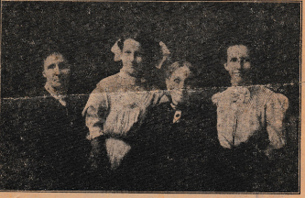
News article provided by Nancy Emery

A Group Of Four Generations (Picture included)

The above half tone represents four generations: Mrs. Eliza A. Warner, aged 80 years; Mrs. Lillian M. Wheeler, aged 57 years; Mrs. Walter D. Shirley, aged 38; and Miss Esther Shirley, aged 15.
Eliza A. Bassett, daughter of George and Sarah Bassett, was born at Stratford, Conn., 1830. In 1851 she was married to Theron B. Warner of Preble by the Rev. Mr. Pratt at Oxford, Conn. After about two years and a half they moved to New York state and bought a farm on Rice Hill where they resided until the death of Mr. Warner about 20 years ago, since which time Mrs. Warner has lived with her children, five in number, all of whom are living, and of which four were present to help her celebrated her 80th birthday feb.9, at the home of her daughters, Mrs. A.D. Fiske in Homer. Despite her many years, Mrs. Warner is very active, performing many duties about the house, and can see to read nicely without the aid of spectacles.
Mrs. Lillian M. Wheeler, her oldest daughter, was born near Waterbury, Conn., in 1853, coming to this state with her parents in her infancy, where she has since resided. In 1869 she was married to David H. Anthony. She has five living children, Mr. Anthony having died about eight years ago. She has since married Mr. Sylvester Wheeler and lives in Syracuse. Her daughter, Mrs. Walter D. Shirley, was born in Scott in 1872, and lives in Cortland at the present time, where her daughter, Miss Esther L. Shirley was born in 1895.

* * * * *

Section 6 - Featured Bassett: Family photo of Albert Moses Bassett of Lawrence, Massachusetts

Albert Moses Bassett descends from #14B Jean Besset of Quebec as follows:

Jean Besset (b. 1642) and wife Anne Seigneur
Francois Besset (b. 1685) and wife Marie Dubois
Clement Bessette (b. 1728) and wife Marie Langureux
Joseph Bessette (b. 1765) and wife Anne Lalanne
Pierre Pascal Bessette and wife Marguerite Stanislas
Moses Bassett (b. 1846) and wife Alfreda Turgeon
Albert Moses Bassett (b. 1878)

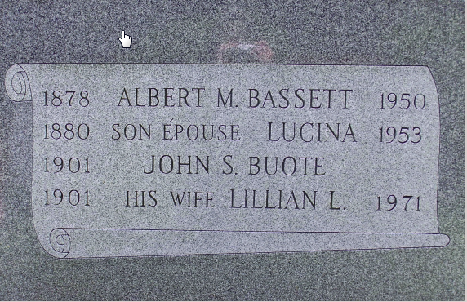
Sacred Heart Cemetery, Andover, Essex County, Massachusetts

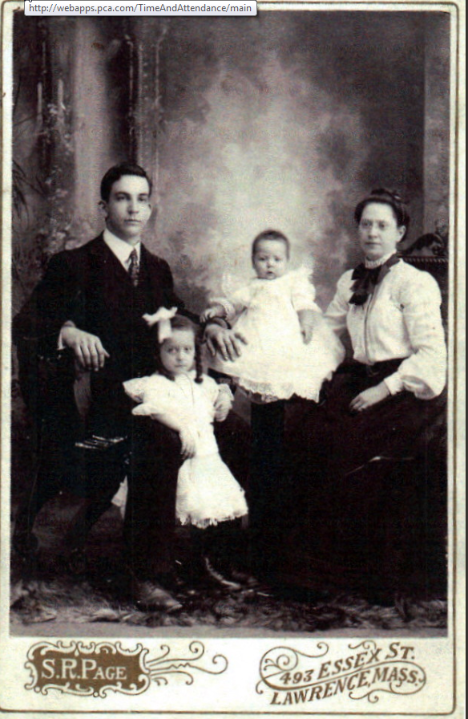
Albert Moses Bassett, Lilian, George and wife Lucina

* * * * *

Section 7 - Featured Bassett: Autobiography of Edward Murray Bassett

Edward Murray Bassett descends from William Bassett of Plymouth, Massachusetts as follows:

William Bassett and wife Elizabeth
William Bassett (b. 1624) and wife Mary Raynesford
William Bassett (b. 1656) and wife Rachel Williston
William Bassett (b. 1680) and wife Abigail Bourne
Elisha Bassett (b. 1714) and wife Ruhamah Jennings
Lot Bassett (b. 1755 and wife Deborah Howes
Francis Edward Bassett (b. 1796) and wife Mehitable Ford
Charles Ralph Bassett (b. 1836) and wife Elvira Rogers
Edward Murray Bassett (b. 1863) and wife Annie Rebecca Preston

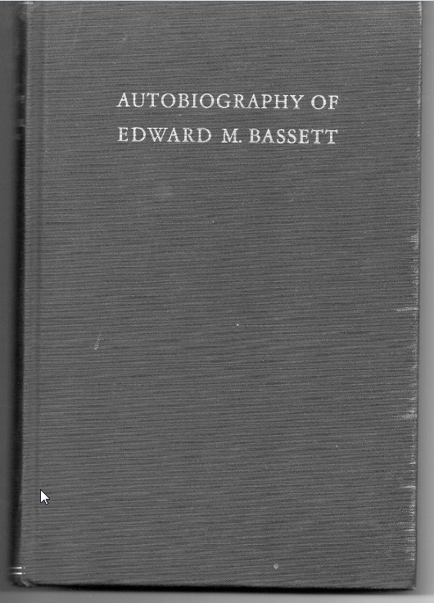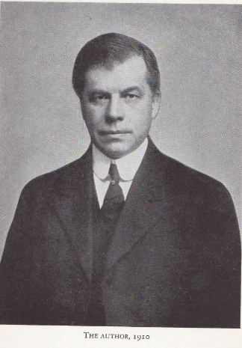

Earlier this month, I purchased the above book about Edward Murray Bassett on ebay.

The New York Times, Thursday,
Edward Bassett, Father of Zoning (picture included)
Lawyer Who Led Movement for Ordinance Here in 1916 Dies - Ex-Congressman

Edward Murray Bassett, a lawyer known as the "Father" of American zoning, former Congressman and Public Service Commissioner, died yesterday in his home at 1716 Newkirk Avenue, Brooklyn, after a brief illness. His age was 85.
Mr. Bassett was the chief author of and primary mover in bringing into being the first comprehensive zoning ordinance in the United States regulating the use, height and area of buildings. That ordinance, which became a model for the rest of the country, was adopted by the New York Board of Estimate in 1916.
Over many years he and associates fought a continuing battle which made the Manhattan skyline, with its attractive towers and setbacks, a thing of beauty instead of the horror it might have been if unregulated. He wrote numerous zoning ordinances for other municipalities and successfully labored for more than thirty years, in legislatures, courts and public debate, for an orderly development of zoning throughout the land.
Born in Brooklyn, a son of Charles R. and Mrs. Elvira Rogers Bassett, Mr. Bassett received an A.B. Degree from Amherst College in 1884 and taught school in Brooklyn while attending Columbia University Law School, from which he was graduated in 1886. He had practiced law here since 1892. He was a member of the law firm of Bassett, Thompson & Gilpatric here from 1902 to 1942, and, with his son, Howard M. Bassett of Rockville Centre, L.I., a member of Bassett & Bassett, 233 Broadway, from 1942 until his death.
Mr. Bassett was a member of Congress from Brooklyn in 1903-1905. He was a member of the Kings County Democratic General Committee for three years. By appointment of the late Charles E. Hughes, then Governor of New York, he became a member of the Public Service Commission in 1907, serving until 1911.
The lack of regulation of buildings led to the formation of a City Height of Building Commission in 1913, with Mr. Bassett as chairman.
In 1916, as chairman of the City Commission on Building Districts and Restrictions, he submitted to the Board of Estimate what became the city's first zoning ordinance, made law last year. From 1916 to 1946 Mr. Bassett was counsel to the Zoning Committee of New York. Later he served as counsel to the New York Zoning commission, the Regional Plan of New York and Its Environs and the old City Planning Commission. He also had been a member of the Advisory Committee on City Planning and Zoning appointed by Herbert Hoover, then Secretary of Commerce, and president of the National Conference on City Planning.
In 1943 leaders in the architectural and community planning fields called Mr. Bassett the "father of zoning and the best-known authority on this subject in America" when they presented to him their Medal of Honor for City Planning, which had been awarded only twice before, in 1939 to George McAneny and in 192? to John D. Rockefeller.
Besides his son, he leaves another son, Preston R. Bassett of Rockville Centre; three daughters, Mrs. Marion B. Luitweiler of New York, Mrs. Isabel B. Wasson of River Forest, Ill, and Mrs. Helen Hauser of Short Hills, N.J.; and brother, George Bassett of Buffalo; a sister, Mrs. Mary Harrington of Buffalo; fifteen grandchildren and five great-grandchildren.
A funeral service will be held at ? P.M. tomorrow at the Flatbush-Tompkins Church, Brooklyn. Burial will be in Ashfield, Mass.

* * * * *

Section 8 - New family lines combined or added since the last newsletter

No new families added and no families combined this month.

* * * * *

Section 9 - DNA project update.

No new results to report on the Bassett DNA project.
Donations of any amount can be made to the Bassett DNA project by clicking on the link below. Any funds donated will be used to fund select Bassett DNA tests that will further our project as a whole and benefit all Bassetts worldwide.

http://www.familytreedna.com/group-general-fund-contribution.aspx?g=Bassett
This is just a reminder that the DNA portion of the Bassett Family Association can be found at:

A current spreadsheet of results can be found at:
http://www.bassettbranches.org/dna/BassettDNA.xls
If you don't have Excel and can't open the spreadsheet above, you can now see the DNA test results at the following website.
http://www.familytreedna.com/public/Bassett/
Jeffrey Bassett
520 Salceda Drive
Mundelein, IL 60060 USA
bassettgenealogy@gmail.com

