Bassett Family Newsletter, Volume XIII, Issue 8, 16 Aug 2015

(1) Welcome
(2) First Bassett Family Reunion of America held in 1897
(3) Bassett Park, Roma, Queensland and Roma Winery
(4) Obituary for Charles Edward Bassett, airline pilot
(5) Oil Paintings of Mary Kate (Colchester) Bassett
(6) Mark Bassett of California
(7) Pierce Bassett Lacrosse Jersey for sale on ebay
(8) New family lines combined or added since the last newsletter
(9) DNA project update

Section 1 - Welcome

No new trees were added this month. I hope to finally sort out the #151B Bassett line in the next few months.

Work travel continues with two more trips to Waco, Texas and 3 more trips to Boise, Idaho in the next month.

I would also like to thank Rick and Jennifer Bassett of North Haven, Connecticut. On my recent trip to Connecticut, I met them for dinner and a walk through the local cemetery. Upon my return home, they had sent me a copy of the Bicentennial History of North Haven, Connecticut that contains dozens of stories and pictures about the Bassett family of North Haven, most descended from #6B William Bassett of New Haven, Connecticut.

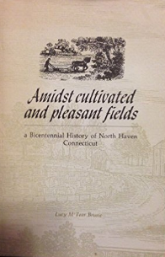

* * * * *

Section 2 - Featured Bassett: First Bassett Family Association Reunion of 1897

The Bassett Family organized a Family Association back in 1897 and held their first reunion at Hill’s Homestead at Savin Rock. I was recently in North Haven, Connecticut and had dinner just a few blocks from the where the reunion was held. I decided to dig through my material to see what else I might have on the reunion.

I

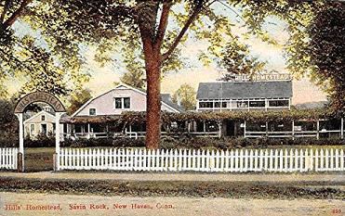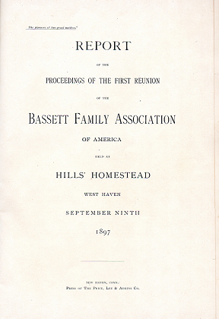

:Hill’s Homestead at Savin Rock Postcard First Bassett Family Association Reunion Report

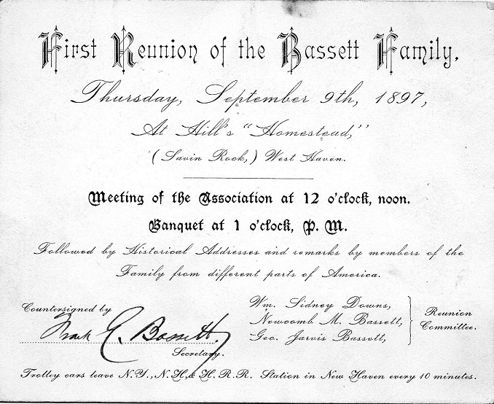
First Reunion of the Bassett Family invitation

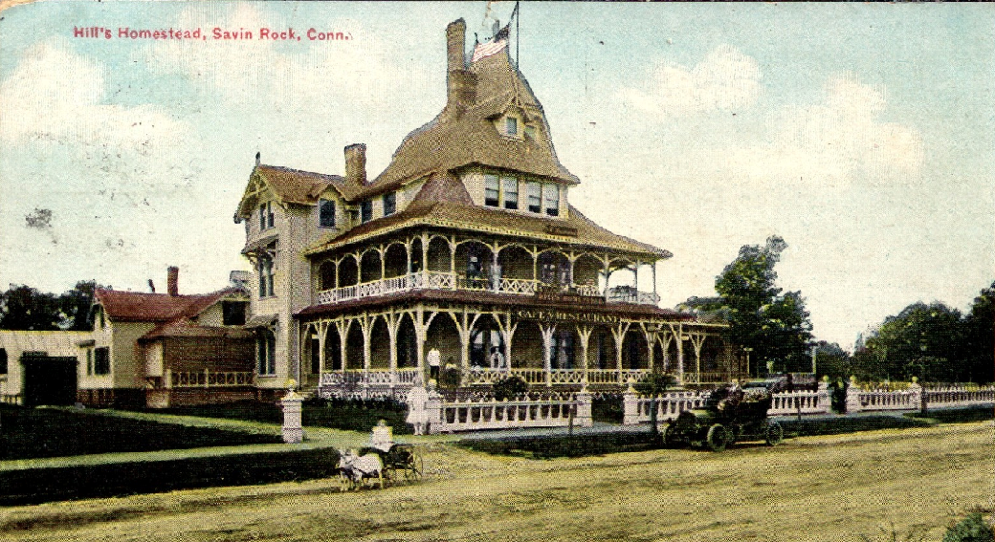
Hill’s Homestead, 445 Beach Street, East of Campbell Ave
(Picture provided by Rick Bassett)

In 1850 Aldren and James Hill purchased the old Allen’s Tavern and named it “Hill’s Homestead. It was acquired many years later by John St. Lawrence who retained the name. It was relocated a few blocks east of the elegant brick Anderson home, on the corner of Peck Ave. This was a temporary measure while the original building was being renovated. In its last years before demolition the old Homestead was acquired by Bob Tiernan who changed the name to Tiernan’s Old Homestead. In numbered among many of its famous guests such names as Casey Stangel, George Weiss, Jimmy Durante and Bob Hope.
* * * * *
Section 3 - Featured Bassett: Romavilla Winery of Australia

Samuel Symons Bassett descends from #44B Emanuel Bassett of Cornwall as follows:

Emanuel Bassett and wife Grace
Thomas Bassett (b. 1628) and wife Lowdy
John Bassett (b. 1658) and wife Phillipa Rickard
John Bassett (b. 1703) and wife Alice Benallack
John Bassett (b. 1725) and wife Mary Roberts
William Bassett (b. 1761) and wife Mary Symons
William Bassett (b. 1800) and wife Philippa Batten
Samuel Symons Bassett

Samuel Symons Bassett and his winery were featured briefly in a previous newsletter. I was sent an article from an Australian newspapers letting me know that the Romavilla Winery of Roma, Queensland, Australia has closed. The following includes more information on this historic winery.

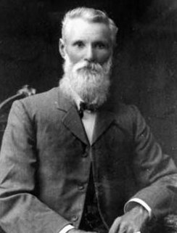
Samuel Symons Bassett, founder of Romavilla Winery
(Picture courtesy of State Library of Queensland)

Western Star and Roma Advertiser, Toowoomba, Saturday, 18 February 1922
An Important Local Industry
Romavilla Vineyards Limited

The Roma district has received much advertisement throughout Queensland and Australia from the high-class wines manufactured by the Romavilla Vineyards, Ltd., and much of the credit for the firm’s pronounced progress is due to the vision, energy, and enterprise of the founder, the late Samuel Symonds Bassett. In establishing Romavilla about 50 years ago, Mr. Bassett saw a great future for viticulture in the Roma district, and although at the time interested in other ventures, he eventually concentrated his activities to winegrowing and wine-making. From an original start of a few acres of vines, by his untiring energy and enterprise, he saw the vineyard grow until over 300 acres of vines were being cultivated before he passed away on Christmas Day, 1912. Starting in the very small way he did, it was some years before the Romavilla wines became established on the market, and the late Mr. Bassett himself used annually to travel to the far west and costal districts of Queensland to Normanton, placing his wines on the market in competition with those manufactured in the Southern States. The old saying, “Good wines needs no bush,” is very applicable, but it is not out of place to mention that at last Brisbane Exhibition the Romavilla wines were awarded 13 first prizes, 13 second prized, 7 third prized, 2 second championships and 2 third championships. As the result of Mr. Bassett’s pioneering work he was able to convert the firm into Romavilla Vineyards Limited, the shareholders being members of his family, and much of the responsibility of management, &c., was taken off his shoulders by his sons prior to his death, but nevertheless he took an active interest in operations up to the last.
The firm employs about 20 permanent hands, Mr. W.A. Bassett being manager and in charge of the cellar, and Messrs, Lionel and Kenneth traveling representatives. The grape and wine making industry has developed into one of the most important local industries, as will be seen from the following particulars gleaned by a representative of the “Star” who paid a recent visit to the well-known cellars.
Crushing operations were in full swing. A new crushing machine, capable of putting through 40 tons of grapes per day, has just been installed. The machine is driven by an 8-horse power oil engine, and three men are engaged where 12 where employed previously. While watching the crusher, a dray arrived from the vineyard with two casks of grapes, each holding half-a-ton. The dray backed up under the tackling, chains were attached, the casks were run along a steel rail, and the grapes tipped into the concrete receiver, which holds three tons. No delay occurred and the dray returned to the vineyard, where a large number of hands were engaged cutting grapes. After being deposited in the receiver, the grapes are forked by one man on to a continuously revolving elevator, from which they drop into the riddler, and then fall into the crusher. Three-inch hose pipes are connected with the must pump, which sends skins, seeds and juice into a reinforced concrete vat holding 1200 gallons. From the riddler the stalks all fall out on to a vehicle ready for carting out of the cellar. One man attends the engine and hose pipes.
After a certain period of fermentation the skins and seeds are put through a hydraulic press, after which process they are dried and eventually used for manurial purposes.
Many other important improvements have been installed during the last few months. Ten reinforced concrete vats, built 12 in. above the floor of the cellar, and each capable of holding 1120 gallons, have been added to the cellar, and a concrete cooler, capable of holding 1500 gallons, was being put down at the time, and two 10,000 gallons concrete storage tanks. The whole floor of the cellar, nearly two acres, has all been concreted, over 150 tons of cement having been used on this and the vats. After going into the cooler the must (unfermented wine) is placed in vats until it reaches a certain temperature and shows a certain percentage of sugar. Mr. Bassett explained that owing to the wet weather that had been experienced special attention had to be given, and this was also necessary when a particular class of wine was required.
The cellar contained about 100,000 gallons of wine before the present vintage, some of it being ten years old. It was expected that the present vintage would yield about 50,000 gallons. The wine is stored in concrete and large wooden vats, and a cooper is permanently employed. The improvements installed this year have cost the firm an expenditure of £3000, the work having been carried out under the supervision of Mr. H. Rees, and expert from Sydney.
The vineyard consists of 400 acres of vines of many varieties. These are constantly being renewed, and it has been found that the cuttings from the acclimated local varieties give much better returns than high-class imported varieties, many of which have been used for experimental purposes.

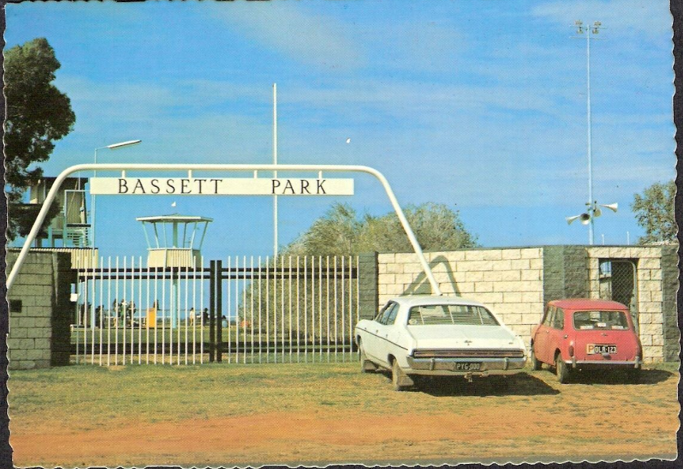
Postcard of Bassett Park Entrance, Roma, Queensland, for sale on ebay.

* * * * *

Section 4 - Featured Bassett: Charles E. Bassett, airline pilot

Charles E. Bassett descends from #165B George C. Bassett of New York as follows:

George C. Bassett (b. 1818) and wife Eliza Smith
Edward Cunningham Bassett (b. 1844) and wife Sylvia Ellen Westenhaver
Clark Bassett (b. 1888) and wife Lillian Delos Geer
Charles Edward Bassett (b. 1915)

Charles was my oldest Bassett contact, still receiving the newsletter via email at age 100.

TC Palm, July 26, 2015
Charles E. Bassett, Jensen Beach, FL (Picture included)

Capt. Charles E. 'Chuck' Bassett, long time resident of Jensen Beach, FL and Ridgefield, CT passed away on June 27, 2015. He was 100 years old on February 28, 2015.
He is preceded in death by his wife "Kit" of 63 years in July of 2003. Three sons, four grandchildren and 7 great grandchildren survive him.
After graduating from Purdue University with a degree in engineering he completed military flight training with the Army Air Corps in San Antonio, Texas. In 1940 Pan American World Airways hired him where he flew for 35 years.
As aviation progressed he flew the Douglas DC 3, the Boeing and Consolidated flying boats and a number of other aircraft up to and including the Boeing 707 and 747. He retired from Pan Am in 1975. During his career he was on several engineering committees representing the airline pilot group. One of which involved the Supersonic Transport or SST. During a demonstration flight at the Paris Air Show he flew the Concorde. His love of flying never took precedence over the love he had for his family.
After retirement during the summer he continued flying his Republic Sea Bee in the North East. His winters spent in Jensen Beach involved many hours fishing in the Indian River and playing poker with friends at his condominium's clubhouse.
His burial will take place in his hometown of La Porte, Indiana.
* * * * *

Section 5 - Featured Bassett: Oil Paintings of Mary Kate (Colchester) Bassett

Mary (Colchester) Bassett is related to the #473B Henry Bassett of England as follows:

Henry Bassett (b. 1806) married Maria
Henry Bassett (b. 1838) married Mary Kate Colchester

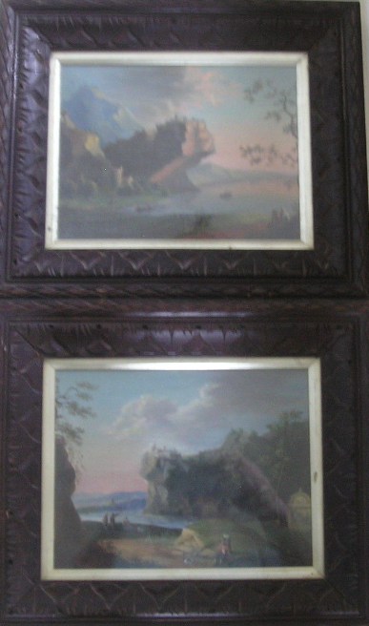
Paintings for sale on ebay.

This is a pair of superb oil paintings painted by MARY KATE BASSETT (nee COLCHESTER) featuring a part of DRESDEN in the late 19th century. The label on the back of both is hand written saying 'Copied in Dresden by M.K. Bassett in black ink and in blue ink is the name 'Colchester' . The paintings are in a carved BLACK FOREST frame and measure 13" x 11" with the frame. A BRIEF HISTORY ABOUT THE ARTIST. She was born in 1846 in Ipswich, Suffolk in 1846 and went on to marry a prominent chemist from ST. PANCREAS, HENRY BASSETT in 1879. They had three children namely DOCTOR HENRY BASSETT (Professor of Chemistry, University College, Reading, KATE R BASSETT and MARY J BASSETT.

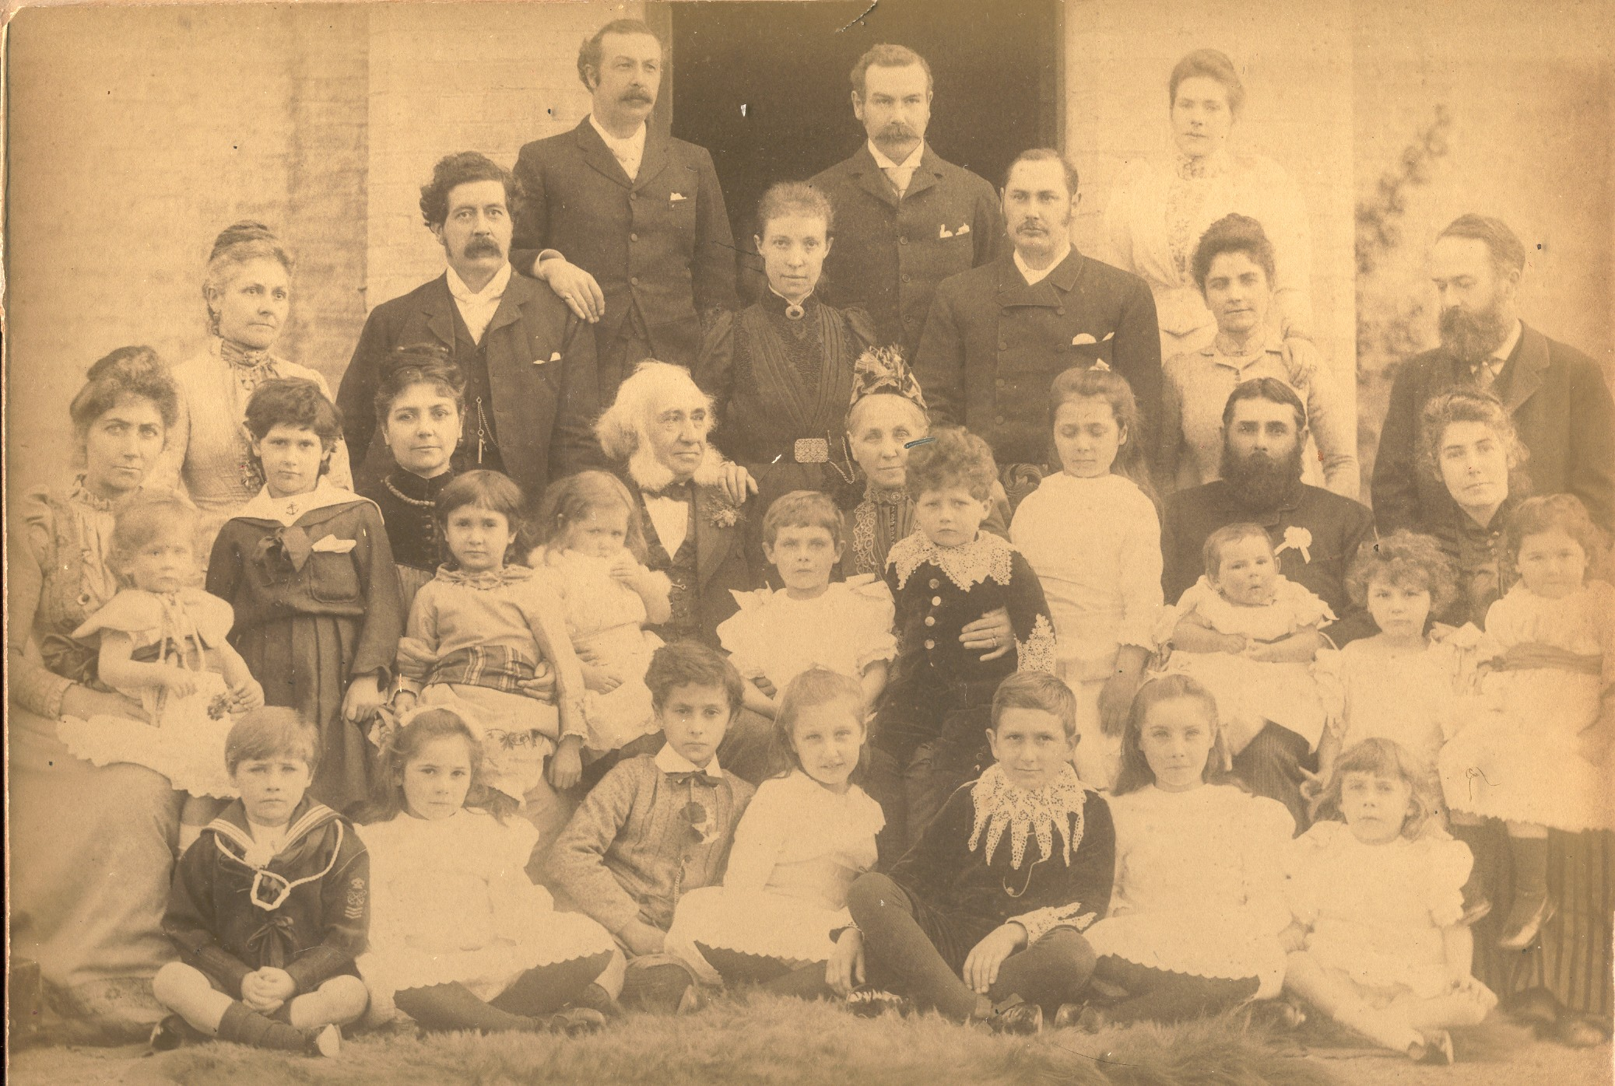

Golden Wedding Anniversary of William and Kate Colchester, Burwall, Cambridgeshire, 1890
Picture courtesy of Giles Colchester
Henry Bassett (far right with long beard)
Kate (Colchester) Bassett (3rd from right in sitting row)
Rose Bassett (standing next to her mother Kate (Colchester) Bassett)
Harry Bassett Jr. (third from right in front row)
Mary Bassett (sitting on the lap of her mother Kate (Colchester) Bassett)

Henry Bassett and Alexander Hastings Bassett of this family were previously featured in the following newsletter:

http://www.bassettbranches.org/newsletters/2012/09/201209.shtml

* * * * *

Section 6 - Featured Bassett: Mark Bassett of California

Mark Bassett descends from #44B Emanuel Bassett of Cornwall as follows:

Emanuel Bassett and wife Grace
Thomas Bassett (b. 1628) and wife Lowdy
John Bassett (b. 1658) and wife Phillipa Rickard
John Bassett (b. 1703) and wife Alice Benallack
Richard Bassett (b. 1747) and wife Elizabeth Glyddon
Richard Bassett (b. 1772) and wife Jenifer Davis
John Davis Bassett (b. 1806) and wife Thomasin Rowe
Mark Bassett (b. 1848) and wife Helena Lander

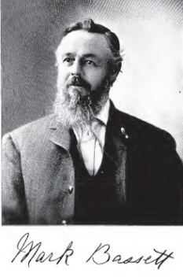
Picture from Find-a-grave

History of Tulare and Kings Counties California
Historic Record Company (1913)
Mark Bassett

A native of England, Mark Bassett, who has achieved more than state-wide reputation as a breeder of horses, cattle, hogs and poultry and whose ranch three miles north of Hanford is one of the show-places of that part of Kings county, was born August 1, 1848. He remained there until 1880, becoming a farmer, then came to Canada and located in Ontario, where he farmed eleven years, until he made his way across the continent to California. He came to Kings county in 1895 from Fresno county and bought one hundred and sixty acres of land two miles north of Hanford, one hundred and sixty acres four miles north, and eighty acres at Armona. His one hundred and sixty-acre homestead has one hundred acres in orchard and vineyard; the other one hundred and sixty acres is in alfalfa except forty acres which is given to fruit; and his eighty acres at Armona is devoted to the cultivation of fruits and grapes. He has a total of eighty acres in vineyard and one hundred and twenty acres in apricots and peaches. Soon after he came to the county he began raising thorough-bred Poland-China hogs. He imported his original stock and now has forty registered sows. During the past six years he exhibited hogs at various state fairs and it is of record that he took first prize at the Seattle Exposition in 1909. His hogs and chickens have taken hundreds of first prizes at fairs and exhibitions in Oregon, Washington and California, and are known for their excellence throughout the entire coast country. He also makes a specialty of Percheron horses and is the owner of a thoroughbred stallion and owns a share in another. His chickens are barred Plymouth Rocks and black Minorcas. His land is all well improved and his home is one of the most attractive in this vicinity.
From time to time Mr. Bassett has very public spiritedly interested himself in numerous enterprises. He is a stockholder in the Lucerne Creamery, in the Armona Fruit and Raisin Packing Co. and in the Farmers and Merchants' Bank of Hanford, and is a member of the Kings County Chamber of Commerce.
In October, 1872, Mr. Bassett married Miss Helena Lander, a member of old English families, who has borne him twelve children, ten of whom are living: Helen, wife of J. Malott; Mabel, who married Frank Pursell; William George; Mark, Jr.; John; Bertha, wife of John Day; Edith, who married Louis Nieson; Ernest; Guy, and Archie.

* * * * *

Section 7 - Featured Bassett: Pierce Bassett Lacrosse Jersey

I found the following for sale on ebay this month. Pierce is a lacrosse player from Arizona. Does anyone know which family he belongs to?

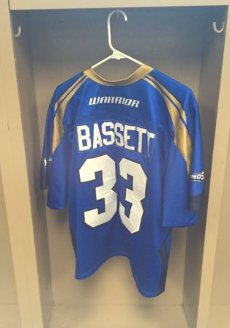
Pierce Bassett Lacrosse Jersey for sale on e-bay

* * * * *

Section 8 - New family lines combined or added since the last newsletter

No lines have been combined or added since the last newsletter.

* * * * *

Section 9 - DNA project update.

No new results to report on the Bassett DNA project.
Donations of any amount can be made to the Bassett DNA project by clicking on the link below. Any funds donated will be used to fund select Bassett DNA tests that will further our project as a whole and benefit all Bassetts worldwide.

http://www.familytreedna.com/group-general-fund-contribution.aspx?g=Bassett
This is just a reminder that the DNA portion of the Bassett Family Association can be found at:

A current spreadsheet of results can be found at:
http://www.bassettbranches.org/dna/BassettDNA.xls
If you don't have Excel and can't open the spreadsheet above, you can now see the DNA test results at the following website.
http://www.familytreedna.com/public/Bassett/
Jeffrey Bassett
520 Salceda Drive
Mundelein, IL 60060 USA
bassettgenealogy@gmail.com

