Bassett Family Newsletter, Volume XIII, Issue 6, 14 June 2015

(1) Welcome
(2) Bassett Family Photograph of Lafayette, Indiana (blog entry sent 6/9/15)
(3) Death of William H. Bassett of Wadsworth, Ohio (blog entry sent 6/1/15)
(4) Bassett, California (Blog entry sent 6/9/15)
(5) More on Robert N. Bassett of Shelton, Connecticut (blog entry sent 6/9/15)
(6) Edward Wilson Bassett and son of Indiana
(7) Stonewall Bassett and sons, aviators
(8) New family lines combined or added since the last newsletter
(9) DNA project update

Section 1 - Welcome

The last major Bassett line from my records has been entered into the website. Thank you Irvin Bassett and family for the work devoted towards the Bassett project. 8,599 individuals from this tree can now be found at the Bassett website.

The following trees were added to the Bassett website database since the last newsletter:

3B. Thomas Bassett of Connecticut (8599 individuals)

* * * * *

Section 2 - Featured Bassett: Bassett family of Lafayette, Indiana (1910)

For sale at marketworks.com, is the following Bassett family photo. Can anyone identify this family?

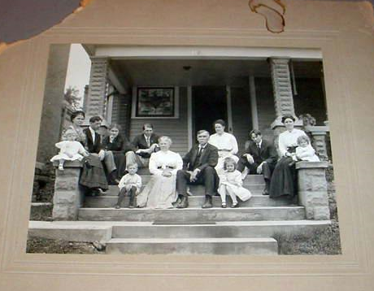
Bassett Family (Lafayette, Indiana 1910)

* * * * *

Section 3 - Featured Bassett: William H. Bassett of Wadsworth, Ohio

William Henry Bassett descends from #251B William Bassett of Cornwall, England as follows:

William Bassett
William Bassett (b. 1815) and wife Grace Johns
William Henry Bassett (b. 1848) and wife Mary Jones

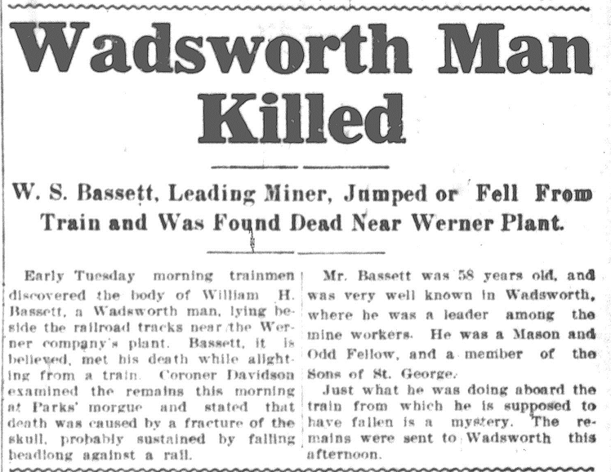

Article found in Akron Beacon Journal, 5 March 1907, sent by James Vallen

* * * * *

Section 4 - Featured Bassett: Bassett, California

Oscar Thomas Bassettt descends from William Bassett of Plymouth as follows:

William Bassett and wife Elizabeth
William Bassett (b. 1624) and wife Mary Rainsford
William Bassett (b. 1656) and wife Rachel Williston
William Bassett (b. 1684) and wife Abigail Bourne
William Bassett (b. 1711) and wife Lydia Smith
Stephen Bassett (b. 1743) and wife Thankful Handy
Perez Bassett (b. 1774) and wife Lydia Snow
Abner S. Bassett (b. 1810) and wife Betsey
Oscar Thomas Bassett (b. 1847) and wife Myrtle Alma Nebeker

On a recent business trip to California, I had a chance to visit Bassett, California, a small township located near City of Industry. It was named for Oscar Thomas after he purchased land there in 1895.

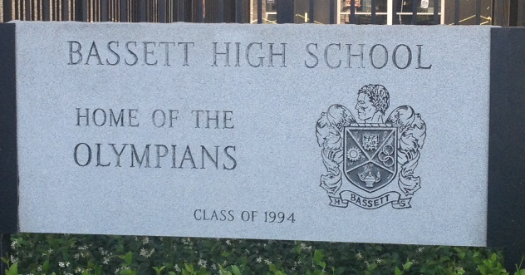

Bassett High School located in Bassett, California

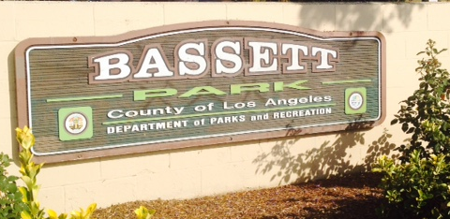

Bassett Park located in Bassett, California

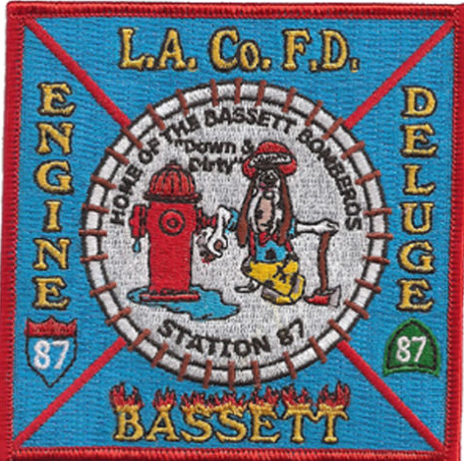

Bassett FD Patch currently for sale on ebay

* * * * *

Section 5 - Featured Bassett: Robert N. Bassett of Shelton, Connecticut

Robert N. Bassett descends from #1B John Bassett of Connecticut as follows:

John Bassett and wife Margery
Robert Bassett and wife Mary
Robert Bassett (b. 1640) and wife Elizabeth Riggs
Samuel Bassett (b. 1692) and wife Deborah Bennett
Samuel Bassett (b. 1719) and wife Sarah Botsford
David Bassett (b. 1749) and wife Mable Tomlinson
Robert N. Bassett (b. 1821)

Robert was first featured in the December 2010 newsletter along with an article about his father.

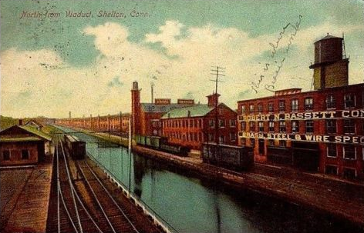

New Haven Register, Monday, December 5, 1892
Well Known People Dead

Robert N. Bassett of Derby died yesterday, aged 72 years. He was taken sick last Wednesday with peritonitis. He was a manufacturer of corset steels and had a factory in Birmingham. He was an attendant of the First Congregational church in Derby. Mr. and Mrs. Bassett celebrated their golden wedding October 5 last. A widow and two daughters survive the deceased.
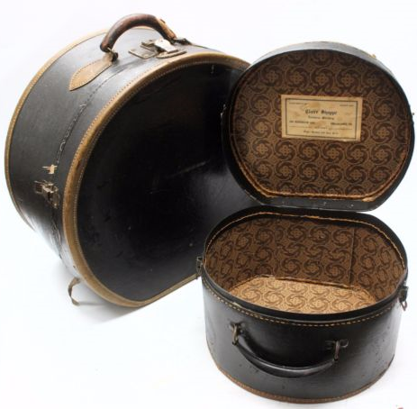
Suitcases made with Bassett latches made by R.N. Bassett Company

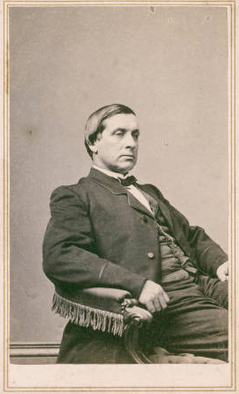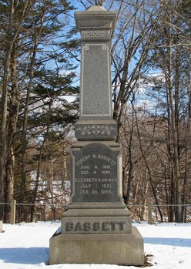
Connecticut State Library Digital Collection Findagrave.com
Robert Newell Bassett

* * * * *

Section 6 - Featured Bassett: Edward Wilson Bassett and son of Indiana

Edward Bassett descends from William Bassett of Plymouth as follows:

William Bassett and wife Elizabeth
William Bassett (b. 1624) and wife Mary Raynesford
William Bassett (b. 1656) and wife Rachel Williston
William Bassett (b. 1680) and wife Abigail Bourne
Nathaniel Bassett (b. 1719) and wife Hannah Hall
Elisha Bassett (b. 1761) and wife Keturah West
Elisha Bassett (b. 1796) and wife Elizabeth Foster
Oliver Langdon Bassett (b.1825) and wife Elizabeth Jane Montgomery
Edward Wilson Bassett (b. 1864) and wife Carrie Ella Howard
Edwin Howard Bassett (b. 1897) died in a plane crash.

History of Greater Indianapolis
by Jacob Piatt Dunn, Volume I

Edward Wilson Bassett is the president of the Bassett Grain Company. He has been a resident of Indianapolis since 1892. When he came to this city he embarked in the grain business, and in 1898 he formed his present business association. The Bassett Grain Company are among the largest handlers of grain in Indianapolis, being both buyers and shippers. Edward Wilson Bassett was born near Battle Ground, on the southern border of White County, Indiana, June 20, 1864, a son of Oliver L. and Elizabeth J. (Montgomery) Bassett, the father born in Jefferson County, Indiana, in 1825, and the mother near Knoxville, Tennessee, in 1831. They were married near Madison, Indiana, in 1847, and of the seven children which blessed their marriage union Edward W. was the fifth born. Oliver L. Bassett, a carpenter and farmer, spent his early life in Madison County, Indiana, from whence he later moved to White County, this state, where his children were born and where he spent the last years of his life, dying in 1875, while his wife, Elizabeth J., survived him until 1904. He was an acceptable member of the Methodist Episcopal Church, and in politics was a Republican.
After and education in the village schools of Battle Ground, Indiana, Edward W. Bassett began teaching at the age of sixteen, and he continued in the profession until he had attained the age of twenty-two. From that time for about six years he was numbered among the merchants of Stockwell, and at the close of that period came, as above stated, to Indianapolis. He married Carrie E. Howard January, 1, 1890. She was born at Stockwell, in Tippecanoe County, Indiana, a daughter of Nelson K. and Eliza P. (Miller) Howard. The father, born in Indiana, enlisted during the Civil War in Company A., Fortieth Regiment of Indiana Volunteers, and he was severely wounded at the battle of Kenesaw Mountain, a bullet passing through his body and lungs and rendering him an invalid during the remainder of his life, his death occurring in 1874. The two children born to Mr. and Mrs. Bassett are Esther M. and Edwin H. Edward W. Bassett is prominently connected with the Masonic fraternity, holding membership relations with Mystic Tie Lodge, the Indianapolis Chapter, Raper Commandery, Indiana Consistory and Murat Temple. He is also a member of the Columbia, Commercial and Canoe clubs and of the Board of Trade, and his politics are Republican.

Miami Herald, Sunday, November 25, 1928
Cleveland-Chicago Passenger Air Liner Wrecked in Ohio Snowstorm
(By The Associated Press)

EDGERTON, Ohio, Nov. 24 – Two men and a woman were killed tonight when a passenger plane, on the way from Cleveland to Chicago, crashed near here. All three persons are believed to have been residents of Cleveland.
The dead: H.H. Bassett pilot of the plane; Mrs. H.H. Bassett, the pilot’s wife, and Glenn R. Butts.
Several persons, who viewed the crash, declared that the pilot evidently became confused during a snowstorm. He circled three time and in gliding down the plane crashed into a tree.
The place was one of a fleet of passenger planes operated between Cleveland and Chicago by the Universal Air Lines.

* * * * *

Section 7 - Featured Bassett: Stonewall Bassett and Sons, Aviators

Stonewall Bassett descends from #13B Richard Bassett of Georgia as follows:

Richard Bassett (b. 1760) and wife Ann
Kilby Bassett (b. 1798) and wife Rebecca Clower
Jonathan Richard Bassett (b. 1833) and wife Mary Jane House
William Capers Bassett (b. 1873) and wife Mattie Richardson
Stonewall Dearen Bassett (b. 1910) and wife Doris V. Kelly
William Walter Bassett & David Edward Bassett

Loved Aviation, Hondo
Stonewall (Stoney) Bassett

Mr. Stonewall (Stoney) Bassett died on Sep 25th in a nursing home in San Antonio after a lengthy illness. He was 77.
Stoney and his family were residents of Hondo from the re-opening of Hondo Air Base in 1951 until it closed again in 1958. Even though they lived here a comparatively short time, they still have many friends in Hondo and especially in the congregation of the First Methodist Church.
Mr. Bassett and a friend first became involved in aviation in the 1930’s when they designed and built their own airplane and then “taught each other to fly it.” His experience and ability led to a flight instructor position at a British Flight Training School in Oklahoma before and during World War II. He taught British pilot trainees all phases of flight including gunnery.
After World War II, he had his own private airport in Wichita, Kansas where he taught veterans and others to fly light aircraft. When the Korean War broke out, he joined Texas Aviation Industries in Hondo to do what he liked best – teach combat pilots. He progresses from instructor to Flight Commander at Hondo Air Base.
When the Air Base closed again, Mr. Bassett filled similar positions at Gary AB, Tx, Fort Sill, Ok, and at Malden AB, Mo., before becoming the Secretary-Treasurer of Doss Aviation, Inc., a contractor responsible for Army Pilot Training at Fort Stewart, Ga. He retired when the civilian-operated pilot training activity ceased.
Mr. Bassett is survived by his sister, Mrs. Nina Duncan, and his brother, Mr. Marshall Bassett, both of Bella Vista, Arkansas, in addition to his sons Bill and David Bassett, both of San Antonio, along with 7 grandchildren. His cremains will be interred in Jesup, Ga, next to his wife, Doris, who preceded him in death by more than 14 years.

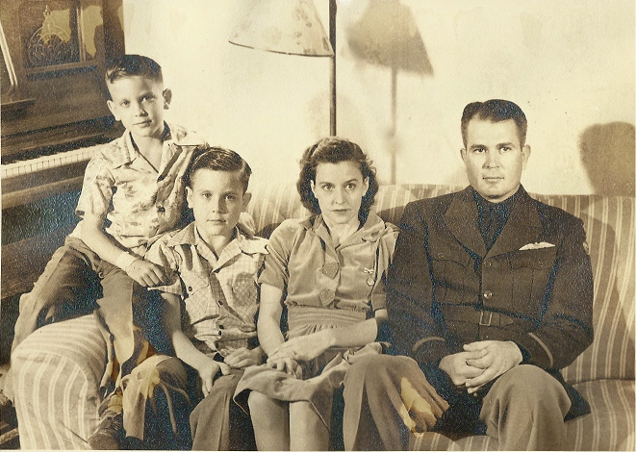

Stonewall Bassett and family. (circa 1941) Picture provided by granddaughter Gail Bassett Wylie

Express-News, March 6, 2013
David Bassett (Picture included)

David Edward Bassett of San Antonio passed away on Sunday, Mar. 3, 2013. He was born Nov. 11, 1934, in Rogers, AR, to Stonewall and Doris (Kelly) Bassett. The family moved several times and lived in Wichita where his father was owner/operator of Sunflower Airport. There David and his brother, Bill, learned to fly. The family moved to Hondo in 1951, just before his senior year, when his father became chief flight instructor at Hondo Airfield. David embraced the small town atmosphere and was his class' valedictorian. He met Shirley Ann Lutz, who was one year his junior. After a semester at Texas A&M, he married his high school sweetheart on Nov. 25, 1953, and joined the Air Force. David was an NCO and propeller mechanic for seven years before going to Officer Candidate School and his classmates remained a big part of his life. He graduated at the top of his class and became a navigator. His career took Shirley and their three children all over the world. He earned numerous decorations throughout his career, including the Distinguished Flying Cross after his tour of duty in Viet Nam. After retiring from the Air Force in 1979, the family made one last move, to San Antonio. He worked as a regional manager for U-Haul for several years, completed a degree in computer programming and then joined his wife working for Northeast ISD. After their final retirement, David and Shirley enjoyed traveling and spending time with their children and grandchildren. They celebrated 46 years of marriage until Shirley's death June 7, 2000. David found love again through his OCS association and married Susan Fretwell. They remained friends throughout. After undergoing treatment for cancer in 2011, David felt very fortunate to have a full year of good health. He continued to enjoy his life, his family and friends, and playing golf. He is preceded in death by his parents, wife and brother. Surviving are his children, Jeff Bassett and wife Kelly, Gail Wylie and husband Randy, and Eric Bassett and wife Becky; grandchildren, Christopher, Steven, Blake, Brian, Ben and Jason; and great-grandchildren, Gabe, Jennifer and Janice; sister-in-law, Tillie Bassett; aunt, Ruth Kelly; and numerous cousins, nieces and nephews. Visitation will be from 10 to 11 a.m., prior to the funeral service at 11 a.m. Thursday, Mar. 7, at First United Methodist Church, Hondo. Interment will be at Hondo Cemetery, St. John's Section. Memorials may be made to the charity of one’s choice. To leave a message for the family, please go to www.quinn-horger.com and select Obituaries.
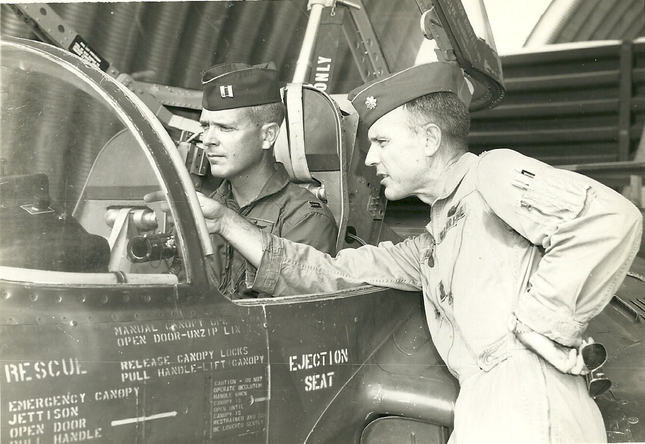Major Bill Bassett pointing out the cockpit of his A-37 Dragonfly to his younger brother, Captain David Bassett in 1968 or 1969 at Da Nang Air Base. Picture supplied by Bill Bassett.

Express News, May 6, 2011
William Bassett (Picture included)

Colonel William (Bill) Walter Bassett passed away on 3 May, 2011 at Brooks Army Medical Center following a short, courageous battle with an illness. He was surrounded with the love of his wife of 55 years Otilia (Tillie), his brother David and two sons Thomas and Steve. He will be greatly missed by all who knew him because he was a shining example of integrity, honesty and service to others.
Bill was born on 24 November, 1931 in Effingham, Illinois. During his early childhood he moved extensively as his parents sought employment following the Great Depression.
Just prior to World War II his father, Stonewall earned his pilot's license and became an airport manager where Bill traded his labor for flying lessons. He received his student pilot's license at 14 but was prohibited from flying solo until his 16th birthday. This early adventure was the beginning of his life-long passion and love of flying.
Bill graduated from high school in 1949 and enrolled in Wichita University. Following the beginning of the Korean War he enlisted in the USAF as an Aerial Gunner on the B-29 and B-26. Upon completion of initial combat crew training he was assigned to the 452nd Bomb Group (L), and the 730th Bomb Squadron flying the B-26. After compiling 55 combat missions, Bill returned to the States and was assigned to the 359th Bomb Squadron as a B-29 gunner at Davis Monthan AFB, Tucson, Arizona. It was during this time he was captured by the charm and beauty of a young nursing student at a VFW rodeo dance. This marked the beginning of an enduring and passionate love affair with his wife of 55 years, Tillie.
While at Davis Monthan Bill applied and was accepted to the Aviation Cadet program earning the Top Graduate award of Class 54-Q on August 31, 1954. It was during this time Bill proposed marriage to Tillie and they were married at his first piloting assignment at Perrin AFB, Texas on May 28, 1955. While at stationed at Perrin, Bill and Tillie were blessed with the birth of three children: Bill born in 1958, Kathy born in 1959 and Tom born in 1960.
The family moved to Okinawa in 1961 before returning in June 1964. During this assignment Bill was a missile officer while continuing to fly the T-33. After leaving Okinawa the family moved to Lubbock, Texas where their youngest son, Steven was born in 1965. While at Reese he became an instructor pilot in Air Force's newest high performance jet trainer, the T-38.
After two years the family moved again to San Antonio, Texas where Bill continued to fly at Randolph AFB and two years later transferred to Tyndall AFB, FL. Following another flying assignment he attended a joint staff school then quickly turned to qualify in the A-37 and prepare for a one year tour of duty as a flying pilot advisor between 1969-1970 at DaNang, Air Base, Vietnam.
Following his second combat flying tour, the family moved to Randolph AFB, Texas where Bill again instructed in the T-38 and became the first Commander of the 560th Flying Training Squadron. While there he was instrumental in establishing Operation Homecoming, a program that refamiliarized returning Prisoners of War with flights in the T-38. Following this rewarding and fulfilling command assignment, the family moved to Montgomery, Alabama while Bill attended the Air War College between 1973-1974. After school, Bill was transferred to the Armed Forces Staff College, Norfolk, Virginia and served as a staff instructor between 1974-1977. While assigned there he was selected for promotion to Colonel.
In 1977 the family took their final military transfer to San Antonio, Texas when Bill was assigned to be the Director of Safety for the Air Training Command. He continued to fill his sense of adventure and excitement with flying the T-38 until his retirement on 1 May 1979, concluding 28 years of service to the Air Force and the Nation.
Bill's numerous decorations include the Legion of Merit, the Distinguished Flying Cross, the Bronze Star, the Meritorious Service Medal with an Oak Leaf Cluster, the Air Medal with 8 Oak Leaf Clusters, the Air Force Commendation Medal and the Good Conduct Medal as well as many other ribbons and awards.
Bill's flying career includes 4706.7 total flying hours as pilot, 462 hours as an enlisted gunner in B-26s and B-29s and 490 combat hours.
Following retirement from the Air Force Bill, Tillie and the family settled in San Antonio where he pursued a second bachelor's degree in Accounting from the University of Texas at San Antonio. After graduation he was awarded his Certified Public Accountant designation from the State of Texas and opened a private practice in Universal City, Texas. He continued to work until he eventually sold his business and became energetically involved with the Order of Daedalians. While working with the Daedalians he served as the organization's National Adjutant and was elected as the Flight Captain at Stinson's flight. He was also visionary and instrumental in establishing the plan to relocate the Daedalians' headquarters from Kelly to Randolph AFB as well as the construction of a new headquarters building.
Bill and Tillie eventually moved to The Towers in 2001 and quickly found new friends and neighbors. He selflessly volunteered to serve as a Board member and was elected the Board President where he focused on improving the quality of life for all its residents.
Bill and Tillie were long-standing members of St Matthews Catholic Church where he actively sang as the choir's majestic tenor voice for 25 years. Bill and Tillie also enjoyed a very active life-style traveling with RV groups and making multiple trips to Europe and scenic locations throughout the U.S. and Mexico.
Bill is survived by his wife of 55 years, Otilia and his brother David E. Bassett. His children include: Bill Bassett, his wife Donna and their two daughters Elizabeth and Julie; Kathy Jordan, her husband Trayce and their three children Ann, Allyn and Theresa; Thomas Bassett and Steve Bassett, his wife Carolyn and their three children, James, David and Natalie. He has numerous nephews and nieces and a large extended family who share in their love and respect of him and Tillie. He was preceded in death by his mother, Doris and father, Stonewall.
Colonel Bill Bassett was a man of impeccable character and honesty; he will be deeply missed by all who knew him.
Visitation will begin on Friday, May 6, at 6:00 P.M. with a Rosary to be recited at 7:00 P.M. at the Angelus Chapel. Funeral Mass will be offered on Saturday, May 7, at 1:00 P.M. at St. Matthew's Catholic Church. Entombment will follow in Holy Cross Cemetery with full military honors.
In lieu of flowers or gifts, the family requests donations be made to the Warrior and Family Support Center at the following address:
Warrior and Family Support Center, 3138 Rawley E. Chambers, Ft Sam Houston, Texas 78219, (210) 916-8219. Condolences may be sent to the Bassett family at www.theangelplusfuneralhome.com. Arrangements by: The Angelus, 1119 N. St. Mary’s St.

* * * * *

Section 8 - New family lines combined or added since the last newsletter

The following family lines have been added since the last newsletter.

323B. George Bassett of Connecticut
508B. Henri Basset of France & Pennsylvania

* * * * *

Section 9 - DNA project update.

No new results to report on the Bassett DNA project.
Donations of any amount can be made to the Bassett DNA project by clicking on the link below. Any funds donated will be used to fund select Bassett DNA tests that will further our project as a whole and benefit all Bassetts worldwide.

http://www.familytreedna.com/group-general-fund-contribution.aspx?g=Bassett
This is just a reminder that the DNA portion of the Bassett Family Association can be found at:

A current spreadsheet of results can be found at:
http://www.bassettbranches.org/dna/BassettDNA.xls
If you don't have Excel and can't open the spreadsheet above, you can now see the DNA test results at the following website.
http://www.familytreedna.com/public/Bassett/
Jeffrey Bassett
520 Salceda Drive
Mundelein, IL 60060 USA
bassettgenealogy@gmail.com

