Splinters From the Tree – July 2014

(1) Welcome
(2) David Bassett of Gloucester, Massachusetts
(3) Death and Funeral of Alfred V. Bassett
(4) Charles Jarvis Holmes Bassett Branding iron
(5) Henry Baldwin Bassett and his troubles
(6) Sgt. Samuel Bassett of Gloucestershire
(7) Book: Hardship and Hardtack based on letters written by Richard Allen Bassett
(8) New family lines combined or added since the last newsletter
(9) DNA project update

Section 1 - Welcome

This month's newsletter includes a guest article written by Alan Bassett of Surrey, England about his 3xg grandfather Samuel Bassett.

The following trees were added to the Bassett website database since the last newsletter:

255B. Isaac Bassett of Gloucester, Massachusetts

* * * * *

Section 2 - Featured Bassett: David Bassett of Gloucester, Massachusetts

David Bassett descends from #255B Isaac Bassett of Gloucester, Massachusetts as follows;
Isaac Bassett and wife Sarah
David Bassett and wife Susanna Lane

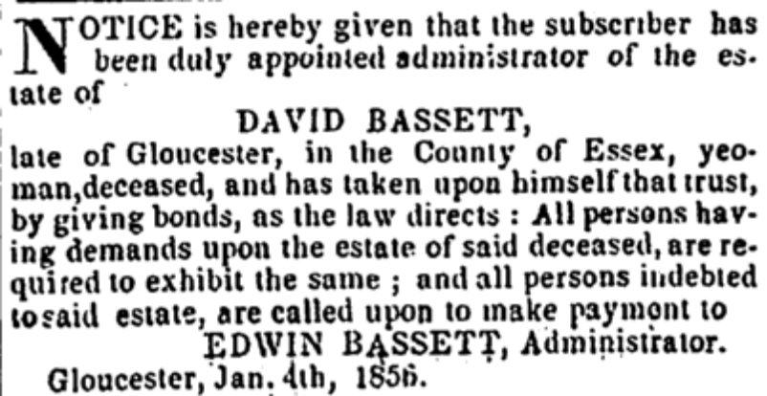

Cape Ann Light & Gloucester Telegraph, Saturday, January 5, 1856

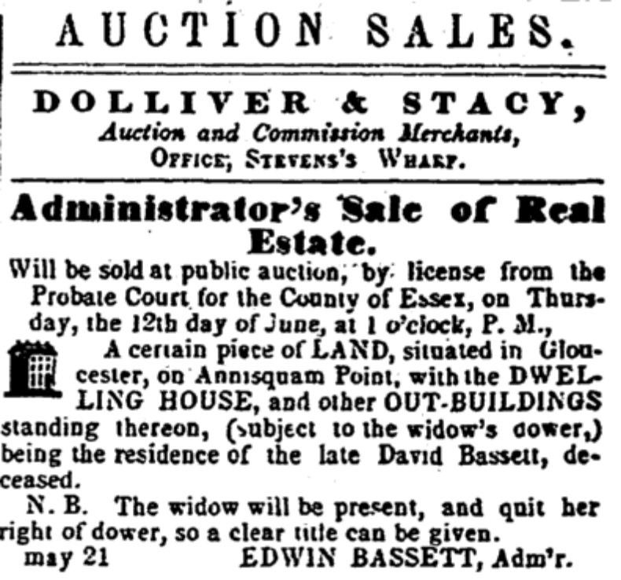
Cape Ann Light & Gloucester Telegraph, Saturday, May 31, 1856

* * * * *

Section 3 - Featured Bassett: Death and Funeral of Alfred Vose Bassett

Alfred Vose Bassett descends from William Bassett of Plymouth as follows:

William Bassett and wife Elizabeth
Joseph Bassett (b. 1635) and wife Martha Hobart
Jeremiah Bassett (b. 1678) and wife Mary Felch
John Bassett (b. 1725) and wife Sarah Shepherd
John Bassett (b. 1762) and wife Phebe Noyes
Alfred Vose Bassett, born 1807.

Trumpet and Universalist Magazine, Boston, Massachusetts
Saturday, January 7, 1832
Rev. Alfred V. Bassett

We noticed in our last the very sudden death of Rev. Alfred V. Bassett, pastor of the Universalist Society in Dedham, Mass. The following account of his death is form the Dedham Advocate, and may be relied on as correct: -
“Dreadful Death – A more melancholy instant of suicide probably never occurred in this region, than that which it is now our painful duty to record. The Rev. Alfred V. Bassett, Pastor of the Universalist Society in this town, committed suicide on Monday night last, by cutting his throat with a razor! The following particulars, as we learn from a friend of the deceased, are substantially correct. – Mr. Bassett had been unwell several days with the prevailing influenza, and complained of a pain in his head, from which it is supposed that a fever on the brain produced that derangement of mind which caused him to commit the fatal deed.
After retiring on Monday night, he arose and extinguished the light, which had been left burning in consequence of his illness. The individual who lodged with him soon fell asleep. About 11 o’clock, being aroused by the struggles and groans of the deceased, he hastened to alarm the family, and the poor man was found lying on the floor, struggling amid the agonies which thirty minutes after, terminated in death. It appeared that he had drawn the razor on both sides of the throat, cutting very deeply on the left side. Mr. Bassett was 25 years of age, a native of Atkinson, N.H., and had been settled in this town two years. He was a young man of respectable talents, and by his amiable manners and kind disposition, had won the esteem of many, who are now calling to unite with his relatives and friends in mourning his untimely exit.
The following is a brief, though just description of the amiable character of the deceased. It is extracted from the Lowell Mercury:
“Mr. Bassett resided in the family of the editor of this paper over a year, and a more amiable and upright person he never saw. It is but justice to say, that there was not one bad trait in the character of this excellent young man. We do not believe that he had even a single enemy, in the whole circle of his acquaintance. Honest, honorable, unsuspecting and confiding in regard to others, he neither thought of deceiving nor of being deceived. He was the youngest of a large family of brothers and sisters; and from that circumstance, and possessing a slender constitution, and enjoying but a poor state of health, he was decidedly the favorite of the whole family. Having been tenderly and affectionately dealt with from his childhood, we often told him that he was not well prepared to encounter the hypocrisy and intrigue, he would be likely to meet with on every public road, and in every sequestered lane he might traverse after leaving the circle of those who loved him, and had no motives of interest or ambition to deceive. Still he could not be prevailed upon to view the world as it was. He viewed it as he wished it, and as it should be rather than as it is. His views of it were rather Utopian than real. We believe this last remark to be true in regard to every fair minded generous young man; but not to th4e same extent.
He was so perfectly honest and sincere in all that he said and did, that he never uttered a syllable on any subject but with the most scrupulous regard to truth, not even in the most familiar social intercourse, by way of joke. In fact he never uttered a joke, on any occasion; and if he was innocently made the subject of one, he would either preserve a complete silence, or reason on its impropriety.
He enjoyed the benefit of a good academic education and studious habits; but was kept from entering and pursuing his studies at college on account of the poorness of his health.
About four years since he began to prepare for the ministry; and about eighteen months since he was ordained over the society with whom he commenced, and closed his pastoral duties.
His religious opinions were the result of investigation. Charitable, just and friendly towards those who differed from him, he secured their friendship and good will. Is it not then a melancholy thought that one so amiable, so upright, so beloved by all who knew him, one of the few who had a large circle of friends, without an enemy, should die so young – and by his own hand! Yet such is the fact. He committed suicide. Of the circumstances that led to this painful result we are yet apprised. From what we knew of him, however, we have little doubt that is was form some sudden and altogether unlooked for aberration of reason that left his mind a wreck, and led to the sad deed of self immolation.
He had been very unwell for several weeks previous to his melancholy exit. Owing to the bad state of his health, a young man of his acquaintance slept with him, and kept a lamp burning that he might afford him and aid he might need.
About 11 o’clock on Monday night, while the young man was asleep, he rose suddenly from his bed and committed the deed, that proved fatal in the course of the next hour. A doctor was called in, but alas, there was no help. From these circumstances it would appear to have been the impulse of the moment.
He has left one to whom he would probably have been united in a few months as a bosom companion, and numerous other relatives and friends to mourn his untimely death.
When we take into consideration the deep and imperishable love of life that exists in the bosom of every human being, and then reflect upon the extreme and hopeless agony necessary to overcome it, whether it be the result of religious despair, of disappointed affection, or the loss of friends, or a sudden change form affluence to extreme poverty, the humane emotions of pity and sorrow for the unfortunate, struggle for the ascendance in the bosoms of the kind and the good. How ardently do friends under the melancholy circumstances wish that the secret of the fatal intention had found its way to them in time to have afforded an opportunity to bind up the broken heart, and stay the hand of despair, by restoring in the afflicted bosom, the mild sway of reason and religion.
We cannot refrain from closing this obituary notice with a few lines of that excellent poet and man, Thomas Campbell – “On the grave of a suicide,” and from “The pleasures of Hope.”

“Ah once we know the social passions glowed
In thy devoted bosom – and the hand
That smote its kindred heart, might yet be prone
To deeds of mercy. Who may understand
Thy many woes, poor suicide, unknown?
He who thy being gave, shall judge of these alone.”

“Mild be the doom of Heaven – as thou wast mild?
For oh! thy heart in holy mould was cast.
And all thy deeds were blameless but the last.”

Religious Inquirer, Hartford, CT
Saturday, January 14, 1832

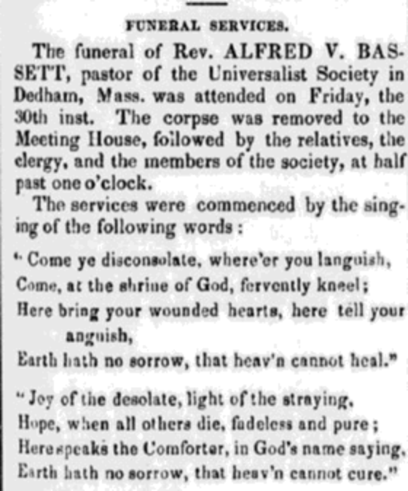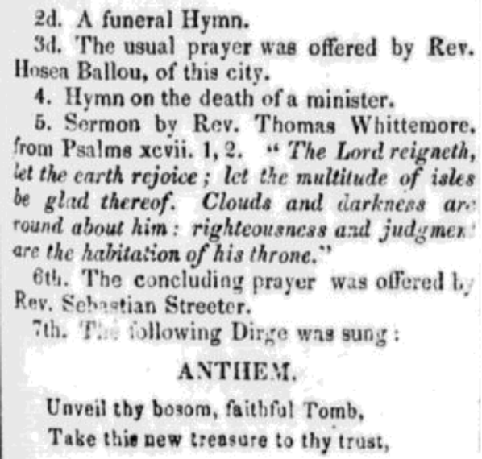

* * * * *

Section 4 - Featured Bassett: C.J.H. Bassett Branding Iron

Charles Jarvis Holmes Bassett descends from William Bassett of Plymouth as follows:

William Bassett and wife Elizabeth
William Bassett (b. 1624) and wife Mary Raynesford
William Bassett (b. 1656) and wife Rachel Williston
William Bassett (b. 1681) and wife Abigail Bourne
John Bassett (b. 1716) and wife Mercy Newcomb
Thomas Bassett (b. 1759) and wife Lydia Mendall
Anselm Bassett (b. 1784) and wife Roselinda Holmes
Charles Jarvis Holmes Bassett (b. 1814)

In follow up to last month's article about Charles Jarvis Holmes Bassett, a fellow Bassett sent me the following.



Brand made from a branding iron belonging to Charles Jarvis Holmes Bassett.
Brand provided by Kendall Bassett of Tacoma, Washington

* * * * *

Section 5 - Featured Bassett: Henry Baldwin Bassett and his troubles

Henry B. Bassett descends from #3B Thomas Bassett as follows:

Thomas Bassett (b. 1598) and wife Joanna Beardsley
Thomas Bassett (b. 1660) and wife Sarah Baldwin
Josiah Bassett (b. 1690) and wife Alice Canfield
Samuel Bassett (b. 1723) and wife Susannah Morris
David Bassett (b. 1754) and wife Sarah Oviatt
David Bassett (b. 1782) and wife Mary Rhoades
Philo Lewis Bassett (b. 1821) and wife Catherine Hubbell
Henry Baldwin Bassett

Southport Chronicle, CT, Monday, June 13, 1898
Stratford News Page
A Trespass Case

A misunderstanding as to the ownership of woodland at Bear Swamp near the Huntington line, has involved several parties in considerable trouble and some concern for their interests. There is a large are of woodland in the vicinity named, which is owned in separate tracts by several parties. Among these owners are Henry B. Bassett and his sister-in-law Mary B. Bassett. One strip of ten acres was owned severally by Joseph P. Curtis of Bridgeport, Chauncey Mills of this town, the estate of Ellen Curtis and William Bassett, each owning 2 ½ acres.
On the 5th, of last month, Mr. Bassett and his sister-in-law purchased from the administrator of the Eben Curtis estate the plot owned by Mrs. Curtis, paying $50 for the two and one-half acres. The deed was not recorded till May 25, but Mr. Bassett began cutting the timber at once. Through an apparent error in his deed he was led to encroach upon Mr. Mills’ land. Upon the fact coming to his notice Mr. Mills demanded financial reparation and Mr. Bassett settled.
Shortly after the chopping commenced D.C. Wood discovered that the choppers were in his domain and interrupted the work. A few days ago, while negotiating with another party for more of the timber land Mr. Bassett showed him his saw mill and was straightway informed that he was on the Joseph P. Curtis land. The latter was notified, and upon looking into the matter found that there were a thousand or so of railroad ties and a lot of posts piled up where the cutting had been done upon his land.
Mr. Bassett had sold and delivered to the Consolidated road 500 of the ties and that company has been served with garnishee papers on behalf of Mr. Curtis. The latter has taken steps, further, to secure damages from Mr. Bassett for trespass and removal of the timber. The affair has thus taken an unfortunate turn for Mr. Bassett, who was operating in perfect good faith under the impression that it was his own woodland that was being converted into railroad ties.

* * * * *

Section 6 - Featured Bassett: Sgt. Samuel Bassett

Sgt. Samuel Bassett is a descendant of #190B William Bassett of Stroud, England as follows:

William Bassett and wife Mary Whiteaker
Samuel Bassett (b. 1782)

Sergeant Samuel Bassett (1782-1846)
61st Regiment of Foot

Samuel Bassett was born to William & Mary (nee Whiteaker) Bassett in Ruscombe (near Stroud), Gloucestershire, UK, and was baptised on 21 July 1792. He enlisted in the 61st Regiment of Foot on 25 July 1799, although it is not known where he joined the regiment. In 1799 it was in fact based in South Africa; in February 1801 was sent to India but was diverted to Cosseir (Al Qusayr, Egypt) on the Red Sea and marched to Kermah and thence to the Nile where it remained until March 1803. The 61st then sailed for Malta, where it was stationed for about two years. In November 1805 it was sent to Naples; to Sicily in January 1806, to Gibraltar in December 1807; and to Lisbon in June 1809 for the Peninsular Wars.
A second battalion of the 61st was raised in 1803, but remained in the United Kingdom for the duration of the Napoleonic Wars (1803-1815). It did however provide reinforcements to what was now the first battalion serving overseas. The second battalion was stationed in Cork, Ireland from February 1806 to February 1807, so it is quite possible that Samuel Bassett was originally in the second battalion before being posted to the first battalion overseas. Additionally, he may have met his future wife in Cork.
Samuel Bassett was promoted to the rank of Corporal in 1802 and then to Sergeant in 1807, and was married in Stroud, Gloucestershire on 18 December 1808 to Elizabeth Roberts (who was born in 1783 in Ireland). By June 1809 he was with the 1st Battalion 61st Regiment of Foot as part of the army led by Sir Arthur Wellesley (later The 1st Duke of Wellington) and engaged in the Peninsular Wars in Portugal and Spain.
One of the major battles of the Peninsular Wars and Wellington’s first victory in Spain was at Talavera. He had driven the French forces out of Portugal and led his army on the offensive into Spain. He joined up with Spanish forces and engaged the occupying French army at the town of Talavera de la Reyna on 27 July 1809. The battle lasted for two days. The 61st Regiment of Foot was part of the 2nd Brigade of the 1st Infantry Division and was heavily engaged on both days. In particular, it was involved in a bayonet charge on the afternoon of the 28th which resulted in heavy losses.
Samuel Bassett’s Statement of Service makes the simple statement that he lost his left leg during the battle. The 61st Casualty List for that time shows that he was taken as a Prisoner of War and this presumably accounts for the fact that his pension application is five years after the battle.
The illustration shows the uniform of the 61st Regiment of Foot during the Napoleonic Wars. Samuel Bassett would have worn sergeant stripes on his upper sleeves, a shako (hat) with a white plume, and would have been armed with a standard-issue Brown Bess flintlock musket and bayonet.
His Statement of Service (dated 06 October 1814) makes for interesting reading as it also contains his physical details, timescales, and an attestation as to his conduct. It was in fact an application for an army pension due to his disability, and was endorsed on the reverse side by the Regimental Surgeon Samuel Peacock on 05 January 1815.
The 1841 census shows Samuel Bassett living in Parliament Street, Stroud, aged 60, with his wife Elizabeth and son Richard; his occupation is given as “army”. Likely children are: Anne (1809-1876), Henry (1820-1862), Richard (1822-1877), and possibly others during the period 1816-1820. His son Henry Bassett’s marriage certificate of 11 Feb 1845 to Mary Ann Cross shows Henry’s father as Samuel Bassett with the occupation “pensioned”.
His most likely death is in Stroud in 1846, and his wife, Elizabeth at about the same time.

Alan Bassett
Surrey, UK

Author’s note:
My late father told me some years ago that a family legend was that an ancestor had fought in the Napoleonic Wars. I was pleased to trace the direct family line back to Samuel Bassett (my 3 x great grandfather) and found his Statement of Service and the 61st Regiment Casualty Lists at the National Archive in Kew. The Soldiers of Gloucestershire Museum in Gloucester provided the Regimental History and photograph of the Regimental uniform and colours.

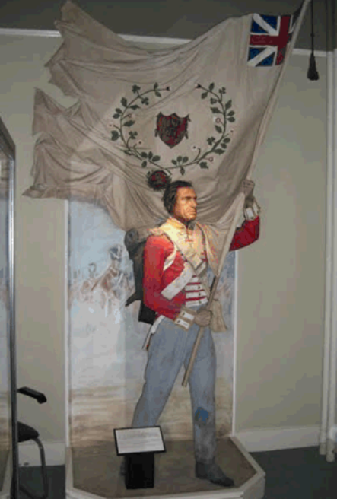
61st Regiment Uniform

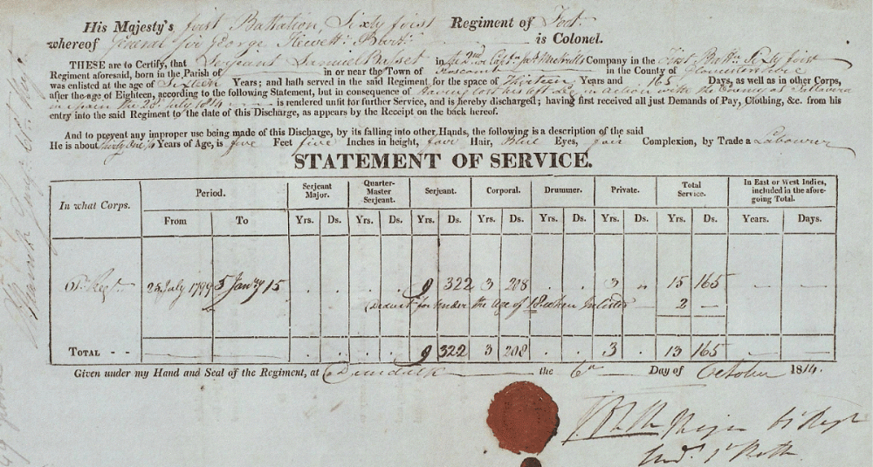

* * * * *

Section 7 - Featured Bassett: Book: Hardship and Hardtack based on Richard Bassett letters

Richard Allen Bassett descends from #6B William Bassett of Connecticut as follows:
William Bassett and wife Hannah (Dickerman) Ives
John Bassett (b. 1652) and wife Mercy Todd
Joseph Bassett (b. 1697) and wife Miriam Bradley
Joel Bassett (b. 1733) and wife Mary
Justus Bassett and wife Beulah Tuttle
Allen Bassett (b. 1795) and wife Druzilla W. Eddy
Richard Allen Bassett (b. 1829) and wife Mary A. Hendrickson

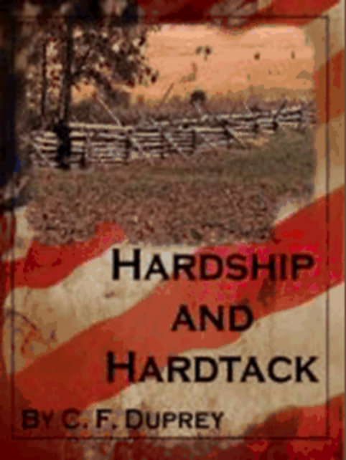

Hardship and Hardtack
By CF Duprey

Richard Bassett leaves his farm, his wife and two little boys to join the army in order to preserve the Union, not knowing that four weeks into his service, he'll be a prisoner of war and unfairly branded a coward.
Based on the letters the very real Richard sent home to his wife during his first year of service, HARDSHIP AND HARDTACK details his struggle to survive in a time of turmoil.
Like most Northerners, Richard Bassett expected the war between the Union and the rebel states to be over quickly. When it isn’t and President Lincoln puts out another call for volunteers, Richard leaves his farm, his wife and his two young boys and goes to do his part. Erasmus, his younger brother, goes with him on the grand adventure that is preserving the Union.
Only, a month into their service, still green and only partially trained, they’re thrust onto the front lines of a battle that will brand them forever. When their general surrenders them to the Confederates, Richard wonders if he’ll ever see home or battle again.
HARDSHIP AND HARDTACK follows the 126th New York Volunteer’s first year of service in the Union Army and is based on the letters the very real Richard Bassett sent home to his wife, Mary. He details life as a prisoner on parole, their subsequent return to active service and the painful waiting as their names are dragged through the mud and their reputations unduly tarnished. It is not until nearly a year has passed that redemption comes in the form of another battle—at Gettysburg, Pennsylvania.

Richard was featured in two earlier newsletters. The first showed entries from a diary from his brother Erasmus.

http://www.bassettbranches.org/newsletters/2006/200609/200609.shtml

The second entry features Richard later in life.

http://www.bassettbranches.org/newsletters/2011/12/201112.shtml

* * * * *

Section 8 - New family lines combined or added since the last newsletter

No lines combined and no new family lines added since the last newsletter.

* * * * *

Section 9 - DNA project update.

No new DNA results to report this month.
Donations of any amount can be made to the Bassett DNA project by clicking on the link below. Any funds donated will be used to fund select Bassett DNA tests that will further our project as a whole and benefit all Bassetts worldwide.

http://www.familytreedna.com/group-general-fund-contribution.aspx?g=Bassett
This is just a reminder that the DNA portion of the Bassett Family Association can be found at:
http://www.bassettbranches.org/dna/
A current spreadsheet of results can be found at:
http://www.bassettbranches.org/dna/BassettDNA.xls
If you don't have Excel and can't open the spreadsheet above, you can now see the DNA test results at the following website.
http://www.familytreedna.com/public/Bassett/
Jeffrey Bassett
520 Salceda Drive
Mundelein, IL 60060 USA
bassettgenealogy@gmail.com

