Splinters From The Tree – March 2014

(1) Welcome
(2) Thomas Bassett and Samuel Kennedy Bassett of New Zealand, Farm Implement Dealers
(3) Charles Farmer Bassett of Western Australia, obituary
(4) The Secret Wedding of Daniel Stevenson Bassett of Philadelphia
(5) Richard Ellsworth Bassett's troubles
(6) Death of Benjamin Bassett, Kyneton, Western Australia
(7) Bassett's Mill of Fremont, New Hampshire
(8) New family lines combined or added since the last newsletter
(9) DNA project update

Section 1 - Welcome

The following trees were added to the Bassett website database since the last newsletter:

107B. Bassetts of Syria and Lebanon (351 individuals)
236B. Abraham Bassett of Mississippi (41 individuals)

My next talk regarding The Bassett Family DNA Project will take place Tuesday, April 8th, 2014. The presentation will take place at the La Porte Parks & Recreation Dept. Office Bldg., Meeting Room, 250 Pine Lake Ave., La Porte, Indiana.

* * * * *

Section 2 - Featured Bassett: Thomas Bassett and Samuel Kennedy Bassett of New Zealand

Thomas and Samuel Kennedy Bassett descend from the #34B County Down family as follows:

John Bassett and wife Agnes Welshman John Bassett and wife Agnes Welshman
Arthur Bassett (d. 1851) and wife Jane Stafford John Bassett and wife Mary Casement
Alexander Bassett William Bassett (b. 1797 and wife Ann Jane Parkinson
Thomas Bassett and wife Sarah Bassett Samuel Kennedy Bassett (b. 1840)

Sarah Bassett, wife of Thomas Bassett, was a sister to Samuel Kennedy Bassett.
Madline Bassett, wife of David Morrow, was also a sister to Samuel Kennedy Bassett.

Wairarapa Daily Times, 20 July 1914
Personal Matters

Advice has been received of the death this morning, at Avonside, Christchurch, of an early settled of the Canterbury Province, in the person of Mr. S.K. Bassett. Deceased, who had been in failing health for some time past, retired from business some years ago, and was formerly a partner in the firm of Messrs Morrow, Bassett and Co., the well-known farm implement agents. A widow, five sons and a daughter, Mrs. E.W. Payton, of Mount Bruce, Masterton, are left to mourn their loss.

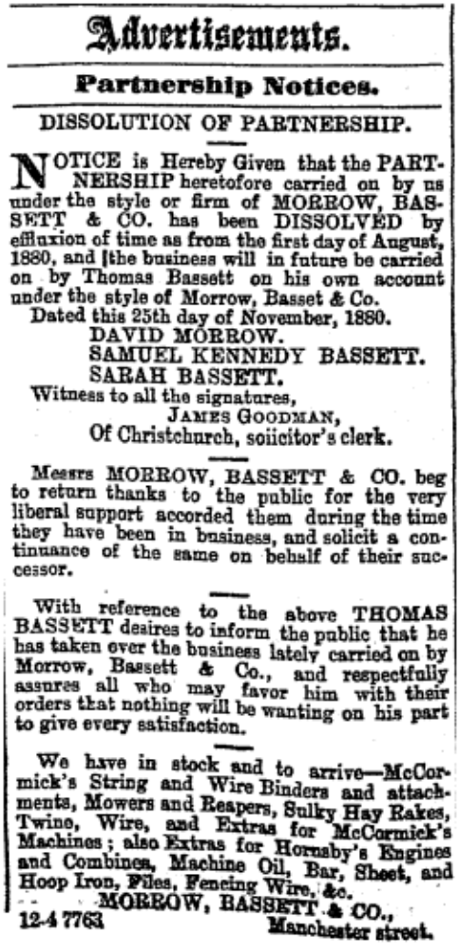

The Press, July 22, 1898
Messrs Morrow, Bassett and Co.’s new Premises

Today the foundation stone of a new building, to be erected for Messrs Morrow, Bassett and Co., will be laid at the corner of Cashel and Manchester streets. The firm originally started here in 1866, and since 1878 has occupied a site in Manchester street. Mr. Thomas Bassett, the present proprietor, took over the sole management of the firm in 1880.
The building it is intended to erect will be an ornament to our street architecture. It will be three storeys high, the ground floor being in Port Chalmers stone, and above this brick built in Milburn cement, and finished with stucco. The first floor has four square-headed windows facing each street, with one on the corner, and mullion windows at the ends facing Manchester and Cashel streets. The second floor is similar, with a moulded renaissance and dentated cornice surmounted by a parapet on which the name of the firm is displayed. The main entrance to the building, which is at the corner of Manchester and Cashel streets, is by double-leaved doors, entering on to a pannelled lobby having English oak swinging doors with upper plate-glass panels. The showroom is 48 x 28, and here the different farming implements, &c., will be placed; this is lighted from Manchester street. The windows fronting Cashel street are cut off by a partition for the display of bicycles. The office is on the north-west corner, with a private entrance from Cashel street. The public office is 22 x 12, with a strong room attached and private office at the back. The shop for bicycle repairing, which is 27 x 20, is at the S.W. corner. The entrance for goods receiving and delivering is on the S.E. corner, and is fitted with large doors and a lift to the upper floors. The yard, for convenience sake, is also in this corner, and will be used as an area for light. The first floor is supported by 8 x l½ in columns, on which rest the rolled iron joists 14 x 6. The rolled iron joists in the show-room and offices are encased in lining with a moulded cornice divided into panels. The walls are 14ft high, lined, and it is intended to paint them. The offices will be lined with picked rimu varnished. The stairs to the first floor rise from the show-room. On this floor it is intended to store all the parts of reapers and binders and farming implements. The upper floor is supported on 7in cast-iron columns, on which rest 12 x 6 rolled iron joists. The second floor is intended for the storing of bicycles and their parts and other light goods. The roof is a double king post one supported upon columns. It is an open roof covered with green Bangor slates. The frontage to Manchester street, it may be noted, is 58ft and 63ft to Cashel street. A well has been sunk by Mr Job Osborne 350 ft, having a 13ft 9in rise. Mr W. A. P. Clarkson, A.R.I.B.A., is the architect, Messrs J. and W. Jamieson the contractors, and Mr J. Bond clerk of the works. The foundation stone wall be laid by Master T. Bassett.

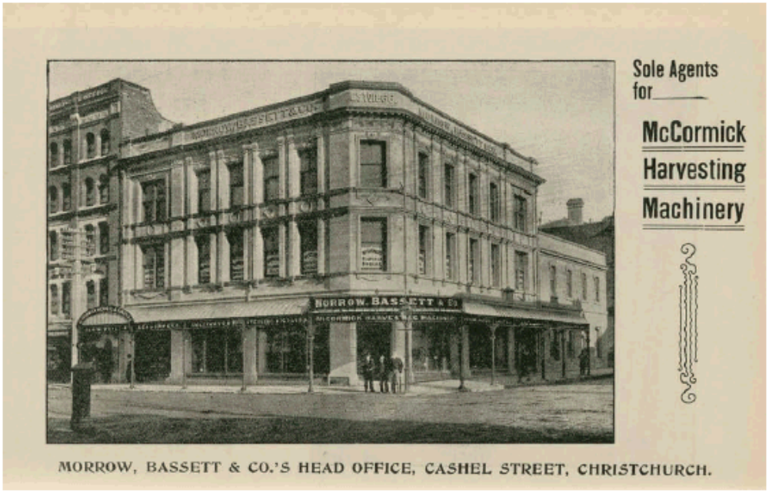
Picture from the Christchurch City Library Blog

* * * * *

Section 3 - Featured Bassett: Charles Farmer Bassett obituary

Charles Farmer Bassett descends from #98B James Bailey Bassett as follows:

James Bailey Bassett (b. 1810) and wife Mary Murrell Farmer
Charles Farmer Bassett (b. 1859) and wife Martha Messenger

The Daily News, Perth, Western Australia, Monday, 31 December 1917
Obituary
The Late Mr. Charles Farmer Bassett

Mr. Charles Farmer Bassett passed away on the 28th inst. at his late residence, “Buckland House,” Loftus street, Claremont, in his 59th year. The deceased, who was born at Willunga, South Australia, had resided in this State for the last 19 years, during which period he had been with the firm of Chas. Moore and Co., Perth. He was well-known in Perth and Claremont, and was highly respected. A widow and a grown up family of two sons and three daughters survive him. The funeral cortege moved from the above residence on Saturday afternoon, the 29th inst, and proceeded to the Karrakatta cemetery, where the remains were interred in the Congregational portion. The Rev. R. C. Chapman, who officiated at the graveside, also held a short service at Buckland House. The chief mourners were Messrs. Walter and Ralph Bassett (sons), Mr. E. F. Sherwood (son-in-law), and Messrs. J. and W. Shepherd. The pall-bearers were Messrs. H. Frick and J. M'Auley (representing Chas. Moore and Co.), R. Miller (Beath, Schiess, and Felstead, Ltd.), C. R. James, H. Wilson, J. Jones, A. Fry, and F. J. Tench. Wreaths were placed on the grave by Mrs. C. Moore, Mr. C. Moore, and Mr. C. S. Smith, Melbourne, the employees of Chas. Moore and Co., Beath, Schiess, and Felstead, Ltd., relatives and many friends, Numerous letters, telegrams, cards, etc, of condolence have been received by the bereaved relatives. The funeral arrangements were in the hands of Messrs. Arthur. E. Davies and Co., of Fremantle and Claremont.

* * * * *

Section 4 - Featured Bassett: Secret Wedding of Daniel Stevenson Bassett of Philadelphia

Daniel Stevenson Bassett descends from #67B Archibald Bassett as follows:

Archibald Bassett (b. 1804) and wife Sarah Ann
Daniel S. Bassett (b. 1830) and wife Emeline S.
George Washington Bassett (b. 1854) and wife Mary Eva Reynolds
Daniel Stevenson Bassett (b. 1877) married Katherine M. Lenahan

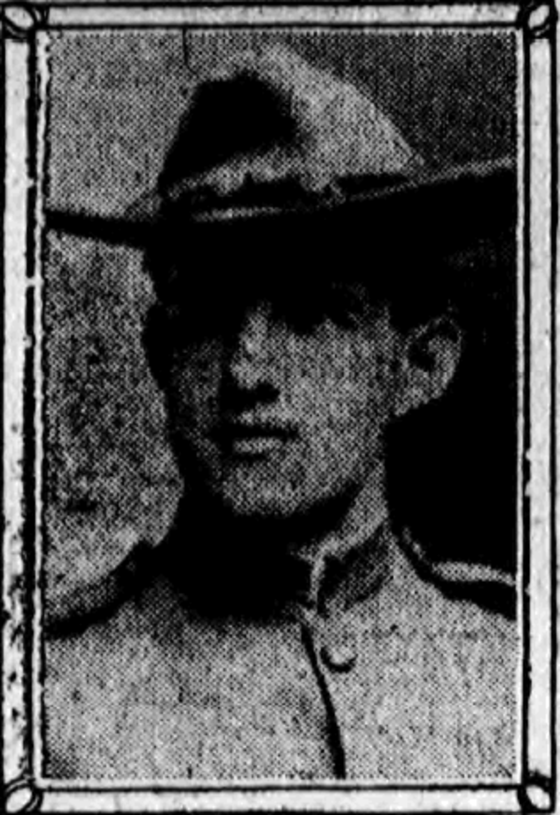
Daniel Stevenson Bassett, Philadelphia Inquirer, 1907

Philadelphia Inquirer, 1907
Soldier’s Secret Bride Two Years
Elopement to New York on Dare Revealed
by Accidental Showing of Wedding Ring

Married almost two years, Mr. and Mrs. Daniel S. Bassett, both of whom are well known in northeastern social circles, have just made their wedding public. The announcement was made last Saturday, and followed the finding of a wedding ring upon the bride’s finger by her mother.
The room is the national Quartermaster General of the American Veterans of Foreign Service, and is a well known Kensington business man. The bride was Miss Katherine M. Lenahan, the daughter of Mrs. L. Lenahan, of 639 East Westmoreland street. The young couple had known each other but eight months before the wedding. On Easter Sunday morning, April 23, 1905, they attended the services at the East Allegheny Avenue Methodist Episcopal Church.
Mr. Bassett was escorting the young woman home, when he turned to her abruptly and said:
“I dare you to elope to New York with me.”
“I’ll take your dare,” said the girl. The couple went to New York the same afternoon, and that evening were married at “The Little Church Around the Corner,” by Rev. E.P. Houghton. They returned to this city, and said nothing of the marriage.
They maintained their secret so well, that not even their relatives knew of the wedding until last Saturday. Then, the bride forgot and wore the tell-tale ring to the dining table. Explanations were asked by Mrs. Lenahan, and when given, the young couple were given the maternal blessing. Then all the relatives were informed, and all are so well pleased with the match that they have arranged a reception for the young couple at R. Bassett’s former home, at 1924 East Arizona street, for next Wednesday evening.
Prominent among the guests at this affair will be veterans of the Spanish-American War and the Philippine campaigns. During the strife with Spain, the groom served as a member of Company K, Third Pennsylvania Regiment. Later, he enlisted with Company F, Twenty-first Regiment, U.S.A., and was in the Philippines from 1899 until 1902. During that time he participated in 19 engagements and was a scout in the government service for ten months Bassett is now commander of General Henry W. Lawton Post, American Veterans of Foreign Service.
The young couple are now residing at 3152 Frankford avenue.

* * * * *

Section 5 - Featured Bassett: Richard Ellsworth Bassett's troubles

Richard Ellsworth Bassett descends from William Bassett of Plymouth as follows:

William Bassett and his wife Elizabeth
William Bassett (b. 1624) and wife Mary Raynesford
William Bassett (b. 1656) and wife Rachel Williston
Jonathan Bassett (b. 1683) and wife Mary Gale
Jonathan Bassett (b. 1709) and wife Mary Francis
Elisha Bassett (b. 1753) and wife Hannah Stone
Elisha Bassett (b. 1783) and wife Polly Dowd
Ellsworth Bassett (b. 1808) and wife Cynthia Howell
Romeo Ellsworth Bassett (b. 1834) and wife Ann Eliza Smith
William Ellsworth Bassett (b. 1870) and wife Mary Elizabeth Knowles
Richard Ellsworth Bassett (b. 1895) and wife Gertrude Hall

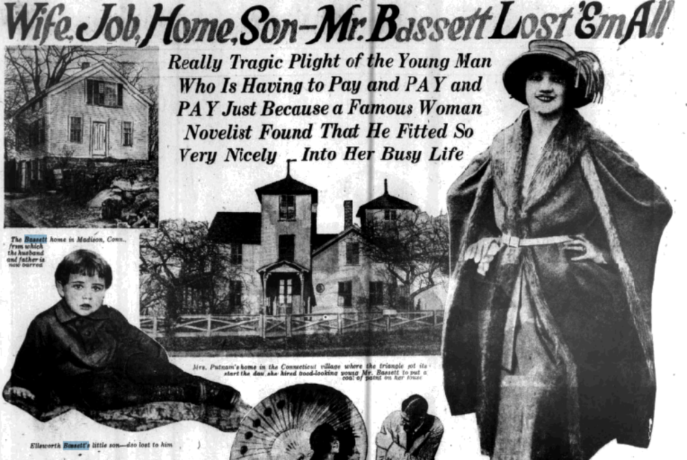

The Philadelphia Inquirer Magazine Section, February 10, 1924
Wife, Job, Home, Son – Mr. Bassett Lost ‘Em All
Really Tragic Plight of the Young Man
Who Is Having to Pay and PAY and PAY Just Because
a Famous Woman Novelist Found That He Fitted So Very Nicely
Into Her Busy Life

In the typical film drama, as every “movie” goer knows, it is the woman who pays and pays and pays. But in real life this is by no means always the case. Quite frequently it is the man who has to pay most heavily for some crime or some mistake, for some treachery on another’s part or some compromising situation in which circumstances make his innocence look like guilt.
Take, for example, that thrilling little drama of reality which Nina Wilcox Putnam, the famous author, her former chauffeur and secretary, Ellsworth Bassett, and the latter’s wife, recently have been presenting, to the public’s great amazement.
The plot of this curious intermingling of comedy and tragedy, on which the curtain rose in the little Connecticut village of Madison, and which later shifted its scene to Canada and Palm Beach and New York, has reached its climax.
And who is the chief victim? Who of the three actors is the one to suffer most as a result of the denouncement that has come?
Both Mrs. Putnam and Mrs. Bassett think they have suffered, and must still suffer, more than any woman should have to, but even their most sympathetic friends will hardly maintain that either of them has the heaviest load un happiness and remorse to bear.
As so often happens outside of the “movies”, Fate has dumped the greatest burden of punishment on the shoulders of a man. It is Ellsworth Bassett, the young and good looking hero, who is having to pay most heavily for the strange tangle in which he and his wife and his former employer became involved.
And what a staggering price it is that he is being to pay for the guilt or the misunderstanding or whatever it was that caused all this trouble!
His wife, his home, his job, his son – Mr. Bassett has lost them all. They have been snatched from him suddenly and completely as if the earth had opened and swallowed them up.
The rosy future he believed he faced a few weeks ago when he sat beside his pretty and talented employer among the palm trees of Florida has become a drab, dismal thing. With almost movie like swiftness he has been yanked away from the balmy luxuries of a fashionable Southern beach and brought back to the worries of a workaday life in the chilly North.
No longer has he an expensive car to drive or a famous novelist to introduce him as her business representative and intrust him with the marketing of her writings. Nothing like that now for Ellsworth Bassett. He is hunting a new job, establishing himself in a new home and awaiting with what equanimity he can the outcome of the situation.
As long as he lives Bassett probably never will forget that morning when this disastrous real-life plot began getting under way. He rose from the breakfast table and, taking his overalls down from a hook behind the kitchen door, started rolling them into a neat bundle.
“What are you going to do, my dear?” his wife asked as she hurried away the breakfast dishes, preparatory to leaving for her day’s work in the village post office.
“Going to paint Nina Wilcox Putnam’s house,” he replied.
Then he explained how he had met the novelist the day before and she had told him she was looking for somebody to give her house a coat of paint. Having no work of his own on hand, Bassett offered his services and Mrs. Putnam gladly accepted them.
“It’s easy work,” said Bassett to his wife, “and she will pay me well.”
As he kissed Mrs. Bassett good-bye and started off she seems as well pleased as he over the money his industry was going to bring into the family pocketbook. Neither of them had nay suspicion of the momentous changes this house-painting job was going to bring in their lives.
Nina Wilcox Putnam has maintained a home in Madison for a number of years, living there between her frequent trips to California, New York, Palm Beach and other places where she goes to gather material for her stories. Her first husband, Robert Faulkner Putnam is dead, and, as the village gossips had long been whispering, she was about to seek a divorce from her second one, Robert J. Sanderson.
In the course of directing the painting of the house Mrs. Putnam became pretty well acquainted with Ellsworth Bassett. She was favorably impressed, as everybody who meets him is, by his stalwart good looks, his gentlemanly manners and his keen intelligence. She found that he could not only paint a house, but could drive a car and repair one, too, and they talked a good deal of the things that interest motorists.
Mrs. Putnam was pleasantly surprised to have a young man of such engaging personality wielding a paint brush on her house. As anybody with half an eye could see, he was capable of much better things – just the type of man to make an ideal chauffeur and business agent and all-round companion and protector for a well-to-do and busy woman who has no husband on the job of looking after her.
The painting was finished and the paths of Mrs. Putnam and Bassett might never again have crossed if she had not suddenly found it necessary to make an automobile trip to Canada. Since a recent illness her physician had forbidden her to drive a car, and she could think of no one except her versatile house painter of a few days ago whom she cared to take along as chauffeur and companion.
Mrs. Putnam asked Mrs. Bassett if she could borrow her husband for a little while. Mrs. Bassett gave her consent. Ellsworth himself was of course delighted at the chance of taking this long motor trip at the good wages the novelist offered.
As the novelist and her new chauffeur sped up the Connecticut River Valley her first favorable impression of him deepened. By the time they reached the Canadian border she had engaged him to drive her car right along. Before they started back to Madison he had ceased to be a mere chauffeur and had been made her confidential representative – with full charge of her household affairs and authority to represent her in the sale of her writings.
The record of what happened after Mrs. Putnam and Bassett arrived back in Madison and broke the news of their new relationship to Mrs. Bassett is badly blurred by the conflicting stories the two heroines tell.
“Nina Wilcox Putnam invited me to her house” – so Mrs. Bassett had since declared – “and tried to persuade me to give up my husband so that she could marry him. When I would not du such a thing he went away with her.”
All this the novelist denies. She declares that Mrs. Bassett said she was glad her husband was working for Mrs. Putnam and “getting good, steady money.”
Whatever the truth about Mrs. Bassett’s attitude, Mrs. Putnam and her new personal representative soon started for Florida together, leaving the wife and her little son to look out for themselves.
For several weeks Mrs. Bassett let nobody know that she felt any dissatisfaction or uneasiness over her husband’s absence under these conditions. But at last the remarks the gossips kept making began to cause her painful heart burnings. Her husband’s letters, enthusiastically describing the great hotels at which he and Mrs. Putnam were living, the plantation where they picked oranges and the delights of the sun-kissed beaches where they strolled, made her only the more unhappy.
One morning she burst into the newspapers, crying that she was love-robbed wife – that the charming novelist had taken her husband away form her and probably would never return him.
When this happened Mrs. Putnam was just starting for New York to see what could be done about her divorce suit, which had been thrown out of a Rhode Island court on the ground that she was not a legal resident of the State.
On reaching New York and seeing the publicity that was being given Mrs. Bassett’s vociferous charges, she suffered a nervous collapse. Form her sick bed she issued vigorous denials and pitiful please to her “public” not to misjudge her. But the wife in Madison only shouted her grievances all the louder.
A few days later Ellsworth Bassett arrived from Florida, and, with a noble gesture of self-sacrifice that would do credit to any hero of novels or “movies”, he resigned the job in which he saw such a glittering future. Then he hurried on to Madison to see a reconciliation with the wife who persisted in describing him as “only a clam digger.”
But Bassett might as well have saved the price of his railroad ticket. In Madison he found that the loss of his job was only a small part of the terrible blow that had fallen on him. He was barred from his home. His wife refused to see him. He was not even permitted a sight of his little son.
At once Bassett, whether guilty of any wrong to his wife or not, became a tremendously pathetic figure – a man who had lost all the things that are dearest, next to life itself, and who stands no chance of winning any of them back unless one or the other of the two women in the triangle takes pity on his plight.
The key to his future happiness seems to rest entirely with his wife and his late employers, and whether either of them will see fit to use it is an interesting question.
Will Mrs. Bassett’s heart eventually lose its bitterness? Will she decide to call the whole thing an unfortunate misunderstanding and take her handsome husband back to her arms?
If she will not do this, then Bassett’s only hope of escape from the bondage of a man who must pay and pay and pay lies in the hands of Nina Wilcox Putnam. Through her only can he regain the good job he lost, and through her also he might win another wife and home and son to replace those that have been taken from him.
As millions of readers of Nina Wilcox Putnam’s stories know, she is an expert at contriving “happy endings” for her plots.
Will she supply one for the tragedy that has overtaken Ellsworth Bassett, as the result of his relations with her, by taking him back into her employ?
And later on, if Mrs. Bassett divorces her husband, and if Mrs. Putnam herself succeeds in securing a divorce, will the novelist promote her personal representative to a still more personal position in her life?
Perhaps Mrs. Putnam’s present husband, Robert J. Sanderson, thinks thi exactly what will happen. Quite possibly this is why, as he recently announced, he has instructed his lawyers to see whether the tangled affairs of his wife and her former house painter and chauffeur and the latter’s wife furnish him the grounds for a divorce.
Unless his wife decides to forgive him or Mrs. Putnam takes pity on her former employee it seems probable he will have to continue paying, perhaps as long as he lives. Of all the heroines of the moves whose predicaments have won the public’s tears, where is there one who has had to shoulder, whether deserved or undeserved, than is being loaded on unfortunate Mr. Bassett?

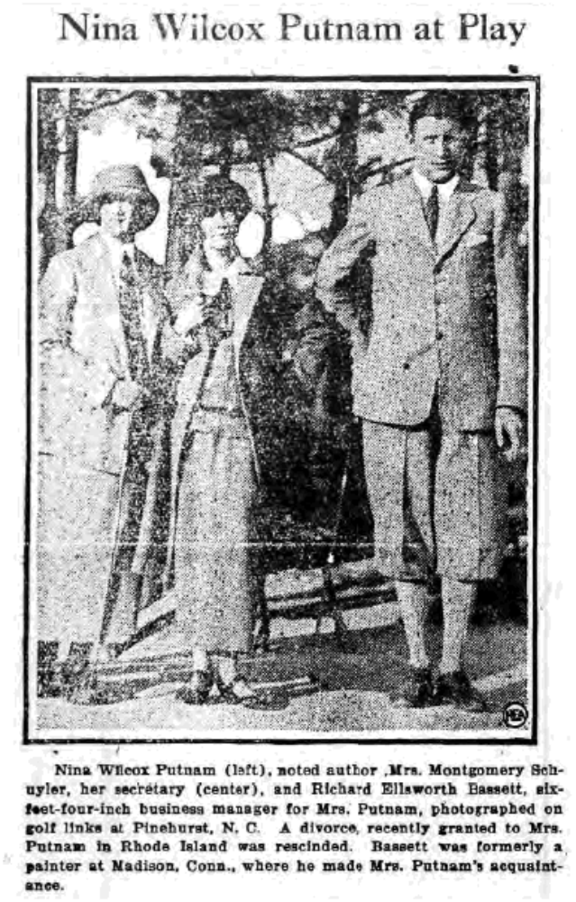
Whitesville New York News

Oakland Tribune, Friday, June 21, 1929
Elopement Charged In Suit For Divorce

NEW HAVEN, Conn. – June 21 – (AP) – Judge F. Arthur Ells in superior court took under advisement the plea of Mrs. Gertrude Hall Bassett, of Madison, for divorce from Richard Ellsworth Bassett of Los Angeles, who took a prominent part in the Rhode Island divorce of Nina Wilcox Putnam, authoress.
Mrs. Bassett charges her husband with eloping with Mrs. Muriel Blanchard Nelson, heiress and wife of William A. Nelson, Madison artist. Mrs. Bassett said Mrs. Nelson took Bassett away in her roadster just after the Putnam divorce. Testimony before Judge Ells brought out that Bassett had been the secretary of the woman writer for thirteen months. Mrs. Nelson is to inherit part of the fortune of Major George Blanchard, millionaire Brooklyn, N.Y., hotel owner.

* * * * *

Section 6 - Featured Bassett: Death of Benjamin Bassett of Kyneton, Western Australia

Benjamin Bassett was the son of #406B John Bassett of Bedfordshire, England.

Kyneton Newspaper, May 8, 1909

Death in the West - The death is announced of Mr Benjamin Bassett, who for many years resided with his family at the extreme western end of Pohlman Street. The sad event, which in consequences of his advanced years, was not wholly unexpected, occurred on April 13th at the residence of his daughter, Mrs Robertson, at Perth, W.A. whither he had gone some years ago in search of improved health, as he had been in a very indifferent state of health for some time previous. Mr Bassett was one of those sturdy pioneers who did much towards the settlement of this fair country. He was a native of Bedfordshire, and came to this State when he had reached his majority. He followed the occupation of a contracter for many years with varying success and succeeded in raising a family in respectability and comfort. One of his sons, well known in this district is Mr B. Bassett, of Sturt Street, Kyneton, whilst Mrs E. Tranter, who for many years has resided in Lauriston, is a respected daughter. Mr Bassett was for many years an enthusiastic member of the Kyneton Baptist church, and on his moving westward he allied himself to the same denomination. His remains were laid to rest in the Karrakatta cemetery, the service being read by the Rev. Samuel J Pitman, of the Baptist denomination.

* * * * *

Section 7 - Featured Bassett: Bassett's Mill of Fremont, New Hampshire

This family descends from #345 Samuel Bassett of New Hampshire as follows:

Samuel Bassett (d. 1872) and wife Hannah Peasley
George W. Bassett (b.1837) and wife Sarah J. (Beede) Blaisdel
Joseph P. Bassett (b. 1867) and wife Eva Kimball
George Albert Bassett (b. 1895) and wife Nellie P.

The Portsmouth Herald, July 23, 1964

A building still standing on Scribner Road was once Bassett’s Mill, where platform rockers and mattresses were made. It was owned by Joseph P. Bassett and his brother George. On one end of the mill the two brothers managed a grocery store and a grist mill for grinding grain by water power.
George A. Bassett, son of Joseph P. Bassett, lives in one of Fremont’s oldest houses, dating to 1766, and owns one of the rockers made by his father’s mill.

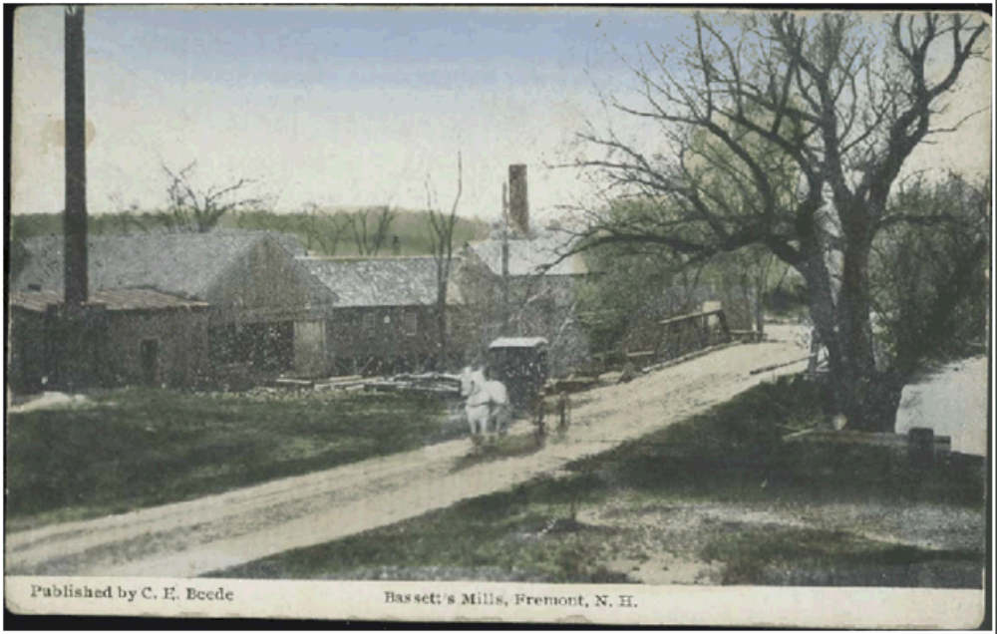
The postcard above was purchased on ebay.

Biographical Review of Rockingham County, New Hampshire (1896)
George W. Bassett

George W. Bassett, a skillful farmer of Fremont, who has met with a fair share of success in his independent calling, is a native of this county, born Feb. 22, 1827, in the town of Epping. His father, Samuel Bassett, who was born in Vermont, in his early manhood settled in Epping, where he married Miss Hannah Peasley. Some time after he removed to Pittsfield, Merrimack County, and was there engaged in teaming and farming for the remainder of his active life. He passed his last days with his son, George W., in Fremont where his death occured June 19, 1872. His first wife, who bore him 4 children, died while in Pittsfield. He subsequently married Sarah Cram, a native of Pittsfield. The children of his first union were: Joseph, who died while serving the Union in the late war; John who is living in N.Y.; Mary Ann, now a resident of Calif; and George W., the subject of this sketch.
George W. Bassett began the battle of life when but 8 years of age. Going then to South Haven, this county, he worked on a farm until he was 18. He was afterward engaged in a different place as a farm laborer, and for some time sold charcoal, when he acquired the sobriquet of "Charcoal Bassett". At length by good management he had saved enough money to warrant him in buying his present farm. The property contains 150 acres. Since entering into possession he has made most of the improvements now to be seen on it, besides bringing the soil to a high state of productiveness. He carries on general agriculture, and continues to deal in charcoal. In politics he is a loyal and faithful Republican, never swerving from party allegiance.
He was married May 8, 1866 to Mrs. Sarah J. (Beede) Blaisdel. She was the widow of Albert Blaisdel and had one son, Albert B. Her father, a well known farmer of this locality, was also a lumber dealer. Mr. & Mrs. Bassett have 2 children; Joseph and George S. Joseph who married Eva Kimball, of Danville, has one child, George Albert; and he and his family live on the home farm. George S. is in business in Haverhill, Mass.

* * * * *

Section 8 - New family lines combined or added since the last newsletter

236B. Abraham Bassett of Mississippi (b. 1820)

* * * * *

Section 9 - DNA project update.

The results for the following kit were received this month.

This kit currently has no matches to any other Bassetts in the study.

Donations of any amount can be made to the Bassett DNA project by clicking on the link below. Any funds donated will be used to fund select Bassett DNA tests that will further our project as a whole and benefit all Bassetts worldwide.

http://www.familytreedna.com/group-general-fund-contribution.aspx?g=Bassett
This is just a reminder that the DNA portion of the Bassett Family Association can be found at:
http://www.bassettbranches.org/dna/
A current spreadsheet of results can be found at:
http://www.bassettbranches.org/dna/BassettDNA.xls
If you don't have Excel and can't open the spreadsheet above, you can now see the DNA test results at the following website.
http://www.familytreedna.com/public/Bassett/
Jeffrey Bassett
520 Salceda Drive
Mundelein, IL 60060 USA
bassettgenealogy@gmail.com

